Appendix 1: Global Soil Health Scenarios
Scenario 1: Failing Farms in Sub-Saharan Africa
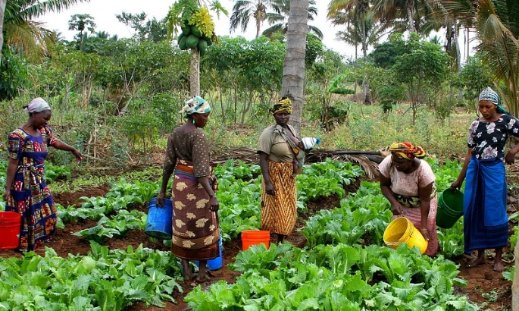
In a rural Kenyan village, most families rely on small plots of land to grow staple crops like maize and beans. These crops have been planted repeatedly without the addition of compost or fertilizer, which has led to depleted nutrients in the soil. The once dark and crumbly soil has become pale and compacted, and plant growth is stunted.
Climate change has made rainfall less predictable — sometimes flooding the fields, other times leaving them dry for weeks. As yields drop, families face food shortages, and younger generations are leaving the village in search of work. Government programs and NGOs have offered some support, but resources are limited. Community members are exploring solutions like composting, intercropping and collecting rainwater to restore soil health.
Scenario 2: Erosion on U.S. Farmland
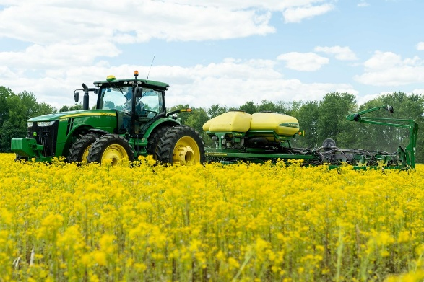
In the heart of the Midwest, a corn and soybean farmer has noticed that each year more of the topsoil is washing away. Heavy spring rains frequently occur after the soil has been tilled and left bare between plantings. This runoff not only strips the field of valuable nutrients but also carries sediment and fertilizers into nearby streams, polluting water supplies.
The once-rich soil has become shallow and less able to retain water. The farmer is considering no-till practices, cover crops and other regenerative strategies but is unsure about the financial risk or how to make the transition. They’ve begun researching support through government conservation programs and local extension services.

Scenario 3: Contaminated Soil in an Urban Garden (USA)
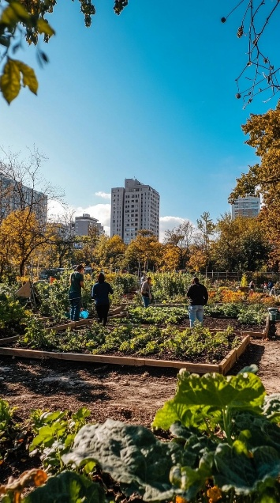
In Detroit, a local neighborhood group is transforming abandoned lots into community gardens to address food insecurity. After setting up raised beds and planting vegetables, a university soil test reveals elevated levels of lead and other heavy metals, a legacy of past industrial activity.
The group is devastated. They worry about the health risks for families and children who were excited to eat from the garden. Soil compaction from old construction materials has also made it difficult for roots to grow. Now the group must decide: Should they replace the soil, plant only in raised beds or look into phytoremediation techniques using specific plants to pull toxins from the ground?
Scenario 4: Deforestation and Nutrient Loss in Brazil
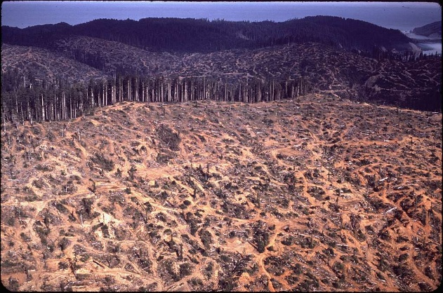
In northern Brazil, large sections of the Amazon rainforest are being cleared for soybean and cattle farming. The rich green canopy is replaced by fields of short grass or bare earth. Although the newly cleared land is initially productive, it quickly loses its fertility.
Tropical rainforest soil is surprisingly thin and relies on constant input from falling leaves and decaying plant matter. Once exposed, the soil is washed away during rains, and the carbon stored in soil and plants is released into the atmosphere, contributing to global warming. Environmental groups are calling for reforestation and more sustainable farming practices while local farmers face pressure from global commodity markets.

Scenario 5: Desertification in Northern China
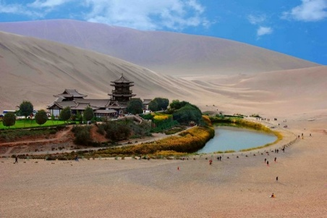
In northern China’s Loess Plateau — a region known for its powdery, yellow soil — centuries of deforestation and overgrazing have left vast areas bare. Without grasses or trees to protect the surface, strong seasonal winds carry topsoil away in massive dust storms. These storms reduce visibility, damage infrastructure and pose serious respiratory health risks for nearby communities.
Rainfall in the region is minimal and irregular. When it does fall, the lack of vegetation and compacted soil leads to flash flooding and runoff, rather than water absorption. Many villages have been abandoned due to unproductive farmland.
The Chinese government has launched large-scale reforestation projects, including the “Great Green Wall” initiative, planting millions of trees and introducing terraced farming to stabilize slopes. Results have varied. Some areas are rebounding while others remain at risk of permanent desertification due to climate pressures and poor land management.
Scenario 6: Salinization in Irrigated Fields of Pakistan
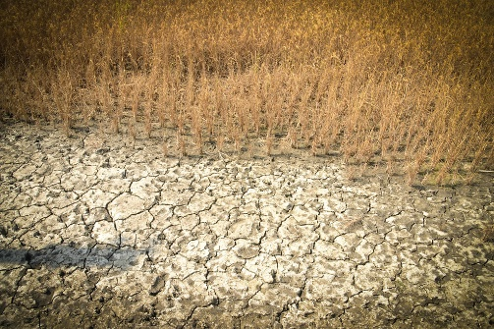
In the Sindh and Punjab regions of Pakistan, irrigation has long supported vital crops like wheat, rice and cotton. Water from the Indus River is diverted across thousands of kilometers of canals and ditches to reach distant fields. However, over the past few decades, poor drainage and repeated flooding have led to salinization, a condition where salts build up in the upper layers of soil eventually forming a crust that stunts or kills crops.
Farmers began noticing white deposits on the soil surface and reduced growth even in freshly irrigated fields. They tried flushing the fields with excess water, but this worsens water waste and raises groundwater tables, compounding the problem.
Research institutions have suggested using salt-tolerant crops like barley or quinoa, improving canal maintenance and implementing subsurface drainage systems. But many rural farmers lack the technical knowledge or funding to make these changes without outside support.

Scenario 7: Deforested Hillsides in Haiti
Haiti’s steep mountainsides were once covered in dense forests, but decades of cutting trees for charcoal and building materials have left the slopes exposed. Each rainy season, the bare hills shed massive quantities of soil in the form of mudslides and sheet erosion. Rivers swell with sediment, damaging roads and homes downstream.
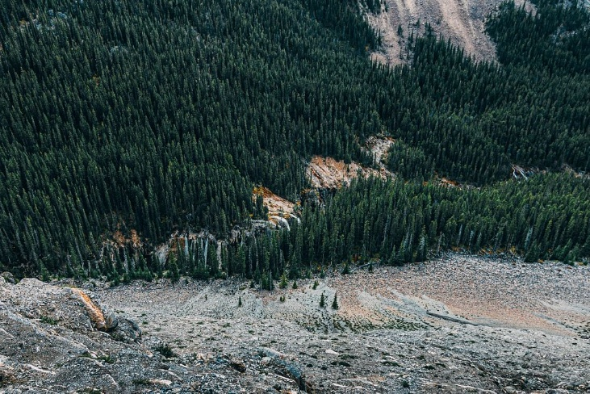
This erosion not only reduces arable land but also pollutes rivers and coastal waters, harming coral reefs and reducing fish populations that coastal communities rely on for food and income.
Efforts to stabilize the land include planting fast-growing trees, training farmers in contour farming and agroforestry and introducing fuel alternatives like propane. However, economic pressures and food insecurity continue to drive deforestation in many areas.
Scenario 8: Overgrazing in Australia
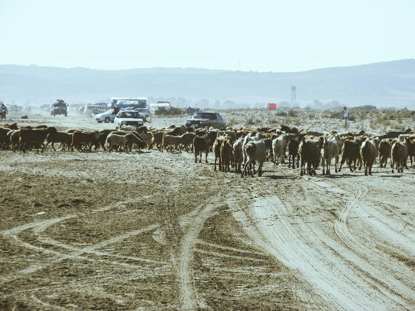
In the dry rangelands of central and western Australia, sheep and cattle roam across massive paddocks (pastures). Over time, overgrazing has worn away the native grasses and broken up soil structure. Invasive weed species often take over, and the compacted soil becomes more vulnerable to erosion.
Without enough vegetation, rainfall runs off quickly, and dust storms become more frequent, especially during hot, dry months. Indigenous communities note that traditional bush tucker plants and habitats for native wildlife are disappearing.
Some landholders are adopting rotational grazing, planting perennial grasses and working with scientists to monitor soil carbon levels. Others hesitate, concerned about reduced stocking rates and upfront costs.

Scenario 9: Urban Sprawl in India
On the outskirts of Delhi and other growing Indian cities, fertile farmland is rapidly being converted into housing developments, shopping centers and industrial sites. As concrete and asphalt spread, the underlying soil becomes sealed off, no longer able to absorb water, support roots or cycle nutrients.
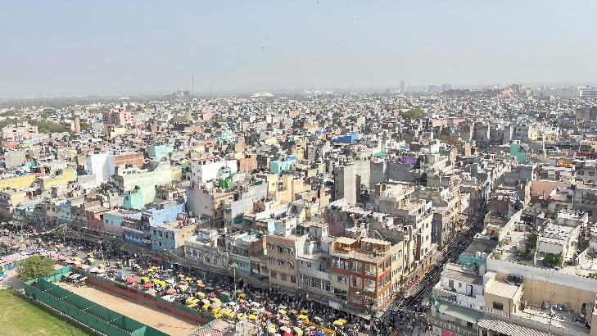
Flooding has become more common during monsoon season because the land cannot soak up excess water. Local vegetable growers are displaced, and food must travel farther to reach urban markets, increasing cost and carbon emissions.
Some urban planners and activists are pushing for green infrastructure (like parks, rain gardens and green roofs), protected farmland zones and peri-urban farming initiatives, but these are difficult to implement in the face of rising land prices and lack of regulation.
Scenario 10: Peatland Destruction in Indonesia
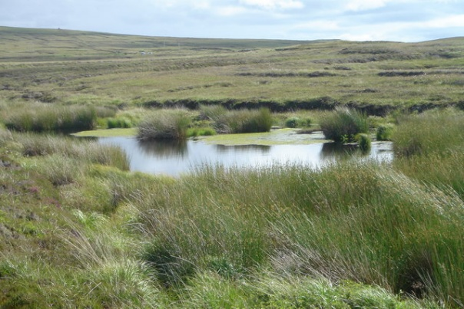
Indonesia is home to vast tropical peatlands, wetlands made of thick layers of partially decayed plant matter. These ecosystems are among the world’s largest carbon sinks, storing massive amounts of greenhouse gases. But over the past 20 years, many have been drained for palm oil plantations.
Once drained, peat dries out, shrinks and becomes highly flammable. Fires often spread uncontrollably, sending choking smoke across Southeast Asia. These fires not only release huge quantities of carbon dioxide but also disrupt local health and schooling.
Conservation groups are promoting peatland restoration through rewetting and blocking drainage canals while others push for stronger enforcement of sustainable palm oil certification standards. However, palm oil remains a major economic driver for both corporations and smallholders, making change politically and economically complex.

