Appendix 1: Soil Health Sort Cards
PHYSICAL FACTORS
CHEMICAL FACTORS
BIOLOGICAL FACTORS
HUMAN ACTIVITY FACTORS

Soil Texture  - Ratio of sand, silt and clay  - Affects how water moves and nutrients are stored  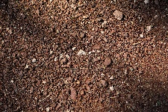 | Soil Structure  - How particles group into aggregates  - Better structure = better root growth and water movement  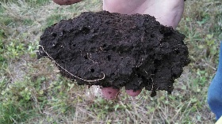
Compaction  - Caused by heavy machinery or animals  - Reduces pore space, air flow and root growth   | Water Retention  - Influenced by texture and organic matter  - Too little = drought stress, too much = root rot  
pH  - Ideal range is 6.5–7.5  - Outside that range, nutrients become unavailable.  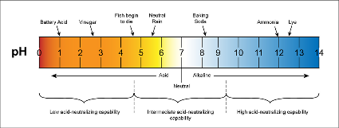 | Nutrient Availability  - Soil must provide nitrogen, phosphorus, potassium and micronutrients.  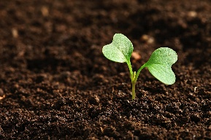
Salinity  - High salt levels reduce water uptake by plants.  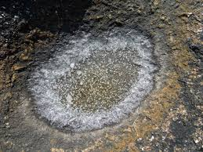 | Organic Matter  - Improves structure  - Holds water  - Provides nutrients  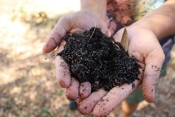
Microorganisms  - Bacteria and fungi break down organic matter and help plants get nutrients.  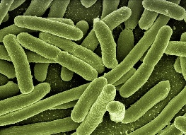 | Soil Biodiversity  - More living organisms = more resilient soil  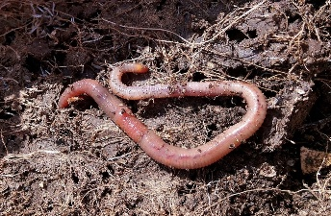
Tillage  - Breaks up soil but can lead to erosion  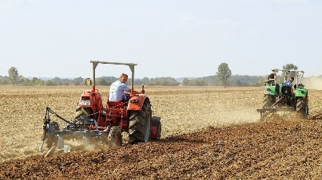 | Fertilizer Use  - Helps crops grow, but overuse harms microbes  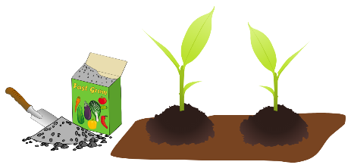
Land Use

- Deforestation and development remove protective cover
