Appendix 1: Soil Organisms
1. Earthworms  Role in Soil Health:  Break down organic matter, improve soil structure and porosity and enhance nutrient cycling through their castings  Thrive In:  - Moist, aerated soils rich in organic matter  - Neutral pH (6-8)  - Undisturbed environments (no-till or reduced-till systems)  Decline In:  - Frequent or deep tillage  - Soil compaction  - Drought or poor drainage  - Heavy pesticide use | 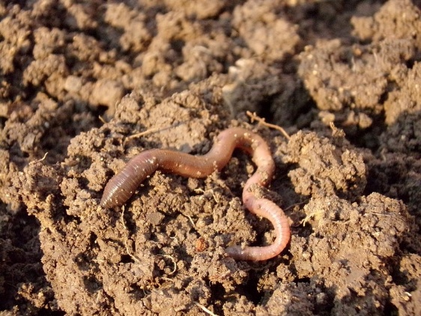
2. Mycorrhizal Fungi  Role in Soil Health:  Form symbiotic relationships with plant roots to increase water and nutrient uptake (especially phosphorus); help build soil aggregates  Thrive In:  - Soils with living plants and root exudates  - Low phosphorus inputs  - Stable, undisturbed environments  Decline In:  - Overuse of synthetic fertilizers  - Tillage (disrupts fungal networks)  - Monocultures  - Bare soils with no root hosts | 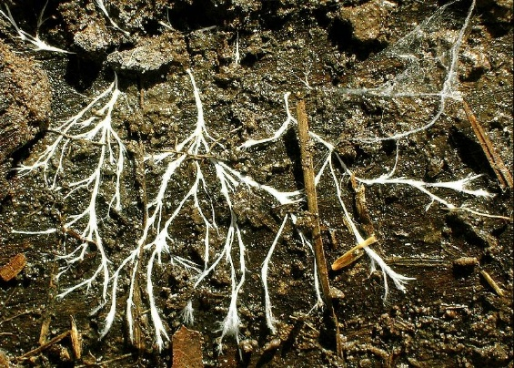

3. Springtails  Role in Soil Health:  Feed on fungi, decaying organic matter and bacteria, helping with decomposition and nutrient cycling  Thrive In:  - Moist, organically rich soils  - Mulched or forested areas  - Leaf litter and compost piles  Decline In:  - Dry or compacted soils  - Chemical pesticide exposure  - Tillage or loss of organic matter | 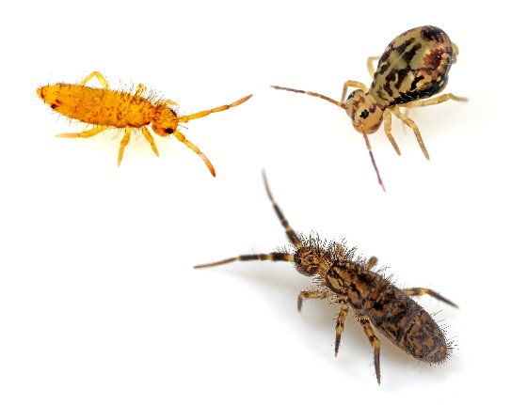
4. Nematodes  Role in Soil Health:  Some species help decompose organic matter or prey on pests; others feed on plant roots (not all are beneficial)  Thrive In:  - Diverse microbial populations  - Moist soil with moderate temperatures  - Adequate organic matter  Decline In:  - Soil fumigation or chemical treatments  - Excessive drought or flooding  - Lack of microbial life or plant diversity | 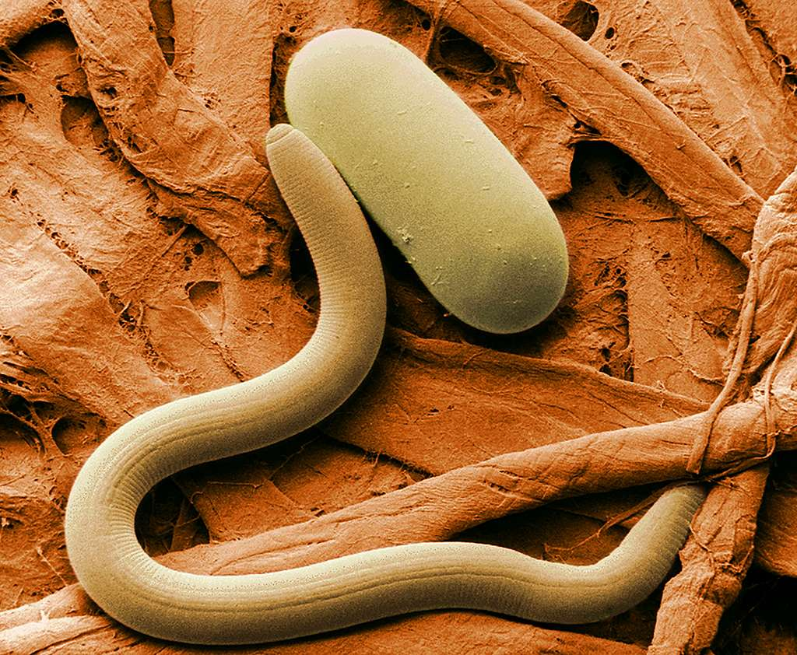

5. Actinomycetes  Role in Soil Health:  A type of bacteria that helps decompose tough materials like cellulose and lignin; contributes to the earthy smell of healthy soil  Thrive In:  - Warm, aerated soils with moderate moisture  - High organic matter  - Near-neutral pH  Decline In:  - Poor drainage or saturated soils  - Soil compaction  - Acidic pH  - Lack of plant residues | 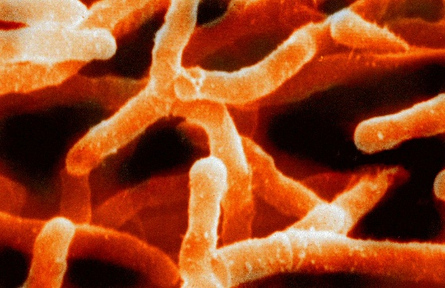
6. Mites  Role in Soil Health:  Include decomposers, predators of pests and contributors to microbial activity; play multiple roles depending on the type  Thrive In:  - Mulched or forested soils  - Moisture-stable environments  - Organic residues or compost  Decline In:  - Disturbed soils (tillage or compaction)  - Dry, bare or nutrient-poor soil  - Chemical exposure | 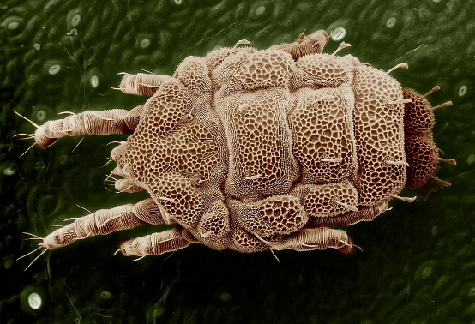

7. Protozoa  Role in Soil Health:  Feed on bacteria, regulating microbial populations and releasing nutrients for plants (especially nitrogen)  Thrive In:  - Moist, well-aerated soils  - Abundant bacterial populations  - Stable temperatures  Decline In:  - Drought or waterlogged soils  - Low microbial activity  - Pesticide exposure | 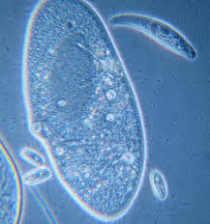
8. Ants  Role in Soil Health:  Aerate soil through tunneling, assist in decomposition and redistribute nutrients and seeds  Thrive In:  - Loamy or sandy soils  - Warm climates  - Undisturbed environments  Decline In:  - Flooded or compacted soils  - High pesticide use  - Loss of ground cover or food sources | 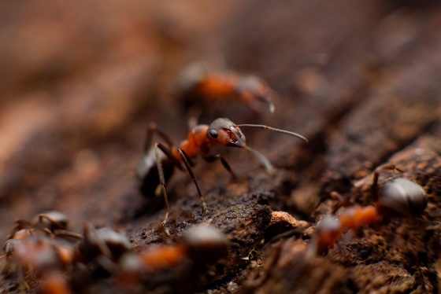

9. Grubs (Larval Beetles)  Role in Soil Health:  Decompose organic material and break down plant matter; some are pests of roots.  Thrive In:  - Moist soils with decaying roots or mulch  - Presence of vegetation (especially turf and pasture)  - Moderate temperatures  Decline In:  - Tillage and soil disruption  - Cold or dry conditions  - Predator populations (e.g., birds, beneficial nematodes) | 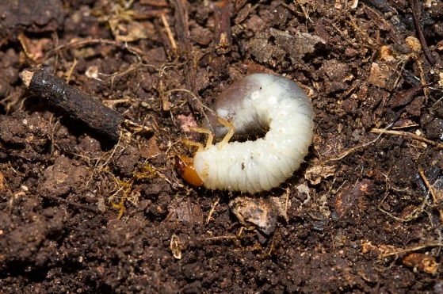
10. Bacteria  Role in Soil Health:  Decompose organic matter, fix nitrogen, suppress diseases and support plant health in countless ways  Thrive In:  - High organic matter  - Moist, oxygenated soils  - pH near neutral (6.5-7.5)  Decline In:  - Acidic, compacted or extremely dry soils  - Pesticide exposure  - Lack of food sources like root exudates | 