Appendix 1: Waste Not, Want Not
Aligned to the following standards:
FFA.PL-A; FFA.PL-C; FFA.PL-D; FFA.PL-F; FFA.PG-I; FFA.PG-J; FFA.CS-N; FFA.CS-P; CS.06; AG6; AGC05.02; CCSS.SL.9-10.2; CCSS.RI.9-10.3; CCSS.W.9-10.1; MP1; CCSS.RST.9-10.4; CCSS.WHST.9-10.6; CRP.02; CRP.04; CRP.05

Part 1
Directions:
Take the quiz “Waste Not, Want Not” in the fall 2021 issue of FFA New Horizons. Circle your answers and then complete the questions.
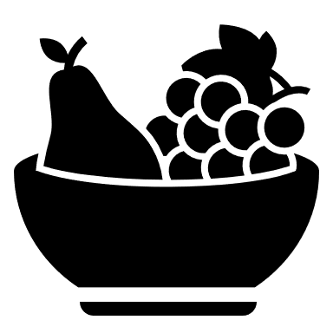

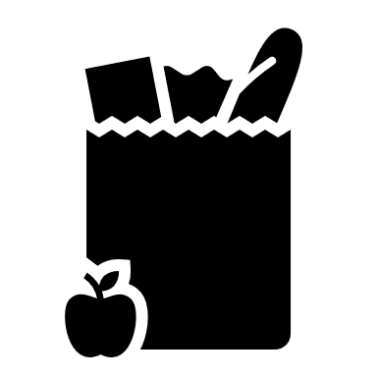
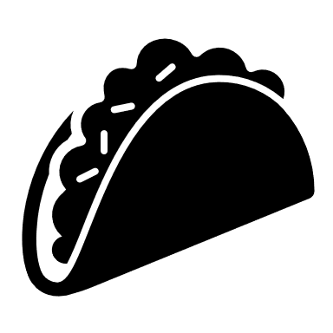

How do you think food waste impacts local communities?
- What percentage of the U.S. food supply goes to waste?
  - 10% to 20%
  - 30% to 40%
  - 50% to 60%
- In the year 2017, how much food waste was generated by American households?
  - 17 million tons
  - 22 million tons
  - 41 million tons
- What category of product gets thrown out most frequently?
  - Dairy
  - Fruit
  - Vegetables
- How much food does the average American family of four waste per year, in terms of cost?
  - $700
  - $1,000
  - $1,500
- Misreading labels is one of the biggest reasons people throw away food. What percentage of Americans throw away perfectly good food because they misunderstand expiration labels, such as “sell by” and “use by”?
  - 30%
  - 50%
  - 80%
- What are some ways you can reduce food waste at home?
  - Utilizing leftovers
  - Composting food scraps
  - Both of the above
Do any of the questions and/or answers from the quiz surprise you? Why or why not?

Why do you think there is so much food wasted in the United States?

Part 2
Directions:
Food waste is a large issue facing the U.S. population. But what can you do to help reduce the amount of food wasted each year? Complete the activities below using the Environmental Protection Agency (EPA) website, https://www.epa.gov/recycle/composting-home, to see what you can do.
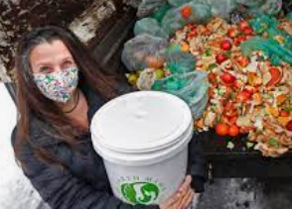
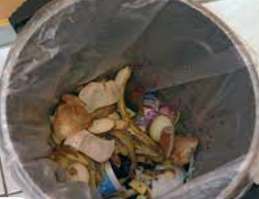
In your own words, what is composting?
Select and circle the most recent meal you consumed.

Breakfast Lunch Dinner

List all the items that you had for your meal. (Ex. Cheerios, milk, banana)

List everything that you threw away. This includes packaging, food, food peels, etc. (Ex. leftover cheerios, banana peel)
Place a square around all the food that was thrown out.
Composting requires three ingredients. Give a minimum of five examples of browns and greens. Explain why water is needed.
Greens
Browns
Water
What two items in your compost pile should have equal amounts?

__________ = __________
What are five items that you regularly consume, see or use that you can compost?
What are five items you should NOT compost?

Identify two benefits that come from composting food waste.

Complete the activities below, and then circle the green and brown composting ingredients.

Part 3
Directions:
In this part of the activity, we are going to see how much food is wasted in your school. At breakfast or lunch, sit at a table close to the waste cans. As students and staff throw out their items, use the space below to record what is thrown away.


With a green marker or highlighter, circle green compost items.
With a black marker, cross out the items that cannot be composted.
Are you surprised by how much food was thrown out? Why or why not?

Part 4
Directions:
You have now learned about food waste in the United States, learned the basics of composting and have witnessed how food is wasted in your school. Today, we are going to plan and design a compost bin for your school. Watch the “How and Why to Compost” video from Tractor Supply Co., https://youtu.be/kmdswODQDPs, and complete the following activity.

Label the image below with the examples Tractor Supply Company recommends for constructing a compost pile:
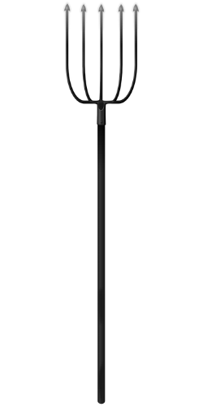
Green and brown material to use:
Building materials:

Tools and their uses:
Location, and why:
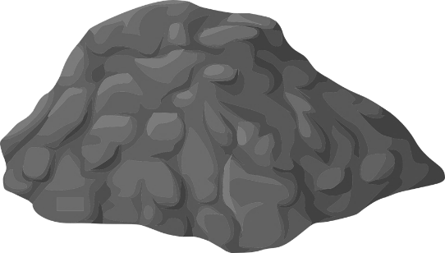

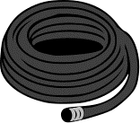
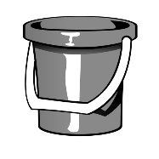

Based on the video you just watched, develop a supply list and determine the cost using the Tractor Supply Co. website, https://www.tractorsupply.com/?cm_sp=Header_Nav-_-Links-_-Logo.

Supply Cost

Total: ___________

Draw an aerial view of you school, and place an X where you would place your new compost bin.

What impact could a compost bin have at your school to combat the food waste issue?

KEY: Waste Not, Want Not
Aligned to the following standards:
FFA.PL-A; FFA.PL-C; FFA.PL-D; FFA.PL-F; FFA.PG-I; FFA.PG-J; FFA.CS-N; FFA.CS-P; CS.06; AG6; AGC05.02; CCSS.SL.9-10.2; CCSS.RI.9-10.3; CCSS.W.9-10.1; MP1; CCSS.RST.9-10.4; CCSS.WHST.9-10.6; CRP.02; CRP.04; CRP.05

Part 1
Directions:
Take the quiz “Waste Not, Want Not” in the fall 2021 issue of FFA New Horizons. Circle your answers and then complete the questions.





How do you think food waste impacts local communities?
Answers will vary.
- What percentage of the U.S. food supply goes to waste?
  - 10% to 20%
  - 30% to 40%
  - 50% to 60%
- In the year 2017, how much food waste was generated by American households?
  - 17 million tons
  - 22 million tons
  - 41 million tons
- What category of product gets thrown out most frequently?
  - Dairy
  - Fruit
  - Vegetables
- How much food does the average American family of four waste per year, in terms of cost?
  - $700
  - $1,000
  - $1,500
- Misreading labels is one of the biggest reasons people throw away food. What percentage of Americans throw away perfectly good food because they misunderstand expiration labels, such as “sell by” and “use by”?
  - 30%
  - 50%
  - 80%
- What are some ways you can reduce food waste at home?
  - Utilizing leftovers
  - Composting food scraps
  - Both of the above
Do any of the questions and/or answers from the quiz surprise you? Why or why not?
Answers will vary.

Why do you think there is so much food wasted in the United States?
Answers will vary.

CVCV
CVCV
CVCV
CVCV
CVCV
CVCV
Part 2
Directions:
Food waste is a large issue facing the U.S. population. But what can you do to help reduce the amount of food wasted each year? Complete the activities below using the Environmental Protection Agency (EPA) website, https://www.epa.gov/recycle/composting-home, to see what you can do.
In your own words, what is composting? Answers will vary. Example response: Compost is organic material that can be added to soil to increase nutrition. Compost can be made from some food scraps that would otherwise be thrown away.
Select and circle the most recent meal you consumed. Answers will vary.

Breakfast Lunch Dinner

List all the items that you had for your meal. (Ex. Cheerios, milk, banana)

Answers will vary.

List everything that you threw away. This includes packaging, food, food peels, etc. (Ex. leftover cheerios, banana peel) Answers will vary.
Place a square around all the food that was thrown out.
Composting requires three ingredients. Give a minimum of five examples of browns and greens. Explain why water is needed.
Greens
Answers will vary. Examples: fruits, vegetables, grass clippings, coffee grounds
Browns
Answers will vary. Examples: dead leaves, branches, twigs
Water
Helps the compost develop
What two items in your compost pile should have equal amounts?

browns = greens
What are five items that you regularly consume, see or use that you can compost?
Answers will vary.
What are five items you should NOT compost?
Answers will vary.
Identify two benefits that come from composting food waste. Answers will vary. Examples: Reduce the amount of food waste going to landfills, create a product that can then be added to grow other plants/food

Complete the activities below, and then circle the green and brown composting ingredients.

Part 4
Directions:
You have now learned about food waste in the United States, learned the basics of composting and have witnessed how food is wasted in your school. Today, we are going to plan and design a compost bin for your school. Watch the “How and Why to Compost” video from Tractor Supply Co., https://youtu.be/kmdswODQDPs, and complete the following activity.

Label the image below with the examples Tractor Supply Company recommends for constructing a compost pile:
Green and brown material to use:
Variety; whole/chopped leaves and stalks, vegetables/fruit trimmings, grass clippings, weeds, straw, shredded paper, cardboard and/or animal manure
Building materials:
Chicken wire, welded wire or plastic gardening fence

Tools and their uses:
Pitchfork: turn/invert the pile
Bucket or garden hose: provide water to the pile
Location, and why:
Corner of or close to the garden, so rain will carry nutrients from compost pile to garden plants; take waste from garden to pile easily

Based on the video you just watched, develop a supply list and determine the cost using the Tractor Supply Co. website, https://www.tractorsupply.com/?cm_sp=Header_Nav-_-Links-_-Logo.

Supply Cost

Answers will vary.

Total: ___________

Draw an aerial view of you school, and place an X where you would place your new compost bin. Answers will vary.

What impact could a compost bin have at your school to combat the food waste issue?
Answers will vary.

