Appendix 1: Where Does Our Water Come From? Understanding Water Sources
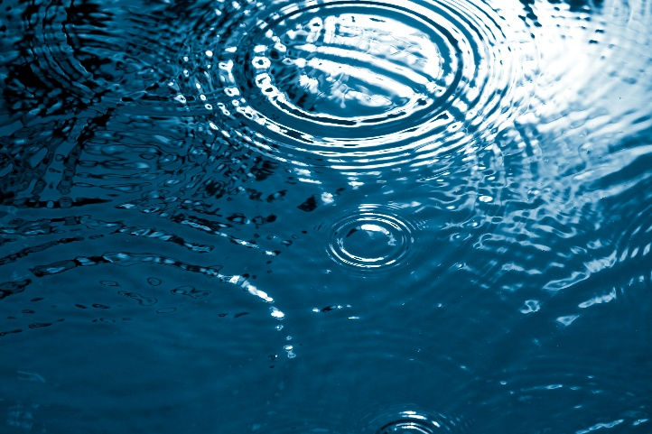
When you turn on the faucet or water your garden, have you ever stopped to wonder where that water comes from? Water is one of our most important natural resources, and it comes from a variety of sources. Understanding these sources helps us make smart decisions about water use and conservation. Let’s explore the key types of water sources and some important terms you should know.

Nature’s Starting Point
All water sources begin with precipitation. This is any form of water that falls from the sky, including rain, snow, sleet or hail. When precipitation reaches the ground, it can follow several different paths — it might soak into the soil, run into rivers and lakes, evaporate back into the sky or be collected by people for later use.

Lakes, Rivers and Streams
Surface water is the water you can see above ground. This includes all lakes, rivers, ponds and streams. Many communities use surface water as their primary source for drinking water, irrigation and recreation. Because it’s exposed, surface water is vulnerable to pollution from chemicals, trash and runoff, which is why it needs to be carefully managed and treated.

Hidden Water Below Us
Not all water stays above ground. Some of it soaks deep into the soil and becomes groundwater. This water fills tiny spaces between rocks and soil underground. Large underground layers that store this water are called aquifers. Aquifers are like natural storage tanks, and many wells draw water from them. In fact, about 40% of drinking water in the U.S. comes from groundwater sources (U.S. Geological Survey).

Stored for Later
A reservoir is a man-made or natural lake where water is stored for future use. Dams are often built to hold back rivers and create reservoirs. These stored water bodies help supply water during dry periods, provide flood control and generate hydroelectric power. Cities and towns often rely on reservoirs as a backup source of clean water, especially when facing a drought — a prolonged period with unusually dry weather, characterized by a lack of precipitation and resulting in a water shortage.

A Free and Natural Option
Rainwater collection is a method of capturing precipitation directly from rooftops or other surfaces and storing it for later use. Collected rainwater can be used for watering gardens, washing cars or even flushing toilets. In some places, rainwater can also be filtered and used for drinking. It’s a simple and sustainable way to reduce water demand on other sources.

Reuse, Don’t Waste
Grey water is gently used water from sinks, showers, bathtubs and washing machines. It’s not clean enough to drink, but it can be reused for things like landscape irrigation or toilet flushing. Using grey water reduces the amount of freshwater we use and helps conserve this precious resource. However, using grey water requires proper systems to keep it safe and effective, and many municipalities have laws or regulations guiding its collection, storage and use.

Why It Matters
Water is essential for life, and understanding where it comes from helps us take better care of it. Whether it’s falling from the sky, flowing across the land or stored underground, every drop counts. By learning how to conserve water and use it wisely, you can be part of the solution to protect our water future.

Sources:
U.S. Geological Survey (USGS). “Groundwater Information.” https://www.usgs.gov/special-topics/water-science-school/science/groundwater
Environmental Protection Agency (EPA). “Water Topics.” https://www.epa.gov/environmental-topics/water-topics
National Geographic. “Freshwater Resources.” https://education.nationalgeographic.org/resource/freshwater-resources/
Alliance for Water Efficiency. “Greywater Reuse.” https://www.allianceforwaterefficiency.org/resources/topic/greywater

