Appendix 1: The Feed: Come to Order
Aligned to the following standards:
FFA.PL-A; FFA.PL-E; FFA.PL-F; FFA.PG-J; FFA.PG-I; FFA.CS-N; CCSS.RI.9-10.2; CCSS.RI.9-10.3; CCSS.ELA.9-10.4; CCSS.W.9-10.2; CCSS.SL.9-10.4; CRP.02; CRP.04; CRP.08
Created: Spring 2021 by the National FFA Organization

Part 1
Directions:
Read the article “The Feed: Come to Order” in the Spring 2021 issue of FFA New Horizons and answer the questions below.


Why did Dr. Daniel Foster decide to become a professionally registered parliamentarian?

If you compete in the National FFA Parliamentary Procedure Leadership Development Event, you gain membership through AIP for how many years?

- 22
- 25
- 27
- 30
Give your own specific example of each term.
When do you think you may use parliamentary procedure in the future? Why?

Why is parliamentary procedure used in many groups, organizations, and businesses?
What are the two professional organizations you could join that focus on parliamentary procedure?

2.

Ex officio:
Quorum:
In your own words, define the terms below.

Quorum:

Ex officio:
Part 2
Directions:
Understanding parliamentary procedure is important as many businesses, organizations, clubs, etc. use this method to maintain order when conducting formal business. Using the FFA Handbook (English, Spanish), we will look at how to set up a room for a meeting. Below you will find the FFA station markers. Cut out each marker and glue it where each officer should be stationed during an FFA meeting. (Note: This is for an FFA meeting; other groups may have variations regarding where officers should be located during the meeting). Note: If you are in a virtual learning environment, draw arrows to indicate where each station marker should go.

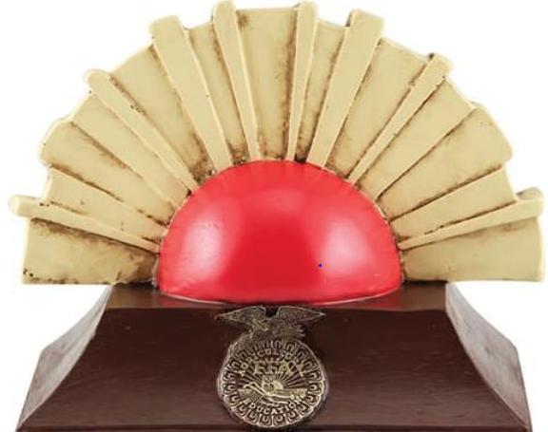
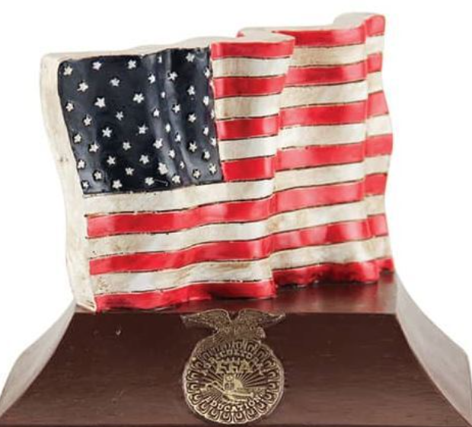
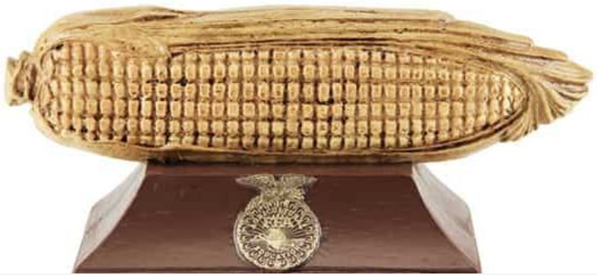
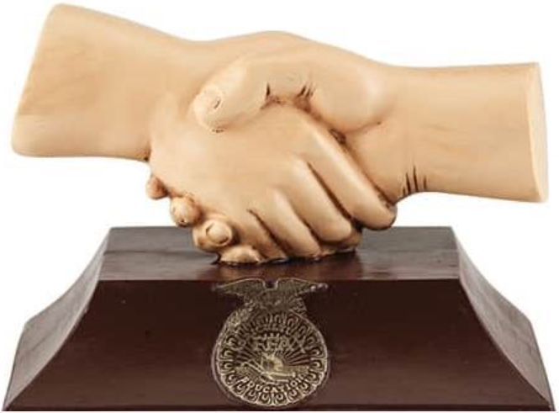
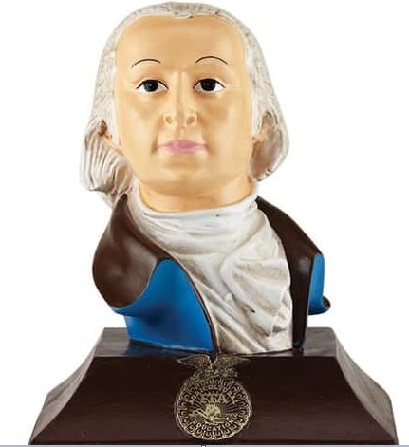
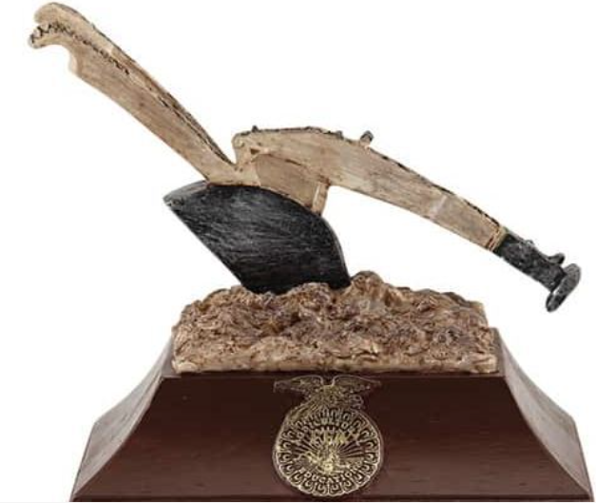
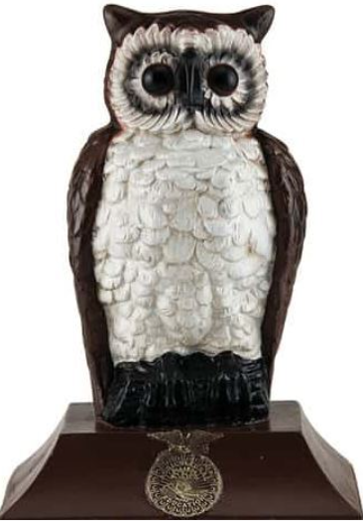
President
Reporter
Secretary
Sentinel
Treasurer

Vice President
Advisor

Door
Podium

Aligned to the following standards:
NRS.01; AGPE01.01; CCSS.ELA-Literacy.RI.9-10.3; CCSS.ELA-Literacy.SL.9-10.1; RST.9.10.1; RST.9.10.2; RST.9.10.4; RST.9.10.5; RST.9.10.6; RST.9.10.8; RST.9.10.9; WHST.9.10.7; WHST.9.10.9; MP3; MP6; AG-NR2; HS-LS2-6; HS-LS2-7

Part 3
Directions:
Now that we have identified where officers are stationed during a meeting, let’s look at how a meeting is conducted. Using the FFA Handbook (English, Spanish), place a number (1 to 11) next to each item below in the order that you think it occurs during a meeting. Begin by placing a 1 in the “Student Order” column next to the item that you believe occurs first.
Student Order Order of Business Official Order

____________ Committee Reports ____________

____________ Entertainment, Recreation, Refreshments ____________

____________ Officer Reports ____________

____________ Unfinished (Old) Business ____________

____________ Opening Ceremonies ____________

____________ Closing Ceremonies ____________

____________ Minutes of Previous Meeting ____________

____________ New Business ____________

____________ Special Features (guest speakers, activities, etc.) ____________

____________ Degree and Installation Ceremonies ____________

After discussing the official order as a class, jot down your thoughts to the following questions.
- What is most surprising about the official order of business?
_______________________________________________________________________________________

_______________________________________________________________________________________

- What is the Program of Activities?
_______________________________________________________________________________________

_______________________________________________________________________________________
- Think of a group you are passionate about (ex. FFA, 4-H, art club, foreign language club, music, etc.). What is an important order of business that would need to come before that group?
________________________________________________________________________________________________________________________________________________________________________________________________________________________________
- A motion is a statement to be brought before the group. What would your motion be based on what you wrote for Question 3 above?
I move ________________________________________________________________________________________________________
_______________________________________________________________________________________________________________
- Now, develop discussion points for the motion you just posed.
  - For:
  - Against:
  - For:
  - Against:
KEY — Appendix 1: The Feed: Come to Order
Aligned to the following standards:
FFA.PL-A; FFA.PL-E; FFA.PL-F; FFA.PG-J; FFA.PG-I; FFA.CS-N; CCSS.RI.9-10.2; CCSS.RI.9-10.3; CCSS.ELA.9-10.4; CCSS.W.9-10.2; CCSS.SL.9-10.4; CRP.02; CRP.04; CRP.08
Created: Spring 2021 by the National FFA Organization

Part 1
Directions:
Read the article “The Feed: Come to Order” in the Spring 2021 issue of FFA New Horizons and answer the questions below.

Why did Dr. Daniel Foster decide to become a professionally registered parliamentarian? He was looking for a way to document and convey his parliamentary knowledge to potential clients and stakeholders.
If you compete in the National FFA Parliamentary Procedure Leadership Development Event, you gain membership through AIP for how many years?
- 22
- 25
- 27
- 30
Give your own specific example of each term.
When do you think you may use parliamentary procedure in the future? Why?
Answers will vary.

Why is parliamentary procedure used in many groups, organizations and businesses?
Parliamentary procedure is used to maintain order as well as have an organized way in which to transact important business.
What are the two professional organizations you could join that focus on parliamentary procedure?

- American Institute of Parliamentarians

- National Associations of Parliamentarians

Ex officio: Answers will vary.
Quorum: Answers will vary.
In your own words, define the terms below.

Quorum: The number of members required to carry out business

Ex officio: Virtue of title
Part 2
Directions:
Understanding parliamentary procedure is important as many businesses, organizations, clubs, etc. use this method to maintain order when conducting formal business. Using the FFA Handbook (English, Spanish), we will look at how to set up a room for a meeting. Below you will find the FFA station markers. Cut out each marker and glue it where each officer should be stationed during an FFA meeting. (Note: This is for an FFA meeting; other groups may have variations regarding where officers should be located during the meeting). Note: If you are in a virtual learning environment, draw arrows to indicate where each station marker should go.

President
Reporter
Secretary
Sentinel
Treasurer

Vice President
Advisor

President

Podium

Secretary
Reporter

Advisor
Treasurer

Door
Aligned to the following standards:
NRS.01; AGPE01.01; CCSS.ELA-Literacy.RI.9-10.3; CCSS.ELA-Literacy.SL.9-10.1; RST.9.10.1; RST.9.10.2; RST.9.10.4; RST.9.10.5; RST.9.10.6; RST.9.10.8; RST.9.10.9; WHST.9.10.7; WHST.9.10.9; MP3; MP6; AG-NR2; HS-LS2-6; HS-LS2-7
Vice President
Sentinel
Part 3
Directions:
Now that we have identified where officers are stationed during a meeting, let’s look at how a meeting is conducted. Using the FFA Handbook (English, Spanish), place a number (1 to 11) next to each item below in the order that you think it occurs during a meeting. Begin by placing a 1 in the “Student Order” column next to the item that you believe occurs first.
Student Order Order of Business Official Order

____________ Committee Reports _____6_______

____________ Entertainment, Recreation, Refreshments _____10______

____________ Officer Reports _____3_______

____________ Unfinished (Old) Business _____5_______

____________ Opening Ceremonies _____1_______

____________ Closing Ceremonies _____9_______

____________ Minutes of Previous Meeting _____2_______

____________ New Business _____7_______

____________ Special Features (guest speakers, activities, etc.) _____4_______

____________ Degree and Installation Ceremonies _____8_______

After discussing the official order as a class, jot down your thoughts to the following questions.
- What is most surprising about the official order of business? Answers will vary.
_______________________________________________________________________________________

_______________________________________________________________________________________

- What is the Program of Activities?
Serves to define chapter goals, outline steps needed to meet those goals and acts as a written guide to provide a calendar of events the chapter will follow in the year ahead
- Think about a group you are passionate about (ex. FFA, 4-H, art club, foreign language club, music, etc.). What is an important order of business that would need to come before that group? Answers will vary.
__________________________________________________________________________________________________________________________________________________________________________________________
- A motion is a statement to be brought before the group. What would your motion be based on what you wrote in Question 3 above? Answers will vary.
I move _______________________________________________________________________________________
_____________________________________________________________________________________________
- Now, develop discussion points for the motion you just posed. Answers will vary.
  - For:
  - Against:
  - For:
  - Against:

