Appendix 1: Committed to Constant Improvement
Aligned to the following standards: CS.02, CS.06, FFA.PL-E, FFA.CS-M, FFA.CS-N, CCSS.ELA-Literacy.RI.9-10.1, CCSS.ELA-Literacy.WHST.9.10.6, CCSS.ELA-Literacy.RST.9-10.9, CCSS.ELA-Literacy.SL.9-10.2, CCSS.ELA-Literacy.SL.9-10.4, AGC10.03

Part 1
Directions:
Read the article “Committed to Constant Improvement” in the spring 2023 issue of FFA New Horizons and complete the following questions.

1. What leadership roles did Mr. Ching serve in during his FFA career?
Chapter Level: ____________________________________________________________________________
State Level: _______________________________________________________________________________
National Level: ____________________________________________________________________________

2. How did he make history? ______________________________________________________________________________________

3. Which career pathway did Ching start out in with his family’s business? Highlight the pathway below in BLUE.

Agribusiness Systems | Animal Systems | Biotechnology Systems
Plant Systems | Power, Structure, and Technical Systems | Sustainability

4. How did/does Ching inspire others? _________________________________________________________________________________

5. Investigate the purpose of the Hawaii Department of Agriculture (HDOA). What are the main roles and responsibilities of this agency?

Roles:

Responsibilities:

6. What surprised you the most while reading this article? ____________________________________________________________

7. What is one question you still have after reading this article? ________________________________________________________ ________________________________________________________________________________________________________________________

Part 2
Directions:
Learn about Hawaiian agriculture by completing the activities below. Utilize the USDA National Agriculture Statistics survey website (https://www.nass.usda.gov/Quick_Stats/Ag_Overview/stateOverview.php?state=HAWAII) and the National Agriculture in the Classroom website (https://agclassroom.org/teacher/agfacts/).
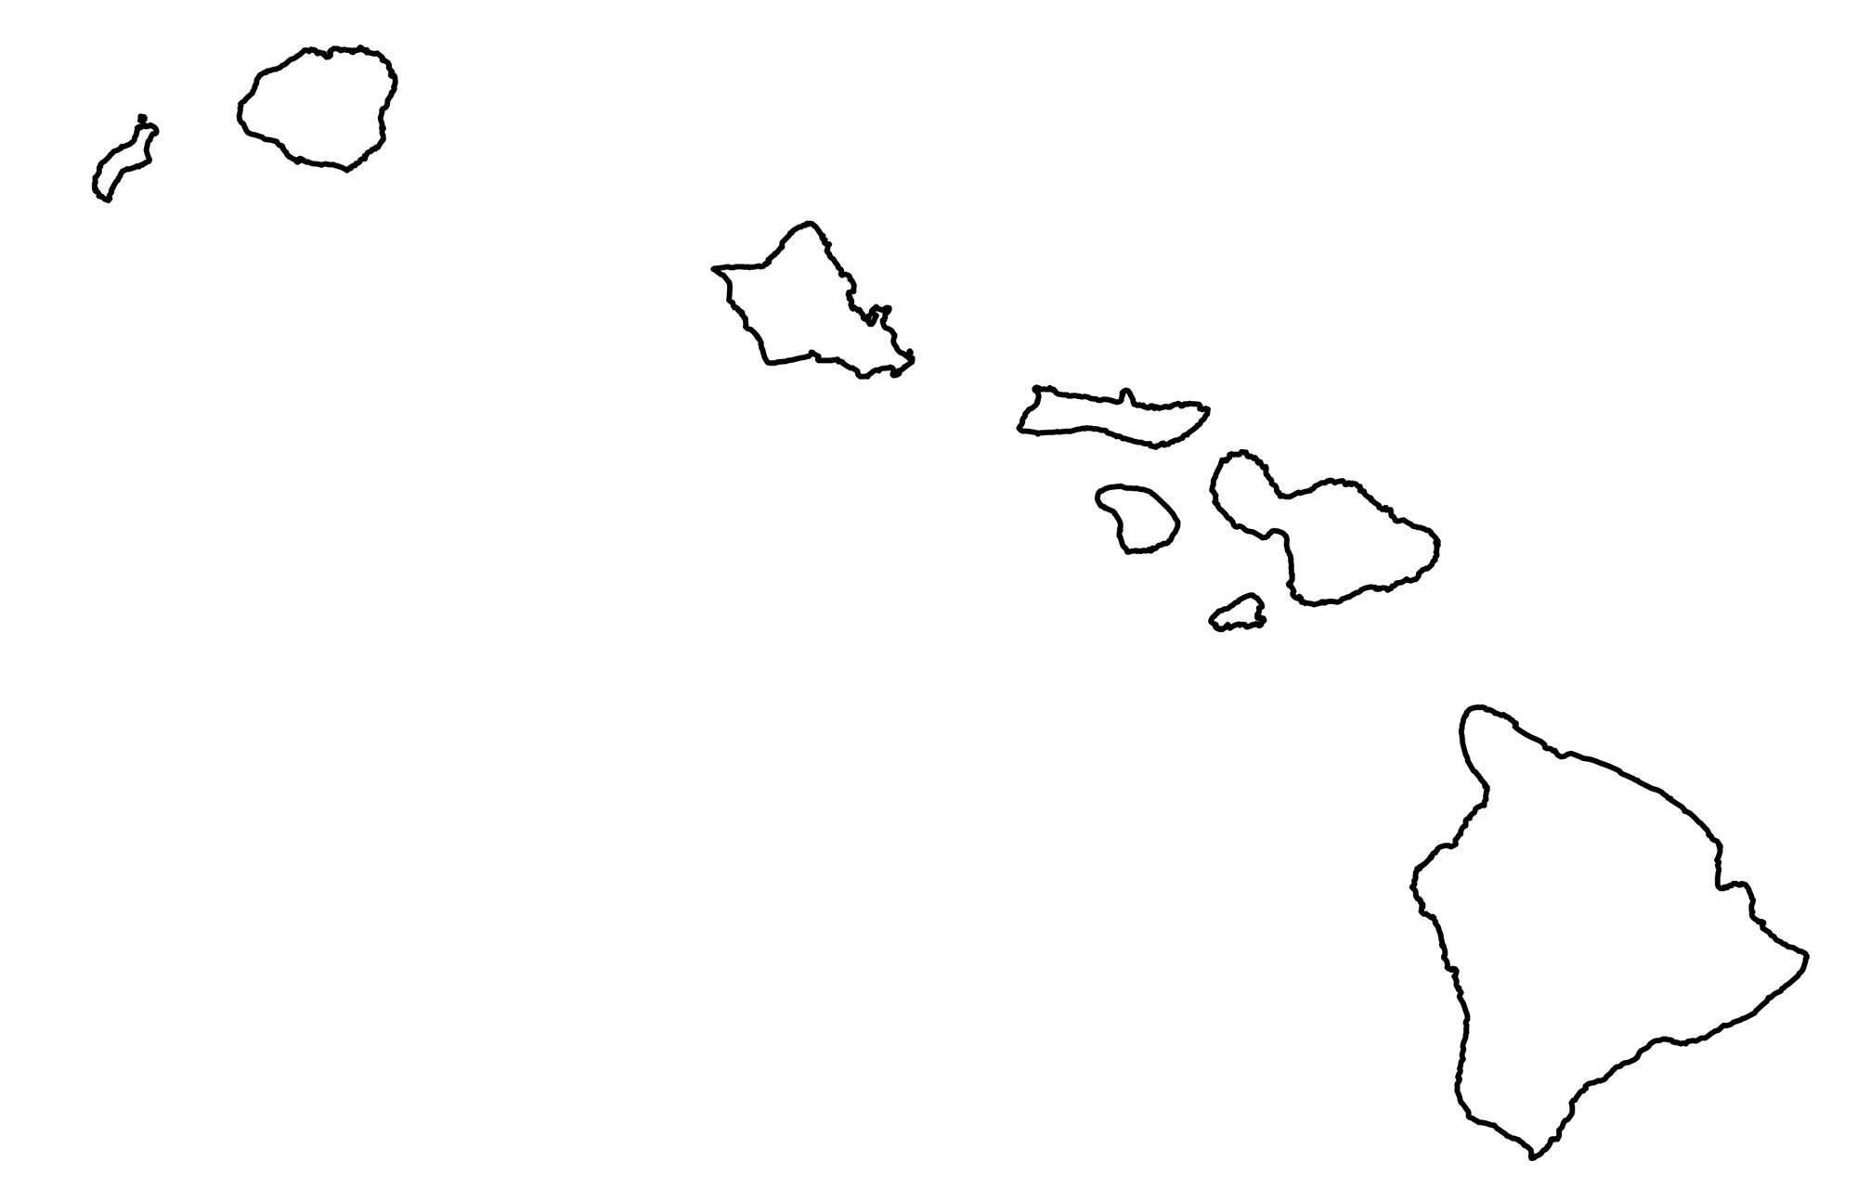
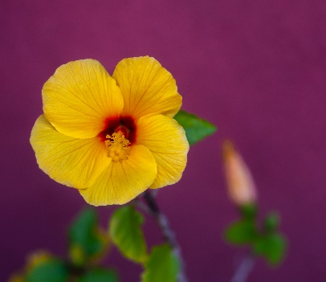
- Label each of the islands of Hawaii.
- Draw a * on the two islands that raise cattle and hogs.
- In blue, shade the two islands that receive snow.
- Identify the island that receives the greatest impact from pineapple production. Draw a pineapple image next to the island.
- In green, shade the island that has a substantial number of dairy and egg farms.

Identify the flower in the image. ______________________________

What connection does it have to Hawaii? _______________________________

Hawaii Agriculture | Topic to Compare | Your State: __________________
 | Population
 | Average size farm
 | Total number of farms
 | Total acres in farm operation
 | State average temperature
 | Average annual precipitation
 | Top commodities
 | Acres of coffee grown

*Draw and label the state tree for Hawaii and your own state in the box below.
Hawaii | Your State: _______________________

*Draw and label the state bird for Hawaii and your own state in the box below.
Hawaii | Your State: _______________________

*What is the biggest takeaway for you when comparing Hawaiian agriculture to your own state’s agriculture?

Part 3
Directions:
Now that you have learned a little about Hawaiian agriculture, take your knowledge and put it to use developing a one- page infographic that could be used to enlighten others about agriculture in Hawaii. This infographic should visually represent the agriculture industry of Hawaii and show that there is more to Hawaii than beautiful beaches for vacationing. Use the space below to develop your infographic, and follow your teacher’s instructions for the final format to turn in for this project.

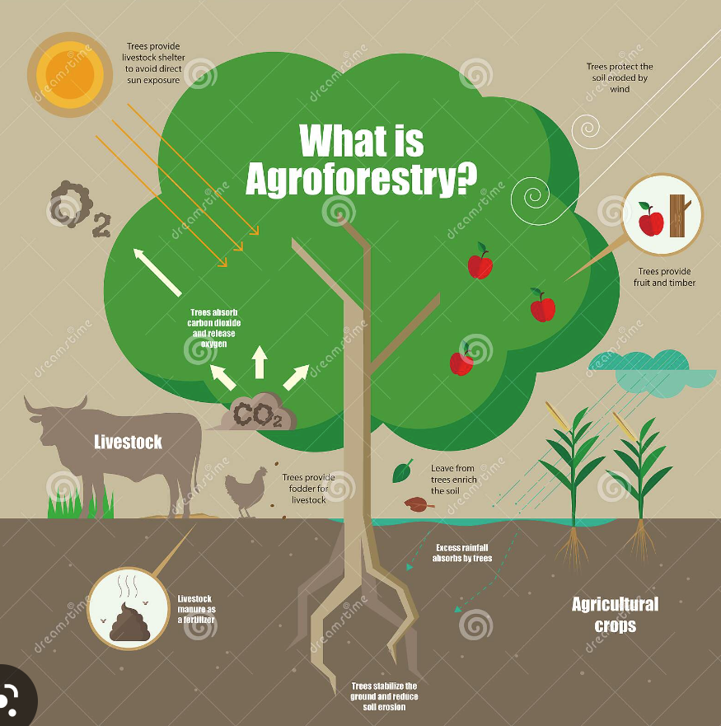
Example Infographic: What to Include:
- Title
- Primarily images and graphics
- Few words — statistics and facts that are short and to the point
- Color — draw attention to the info.
- Organized — easy to view and follow

Brainstorm: Use the box below to help you plan your infographic.

*Use the box below to develop your infographic.
Aligned to the following standards: CS.02, CS.06, FFA.PL-E, FFA.CS-M, FFA.CS-N, CCSS.ELA-Literacy.RI.9-10.1, CCSS.ELA-Literacy.WHST.9.10.6, CCSS.ELA-Literacy.RST.9-10.9, CCSS.ELA-Literacy.SL.9-10.2, CCSS.ELA-Literacy.SL.9-10.4, AGC10.03

KEY: Appendix 1: Committed to Constant Improvement
Part 1
Directions:
Read the article “Committed to Constant Improvement” in the spring 2023 issue of FFA New Horizons and complete the following questions.

What leadership roles did Mr. Ching serve in during his FFA career?
Chapter Level: Chapter president
State Level: State president
National Level: National vice president

How did he make history? He was the first national officer of color and remains the only national officer from Hawaii.

Which career pathway did Ching start out in with his family’s business? Highlight the pathway below in BLUE.

Agribusiness Systems | Animal Systems | Biotechnology Systems
Plant Systems | Power, Structure, and Technical Systems | Sustainability

How did/does Ching inspire others? He embodied the hard work, service and dedication that FFA imparts. He was also a visionary who supported the organization’s commitment to constant improvement. Lastly, he was patient and persevered.

Investigate the purpose of the Hawaii Department of Agriculture (HDOA). What are the main roles and responsibilities of this agency?

To support, enhance, promote and protect Hawaii’s agriculture and aquaculture industries

To create and maximize opportunities for exporting and facilitate growth of existing and new agricultural commodities and value-added products

To prevent the introduction and establishment of plants, animals and diseases that are detrimental to the state’s agriculture industry and the environment

What surprised you the most while reading this article? __Answers will vary. ____________________________________

7. What is one question you still have after reading this article? _______ Answers will vary. ___________________________

Part 2
Directions:
Learn about Hawaiian agriculture by completing the activities below. Utilize the USDA National Agriculture Statistics survey website (https://www.nass.usda.gov/Quick_Stats/Ag_Overview/stateOverview.php?state=HAWAII) and the National Agriculture in the Classroom website (https://agclassroom.org/teacher/agfacts/).

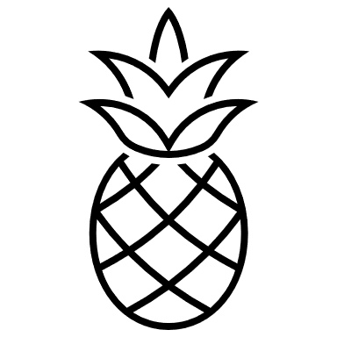

- Label each of the islands of Hawaii.
- Draw a * on the two islands that raise cattle and hogs.
- In blue, shade the two islands that receive snow.
- Identify the island that receives the greatest impact from pineapple production. Draw a pineapple image next to the island.
- In green, shade the island that has a substantial number of dairy and egg farms.

Kauai
Oahu
Molokai
Maui
Lanai
Hawaii
Niihau

Identify the flower in the image. Yellow hibiscus

What connection does it have to Hawaii? It is the state flower.

Hawaii Agriculture | Topic to Compare | Your State: __________________
1.3 million | Population | Answers will vary.
149-151 acres | Average size farm | Answers will vary.
7,300-7,500 farms | Total number of farms | Answers will vary.
1.1 million acres | Total acres in farm operation | Answers will vary.
July: 77 degrees  January: 71 degrees | State average temperature | Answers will vary.
400” in the mountains  10” in the lowlands | Average annual precipitation | Answers will vary.
Greenhouse and nursery products | Top commodities | Answers will vary.
7,200 acres | Acres of coffee grown | Answers will vary.

*Draw and label the state tree for Hawaii and your own state in the box below.
Hawaii  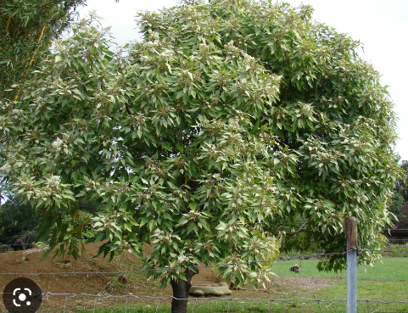 | Answers will vary.

*Draw and label the state bird for Hawaii and your own state in the box below.
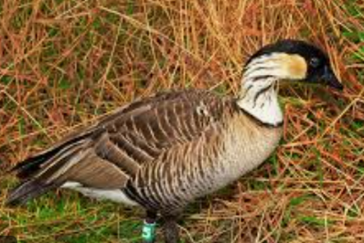  Hawaii | Answers will vary.

*What is the biggest takeaway for you when comparing Hawaiian agriculture to your own state’s agriculture?
Answers will vary.

Part 3
Directions:
Now that you have learned a little about Hawaiian agriculture, take your knowledge and put it to use developing a one-page infographic that could be used to enlighten others about agriculture in Hawaii. This infographic should visually represent the agriculture industry of Hawaii and show that there is more to Hawaii than beautiful beaches for vacationing. Use the space below to develop your infographic, and follow your teacher’s instructions for the final format to turn in for this project.

Example Infographic: What to Include:
- Title
- Primarily images and graphics
- Few words — statistics and facts that are short and to the point
- Color — draw attention to the info.
- Organized — easy to view and follow

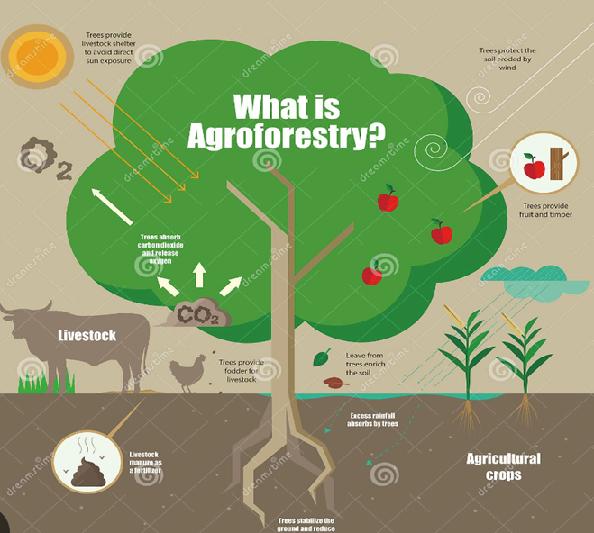

Brainstorm: Use the box below to help you plan your infographic.
Answers will vary.

*Use the box below to develop your infographic.
Answers will vary.

Infographic Rubric

 | Level 1 | Level 2 | Level 3 | Level 4
Knowledge/Understanding Topic  ( /10) | Provides limited data or data unnecessary to topic | Provides some topic-related information | Provides a considerable amount of information related to the topic | Provides thorough and meaningful information related to the topic
Thinking/Inquiry  Organization  ( /10) | Little organization is evident. Information is confusing and difficult to read. | Some organization is evident. Information is somewhat clear. | Considerable organization is evident. Content is nicely spaced and clear to read. | Thorough organization is evident. There is clear and consistent method to the content.
Communication  Form and Audience  ( /10) | Limited use of infographic features, or features convey information poorly | Some use of infographic features, some features convey information | Considerable use of infographic features that clearly convey information | Thorough use of infographic features, selected features convey information succinctly

Strong parts of your infographic (Gems):

Suggestions (Opportunities for improvement):

One thing I really liked about your infographic was …

