Aligned to the following standards: AS.02; AS.05; AS.06; AS.08; FPS.04; FPS.06; FFA.PL-A3; FFA.PL-A4; FFA.PL-F3; FFA.PL-F5; FFA.PG-J1; FFA.PG-J4; FFA.CS-M1; FFA.CS-N2; CCSS.ELA.RI9-10.1; CCSS.ELA.W9-10.2; CCSS.ELA.W9-10.3; CCSS.ELA.W9-10.4; CCSS.ELA.W9-10.7; CCSS.ELA.W9-10.9; CCSS.ELA.SL9-10.2; CCSS.ELA.L9-10.6; CRP.02; CRP.07; CRP.08
Appendix 2: Hooked on Conservation
Part 1
Directions:
Read the article “Hooked on Conservation” in the spring/summer 2026 issue of FFA New Horizons and answer the questions below.

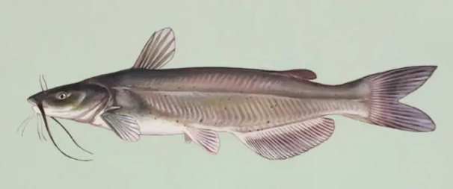
- How long are the channel catfish fingerlings when they arrive at Shanksville-Stonycreek School in October each year?
How long are they when the students release them in May?

- Which government agency does the school collaborate with for this project?
  - Pennsylvania Department of Agriculture
  - Pennsylvania Animal Control
  - Pennsylvania Fish and Boat Commission
  - Pennsylvania Department of Conservation and Natural Resources

- Where do students raise the catfish at the school?
- What are three pieces of equipment necessary for raising the catfish? What are their functions?
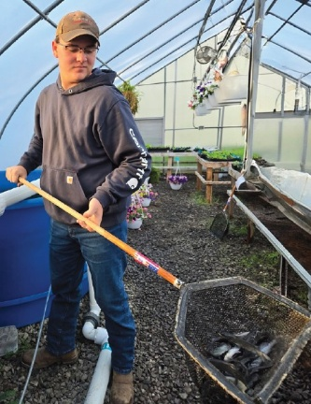

- What are four tasks the students perform while raising the fish?

- Fill in the quote from advisor, Britton Stutzman, below.
"They learn about _________________, _____________________, ________________ and all of the aspects that affect _______________ ____________________. If a __________________ __________________ isn't done, they can see the ________________ firsthand, and they are learning how ________________________ it is to take care of the ______________________________ we have."
- What activities do students participate in when it comes time to release the fish?
- What impact does Don Anderson, district commissioner with the Pennsylvania Fish and Boat Commission, hope this program has on students who participate?

Part 2
Directions:
Choose a freshwater fish species native to your area and research it using the table below.

Common Name: |  | Scientific Name:
Natural Habitat: |  | Regions It's Located In:
Typical Adult Size: |  | Preferred Water Temperature Range:
Diet: |  | Natural Predators:  (if any)
Describe the fish’s natural environment (water movement, clarity, depth).
Why is this fish important in the local ecosystem? What role or function does it serve?
Draw or paste a picture of your fish below.

Part 3
Directions:
Do additional research on your selected fish species and how it can be raised in a controlled environment. Create a plan for an aquaculture system design that could be used to raise this fish at your school.
System Type: (circle one) | Tank Pond Recirculating System
System Size: (in gallons)
How will water temperature be controlled? |  | How will oxygen be supplied?
What type of filter will your system use?  Why did you choose this filter? |  | Explain how your fish will be fed. What food will you use? How often will you feed? How will you feed?
What additional equipment or tools would be helpful in raising this species in an aquaculture setting? |  | Are there any government agency programs in your area like the one described in the article? If so, describe them below.
What is one challenge you might encounter in raising this fish species?
What is a possible solution to the challenge you identified?
Conclusion Questions:
- Why might raising native fish be better than raising nonnative fish?
- How could aquaculture help support food systems and/or conservation efforts?

Aligned to the following standards: AS.02; AS.05; AS.06; AS.08; FPS.04; FPS.06; FFA.PL-A3; FFA.PL-A4; FFA.PL-F3; FFA.PL-F5; FFA.PG-J1; FFA.PG-J4; FFA.CS-M1; FFA.CS-N2; CCSS.ELA.RI9-10.1; CCSS.ELA.W9-10.2; CCSS.ELA.W9-10.3; CCSS.ELA.W9-10.4; CCSS.ELA.W9-10.7; CCSS.ELA.W9-10.9; CCSS.ELA.SL9-10.2; CCSS.ELA.L9-10.6; CRP.02; CRP.07; CRP.08;
KEY: Appendix 2: Hooked on Conservation
Part 1
Directions:
Read the article “Hooked on Conservation” in the spring/summer 2026 issue of FFA New Horizons and answer the questions below.
- How long are the channel catfish fingerlings when they arrive at Shanksville-Stonycreek School in October each year?
The fish are just one or two inches long when they first get them.
How long are they when the students release them in May?
By the time the fish are ready to release, students have grown them to four to eight inches long.

- Which government agency does the school collaborate with for this project?
  - Pennsylvania Department of Agriculture
  - Pennsylvania Animal Control
  - Pennsylvania Fish and Boat Commission
  - Pennsylvania Department of Conservation and Natural Resources

- Where do students raise the catfish at the school?
They raise them in three 500-gallon tanks in the school’s greenhouse.
- What are two pieces of equipment necessary for raising the catfish? What is their function?
  - Pool heaters help keep the water at 80 degrees Fahrenheit.
  - Aerators help improve water quality.
  - Dechlorinator provides fresh, nonchlorinated water for the fish.
- What are four tasks the students perform while raising the fish?
  - Feeding fish
  - Water changes
  - Water testing
  - Checking for nitrates and ammonia
- Fill in the quote from advisor, Britton Stutzman, below.
“They learn about _____erosion_____, ______pollution_______, _____runoff_____ and all of the aspects that affect ____water____ ______quality______. If a ______water______ ______change______ isn't done, they can see the _____results_____ firsthand, and they are learning how ________important_________ it is to take care of the _________environment__________ we have.”
- What activities do students participate in when it comes time to release the fish?
A lake instruction day where they can go in kayaks and canoes and learn about boat safety and fish. They also help the Fish and Boat Commission place habitats they built during the school year.
- What impact does Don Anderson, district commissioner with the Pennsylvania Fish and Boat Commission, hope this program has on students who participate?
He hopes students will either pursue a career in conservation or continue to do conservation work as volunteers.

Part 2
Directions:
Choose a freshwater fish species native to your area and research it using the table below.

Common Name: | Answers will vary. | Scientific Name: | Answers will vary.
Natural Habitat: | Answers will vary. | Regions It's Located In: | Answers will vary.
Typical Adult Size: | Answers will vary. | Preferred Water Temperature Range: | Answers will vary.
Diet: | Answers will vary. | Natural Predators:  (if any) | Answers will vary.
Describe the fish’s natural environment (water movement, clarity, depth).
Answers will vary.
Why is this fish important in the local ecosystem? What role or function does it serve?
Answers will vary.
Draw or paste a picture of your fish below.
Answers will vary.

Part 3
Directions:
Do additional research on your selected fish species and how it can be raised in a controlled environment. Create a plan for an aquaculture system design that could be used to raise this fish at your school.
System Type: (circle one) | Tank Pond Recirculating System
System Size: (in gallons) | Answers will vary.
How will water temperature be controlled? |  | How will oxygen be supplied?
Answers will vary. |  | Answers will vary.
What type of filter will your system use?  Why did you choose this filter? |  | Explain how your fish will be fed. What food will you use? How often will you feed? How will you feed?
Answers will vary. |  | Answers will vary.
What additional equipment or tools would be helpful in raising this species in an aquaculture setting? |  | Are there any government agency programs in your area like the one described in the article? If so, describe them below.
Answers will vary. |  | Answers will vary.
What is one challenge you might encounter in raising this fish species?
Answers will vary.
What is a possible solution to the challenge you identified?
Answers will vary.
Conclusion Questions:
- Why might raising native fish be better than raising nonnative fish?
Answers will vary.
- How could aquaculture help support food systems and/or conservation efforts?
Answers will vary.

