Appendix 2: Preparing for the Worst
Aligned to the following standards:
FFA.PL-A; FFA.PG-J; FFA.CS-N; CCSS.ELA.RI.9-10.4; MP5; MP6; CRP.02; CRP.04; CRP.06
Created: Summer 2019 by the National FFA Organization
Directions:
Read the scenario and answer the questions below.
Imagine this:
No electricity. No water. Demolished houses. Steep mountain roads made impassable by mud and vegetation. Rations at the grocery store to ensure there is enough food
to go around. Limited medical supplies at the hospital. A lack of gasoline, even for first
responders, and long lines of cars waiting for the next tanker. Helicopters flying overhead,
dropping supplies for stranded communities.

How does this situation make you feel? What would you do?

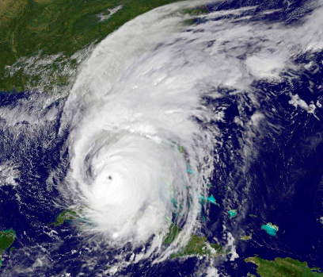
Directions:
Read the article “Help After the Hurricane” in the Summer 2019 issue of FFA New Horizons. Disaster can strike when we least expect it. However, understanding how we can prepare and knowing where and how to get help, if needed, can enable us to feel more confident when poor weather is predicted or hits close to home.

- Review each of the natural disasters listed below and then complete the matching activity using this information.

- Earthquake
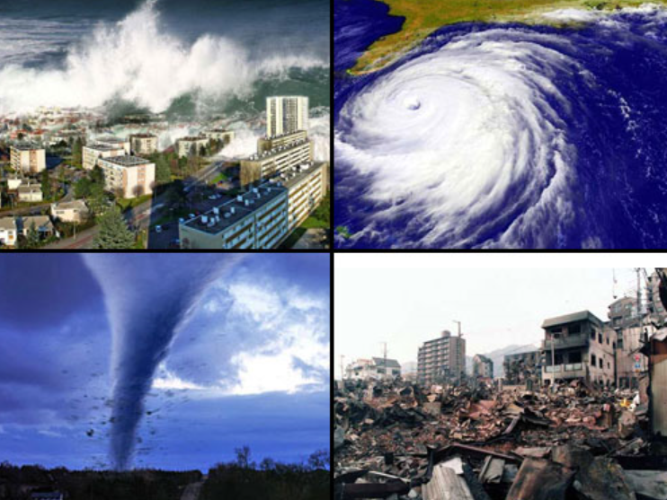
- Flood
- Landslide
What impact do natural disasters have on agriculture? Give 2 specific examples.
- Tornado
- Wildfire
What would you and your family do if a natural disaster hit your community?

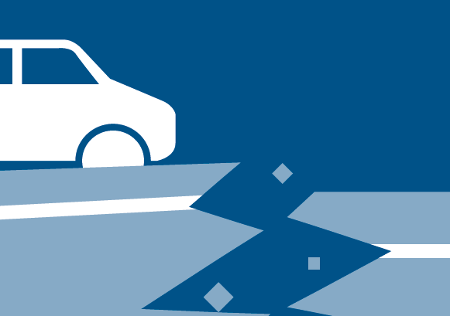
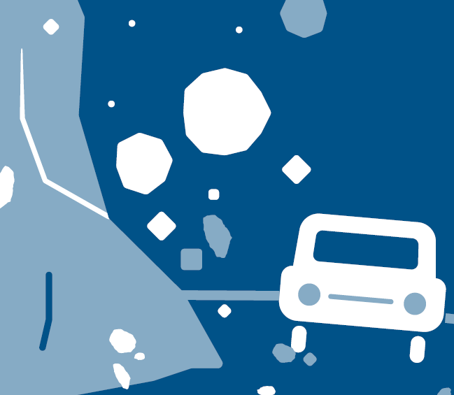
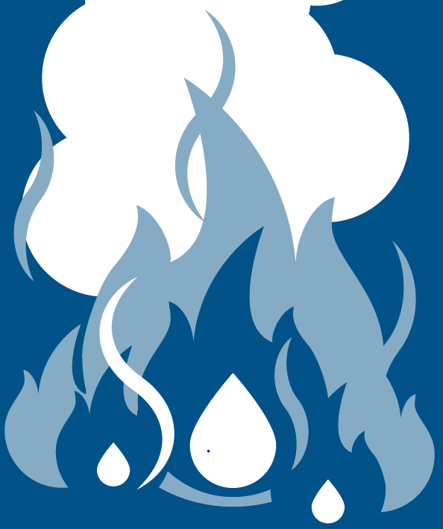

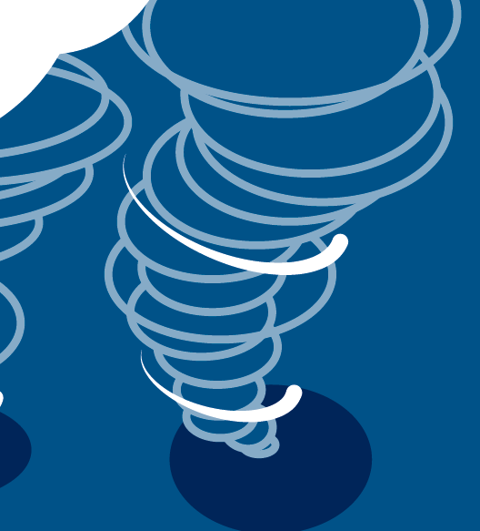

- ______ Which natural disaster requires you to stay in bed if that is where you are when it begins?
- ______ Which natural disaster is often caused by humans?
- ______ Which natural disaster can be caused or intensified with little to no rain and high winds?
- ______ Which natural disaster can cause a tsunami, landslide or avalanche?
- ______ The best place to be is in a basement, cellar or windowless centralized room.
- ______ Moving to higher ground may be your best option during this natural disaster.
- ______ This natural disaster can be caused by flooding.
CALL OUT!
Did you know National FFA offers grants that could help with relief efforts for natural disasters? Learn more at FFA.org/livingtoserve/.
- ______ “Drop, cover and hold on” is what you should do immediately.
- ______ This is when rocks and other debris move down a slope.
- ______ This has rotating columns of air that can touch the ground.
- Select one of the natural disasters most likely to occur in your state. The Federal Emergency Management Agency (FEMA) works to educate the public and respond when disasters occur. However, some people do not understand the preparation needed, the correct actions to take and the protocol after a natural disaster. Using blank paper, create your own infographic to educate others in your school.
  - Select one natural disaster.
  - Look at the resources offered by FEMA (https://www.fema.gov/) and USA.gov (https://www.usa.gov/after-disaster).
  - Create an infographic that will resonate with your peers.
  - Note: If you would like to create your infographic digitally, resources like Piktochart are available online but require login information.
Infographic Rubric
Criteria | Below Average  (0–1 points) | Average  (2–3 points) | Above Average  (4–5 points)
Knowledge | Work shows little to no understanding of the topic. | Work shows some understanding of the topic. | Work shows excellent understanding of the topic.
Quality | Work is very low quality with little evidence of effort. | Work shows some effort and is mostly neat. | Work shows excellent effort and is of high quality.
Instructions | Student did not follow instructions for the task. | Student followed some of the instructions. | Student followed all instructions for the task.
Timeliness | Work was submitted more than one day late. | Work was one day late. | Work was submitted on time.
Audience | Developed for adults or younger children | ___________________ | Developed for peers
Total

KEY — Appendix 2: Preparing for the Worst
Aligned to the following standards:
FFA.PL-A; FFA.PG-J; FFA.CS-N; CCSS.ELA.RI.9-10.4; MP5; MP6; CRP.02; CRP.04; CRP.06
Created: Summer 2019 by the National FFA Organization
Directions:
Read the scenario and answer the questions below.
Imagine this:
No electricity. No water. Demolished houses. Steep mountain roads made impassable by mud and vegetation. Rations at the grocery store to ensure there is enough food
to go around. Limited medical supplies at the hospital. A lack of gasoline, even for first
responders, and long lines of cars waiting for the next tanker. Helicopters flying overhead,
dropping supplies for stranded communities.

How does this situation make you feel? What would you do?
Answer will vary.

Directions:
Read the article “Help After the Hurricane” in the Summer 2019 issue of FFA New Horizons. Disaster can strike when we least expect it. However, understanding how we can prepare and knowing where and how to get help, if needed, can enable us to feel more confident when poor weather is predicted or hits close to home.

- Review each of the natural disasters listed below and then complete the matching activity using this information.

- Earthquake
- Flood
- Landslide
What impact do natural disasters have on agriculture? Give 2 specific examples.
Answers will vary.
- Tornado
- Wildfire
What would you and your family do if a natural disaster hit your community? Answers will vary.

- B Which natural disaster requires you to stay in bed if that is where you are when it begins?
- D Which natural disaster is often caused by humans?
- D Which natural disaster can be caused or intensified with little to no rain and high winds?
- B Which natural disaster can cause a tsunami, landslide or avalanche?
- A The best place to be is in a basement, cellar or windowless centralized room.
- E Moving to higher ground may be your best option during this natural disaster.
- C This natural disaster can be caused by flooding.
CALL OUT!
Did you know National FFA offers grants that could help with relief efforts for natural disasters? Learn more at FFA.org/livingtoserve/.
- B “Drop, cover and hold on” is what you should do immediately.
- C This is when rocks and other debris move down a slope.
- A This has rotating columns of air that can touch the ground.
- Select one of the natural disasters most likely to occur in your state. The Federal Emergency Management Agency (FEMA) works to educate the public and respond when disasters occur. However, some people do not understand the preparation needed, the correct actions to take and the protocol after a natural disaster. Using blank paper, create your own infographic to educate others in your school.
  - Select one natural disaster.
  - Look at the resources offered by FEMA (https://www.fema.gov/) and USA.gov (https://www.usa.gov/after-disaster).
  - Create an infographic that will resonate with your peers.
  - Note: If you would like to create your infographic digitally, resources like Piktochart are available online but require login information.
Infographic Rubric
Criteria | Below Average  (0–1 points) | Average  (2–3 points) | Above Average  (4–5 points)
Knowledge | Work shows little to no understanding of the topic. | Work shows some understanding of the topic. | Work shows excellent understanding of the topic.
Quality | Work is very low quality with little evidence of effort. | Work shows some effort and is mostly neat. | Work shows excellent effort and is of high quality.
Instructions | Student did not follow instructions for the task. | Student followed some of the instructions. | Student followed all instructions for the task.
Timeliness | Work was submitted more than one day late. | Work was one day late. | Work was submitted on time.
Audience | Developed for adults or smaller children | ___________________ | Developed for peers
Total

