Aligned to the following standards: FFA.PL-A; FFA.PL-E; FFA.PL-F; FFA.PG-I; FFA.CS-M; FFA.CS-N; CCSS.RI.9-10.2; CCSS.RI.9-10.4; CCSS.SL.9-10.2; CCSS.SL.9-10.4; CCSS.WHST.9.10.4; CRP.02; CRP.04; CRP.05; CRP.07; CRP.08; CRP.11
Appendix 2: SAEs in the USA
Part 1
Directions:
The supervised agricultural experience (SAE) that you have during your high school career can play a huge role in your future. The great thing about SAEs is how they are unique to your interests and resources. Read the article “SAEs in the USA” in the spring/summer 2025 issue of FFA New Horizons. Choose one SAE you are interested in from each region and answer the questions below.

- Using saeforall.org, in your own words, define what an SAE is in two or three sentences.

- Fill in the table below for the SAE you chose from the southern region.
Author: | State:
SAE Title:
What is the SAE?

Why does this SAE interest you? (two or three sentences)

- Fill in the table below for the SAE you chose from the eastern region.
Author: | State:
SAE Title:
What is the SAE?

Why does this SAE interest you? (two or three sentences)

- Fill in the table below for the SAE you chose from the central region.
Author: | State:
SAE Title:
What is the SAE?

Why does this SAE interest you? (two or three sentences)

- Fill in the table below for the SAE you chose from the western region.
Author: | State:
SAE Title:
What is the SAE?

Why does this SAE interest you? (two or three sentences)

- What are two or three differences you notice in SAEs across the different regions?

- What are two or three similarities you notice in SAEs across the different regions?

- Which of these SAEs are you most interested in? Why?

Part 2
Directions:
Now is your chance to choose the pathway you will be researching. First, cut out the fortune teller on the following page and fold according to the directions below. Once done, partner up and do the fortune teller activity using the directions below.

Fortune Teller Folding Directions:
If you need a visual, this video will help explain how to create a fortune teller: https://youtu.be/CODnVX7VAZ8?feature=shared.

- Fold Diagonally: Fold the square paper diagonally in half to form a triangle. Open it back up and fold it diagonally the other way. When you unfold it, you should have two diagonal creases that cross in the center.
- Fold the Corners to the Center: With the square flat, take each corner of the paper and fold it toward the center point where the two diagonal creases meet. You should now have a smaller square shape. The writing should be face down.
- Flip and Repeat: Flip the paper over so the folded flaps are facing down. Again, fold each corner to the center point. You'll end up with an even smaller square.
- Create Creases for Opening: Fold the smaller square in half horizontally, then unfold it. Then fold it in half vertically and unfold it again. This will create creases that make it easier to manipulate the fortune teller.
- Form the Pockets: With the folds facing up, gently lift the paper and slip your fingers under the four flaps (pockets) created on the back side. Pinch the sides together to form a 3D shape.
- Shape It for Use: Once your fingers are in place, you can move the flaps back and forth by pinching and pulling with your fingers. Your fortune teller is ready!

Fortune Teller Activity Directions:

- Ask the person you’re playing with to choose a number from the ones written on the top flaps of the fortune teller.
- Spell out the number or count it out to reveal new numbers.
- Choose another number and count or spell again.
- Ask the person to choose one final number and lift the flap to reveal the pathway.
- Repeat until each person has the pathway they will be researching. Write your pathway on the blank below.
- The pathway I will be researching is ______________________________________.

Example Sequence:

- The person picks “4.” You spell out “F-O-U-R” while moving the fortune teller in and out.
- They see the new numbers inside and pick “7.” You move the fortune teller seven times.
- Finally, they pick “5.” You open up the flap for “5” and reveal the SAE pathway underneath.

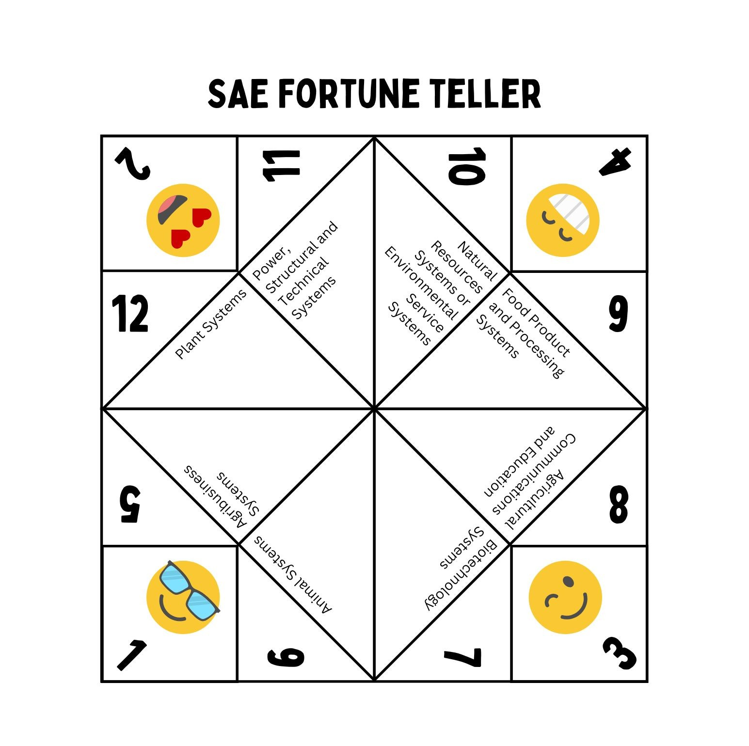

Part 3
Directions:
Using the pathway you were given during Part 2, you will research an SAE that fits that pathway. Utilizing the SAE Idea Cards as a resource, choose one SAE that interests you, and answer the questions below.
SAE Idea Cards: https://FFA.box.com/v/saeideacards

- What is the name of the SAE you chose?

- What are three activities you would do during this SAE?

- Why did you choose this SAE?

- What resources would you need for this SAE?

- What three skills would you learn through this SAE?

- What are three future careers this SAE can prepare you for? Use AgExplorer.FFA.org/ to help.

Part 4
Directions:
Congratulations! You have been invited to host an SAE booth in the first annual SAE Hall of Fame during National FFA Convention. Using the research you conducted in Part 3, you are going to create a mini booth to highlight your SAE. You will be constructing this in a shoebox, and your peers will be viewing your display. Sketch your ideas in the blank space below before using the materials provided by your teacher to construct your mini booth. Create your booth with color and make it eye-catching using the following guidelines.

  - Name of the SAE
  - Activities conducted in the SAE
  - Resources needed for this SAE
  - Why someone should do this SAE
  - Skills gained through this SAE
  - Careers this SAE prepares you for
  - An interactive component to draw people into your booth (Ex. games, activities, scavenger hunt, etc.)
  - Ideas for giveaways you could hand out at National FFA Convention (Ex. stickers, pins, shirts, candy, keychains, etc.)
  - A minimum of four pictures

Part 5
Directions:
Now is your chance to travel to all the SAE mini booths, created by your classmates, to learn more about the many SAE opportunities available to you. Visit each booth and fill in the chart below as you learn about each SAE! Make sure to fill in out one row per booth. When done, answer the discussion questions below.

SAE | Activities Conducted for That SAE | Resources Needed | Why you Should Do That SAE | Skills Gained | Future Careers

- Which booth was your favorite and why?

- Which SAE are you most interested in doing and why?

Aligned to the following standards: FFA.PL-A; FFA.PL-E; FFA.PL-F; FFA.PG-I; FFA.CS-M; FFA.CS-N; CCSS.RI.9-10.2; CCSS.RI.9-10.4; CCSS.SL.9-10.2; CCSS.SL.9-10.4; CCSS.WHST.9.10.4; CRP.02; CRP.04; CRP.05; CRP.07; CRP.08; CRP.11

KEY: Appendix 2: SAEs in the USA
Part 1
Directions:
The SAE that you have during your high school career can play a huge role in your future. The great thing about SAEs is how they are unique to your interest and resources. Read the article “SAEs in the USA” in the spring/summer 2025 issue of FFA New Horizons. Choose one SAE you are interested in from each region and answer the questions below.

- Fill in the table below for the SAE you chose from the southern region.
Author: Answers will vary. | State: Answers will vary.
SAE Title: Answers will vary.
What is the SAE?

Answers will vary.

Why does this SAE interest you? (two or three sentences)

Answers will vary.

- Fill in the table below for the SAE you chose from the eastern region.
Author: Answers will vary. | State: Answers will vary.
SAE Title: Answers will vary.
What is the SAE?

Answers will vary.

Why does this SAE interest you? (two or three sentences)

Answers will vary.

- Fill in the table below for the SAE you chose from the central region.
Author: Answers will vary. | State: Answers will vary.
SAE Title: Answers will vary.
What is the SAE?

Answers will vary.

Why does this SAE interest you? (two or three sentences)

Answers will vary.

- Fill in the table below for the SAE you chose from the western region.
Author: Answers will vary. | State: Answers will vary.
SAE Title: Answers will vary.
What is the SAE?

Answers will vary.

Why does this SAE interest you? (two or three sentences)

Answers will vary.

- Which of these SAEs are you most interested in and why?

Answers will vary.

Part 2
Directions:
Now is your chance to choose the pathway that you will be researching. First, cut out the fortune teller on the following page and fold according to the directions below. Once done, partner up and do the fortune teller activity using the directions below.

Fortune Teller Folding Directions:
If you need a visual, this video will help explain how to create a fortune teller: https://youtu.be/CODnVX7VAZ8?feature=shared.

- Fold Diagonally: Fold the square paper diagonally in half to form a triangle. Open it back up and fold it diagonally the other way. When you unfold it, you should have two diagonal creases that cross in the center.
- Fold the Corners to the Center: With the square flat, take each corner of the paper and fold it toward the center point where the two diagonal creases meet. You should now have a smaller square shape. The writing should be face down.
- Flip and Repeat: Flip the paper over so the folded flaps are facing down. Again, fold each corner to the center point. You'll end up with an even smaller square.
- Create Creases for Opening: Fold the smaller square in half horizontally, then unfold it. Then fold it in half vertically and unfold it again. This will create creases that make it easier to manipulate the fortune teller.
- Form the Pockets: With the folds facing up, gently lift the paper and slip your fingers under the four flaps (pockets) created on the back side. Pinch the sides together to form a 3D shape.
- Shape It for Use: Once your fingers are in place, you can move the flaps back and forth by pinching and pulling with your fingers. Your fortune teller is ready!

Fortune Teller Activity Directions:

- Ask the person you’re playing with to choose a number from the ones written on the top flaps of the fortune teller.
- Spell out the number or count it out to reveal new numbers.
- Choose another number and count or spell again.
- Ask the person to choose one final number and lift the flap to reveal the pathway.
- Repeat until each person has the pathway they will be researching. Write your pathway on the blank below.
- The pathway I will be researching is ______________________________________.

Example Sequence:

- The person picks “4.” You spell out “F-O-U-R” while moving the fortune teller in and out.
- They see the new numbers inside and pick “7.” You move the fortune teller seven times.
- Finally, they pick “2.” You open up the flap for “2” and reveal the SAE pathway underneath.

Part 3
Directions:
Using the SAE pathway you were given during Part 2, you will research an SAE that fits that pathway. Utilizing the SAE Idea Cards as a resource, choose one SAE that interests you, and answer the questions below.
SAE Idea Cards: https://FFA.box.com/v/saeideacards

- What is the name of the SAE you chose?

Answers will vary.

- What activities would you do during this SAE?

Answers will vary.

- Why did you choose this SAE?

Answers will vary.

- What resources would you need for this SAE?

Answers will vary.

- What three skills would you learn through this SAE?

Answers will vary.

- What are three future careers this SAE can prepare you for?

Answers will vary.

Part 4
Directions:
Congratulations! You have been invited to host an SAE booth in the first annual SAE Hall of Fame during National FFA Convention. Using the research you conducted in Part 3, you are going to create a mini booth to highlight your SAE. You will be constructing this in a shoebox, and your peers will be viewing your display. Sketch your ideas in the blank space below before using the materials provided by your teacher to construct your mini booth. Create your booth with color and make it eye-catching using the following guidelines.

  - Name of the SAE
  - Activities conducted in the SAE
  - Resources needed for this SAE
  - Why someone should do this SAE
  - Skills gained through this SAE
  - Careers this SAE prepares you for
  - An interactive component to draw people into your booth (Ex. games, activities, scavenger hunt, etc.)
  - Ideas for giveaways you could hand out at National FFA Convention (Ex. stickers, pins, shirts, candy, keychains, etc.)
  - A minimum of four pictures

Part 5
Directions:
Now is your chance to travel to all the SAE mini booths, created by your classmates, to learn more about the many SAE opportunities available to you. Visit each booth and fill in the chart below as you learn about each SAE! Make sure to fill in one row per booth. When done, answer the discussion questions below.

SAE | Activities Conducted for That SAE | Resources Needed | Why you Should Do That SAE | Skills Gained | Future Careers
Answers will vary. | Answers will vary. | Answers will vary. | Answers will vary. | Answers will vary. | Answers will vary.
Answers will vary. | Answers will vary. | Answers will vary. | Answers will vary. | Answers will vary. | Answers will vary.
Answers will vary. | Answers will vary. | Answers will vary. | Answers will vary. | Answers will vary. | Answers will vary.
Answers will vary. | Answers will vary. | Answers will vary. | Answers will vary. | Answers will vary. | Answers will vary.
Answers will vary. | Answers will vary. | Answers will vary. | Answers will vary. | Answers will vary. | Answers will vary.
Answers will vary. | Answers will vary. | Answers will vary. | Answers will vary. | Answers will vary. | Answers will vary.
Answers will vary. | Answers will vary. | Answers will vary. | Answers will vary. | Answers will vary. | Answers will vary.
Answers will vary. | Answers will vary. | Answers will vary. | Answers will vary. | Answers will vary. | Answers will vary.
Answers will vary. | Answers will vary. | Answers will vary. | Answers will vary. | Answers will vary. | Answers will vary.
Answers will vary. | Answers will vary. | Answers will vary. | Answers will vary. | Answers will vary. | Answers will vary.
Answers will vary. | Answers will vary. | Answers will vary. | Answers will vary. | Answers will vary. | Answers will vary.
Answers will vary. | Answers will vary. | Answers will vary. | Answers will vary. | Answers will vary. | Answers will vary.
Answers will vary. | Answers will vary. | Answers will vary. | Answers will vary. | Answers will vary. | Answers will vary.

- Which booth was your favorite and why?

Answers will vary.

- Which SAE are you most interested in doing and why?

Answers will vary.

