Appendix 2: 6 Unusual Careers in Agriculture
Aligned to the following standards: CS.02, CS.05, FFA.PL-A, FFA.PL-E, FFA.CS-M, FFA.CS-N, FFA.PL-C, FFA.PL-E, FFA.PL-F, FFA.PG-I, CCSS.ELA-Literacy.RI.9-10.4, CCSS.ELA-Literacy.WHST.9.10.6, MP2, MP3, CCSS.ELA-Literacy.W.9-10.1, CCSS.ELA-Literacy.W.9-10.2, CCSS.ELA-Literacy.SL.9-10.2, CCSS.ELA-Literacy.SL.9-10.4, AG1, CRP.02., CRP.04, CRP.05, CRP.06, CRP.08, CRP.11

Part 1
Directions:
Read the article “6 Unusual Careers in Ag” in the spring 2023 issue of FFA New Horizons and complete the following activities.

*Identify three key takeaways for each of the careers discussed in the article, and record that information on and/or near each picture that represents the career.

Zoologist


Restoration Specialist



Flavor Technologist





Game Warden
Athletic Turf Manager
Wind Turbine Technician
- Rank the careers in the article based on your interest in them with 1 being the most interesting.
Career | Rank | Importance of the Career to the Industry
Athletic Turf Manager
Flavor Technologist
Game Warden
Restoration Specialist
Wind Turbine Technician
Zoologist

- Pick one of the careers above and describe in detail a scenario that would require a person in this career to take part in and be beneficial to the agriculture industry.

Part 2
Directions:
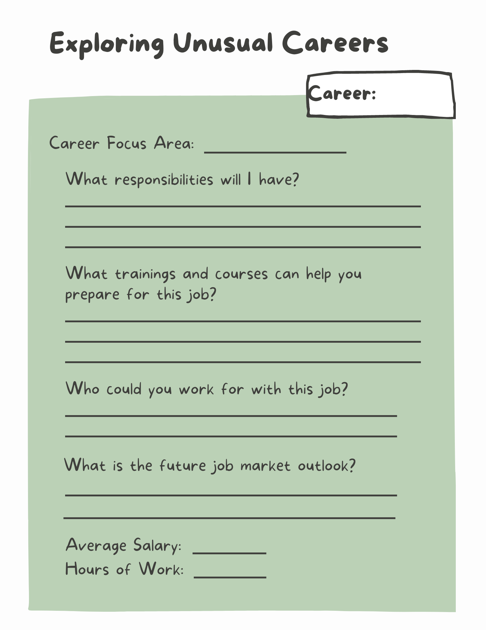
Select one of the six unusual careers from the article and explore more about the career by utilizing AgExplorer (AgExplorer.FFA.org/) to complete the activity below.

Part 3
Directions:

Using AgExplorer (AgExplorer.FFA.org/), select a career that you were surprised to find is related to agriculture and then complete the activity below.
- Review what you recorded about the career you identified in Part 3. Now that you know more about the career, rate the following with an emoji that reflects how you feel about each aspect of the career.

Average Salary
Responsibilities
Education/Training Required
Job Outlook
Career Overall

KEY: Appendix 2: 6 Unusual Careers in Agriculture
Aligned to the following standards: CS.02, CS.05, FFA.PL-A, FFA.PL-E, FFA.CS-M, FFA.CS-N, FFA.PL-C, FFA.PL-E, FFA.PL-F, FFA.PG-I, CCSS.ELA-Literacy.RI.9-10.4, CCSS.ELA-Literacy.WHST.9.10.6, MP2, MP3, CCSS.ELA-Literacy.W.9-10.1, CCSS.ELA-Literacy.W.9-10.2, CCSS.ELA-Literacy.SL.9-10.2, CCSS.ELA-Literacy.SL.9-10.4, AG1, CRP.02., CRP.04, CRP.05, CRP.06, CRP.08, CRP.11

Part 1
Directions:
Read the article “6 Unusual Careers in Ag” in the Spring 2023 issue of FFA New Horizons and complete the following activities.

*Identify three key takeaways for each of the careers discussed in the article, and record that information on and/or near each picture that represents the career.
Zoologist

Answers will vary.

Restoration Specialist

Flavor Technologist

Answers will vary.

Game Warden
Athletic Turf Manager
Wind Turbine Technician
- Rank the careers in the article based on your interest in them with 1 being the most interesting.
Career | Rank | Importance of the Career to the Industry
Athletic Turf Manager |  | Answers will vary.
Flavor Technologist
Game Warden
Restoration Specialist
Wind Turbine Technician
Zoologist

- Pick one of the careers above and describe in detail a scenario that would require a person in this career to take part in and be beneficial to the agriculture industry.
Answers will vary.

Part 2
Directions:
Select one of the six unusual careers from the article and explore Select one of the six unusual careers from the article and explore more about the career by utilizing AgExplorer (AgExplorer.FFA.org/) to complete the activity below.
Answers will vary.

Part 3
Directions:
Using AgExplorer (AgExplorer.FFA.org/), select a career that you were surprised to find is related to agriculture and then complete the activity below.
Review what you recorded about the career you identified in Part 3. Now that you know more about the career, rate the following with an emoji that reflects how you feel about each aspect of the career.

Average Salary | Answers will vary
Responsibilities
Education/Training Required
Job Outlook
Career Overall

