Aligned to the following standards:
FFA.PL-A1, FFA.PL-A3, FFA.PL-B2, FFA.PL-B5, CCSS.RI.9-10.1, CCSS.RI.9-10.4, CCSS.W.9-10.4, CCSS.W.9-10.5, CCSS.ELA.SL.9-10.1, CCSS.ELA.SL.9-10.4, CCSS.ELA.SL.9-10.6, CCSS. ELA.SL.11-12.6, CCSS.ELA.L.9-10.6, CCSS.ELA.L.11-12.6, CRP.02, CRP.04, CRP.08
Appendix 3: Farm Fire Prevention
Part 1
Directions:
Read the article “On the Front Lines of Farm Fire Prevention” in the spring/summer 2026 issue of FFA New Horizons and complete the following activities.

- How many hours has Dakine Thompson logged for his supervised agricultural experience (SAE)?  - 15  - 100  - 200    - More than 300 | - Which state is Dakine Thompson from? Draw a picture of the state in the space provided, and draw a star with a label to identify the location of the volunteer fire department he works at.
- Identify three skills that Dakine has developed from his service-learning SAE.

- ________________________________________
- ________________________________________
- ________________________________________
- Due to the surprise that so many were unprepared if a fire or an evacuation were to occur, what did Dakine develop for his community?

- E____________________ C____________________ L__________________
  - What role do you think this resource plays if a fire or evacuation were to occur?

- F____________________ E____________________ P__________________
  - What role do you think this resource plays if a fire or evacuation were to occur?

- F____________________ P____________________ C__________________
  - What role do you think this resource plays if a fire or evacuation were to occur?

- Identify three risks that are often identified on farms that farmers may be unaware of.
- _______________________________ (2) _____________________________ (3) ____________________________
- What is the name of the Facebook page that Dakine developed to feature demonstrations and educational resources? ____________________________________________________

- Why do you think many may not have fire and evacuation plans for their farms or homes?
Part 2
Aligned to the following standards:
FFA.PL-A1, FFA.PL-A3, FFA.PL-B2, FFA.PL-B5, CCSS.RI.9-10.1, CCSS.RI.9-10.4, CCSS.W.9-10.4, CCSS.W.9-10.5, CCSS.ELA.SL.9-10.1, CCSS.ELA.SL.9-10.4, CCSS.ELA.SL.9-10.6, CCSS. ELA.SL.11-12.6, CCSS.ELA.L.9-10.6, CCSS.ELA.L.11-12.6, CRP.02, CRP.04, CRP.08

Directions:
Using the prompts below, complete the following activities.
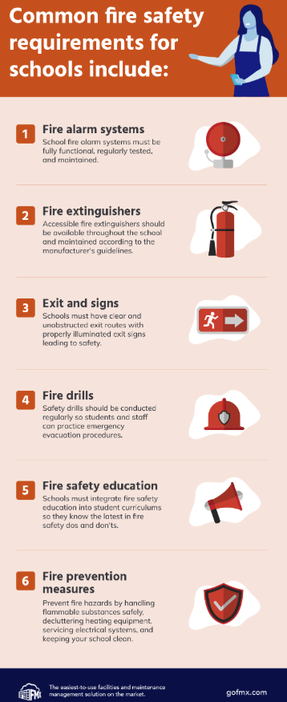
- Walk through your classroom and department facilities (Ex. mechanics shop, greenhouse, livestock facility, storage rooms, etc.). Identify the fire safety measures in place and any fire safety concerns you notice that could affect your ability to escape. When evaluating the space, consider the items in the room, both on the floor and on the walls.

Safety Measures in Place | Potential Hazards
- Think about your home. What types of safety measures and hazards exist in your home?
Safety Measures in Place | Potential Hazards
- What did you notice that surprised you as you looked at and thought through the classroom, facilities and your home?

- Why?

- Using the U.S. Fire Administration website, https://www.usfa.fema.gov/statistics/, identify three statistics that surprise you about fires in the U.S.
Statistic | What Does the Statistic Mean? | What Surprised You About This Statistic?
- Based on what you have learned about fires and fire safety, develop a 30-second public service announcement (PSA) for your community about the importance of fire safety and the things they need to think about now for future safety. Use the space below to write your PSA.

Area | 4 Points | 3 Points | 2 Points | 1 Point
Content | All content is accurate. There are no factual errors. | Most of the content is accurate, but there is one piece of information that seems inaccurate. | The content is generally accurate, but one piece of information is clearly inaccurate. | Content is confusing or contains more than one factual error.
Clarity and Creativity | The PSA is easy to understand, and all elements are clearly written or spoken. Creativity was used. | The PSA is easy to understand, and most elements are clearly written or spoken. Some creativity was used. | The PSA is hard to understand with very quiet speaking or very hard-to-read writing. Little creativity was used. | The PSA is hard to understand, and one cannot follow the thought process. No creativity was used.
Narration and Preparedness | The PSA is clearly rehearsed and presented with no mistakes.  Student spoke slowly and clearly. | One mistake is heard in the PSA. | Two mistakes are heard in the PSA. | Three or more mistakes are heard in the PSA.  Student spoke very fast and was unclear.
Time | PSA was 30 seconds. |  |  | Student was either under or over the allotted time.

Part 3
Directions:
Fire safety is a critical part of any home, office, school or farm. Develop a 30-minute elementary education activity that you could present to teach about fire safety. Use the steps below to plan your event/activity.
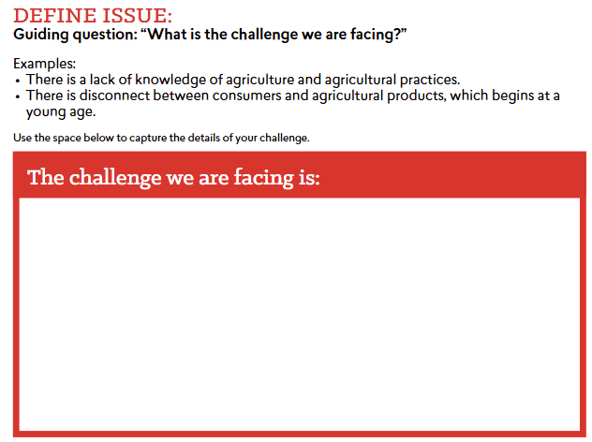
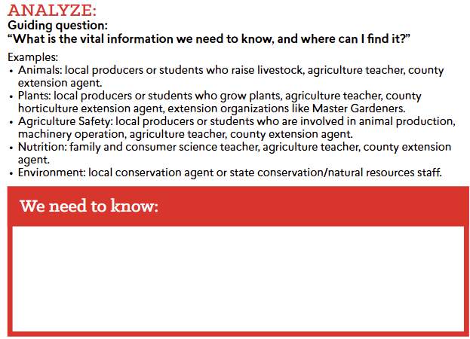
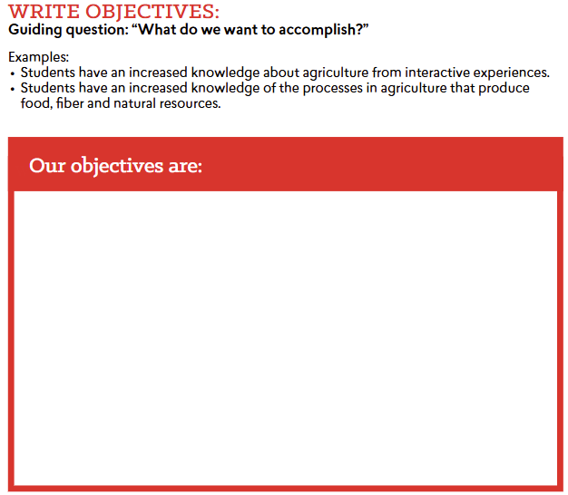

Describe the activity you going to complete with students.

What supplies will you need?

Reflection:
1. What did you find challenging about planning this event?

2. What did you find exciting about planning this event?

3. Why is fire safety so important?

4. Complete the following statements.
- Three things I learned:
(1)
(2)
(3)
- Two questions I still have:
(1)
(2)
- One final statement about farm fire safety:

KEY: Appendix 3: Farm Fire Prevention
Part 1
Directions:
Read the article “On the Front Lines of Farm Fire Prevention” in the spring/summer 2026 issue of FFA New Horizons and complete the following activities.

- How many hours has Dakine Thompson logged for his supervised agricultural experience (SAE)?  - 15  - 100  - 200  - More than 300 | - Which state is Dakine Thompson from? Draw a picture of the state in the space provided, and draw a star with a label to identify the location of the volunteer fire department he works at.  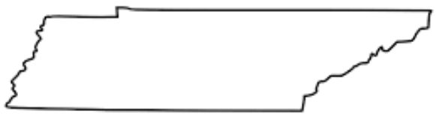Tusculum Volunteer Fire Department
- Identify three skills that Dakine has developed from his community service SAE.

- Fire suppression ________________________________________
- Vehicle extractions________________________________________
- Repelling from windows________________________________________
- What did Dakine develop for his community due to the surprise that so many were unprepared if a fire or an evacuation were to occur?

- Emergency Contact Lists
  - What role do you think this resource plays if a fire or evacuation were to occur? Answers will vary.
- Farm Evacuation Plans
  - What role do you think this resource plays if a fire or evacuation were to occur? Answers will vary.
- Fire Preparedness Checklist
  - What role do you think this resource plays if a fire or evacuation were to occur? Answers will vary.
- Identify three risks that are often identified on farms that farmers may be unaware of.
- Risk of dust/debris/buildup (2) Motors, electrical equipment (3) Heating and air
- What is the name of the Facebook page that Dakine developed to feature demonstrations and educational resources? The Blue Jacket Way

- Why do you think many may not have fire and evacuation plans for their farms or homes?
Answers will vary.
Aligned to the following standards:
FFA.PL-A1, FFA.PL-A3, FFA.PL-B2, FFA.PL-B5, CCSS.RI.9-10.1, CCSS.RI.9-10.4, CCSS.W.9-10.4, CCSS.W.9-10.5, CCSS.ELA.SL.9-10.1, CCSS.ELA.SL.9-10.4, CCSS.ELA.SL.9-10.6, CCSS. ELA.SL.11-12.6, CCSS.ELA.L.9-10.6, CCSS.ELA.L.11-12.6, CRP.02, CRP.04, CRP.08

Part 2
Directions:
Using the prompts below, complete the following activities.
- Walk through your classroom and department facilities (Ex. mechanics shop, greenhouse, livestock facility, storage rooms, etc.). Identify the fire safety measures in place and any fire safety concerns you notice that could affect your ability to escape. When evaluating the space, consider the items in the room, both on the floor and the walls.
Answers will vary.
Safety Measures in Place | Potential Hazards
- Think about your home. What types of safety measures and hazards exist in your home? Answers will vary.
Safety Measures in Place | Potential Hazards
- What did you notice that surprised you as you looked through and thought through the classroom, facilities and your home? Answers will vary.

- Why? Answers will vary.

- Using the U.S. Fire Administration website, https://www.usfa.fema.gov/statistics/, identify three statistics that surprise you about fires in the U.S. Answers will vary.
Statistic | What Does the Statistic Mean? | What Surprised You About This Statistic?
- Based on what you have learned about fires and fire safety, develop a 30-second public service announcement (PSA) for your community about the importance of fire safety and the things they need to think about now for future safety. Use the space below to write your PSA.

Answers will vary.

Area | 4 Points | 3 Points | 2 Points | 1 Point
Content | All content is accurate. There are no factual errors. | Most of the content is accurate, but there is one piece of information that seems inaccurate. | The content is generally accurate, but one piece of information is clearly inaccurate. | Content is confusing or contains more than one factual error.
Clarity and Creativity | The PSA is easy to understand, and all elements are clearly written or spoken. Creativity was used. | The PSA is easy to understand, and most elements are clearly written or spoken. Some creativity was used. | The PSA is hard to understand with very quiet speaking or very hard-to-read writing. Little creativity was used. | The PSA is hard to understand, and one cannot follow the thought process. No creativity was used.
Narration and Preparedness | The PSA is clearly rehearsed and presented with no mistakes.  Student spoke slowly and clearly. | One mistake is heard in the PSA. | Two mistakes are heard in the PSA. | Three or more mistakes are heard in the PSA.  Student spoke very fast and was unclear.
Time | PSA was 30 seconds. |  |  | Student was either under or over the allotted time.

Part 3
Directions:
Fire safety is a critical part of any home, office, school or farm. Develop a 30-minute elementary education activity that you could present to teach about fire safety. Use the steps below to plan your event/activity. Answers will vary.

Describe the activity you going to complete with the students.

What supplies will you need?

Reflection:
1. What did you find challenging about planning this event? Answers will vary.

2. What did you find exciting about planning this event? Answers will vary.

3. Why is fire safety so important?
Answers will vary. Example: Without fire safety we put ourselves, friends, family and facilities at both physical and financial risk.

4. Complete the following statements. Answers will vary.
- Three things I learned:
(1)
(2)
(3)
- Two questions I still have:
(1)
(2)
- One final statement about farm fire safety:

