Appendix 3: On the Record: Dr. Shonna Tart
Aligned to the following standards:
FFA.PL-A; FFA.PL-C; FFA.PL-E; FFA.PL-F; FFA.PG-I; FFA.CS-P; CS.05; AG5; CCSS.ELA.RI.9-10.1; CCSS.ELA.RI.9-10.2; CCSS.ELA.W.9-10.4; CR.02; CRP.04; CRP.07; CRP.10
Part 1
Directions:
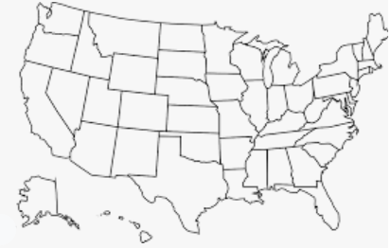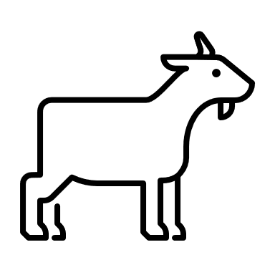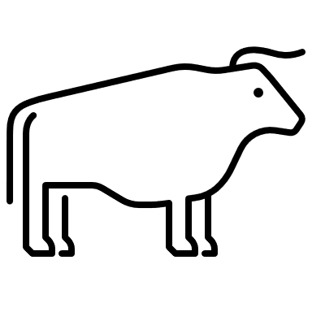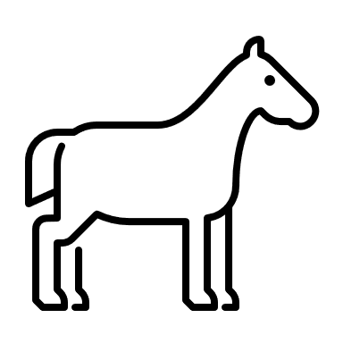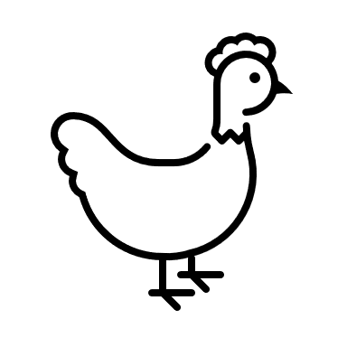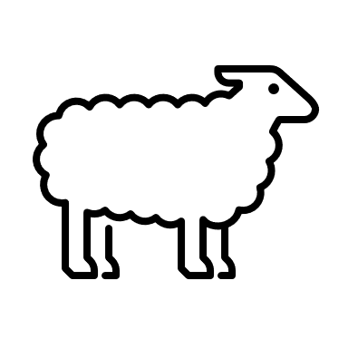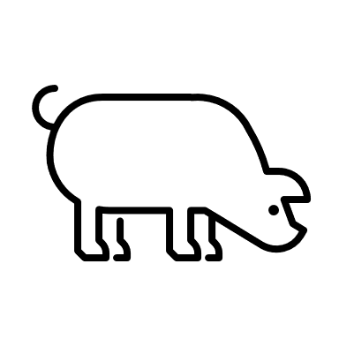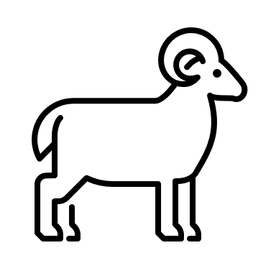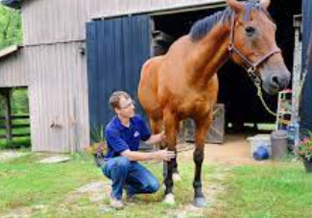Read the article “On the Record: Dr. Shonna Tart” in the spring 2022 issue of FFA New Horizons and complete the following activities while you read.
Color the state where FFA alumna Shonna Tart works as a veterinarian.
What vet school did Tart attend?
a. Auburn University
b. Tufts University
c. Purdue University
d. University of Tennessee
What species of animal did Tart hope to primarily work with?
- Cattle
- Pigs
- Chickens
- Sheep/goats
Describe why being solely a large-animal vet can be difficult.
Which of the following is a challenge of being a rural vet?
- Income challenges
- Veterinarians are not called for preventative care.
- Veterinarians are only called for emergencies.
- All of the above

Describe the large-animal veterinary science industry in a way that any of your friends or family could understand.
What are three opportunities that you could take advantage of now, in your school or community, that would prepare you for a career in the animal industry?

- ________________________________________________________
- ________________________________________________________
- ________________________________________________________

Part 2
Directions:
When considering the veterinary science field for a career, many begin by thinking you have to be a veterinarian, but there is so much more! Below are a few of the many available careers in the realm of veterinary science. Select three careers of interest by highlighting your choices in green. Once you have made your selections, complete the activities that follow.
Animal Geneticist | Veterinary Assistant | Veterinary Pathologist | Veterinary Technician
Ruminant Nutritionist | Animal Biotechnologist | Nutritional Specialist | Animal Physical Therapist

In each box, write one of the careers you selected. Use AgExplorer.FFA.org to learn more. Draw icons or emojis that visually describe the function of the career. Then identify the skills needed for the career as well as the overall impact on the animal industry. See the example below to better understand your task.



What are three skills needed for this career?
(1)
(2)
(3)
What are three skills needed for this career?
(1)
(2)
(3)
What are three skills needed for this career?
(1)
(2)
(3)
Example:
Career: Small-Animal
Veterinarian

+ =
Would you be well suited for a career in the veterinary science field? Why or why not?
Identify five skills you have that would benefit you in this career field.
(1)

(2)

(3)

(4)

(5)
What is the impact of this career on the animal industry?
Career: _________________________

What is the impact of this career on the animal industry?
Career: _________________________

What is the impact of this career on the animal industry?
Career: _________________________

What is the impact of this career on the animal industry?
Ensures the health and well-being of small animals.
What are three skills needed for this career?
(1) Detail oriented
(2) Enjoys a different schedule each day
(3) Ability to think critically
KEY: Appendix 3: On the Record: Dr. Shonna Tart
Aligned to the following standards:
FFA.PL-A; FFA.PL-C; FFA.PL-E; FFA.PL-F; FFA.PG-I; FFA.CS-P; CS.05; AG5; CCSS.ELA.RI.9-10.1; CCSS.ELA.RI.9-10.2; CCSS.ELA.W.9-10.4; CR.02; CRP.04; CRP.07; CRP.10
Part 1
Directions:
Read the article “On the Record: Dr. Shonna Tart” in the spring 2022 issue of FFA New Horizons and complete the following activities while you read.
Color the state where FFA alumna Shonna Tart works as a veterinarian.
What vet school did Tart attend?
a. Auburn University
b. Tufts University
c. Purdue University
d. University of Tennessee
What species of animal did Tart hope to primarily work with?
- Cattle
- Pigs
- Chickens
- Sheep/goats
Describe why being solely a large-animal vet can be difficult. Answers will vary. Example: You need to be located in an area that requires preventative care; otherwise producers sell their animals, not needing a veterinarian.
Which of the following is a challenge of being a rural vet?
- Income challenges
- Veterinarians are not called for preventative care.
- Veterinarians are only called for emergencies.
- All of the above

What are three opportunities that you could take advantage of now, in your school or community, that would prepare you for a career in the animal industry?
Answers will vary.

- Take animal science/agriculture courses.
- Volunteer or work at a veterinary clinic.
- Be a part of activities that support your goal of being a vet (Example: livestock judging).
Describe the large-animal veterinary science industry in a way that any of your friends or family could understand.
Answers will vary.

Part 2
Directions:
When considering the veterinary science field for a career, many begin by thinking you have to be a veterinarian, but there is so much more! Below are a few of the many available careers in the realm of veterinary science. Select three careers of interest by highlighting your choices in green. Once you have made your selections, complete the activities that follow.
Animal Geneticist | Veterinary Assistant | Veterinary Pathologist | Veterinary Technician
Ruminant Nutritionist | Animal Biotechnologist | Nutritional Specialist | Animal Physical Therapist

In each box, write one of the careers you selected. Use AgExplorer.FFA.org to learn more. Draw out icons or emojis that would visually describe the function of the career. Then identify the skills needed for the career as well as the overall impact on the animal industry. See the example below to better understand your task. Answers will vary.
Identify five skills you have that would benefit you in this career field.
Answers will vary.
(1)

(2)

(3)

(4)

(5)
What are three skills needed for this career?
(1)
(2)
(3)
What are three skills needed for this career?
(1)
(2)
(3)
What are three skills needed for this career?
(1)
(2)
(3)
Example:
Career: Small-Animal
Veterinarian

+ =
Would you be well suited for a career in the veterinary science field? Why or why not?
Answers will vary.
What is the impact of this career on the animal industry?
Career: _________________________

What is the impact of this career on the animal industry?
Career: _________________________

What is the impact of this career on the animal industry?
Career: _________________________

What is the impact of this career on the animal industry?
Ensures the health and well-being of small animals
What are three skills needed for this career?
(1) Detail oriented
(2) Enjoys a different schedule each day
(3) Ability to think critically

