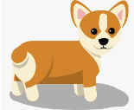



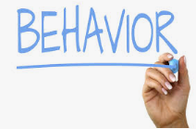
Appendix 3: Engineering and Agriculture
Aligned to the following standards:
AGPC01.02; CS.02; FFA.PL-A; FFA.PL-E; FFA.PL-F; FFA.PG-I; FFA.PG-J; FFA.CS-M; FFA.CS-N; AG2; CCSS.ELA.RI.9-10.4; MP5; MP6; CRP.02; CRP.04; CRP.06; CRP.07; CRP.08
What is animal behavior?
What is a specific example of a behavior shown by a dog?
What are the four basic reasons why animals behave the way they do?

- ____________________ 2. _____________________ 3. ____________________ 4. ____________________
How do you act when you are happy? Give two examples.

- _____________________________

- _____________________________
How do you act when you are sad? Give two examples.

- _____________________________

- _____________________________
How do you act when you are bored? Give two examples.

- _____________________________

- _____________________________
What do animals do when they are happy, sad and bored?
What makes humans and animals act this way?
What is the scientific study of animal behavior called?

______________
Created: Summer 2019 by the National FFA Organization
Part 1
Directions:
Begin by answering the following questions:

Directions:
Read the article “Engineering Elephants” in the Summer 2019 issue of FFA New Horizons. Complete the following activities once you have finished reading.

- Visit the SeaWorld Parks and Entertainment website, https://seaworld.org/animals/all-about/training/animal-behavior-and-learning/, and answer the following questions.

- Now that we have a basic understanding of what behavior is, let’s explore different behaviors. Using the website https://sciencing.com/innate-learned-animal-behavior-6668264.html, define each of the different types of animal behavior and draw a picture that represents that type of behavior. Your drawing must be an example not used on the website. Think about the animals you own, come into contact with every day or have seen in videos (ex. dogs, cats, sheep, rabbits, etc.) to complete this activity.
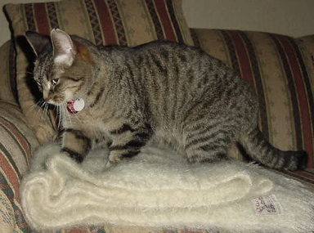
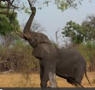
Your Selected Animal: ____________

- _______________________
  - Why?

  - Corrective action or reinforcement of action:

- _______________________
  - Why?

  - Corrective action or reinforcement of action:

- _______________________
  - Why?

  - Corrective action or reinforcement of action:

- _______________________
  - Why?

  - Corrective action or reinforcement of action:
Dog Behaviors:

- Biting
  - Why?

  - Corrective action:

- Yawning
  - Why?

  - Corrective action:

- Circling
  - Why?

  - Corrective action:

- Panting
  - Why?

  - Corrective action:

- We now have an understanding of behaviors in animals. Let’s look at behaviors that are exhibited and what they could mean.
  - Five dog behaviors are listed. Using the Hill’s Science Diet website, identify why the dog is exhibiting that behavior and a corrective action that can be taken.

  - Select an animal (other than a dog). Identify 5 behaviors that animal exhibits. Thinking about the behavior, what is a corrective action (for negative behaviors) or reinforcement of the action (for good behaviors) that can be taken to address each behavior?

In the article, they talk about how the elephants sway. Why did the elephants do this? How can the caretakers correct the behavior?
Learned Behavior
Definition:

Picture:
Vs.
Innate Behavior
Definition:

Picture:
Part 2
Directions:
Within the article, students had to apply the skills they learned in their agricultural mechanics class. Now, we will walk through some of the most common welding joints used in the industry, which would have been used to create the elephant feeder. Using the website http://www.theweldingmaster.com/types-welding-joints/, examine each of the different types of welding joint and the variations in each weld. After you learn about each weld, you will create the weld using graham crackers and icing. Draw or take a picture and place it next to each weld below. If you are not performing this lab, draw a picture of each joint weld.

Butt Joint
Description: Variations: Picture:
Corner Joint
Description: Variations: Picture:
T Joint
Description: Variations: Picture:
Example: Bevel groove weld

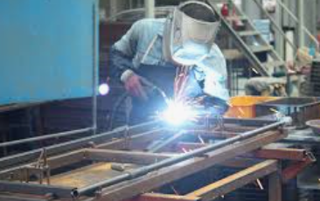
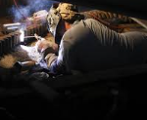
Edge Joint
Description: Variations: Picture:
Lap Joint
Description: Variations: Picture:
Find a weld that you have in your classroom! Describe it.
What role do welders play in our everyday lives?
(Hint: Think about your day-to-day tasks).
What classes could you take to prepare for a career in welding?

Part 3
Directions:
You have now learned about animal behavior and welding. How do they fit together? Read the scenario below. Thinking about what you have learned, construct a solution to the problem.

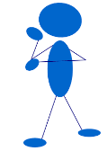
Scenario:

Your friend has six rabbits of varying breeds. The rabbits are cared for daily. These rabbits are not only for meat purposes, but also serve as pets. The rabbits have been consistently hopping back and forth in front of the door to their enclosure and flipping their feed dishes. This behavior has caused sore hocks and a loss of feed.

- Identify the behaviors exhibited by the rabbits.

- Why do you think they are exhibiting these behaviors?

- Design a hutch (rabbit house) that will fix the issues your friend is having with the rabbits. Draw a picture of the hutch below. Be sure to label any welding joints that may be used and describe why your design will solve the problem.
Design
Explanation
Key — Appendix 3: Engineering and Agriculture
What is animal behavior?

Anything that an animal does is a behavior.
What is a specific example of a behavior shown by a dog?

Answers will vary. Example: wagging
his or her tail
What are the four basic reasons why animals behave the way they do?

- Finding food and water 2. Interaction 3. Avoiding predators_ 4. Reproduction
How do you act when you are happy? Give two examples.
Answers will vary.
- _____________________________

- _____________________________
How do you act when you are sad? Give two examples.
Answers will vary.
- _____________________________

- _____________________________
How do you act when you are bored? Give two examples.
Answers will vary.
- _____________________________

- _____________________________
What do animals do when they are happy, sad and bored?

Animals will exhibit behaviors like we do. Examples: happy = running and playing, sad = not sociable, bored = pacing
What makes humans and animals act this way?

Not having the correct environment or stimulation can cause behavior to change.
What is the scientific study of animal behavior called?

Ethology
Aligned to the following standards:
AGPC01.02; CS.02; FFA.PL-A; FFA.PL-E; FFA.PL-F; FFA.PG-I; FFA.PG-J; FFA.CS-M; FFA.CS-N; AG2; CCSS.ELA.RI.9-10.4; MP5; MP6; CRP.02; CRP.04; CRP.06; CRP.07; CRP.08
Created: Summer 2019 by the National FFA Organization
Part 1
Directions:
Begin by answering the following questions:

Directions:
Read the article “Engineering Elephants” in the Summer 2019 issue of FFA New Horizons. Complete the following activities once you have finished reading.

- Visit the SeaWorld Parks and Entertainment website, https://seaworld.org/animals/all-about/training/animal-behavior-and-learning/, and answer the following questions.

- Now that we have a basic understanding of what behavior is, let’s explore different behaviors. Using the website, https://sciencing.com/innate-learned-animal-behavior-6668264.html, define each of the different types of animal behavior and draw a picture that represents that type of behavior. Your drawing must be an example not used on the website. Think about the animals you own, come into contact with every day or have seen in videos (ex. dogs, cats, sheep, rabbits, etc.) to complete this activity.
Your Selected Animal: ____________

- _______________________
  - Why?

  - Corrective action or reinforcement of action:

- _______________________
  - Why?

  - Corrective action or reinforcement of action:

- _______________________
  - Why?

  - Corrective action or reinforcement of action:

- _______________________
  - Why?

  - Corrective action or reinforcement of action:
Answers will vary. Animal should be something other than a dog.
Dog Behaviors:

- Biting
  - Why? Anxiety, fear, aggression
  - Corrective action: Reduce stress; may need an animal behaviorist
- Yawning
  - Why? Tired or nervous
  - Corrective action: Reduce stressors
- Circling
  - Why? Health problem of some sort
  - Corrective action: A trip to the vet
- Panting
  - Why? Hot or in pain

  - Corrective action: Water/reduce physical activity until cool; visit a vet

In the article, they talk about how the elephants sway. Why did the elephants do this? How can the caretakers correct the behavior?

The elephants sway out of boredom and need to have activity and stimuli in their environment. The elevated hay feeder will help.
- We now have an understanding of behaviors in animals. Let’s look at behaviors that are exhibited and what they could mean.
- Five dog behaviors are listed. Using the Hill’s Science Diet website, https://www.hillspet.com/dog-care/behavior-appearance/types-of-common-dog-behavior, identify why the dog is exhibiting that behavior and a corrective action that can be taken.

- Select an animal (other than a dog). Identify 5 behaviors that animal exhibits. Thinking about the behavior, what is a corrective action (for negative behaviors) or reinforcement of the action (for good behaviors) that can be taken to address each behavior?

Learned Behavior
Definition: A behavior that is learned by watching another animal.

Picture: Pictures will vary. Example: how to hunt for food
Vs.
Innate Behavior
Definition: A behavior that an animal is born with; it is in his or her DNA.

Picture: Pictures will vary. Example: sea turtles hatching and heading toward the sea
Part 2
Directions:
Within the article, students had to apply the skills they learned in their agricultural mechanics class. Now, we will walk through some of the most common welding joints used in the industry, which would have been used to create the elephant feeder. Using the website http://www.theweldingmaster.com/types-welding-joints/, examine each of the different types of welding joint and the variations in each weld. After you learn about each weld, you will create the weld using graham crackers and icing. Draw or take a picture and place it next to each weld below. If you are not performing this lab, draw a picture of each joint weld.

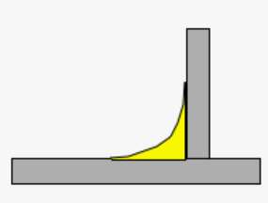
Butt Joint
Description: Variations: Picture:
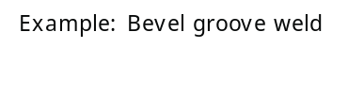
Corner Joint
Description: Variations: Picture:
T Joint
Description: Variations: Picture:
Formed by placing two pieces of metal side-by-side and laying a bead to connect the two pieces
Two metal pieces forming a right angle
Placing one piece of metal upright on top of a horizontal piece of metal and laying beads on each side, creating two right angles
Example: spot weld
Example: slot weld

Example, Plug weld.
Edge Joint
Description: Variations: Picture:
Lap Joint
Description: Variations: Picture:
Find a weld that you have in your classroom! Describe it.
Answers will vary. Example: desk legs
What role do welders play in our everyday lives?
(Hint: Think about your day-to-day tasks).

Welders are crucial to the development of many structures and products we depend on. Examples: buildings, cars (even though the welding is automated).
What classes could you take to prepare for a career in welding?

Agricultural mechanics, industrial technology classes, math classes
Two pieces of metal are placed horizontally on top of each other (one piece hanging out over the other) and then two welds are made.
Example: spot weld
Welding the edges of two pieces of metal together
Example: square-groove weld

Example, slot weld.



Example, V-groove weld.
Example, square groove weld.
Welding the edges of two pices of metal together.

Part 3
Directions:
You have now learned about animal behavior and welding. How do they fit together? Read the scenario below. Thinking about what you have learned, construct a solution to the problem.

Scenario:

Your friend has six rabbits of varying breeds. The rabbits are cared for daily. These rabbits are not only for meat purposes, but also serve as pets. The rabbits have been consistently hopping back and forth in front of the door to their enclosure and flipping their feed dishes. This behavior has caused sore hocks and a loss of feed.

- Identify the behaviors exhibited by the rabbits.

The rabbits are moving back and forth and dumping their feed dishes.

- Why do you think they are exhibiting these behaviors?

The rabbits could be bored.

- Design a hutch (rabbit house) that will fix the issues your friend is having with the rabbits. Draw a picture of the hutch below. Be sure to label any welding joints that may be used and describe why your design will solve the problem.
Design

Answers will vary.
Explanation

Answers will vary.

