Appendix 3: On the Record: Steve Rosenzweig
Aligned to the following standards:
CS.01; CS.02; AG1; AG2; FFA.PL-A; FFA.PL-E; FFA.PL-F; FA.PG-J; FFA.CS-N; CCAA.RI.9-10.1; CCSS.RI.9-10.3; CCSS.WHST.9.10.4; CCSS.W.9-10.2; CCSS.W.9-10.4; CRP.02; CRP.04; CRP.08

Created: Spring 2021 by the National FFA Organization
Directions:
Begin reading the article “On the Record: Steve Rosenzweig” in the spring 2021 issue of FFA New Horizons and complete the following activities.
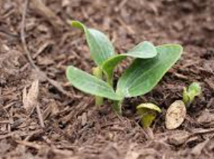
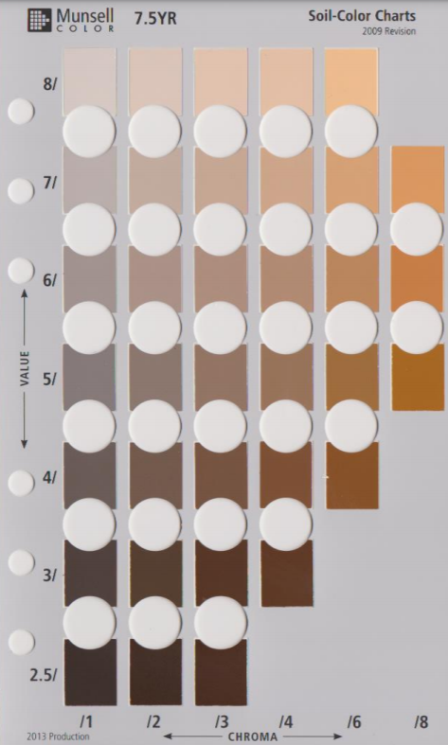
The Munsell Chart helps to scientifically evaluate the color of a soil sample.
- What company does Steve Rosenzweig
work for?

- Kraft
- Sargento
- Nabisco
- General Mills

- What day is Earth Day observed?

- April 20
- April 22
- April 24
- April 26
3. What is NRCS?

- National Resources Conservation Services
- Natural Resources Conservation Systems
- Natural Resources Conservation Service
- National Regional Conservation Systems

4. Which of the following are NOT one of the six soil practices being incorporated by farmers?

- Minimize soil disturbance
- Keep the soil covered
- Maximize plant diversity
- Integrate livestock
- Plant the same crop
What benefits come from caring for the soil?
Soil health is undoubtedly important, not only for farmers but for everything that we do in society. Today, you are going to evaluate the soil where you live. Follow the steps below to evaluate the soil in your area.

- According to the article, what color is better for soil health? _____________
- According to the article, how should the soil smell? _____________________________________
- How should the soil appear for better soil health? _____________________________________________________
- Go outside with a tool suitable for digging up a small soil sample (shovel, trowel, spoon, etc.). What tool have you selected? _________________________________________
- Pull the sample using your selected tool and evaluate the health of the soil sample.
The sample needs to be large enough to see the color and evaluate the way it feels.
  - Pull the sample using your selected tool and evaluate the health.
  - What color is your soil sample? Circle the color on the Munsell Chart that
best matches your soil sample.
    - Where did you pull your sample from? _______________________
    - Do you think your soil is healthy? Circle your answer. Yes No
      - Why?

  - How does your soil sample smell? ________________________________

  - How does the soil appear? (Ex. crumbly, sticky, etc.)


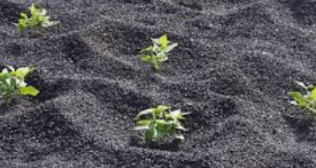
- Now, find a different location and follow the same steps as you did for your first sample. Pull the sample using your selected tool and evaluate the health.

- What color is your soil sample? Circle the color on the Munsell Chart that
best matches your soil sample.
    - Where did you pull your sample from? _______________________
    - Do you think your soil is healthy? Circle your answer. Yes No
      - Why?

- How does your soil sample smell? ________________________________

- How does the soil appear? (Ex. crumbly, sticky, etc.)

What role does soil health play in your community? Explain and give specific examples.

How can evaluating the soil in your home and community be beneficial to you and your family? Explain and give specific examples.

Why should everyone, not just farmers, care about the soil and its health?
If you only had two sentences to share with someone about why they should care about soil, what would you say to them?
How are the samples similar? How are they different?
Why do you think they are so similar or so different?
KEY — Appendix 3: On the Record: Steve Rosenzweig
Aligned to the following standards:
CS.01; CS.02; AG1; AG2; FFA.PL-A; FFA.PL-E; FFA.PL-F; FA.PG-J; FFA.CS-N; CCAA.RI.9-10.1; CCSS.RI.9-10.3; CCSS.WHST.9.10.4; CCSS.W.9-10.2; CCSS.W.9-10.4; CRP.02; CRP.04; CRP.08

Created: Spring 2021 by the National FFA Organization
Directions:
Begin reading the article “On the Record: Steve Rosenzweig” in the spring 2021 issue of FFA New Horizons and complete the following activities.
The Munsell Chart helps to scientifically evaluate the color of a soil sample.
- What company does Steve Rosenzweig
work for?

- Kraft
- Sargento
- Nabisco
- General Mills

- What day is Earth Day observed?

- April 20
- April 22
- April 24
- April 26
3. What is NRCS?

- National Resources Conservation Services
- Natural Resources Conservation Systems
- Natural Resources Conservation Service
- National Regional Conservation Systems

4. Which of the following are NOT one of the six soil practices being incorporated by farmers?

- Minimize soil disturbance
- Keep the soil covered
- Maximize plant diversity
- Integrate livestock
- Plant the same crop
What benefits come from caring for the soil? Caring for soil is important for food production, being able to build homes/businesses, septic systems and so much more. Without healthy soil, all these items would not be successful.
Soil health is undoubtedly important, not only for farmers but for everything that we do in society. Today, you are going to evaluate the soil where you live. Follow the steps below to evaluate the soil in your area.

- According to the article, what color is better for soil health? Darker is better.
- According to the article, how should the soil smell? Earthy and rich
- How should the soil appear for better soil health? Like cottage cheese
- Go outside with a tool suitable for digging up a small soil sample (shovel, trowel, spoon, etc.). What tool have you selected? Answers will vary.
- Find a spot where you can pull a soil sample. Answers will vary.
  - Pull the sample using your selected tool and evaluate the health.
The sample needs to be large enough to see the color and evaluate the
way it feels.
  - What color is your soil sample? Circle the color on the Munsell Chart that
best matches your soil sample.
    - Where did you pull your sample from? _______________________
    - Do you think your soil is healthy? Circle your answer. Yes No
      - Why?

  - How does your soil sample smell? ________________________________

  - How does the soil appear? (Ex. crumbly, sticky, etc.)

- Now, find a different location and follow the same steps as you did for your first sample. Pull the sample using your selected tool and evaluate the health. Answers will vary.

  - What color is your soil sample? Circle the color on the Munsell Chart that
best matches your soil sample.
    - Where did you pull your sample from? _______________________
    - Do you think your soil is healthy? Circle your answer. Yes No
      - Why?

  - How does your soil sample smell? ________________________________

  - How does the soil appear? (Ex. crumbly, sticky, etc.)

What role does soil health play in your community? Explain and give specific examples.
Answers will vary.

How can evaluating the soil in your home and community be beneficial to you and your family? Explain and give specific examples.
Answers will vary.

Why should everyone, not just farmers, care about the soil and its health? Soil health impacts us every day — from the food we eat to the houses we build. Soil impacts everyone. Specific examples will vary.
If you only had two sentences to share with someone about why they should care about soil, what would you say to them?
Answers will vary.
Why do you think they are so similar or so different? Answers will vary.
How are the samples similar? How are they different? Answers will vary.

