Appendix 3: Rich in Tradition
Aligned to the following standards:
FFA.PL-A; FFA.PL-D; FFA.PL-F; FFA.PG-I; FFA.CS-N; FFA.CS-O; FFA.CS-P; CCSS.ELA.RI.9-10.2; CCSS.ELA.W.9-10.2; CCSS.ELA.W.9-10.4; CCSS.ELA.W.9-10.5; CRP.01; CRP.04; CRP.07
Part 1
Directions:
Read the article “Rich in Tradition” in the fall 2022 issue of FFA New Horizons and complete the following questions.

- Using the color green, color in the box that names the month Native American Heritage is celebrated.
January | February | March | April | May | June
July | August | September | October | November | December

- Approximately how many Native Americans are now members of FFA?
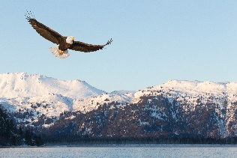
  - 5,000
  - 8,000
  - 12,000
  - 20,000

- How did Anthony first get hooked on FFA?

  - How do you think these types of experiences could impact other students who may be interested in joining a club or organization?
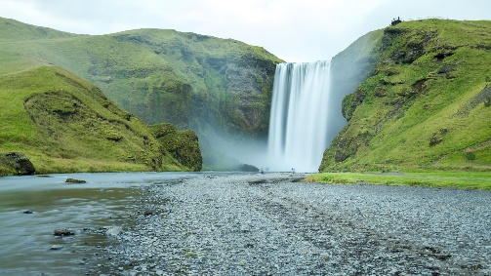

- Many Natives lived a ____________ lifestyle.
  - What does this term mean?

  - What are you passionate about?

- __________________________________
What similarities and differences exist?

- __________________________________
- __________________________________
- __________________________________
  - According to the article, what are Natives passionate about?

- _____________________________
- _____________________________
- _____________________________
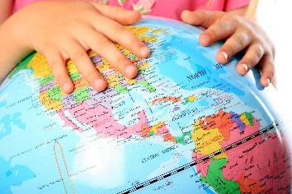
- _____________________________
- What is a misconception?

- What are two misconceptions people still hold today about Native Americans?

a. Why do you think these misconceptions still exist? What can be done to ensure these misconceptions are not continued?
Part 2
Directions:
Using the Native Land Digital program, type in your home or school zip code to determine what Native American tribes used to and/or still reside where you live/go to school.

- My zip code: __________________________

- Which tribes used to and/or still reside in the zip code you searched? (These will show on the left side of the screen or show as you move your mouse over the map.)

- Select one tribe you would like to learn more about (record it here): ________________________________________________

- Click on the tribe to begin learning more.
  - Record four facts that you found interesting about this tribe. What made them interesting to you?

Fact | Why is this fact interesting to you?
(1)

(2)

(3)

(4)

Part 3
Directions:
Now that you have learned a little about the cultural history, let’s take a look at the agricultural history and the impact it has on today’s agricultural practices. Read the article “7 Facts About Indigenous Agriculture” to start learning about the impact that indigenous agriculture has had on current agriculture. (Note: This is not an exhaustive list.) Select an indigenous agricultural practice (consider one that may have been practiced by the tribe you learned about in Part 2) and identify the traditional practice and the modern agricultural practice it has led to.

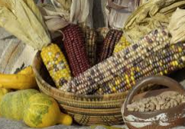
- Describe the indigenous practice you selected.

  - What supplies were needed?

  - What commodity was raised?

  - What need did this practice fulfill for the people who depended on it (trade, food, home, etc.)? Explain.

- Describe how this indigenous practice has changed today. If it has not changed, describe why.

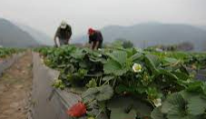

  - What commodity or commodities are raised through this practice today?

  - How has this indigenous practice shaped the way that agriculture has progressed to meet the needs of the current economy and population?

- Create an Instagram post to share the impact indigenous people had, and are still having, on agriculture across the U.S. Be sure to include a description and image.



How does this information impact you and your involvement in agriculture or everyday life?

Popcorn is a crop that was first grown by Native Americans that has become a very common food consumed today. Draw a picture of popcorn in a food stage and a growing stage.

Think about the research you just completed. How did the indigenous practices impact popcorn production as we know it today?


Consider the research you just completed. How did the indigenous practices impact cotton production as we know it today?
Cotton is a crop that was first grown by Native Americans that has become very common today. Draw a picture of cotton in a stage of use and a growing stage.

What indigenous customs or practices do you find most interesting and why?
Describe why it is important to learn history.
By drawing a series of emojis, describe how you feel impacted by what you have learned in this lesson. Include a minimum of three emojis.
KEY: Appendix 3: Rich in Tradition
Aligned to the following standards:
FFA.PL-A; FFA.PL-D; FFA.PL-F; FFA.PG-I; FFA.CS-N; FFA.CS-O; FFA.CS-P; CCSS.ELA.RI.9-10.2; CCSS.ELA.W.9-10.2; CCSS.ELA.W.9-10.4; CCSS.ELA.W.9-10.5; CRP.01; CRP.04; CRP.07
Part 1
Directions:
Read the article “Rich in Tradition” in the fall 2022 issue of FFA New Horizons and complete the following questions.

- Using the color green, color in the box that names the month Native American Heritage is celebrated.
January | February | March | April | May | June
July | August | September | October | November | December

- Approximately how many Native Americans are now members of FFA?
  - 5,000
  - 8,000
  - 12,000
  - 20,000

- How did Anthony first get hooked on FFA?
Meeting the state officers at DLS

  - How do you think these types of experiences could impact other students that may be interested in joining a club or organization? Answers will vary.

- Many Natives lived a nomadic lifestyle.
  - What does this term mean?

  - What are you passionate about? Answers will vary.
- __________________________________
What similarities and differences exist?
Answers will vary.

- __________________________________
- __________________________________
- __________________________________
  - According to the article, what are Natives passionate about?
- Family
- Food
- Keeping traditions alive
- Keeping languages alive
- What are two misconceptions people still hold today about Native Americans?
- Teepees are still used.

- English is not spoken.

Why do you think these misconceptions still exist? What can be done to ensure these misconceptions are not continued? Answers will vary.

Part 2
Directions:
Using the Native Land Digital program, type in your home or school zip code to determine what Native American tribes used to and/or still reside where you live/go to school. Answers will vary.

- My zip code: __________________________

- Which tribes used to and/or still reside in the zip code you searched? (These will show on the left side of the screen or show as you move your mouse over the map.)

- Select one tribe you would like to learn more about (record it here): ________________________________________________

- Click on the tribe to begin learning more.
  - Record two facts that you found interesting about this tribe. What made them interesting to you?

Fact | Why is this fact interesting to you?
- Answers will vary. | Answers will vary.
- Answers will vary. | Answers will vary.
- Answers will vary. | Answers will vary.
- Answers will vary. | Answers will vary.
Part 3
Directions:
Now that you have learned a little about the cultural history, let’s take a look at the agricultural history and the impact it has on today’s agricultural practices. Read the article “7 Facts About Indigenous Agriculture” to start learning about the impact that indigenous agriculture has had on current agriculture. (Note: This is not an exhaustive list.) Select an indigenous agricultural practice (consider one that may have been practiced by the tribe you learned about in Part 2) and identify the traditional practice and the modern agricultural practice it has led to.

- Describe the indigenous practice you selected. Answers will vary.

  - What supplies were needed? Answers will vary.

  - What commodity was raised? Answers will vary.

  - What need did this practice fulfill for the people that depended on it (trade, food, home, etc.)? Explain.
Answers will vary.

- Describe how this indigenous practice has changed today. If it has not changed, describe why.
Answers will vary.

  - What commodity or commodities are raised through this practice today?
Answers will vary.

  - How has this indigenous practice shaped the way that agriculture has progressed to meet the needs of the current economy and population?
Answers will vary.

- Create an Instagram post to share the impact indigenous people had, and are still having, on agriculture across the U.S. Be sure to include a description and image. Answers will vary.

How does this information impact you and your involvement in agriculture or everyday life? Answers will vary.

Popcorn is a crop that was first grown by Native Americans that has become a very common food consumed today. Draw a picture of popcorn in a food stage and a growing stage.
Answers will vary.

Think about the research you just completed. How did the indigenous practices impact popcorn production as we know it today? Answers will vary.

Consider the research you just completed. How did the indigenous practices impact cotton production as we know it today? Answers will vary.

Cotton is a crop that was first grown by Native Americans that has become very common today. Draw a picture of cotton in a stage of use and a growing stage.
Answers will vary.

By drawing a series of emojis, describe how you feel impacted by what you have learned in this lesson. Include a minimum of three emojis.
Answers will vary.

What indigenous customs or practices do you find most interesting and why? Answers will vary.

Describe why it is important to learn history. Answers will vary.

