Aligned to the following standards: CS.02; CS.05; FFA.PL-A; FFA.PL-C; FFA.PL-E; FFA.PL-F; FFA.PG-I; FFA.PG-J; FFA.CS-M; FFA.CS-N; CCSS.ELA.RI.9-10.2; CCSS.ELA.RI.9-10.4; CCSS.ELA.W.9-10.2; CCSS.ELA.W.9-10.3; CCSS.ELA.W.9-10.4; CCSS.ELA.SL.9-10.1; CCSS.ELA.L.9-10.6; AG2; AG5; CRP.02; CRP.04; AGC09.02
Appendix 3: Attention Future Ag Teachers
Part 1
Directions:
Read the article “Attention Future Ag Teachers” in the fall 2023 issue of FFA New Horizons and answer the questions below.

- When is National Teach Ag Day in 2023?

- Fill out the sticky notes below with information from the article.


2. _____ ___ _______________
“Teaching is not just an ______ to ______ job, ____________________ for ag teachers.”

- What does Mr. Davenport say one can expect as an agriculture teacher?

- How does he say agriculture teachers “prepare students for life in general”?
1. ________ ______ __________
“You ______________ know what you might _________________.”

- What topics could agriculture teachers end up teaching about?
- What other kinds of classes does Mr. Davenport say could be beneficial to future agriculture teachers?



Draw an icon below to go with each piece of Mr. Davenport’s advice.
3. _____ ________________
“Be willing to _____________ and ___________ _________________________ of the box and go with the _____________ to maximize the ________________ of your program.”

- What does Mr. Davenport credit for the increased community awareness and involvement in his program?

Part 2
Directions:
Find a college or university in your state or a neighboring state that offers a degree in agricultural education. Create a banner about that institution using the template below. Information you could add to your banner:
- Name of institution and logo
- Campus information (number of students, location, amenities, etc.)
- Cost of attendance
- Admission requirements
- Contact information for the department that offers the agricultural education degree
- Other selling points for the school

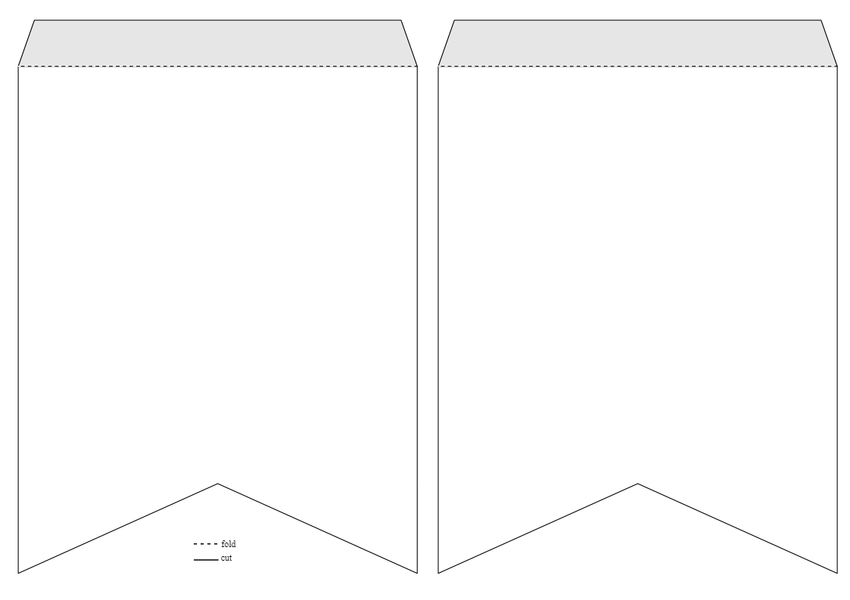

Part 3
Directions:
Using the template below, create a job post for an agriculture teacher. You may use AgExplorer.FFA.org/career/agriculture-science-teacher-secondary/ to help you create the post.

Job Post: Agriculture Teacher
School Name/Location:
Job Description:
(four to six sentences)
Job Requirements:  (Education, training, experience, certification, etc.) |  | Job Responsibilities:
Salary:

- What are two reasons we need to recruit quality agriculture teachers?

- Based on your experience in agricultural education courses, what would be one additional piece of advice you would give to someone pursuing a career as an agriculture teacher?

Aligned to the following standards: CS.02; CS.05; FFA.PL-A; FFA.PL-C; FFA.PL-E; FFA.PL-F; FFA.PG-I; FFA.PG-J; FFA.CS-M; FFA.CS-N; CCSS.ELA.RI.9-10.2; CCSS.ELA.RI.9-10.4; CCSS.ELA.W.9-10.2; CCSS.ELA.W.9-10.3; CCSS.ELA.W.9-10.4; CCSS.ELA.SL.9-10.1; CCSS.ELA.L.9-10.6; AG2; AG5; CRP.02; CRP.04; AGC09.02
KEY: Appendix 3: Attention Future Ag Teachers
Part 1
Directions:
Read the article “Attention Future Ag Teachers” in the fall 2023 issue of FFA New Horizons and answer the questions below.

- When is National Teach Ag Day in 2023?
September 21

- Fill out the sticky notes below with information from the article.
2. It’s an investment.
“Teaching is not just an 8 a.m. to 3 p.m. job, especially for ag teachers.”

- What does Mr. Davenport say one can expect as an agriculture teacher?
Hands-on learning experiences, one-on-one opportunities
- How does he say agriculture teachers “prepare students for life in general”?
Managing classrooms and
expectations, holding students
accountable
1. Consider your education.
“You never know what you
might teach.”

- What topics could agriculture teachers end up teaching about?
Animals, ag mechanics, horticulture, food science, intro to ag
- What other kinds of classes does Mr. Davenport say could be beneficial to future agriculture teachers?
Computer or management
classes

Draw an icon below to go with each piece of Mr. Davenport’s advice.
Answers will vary.
3. Be innovative.
“Be willing to change and step outside of the box and go
with the trends to maximize the success of your program.”

- What does Mr. Davenport credit for the increased community awareness and involvement in his program?
Creating a Facebook page for
his FFA chapter

Part 2
Directions:
Find a college or university in your state or a neighboring state that offers a degree in agricultural education. Create a banner about that institution using the template below. Information you could add to your banner:
- Name of institution and logo
- Campus information (number of students, location, amenities, etc.)
- Cost of attendance
- Admission requirements
- Contact information for the department that offers the agricultural education degree
- Other selling points for the school

Answers will vary.

Part 3
Directions:
Using the template below, create a job post for an agriculture teacher. You may use AgExplorer.FFA.org/career/agriculture-science-teacher-secondary/ to help you create the post.

Job Post: Agriculture Teacher
School Name/Location: | Answers will vary.
Job Description:
(four to six sentences)
Answers will vary.
Job Requirements:  (Education, training, experience, certification, etc.) |  | Job Responsibilities:
Answers will vary. |  | Answers will vary.
Salary: |  | Answers will vary.
Answers will vary. |  | Answers will vary.

- What are two reasons we need to recruit quality agriculture teachers?
Answers will vary.

- Based on your experience in agricultural education courses, what would be one additional piece of advice you would give to someone pursuing a career as an agriculture teacher?

Answers will vary.

