Aligned to the following standards:
FFA.PL-F; FFA.PG-I; FFA.PG-J; FFA.CS-N; FFA.CS-P; CCSS.RI.9-10.2; CCSS.RI.9-10.3; CCSS.RI.9-10.4; CCSS.W.9-10.4; CRP.04; CRP.06; CRP.08
Appendix 4: Lifesaving Labrador
Part 1
Directions:
Read the article “Lifesaving Labrador” in the fall 2021 issue of FFA New Horizons and complete the following activities.



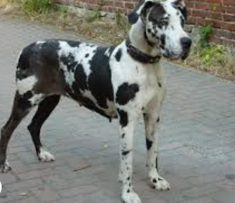
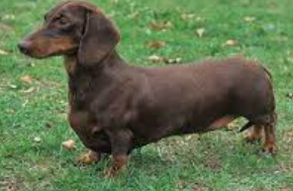
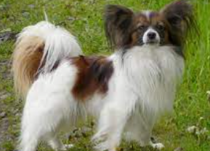
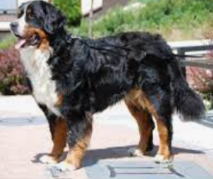
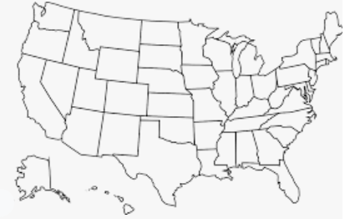
Place a on the location of the North Clay FFA Chapter.
What event did the chapter coordinate to raise money for a service dog for their fellow FFA member?

- Chili cook-off
- Dog supply collection drive
- Basketball tournament
- A fun race for people to run
How long can it take to train a service dog, depending on the need?
- Up to 6 months
- Up to 1 year
- Up to 2 years
- Up to 3 years
Why do you think it takes this long to train a service dog?
How else has the chapter, or Worthey, engaged with and planned to help the SIT Service Dogs group?

- ____________________________________________________________________________
- ____________________________________________________________________________
Directions:
Use the American Kennel Club (AKC) website, https://www.akc.org/expert-advice/training/service-dog-training-101/, to complete the following activities.
Circle the dog(s) below that are specifically mentioned by the AKC as beneficial dogs for the service animal industry. Place an X through the dog(s) that are not specifically mentioned.
What are three qualities a dog must have to be considered for a service animal training program?

1. ______________________________________
2. ______________________________________
3. ______________________________________
Why do you think there is such a large variety of dogs that are recommended by the AKC for service positions?

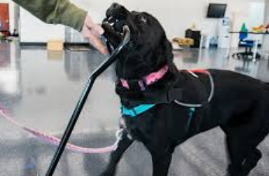
What are three qualities that would not make for a good service animal?

- ____________________________________
- ____________________________________
- ____________________________________
Why are these “must-have” qualities good for a service dog? Why would the “not-so-good” qualities be a problem for a service dog?

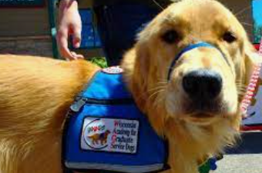

Part 2:
Directions: Using the SIT Service Dogs website,
https://www.sitservicedogs.com/, complete the following activities.
What types of service dogs are trained/provided by SIT Service Dogs?

- ___________________________________
- ___________________________________
- ___________________________________
- ___________________________________
Circle the type of service dog Worthey (from the article you read) is waiting for.
Can the same breeds of dogs be used for all four of these different types of service needs? Why or why not?

Directions:
Read each of the descriptions below and determine which type of service the dog has been trained to perform. Be sure to explain why you selected the service that you did.

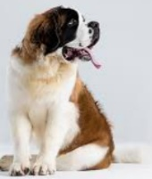
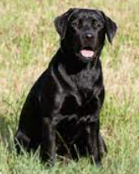
This is Maxine. She is an 8lb toy poodle that is very intelligent and has a very powerful nose. She is very good at getting the attention of her owner. What type of service might she have been trained for? Why?
This is Roman. He is a Saint Bernard and weighs 152lbs. He is very strong and can pull and sit still to assist his owner with movement. What type of service might he have been trained for? Why?
This is Marco. He is a 65lb Labrador retriever and very talented at keeping his friends safe. He has even been known to help when a person may be having a tough time standing. What type of service might he have been trained for? Why?

In your own words, describe what role service dogs play in society.

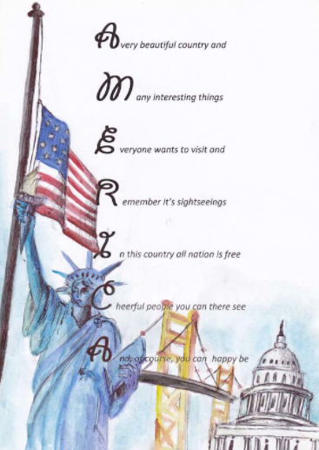

Part 3:
Directions:
Develop an acrostic poem to describe why service dogs are so important to society. An acrostic poem uses a word, in this case “Service Animal,” and has a statement that starts with each letter in the word.
S
E
R
V
I
C
E

A
N
I
M
A
L
KEY: Appendix 4: Lifesaving Labrador
Aligned to the following standards:
FFA.PL-F; FFA.PG-I; FFA.PG-J; FFA.CS-N; FFA.CS-P; CCSS.RI.9-10.2; CCSS.RI.9-10.3; CCSS.RI.9-10.4; CCSS.W.9-10.4; CRP.04; CRP.06; CRP.08
Part 1
Directions:
Read the article “Lifesaving Labrador” in the fall 2021 FFA issue of FFA New Horizons and complete the following activities.
Place a on the location of the North Clay FFA Chapter.
What event did the chapter coordinate to raise money for a service dog for their fellow FFA member?

- Chili cook-off
- Dog supply collection drive
- Basketball tournament
- A fun race for people to run
How long can it take to train a service dog, depending on the need?
- Up to 6 months
- Up to 1 year
- Up to 2 years
- Up to 3 years
Why do you think it takes this long to train a service dog?
Answers will vary.
How else has the chapter, or Worthey, engaged with and planned to help the SIT Service Dogs group?

- Hosted a donation drive
- Volunteer

Directions:
Use the American Kennel Club (AKC) website, https://www.akc.org/expert-advice/training/service-dog-training-101/, to complete the following activities.
Circle the dog(s) below that are specifically mentioned by the AKC as beneficial dogs for the service animal industry. Place an X through the dog(s) that are not specifically mentioned.
What are three qualities a dog must have to be considered for a service animal training program? Answers will vary.
1. Be alert, but not reactive
2. Have a willingness to learn
3. Be calm, especially in unfamiliar settings
Why do you think there is such a large variety of dogs that are recommended by the AKC for service positions? Answers will vary.

What are three qualities that would not make for a good service animal? Answers will vary.
- Easily distracted
- Becomes overly excited and loses focus
- Cannot perform repetitive tasks
Why are these “must-have” qualities good for a service dog? Why would the “not-so-good” qualities be a problem for a service dog?
Answers will vary.

Part 2:
Directions: Using the SIT Service Dogs website,
https://www.sitservicedogs.com/, complete the following activities.

What types of service dogs are trained/provided by SIT Service Dogs?

- Seizure response
- Mobility assistance
- Medical alert
- Traumatic Brain Injury/Neurological
Circle the type of service dog Worthey (from the article you read) is waiting for.
Can the same breeds of dogs be used for all four of these different types of service needs? Why or why not? No. Different breeds will be more successful in some areas than others. Example: a toy poodle would be too small to help a full-size adult to stand. However, a toy poodle may be skilled enough to help someone that is diabetic with blood sugar issues.

Directions:
Read each of the descriptions below and determine which type of service the dog has been trained to perform. Be sure to explain why you selected the service that you did.
This is Maxine. She is an 8lb toy poodle that is very intelligent and has a very powerful nose. She is very good at getting the attention of her owner. What type of service might she have been trained for? Why? Medical alert. Could smell fluctuations in a person. Example: oxygen, blood sugar
This is Roman. He is a Saint Bernard and weighs 152lbs. He is very strong and can pull and sit still to assist his owner with movement. What type of service might he have been trained for? Why? Traumatic brain injury/neurological. Can sit steady to allow a person to use him as a support to stand.
This is Marco. He is a 65lb Labrador retriever and very talented at keeping his friends safe. He has even been known to help when a person may be having a tough time standing. What type of service might he have been trained for? Why? Seizure response. Would be able to catch a person that falls.

