Aligned to the following standards:
FFA.PL-A; FFA.PL-F; FFA.CS-N; ELA.RI.9-10.2; ELA.W.9-10.4; ELA.W.9-10.5; CRP.02; CRP.04; CRP.06

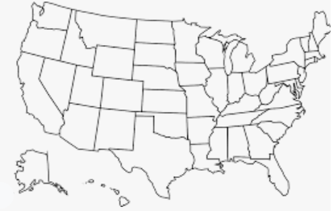


Appendix 4: Swapping Surprises
What state organized the box exchange during National FFA Week in 2021? Color and label the state below.

How many states participated? _______
Chapters were matched based upon their

p______________________.
If you were to do an exchange box, would you want it to be with a group that is similar to what you are used to or different? Why?
Explain the broken crayons that were sent.
How could the “broken crayon” concept help you?
Part 1
Directions:
Read the article “Swapping Surprises” in the spring 2022 issue of FFA New Horizons and
What role could an exchange box have on a student organization? This can be any group, club, team, etc.
complete the following activities as you read.

Part 2
Directions:
Exchange boxes can be a great way to learn more about other states, students and industries. Today, you are going to put together an exchange box that will represent where you live. For your box, you will select three items to describe the agriculture in your area/state (Ex. Indiana is second in popcorn production), three items that represent your state (Ex. An Indy Car to represent the Indianapolis 500) and three items that represent you (Ex. Picture of your pet).







Create a tag to hang on each item to explain why you included the item and the significance.

Create a tag to hang on each item to explain why you included the item and the significance.

Agriculture

- _________________________________

- _________________________________

3. ___________________________________
State

- _________________________________

- _________________________________

3. ___________________________________
You

- _________________________________

- _________________________________

3. ___________________________________
Create a tag to hang on each item to explain why you included the item and the significance.
Be creative with your message. Be sure to decorate each of your tags!
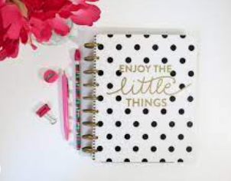
What impact do you think sending an exchange box like this could have on you and your peers?
Part 3
Directions:
In the space below, develop a fun note that you would send with your box. Be sure to include (1) opening instructions, (2) background information about yourself and your group and (3) a kind greeting. Be sure to be creative and decorate your note to make it more personal!

________________________________________________________________________________________________________________________________________________________________________________________________________________________________________________________________________________________________________________________________________________________________________________________________________________________________________________________________________________________________________________________________________________________________________________________________________________________________________________________________________________________________________________________________________________________________________________________________________________________________________________________________________________________________________________________________________________________________________________________________________________________________________________________________________________________________________________________________________________________________________________________________________________________________________________________________________________________________________________________________________________________________________________________________________________________________________________________________________________________________________________________________________________________________________________________________________________________________________________________________________________________________________________________________________________________________________________________________________________________________________________________________________________________________________________
KEY: Appendix 4: Swapping Surprises
What state organized the box exchange during National FFA Week in 2021? Color and label the state below.

How many states participated? 20
Chapters were matched based upon their

preferences.
If you were to do an exchange box, would you want it to be with a group that is similar to what you are used to or different? Why?
Answers will vary.
Explain the broken crayons that were sent.
They served as a reminder that even if you are broken, you are still useful.
How could the “broken crayon” concept help you? Answers will vary.
Missouri
Aligned to the following standards:
FFA.PL-A; FFA.PL-F; FFA.CS-N; ELA.RI.9-10.2; ELA.W.9-10.4; ELA.W.9-10.5; CRP.02; CRP.04; CRP.06
Part 1
Directions:
Read the article “Swapping Surprises” in the spring 2022 issue of FFA New Horizons and
What role could an exchange box have on a student organization? This can be any group, club, team, etc.
Answers will vary.
What role could an exchange box have on a student organization? This can be any group, club, team, etc.
complete the following activities as you read.

Part 2
Directions:
Exchange boxes can be a great way to learn more about other states, students and industries. Today, you are going to put together an exchange box that will represent where you live. For your box, you will select three items to describe the agriculture in your area/state (Ex. Indiana is second in popcorn production), three items that represent your state (Ex. An Indy Car to represent the Indianapolis 500) and three items that represent you (Ex. Picture of your pet).
Answers will vary.
Create a tag to hang on each item to explain why you included the item and the significance.

Create a tag to hang on each item to explain why you included the item and the significance.

Agriculture

- _________________________________

- _________________________________

3. ___________________________________
State

- _________________________________

- _________________________________

3. ___________________________________
You

- _________________________________

- _________________________________

3. ___________________________________
Create a tag to hang on each item to explain why you included the item and the significance.
Be creative with your message. Be sure to decorate each of your tags!
What impact do you think sending an exchange box like this could have on you and your peers? Answers will vary.
Part 3
Directions:
In the space below, develop a fun note that you would send with your box. Be sure to include (1) opening instructions, (2) background information about yourself and your group and (3) a kind greeting. Be sure to be creative and decorate your note to make it more personal! Answers will vary.

________________________________________________________________________________________________________________________________________________________________________________________________________________________________________________________________________________________________________________________________________________________________________________________________________________________________________________________________________________________________________________________________________________________________________________________________________________________________________________________________________________________________________________________________________________________________________________________________________________________________________________________________________________________________________________________________________________________________________________________________________________________________________________________________________________________________________________________________________________________________________________________________________________________________________________________________________________________________________________________________________________________________________________________________________________________________________________________________________________________________________________________________________________________________________________________________________________________________________________________________________________________________________________________________________________________________________________________________________________________________________________________________________________________________________________

