Aligned to the following standards: AS.02; FFA.PL-A; FFA.PL-C; FFA.PL-D; FFA.PL-E; FFA.PL-F; FFA.PG-I; FFA.CS-N; FFA.CS-O; FFA.CS-P; CS.02; AG2; CCSS.ELA.RI.9-10.2; CCSS.ELA.RI.9-10.4; CCSS.W.9-10.4; CCSS.ELA.W.9-10.8; CCSS.SL.9-10.2; MP1; MP6; CRP.02; CRP.04; CRP.07; CRP.08
Appendix 4: Teacher’s Pets
Part 1
Directions:
Read the article “Teacher’s Pets” in the fall 2022 issue of FFA New Horizons. Complete the following activities to learn more.

- Where is the Lexington Technology Center (LTC) located? In the space provided, draw the outline of the state and place a star where the school is located.

- In your own words, describe the purpose of the animal program at LTC.
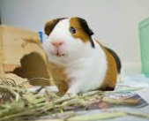

- What group is now a partner with LTC for the small animal project?

H______________________ S_____________________ of S__________ C_____________________

- What is the overall purpose of a local humane society?

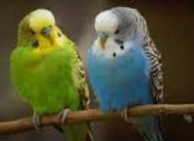
- Where is your local/closest humane society located? Provide the address.

- What life skills can be gained from working with small animals? Give a minimum of three.
(1)

(2)

(3)

  - Select one of the three identified skills above, and describe how this skill would benefit you in your everyday life or in your future career plans/goals.


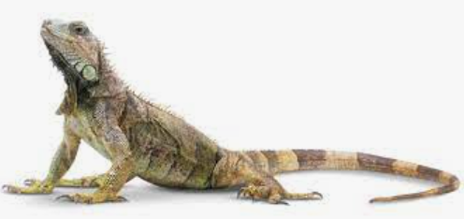
Part 2
Using the American Veterinary Medical Association (AVMA), explore the number of small animals that have homes in the United States. Select two companion animals and three exotic animals and create a bar chart that depicts the total number of households that own small animals in the U.S. Be sure to label everything, including the axis!
Draw an emoji that depicts your thoughts as you look at the statistic you explored from the AVMA.
Directions:
Complete the following activities to learn about small pets, their needs and overall care.

What do these numbers mean for our economy?
Part 3
Directions:
Explore small animals and the care needed through the following activities.

- Select one of the small animals shared on the AVMA.

  - My animal is ___________________________________________________.

- Research to determine the supplies you will need to properly care for the small animal you selected. Include notes from your research in the brainstorm section below.

- Use the Tractor Supply Co. website to explore all the supplies you need to care for the small animal you selected.
  - Be sure to include the following items: housing, bedding, feed and supplements, stimulation (Ex. ball, running wheel, etc.) Note: If you need more space, add another row, and if you have extra rows, place an X in the empty boxes.
Supply total: $_____________________
Supply Needed | Description/Reason | Cost

- In the space provided, draw a picture of the habitat for the animal you selected. Label all the important supplies you identified in Step 3.

- Develop a daily plan to care for the animal you selected in Step 1. Be sure to consider food, water, cleaning and interaction with the pet. Note: If you need more space, add another row, and if you have extra rows, place an X in the empty boxes.
Time | Care Procedure | Why is this necessary?
What is one thing that surprised you as you were learning about your selected animal and developing your supply and care lists?
What is one thing that you learned about yourself while learning about your selected animal?
In one sentence, why is it important to plan prior to adding an animal to your household?
KEY: Appendix 4: Teacher’s Pets
Aligned to the following standards: AS.02; FFA.PL-A; FFA.PL-C; FFA.PL-D; FFA.PL-E; FFA.PL-F; FFA.PG-I; FFA.CS-N; FFA.CS-O; FFA.CS-P; CS.02; AG2; CCSS.ELA.RI.9-10.2; CCSS.ELA.RI.9-10.4; CCSS.W.9-10.4; CCSS.ELA.W.9-10.8; CCSS.SL.9-10.2; MP1; MP6; CRP.02; CRP.04; CRP.07; CRP.08
Part 1
Directions:
Read the article “Teacher’s Pets” in the fall 2022 issue of FFA New Horizons. Complete the following activities to learn more.
- Where is the Lexington Technology Center (LTC) located? In the space provided, draw the outline of the state and place a star where the school is located.
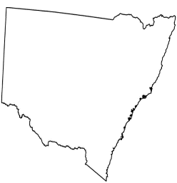

- In your own words, describe the purpose of the animal program at LTC.
Answers will vary.

- What group is now a partner with LTC for the small animal project?

Humane Society of South Carolina

- What is the overall purpose of a local humane society?
A humane society is an organization that looks to maintain animal welfare. Humane societies also work to adopt animals into homes. Many also offer low-cost spay/neuter services.

- Where is your local/closest humane society located? Provide the address.
Answers will vary.

- What life skills can be gained from working with small animals? Give a minimum of three.
- Answers will vary.

(2)

(3)

  - Select one of the three identified skills above and describe how this skill would benefit you in your everyday life or in your future career plans/goals.
Answers will vary.

Part 2
Using the American Veterinary Medical Association (AVMA), explore the number of small animals that have homes in the United States. Select two companion animals and three exotic animals and create a bar chart that depicts the total number of households that own small animals in the U.S. Be sure to label everything, including the axis!
Answers will vary.
Draw an emoji that depicts your thoughts as you look at the statistic you explored from the AVMA.
Answers will vary.
Directions:
Complete the following activities to learn about small pets, their needs and overall care.

What do these numbers mean for our economy? Answers will vary. Example: With large numbers of people owning companion animals, there is a large need for supplies and education to ensure proper care.
Part 3
Directions:
Explore small animals and the care needed through the following activities.

- Select one of the small animals shared on the AVMA.

  - My animal is answers will vary.

- Research to determine the supplies you will need to properly care for the small animal you have selected. Include notes from your research in the brainstorm section below.

Answers will vary.

- Use the Tractor Supply Co. website to explore all the supplies you need to care for the small animal you selected.
  - Be sure to include the following items: housing, bedding, feed and supplements, stimulation (Ex. ball, running wheel, etc.) Note: If you need more space, add another row, and if you have extra rows, place an X in the empty boxes.
Supply total: $_____________________
Supply Needed | Description/Reason | Cost
Answers will vary.

- In the space provided, draw a picture of the habitat for the animal you selected. Label all the important supplies you identified in Step 3. Answers will vary.

- Develop a daily plan to care for the animal you selected in Step 1. Be sure to consider food, water, cleaning and interaction with the pet. Note: If you need more space, add another row, and if you have extra rows, place an X in the empty boxes. Answers will vary.
Time | Care Procedure | Why is this necessary?
What is one thing that surprised you as you were learning about your selected animal and developing your supply and care lists? Answers will vary.
What is one thing that you learned about yourself while learning about your selected animal? Answers will vary.
In one sentence, why is it important to plan prior to adding an animal to your household? Answers will vary.

