Appendix 4: The Ecozone
Directions:
Watch the video “Ecozone: Giving Back to Nature,” https://vimeo.com/309301311, and complete the questions below.
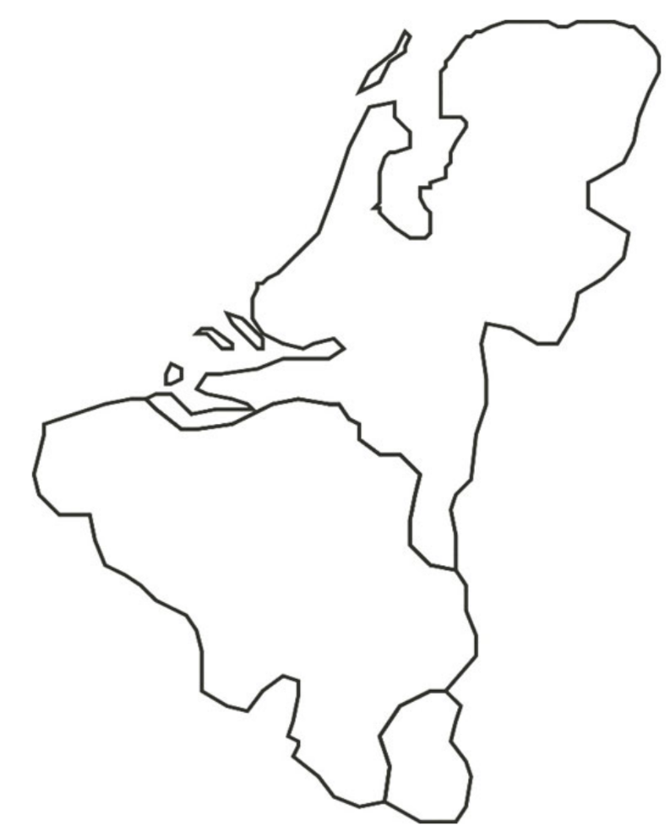
Where did Darling Ingredients study to develop the ecozone?

________________
What did Darling Ingredients study near its factories?
__________________
_________
*Answer each of the questions on the map to the right.
*Shade and outline the country to represent the colors of this country’s flag.
Describe the terms “flora” and “fauna” that are mentioned in the video by drawing visual representations of each.

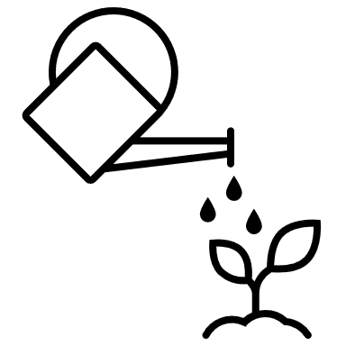

Water is a byproduct retrieved through plant operations. Darling captures this water, then recovers and treats the water from the raw materials. Lastly, the company gives this water back to the environment. Daily, it retrieves 3,600 cubic meters of water and 1.3 million cubic meters per year. Complete the math to convert that to the number of gallons Darling gives back to the environment. (1 cubic meter = 265 gallons)

Amount in Cubic Meters | Conversion to Gallons | Total Gallons Retrieved | Number of Olympic-Size Pools That Could Be Filled
3,600 cubic meters
1,300,000 cubic meters



Darling Ingredients receives an excess of raw materials such as _______________________________________________ that they repurpose into valuable ingredients for __________________________________________________________.

Identify the three major tasks that were completed so that Darling could start giving water back to the environment.

1.

2.

3.

How do the efforts of Darling Ingredients giving back water impact you? ____________________________________
The ecozone brought many new visitors to the area. What did Darling provide for its new visitors?

Who could be found resting at ecozone? Draw and label an example below.
Identify an area near your school that could be turned into an environmentally friendly space like the ecozone.
Location: __________________

Why is this an ideal location?

