Appendix 4: Female Leadership
Aligned to the following standards:
FFA.PL-A; FFA.PL-E; FFA.CS-N; FFA.PG-J; FFA.PL-C; CCSS.ELA.RI.9-10.2; CCSS.ELA.WHST.9-10.4; MP5; MP6; CRP.02; CRP.04
Created: Spring 2019 by the National FFA Organization
Part 1
Directions:
Read the article “Let’s Celebrate Women in FFA!” in the Spring 2019 issue of FFA New Horizons and complete the following activities.

Using the table, compare and contrast the first and most recent female National FFA presidents and their time in office. Things to consider: what was happening during the two different time periods? What did each accomplish in and out of FFA?
 | Jan Eberly, 1982 | Similarities | Breanna Holbert, 2017
 | First female National FFA president | National FFA president | First African American female National FFA president
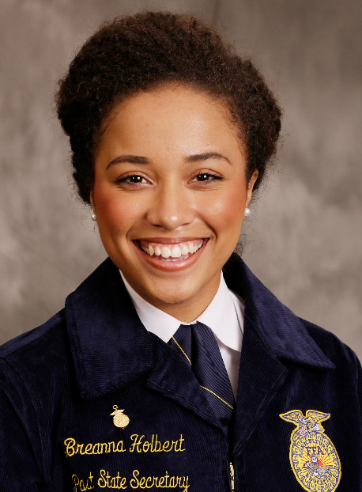
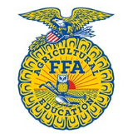
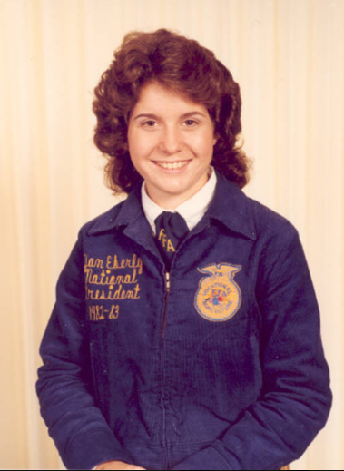

Part 2
Directions:
Aligned to the following standards:
FFA.PL-A; FFA.PL-E; FFA.CS-N; FFA.PG-J; FFA.PL-C; CCSS.ELA.RI.9-10.2; CCSS.ELA.WHST.9-10.4; MP5; MP6; CRP.02; CRP.04
Women not only made strides by being accepted into FFA in 1969, but also had many accomplishments in agriscience. Cut out each picture, name scramble and fact (on the next page). Unscramble each name, then glue the matching picture and name to a blank piece of paper. Next, identify the historical date range and accomplishment of each scientist and glue them next to the picture. (There will be one historical date range and one accomplishment for each picture).

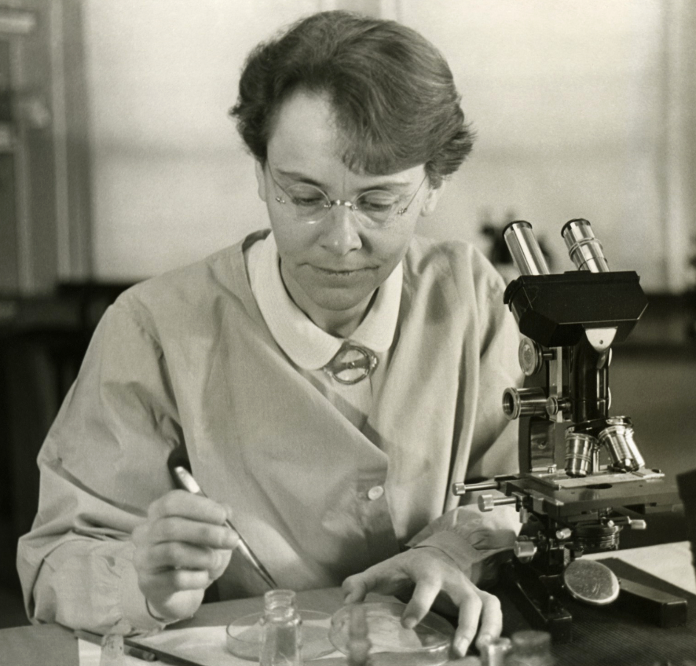
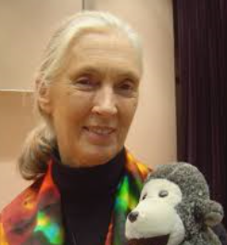
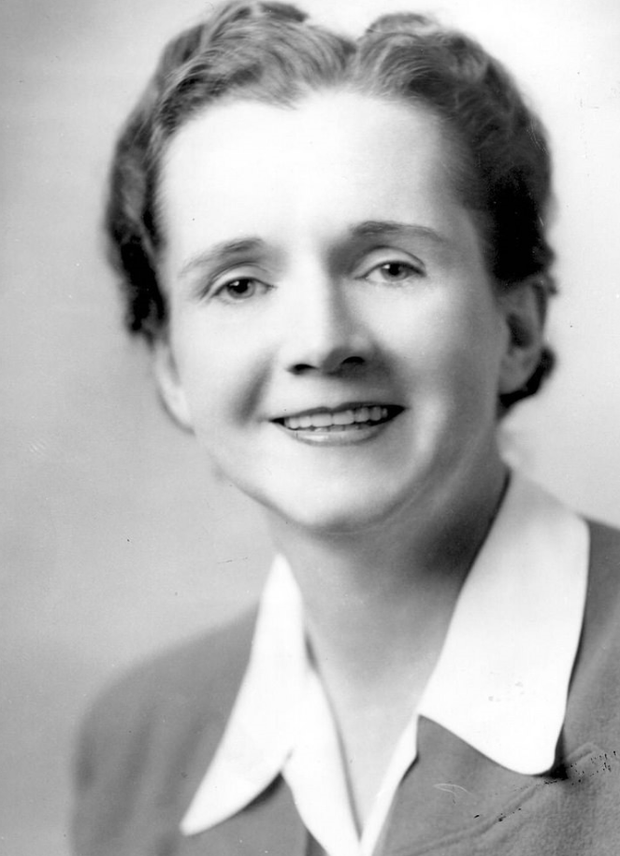

RABRAAB KCMCCINLTO
___ ___ ___ ___ ___ ___ ___

___ ___ ___ ___ ___ ___ ___ ___ ___ ___ ___
NEJA ALLGDOO
___ ___ ___ ___

___ ___ ___ ___ ___ ___ ___
LAHCER RASONC
___ ___ ___ ___ ___ ___

___ ___ ___ ___ ___ ___

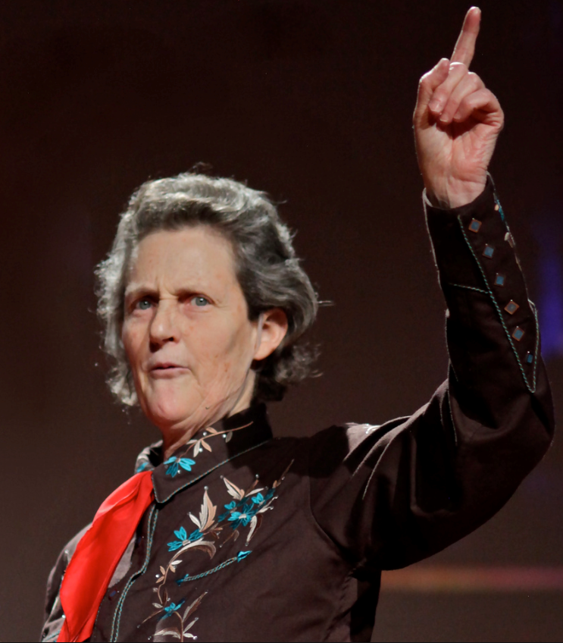
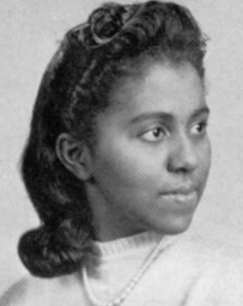
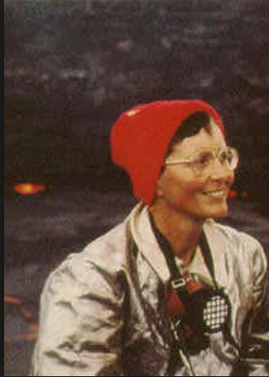

ATKAI FFTRAK
___ ___ ___ ___ ___

____ ____ ____ ____ ____ ____
TPMLEE NGANDRI
___ ___ ___ ___ ___ ___

___ ___ ___ ___ ___ ___ ___
IEARM YDLA
___ ___ ___ ___ ___

____ ____ ____ ____

Scientific Accomplishment
Known for her work in animal behavior. She has worked to find and implement more humane methods of slaughtering livestock.
Known for working and living with chimpanzees to better understand their behavior. She brought light to animal rights and behavior.
Among the first to photograph and film volcanoes and their eruptions.
Known for writing Silent Spring and bringing attention to chemical use in the agriculture industry.
A chemist that studied the impact of foods on health through chemistry.
A geneticist that studied cells in corn. Won the Nobel Peace Prize for her work.
Dates in History
1921–2003
1907–1964
1947–present
1902–1992
1934–present
1942–1991
Name Word Bank
Jane Goodall
Temple Grandin
Katia Krafft
Barbara McClintock
Rachel Carson
Maria Daly
Aligned to the following standards:
FFA.PL-A; FFA.PL-E; FFA.CS-N; FFA.PG-J; FFA.PL-C; CCSS.ELA.RI.9-10.2; CCSS.ELA.WHST.9-10.4; MP5; MP6; CRP.02; CRP.04
Aligned to the following standards:
FFA.PL-A; FFA.PL-E; FFA.CS-N; FFA.PG-J; FFA.PL-C; CCSS.ELA.RI.9-10.2; CCSS.ELA.WHST.9-10.4; MP5; MP6; CRP.02; CRP.04



Part 3
Aligned to the following standards:
FFA.PL-A; FFA.PL-E; FFA.CS-N; FFA.PG-J; FFA.PL-C; CCSS.ELA.RI.9-10.2; CCSS.ELA.WHST.9-10.4; MP5; MP6; CRP.02; CRP.04
Directions:
Option #1: Select a noteworthy female scientist in a field of study in which you have a personal interest and outline her accomplishments below. Draw a picture of the individual in the box.

Option #2: Select an impactful female member of your community and outline her accomplishments below. Draw a picture of the individual in the box.
Draw and color a picture of the person you selected.

What is this person’s major accomplishment(s)?

Why did you select this person?

What can you learn from this person and apply to your own life to be successful?
KEY — Appendix 4: Female Leadership
Aligned to the following standards:
FFA.PL-A; FFA.PL-E; FFA.CS-N; FFA.PG-J; FFA.PL-C; CCSS.ELA.RI.9-10.2; CCSS.ELA.WHST.9-10.4; MP5; MP6; CRP.02; CRP.04
Created: Spring 2019 by the National FFA Organization
Part 1
Directions:
Read the article “Let’s Celebrate Women in FFA!” in the Spring 2019 issue of FFA New Horizons and complete the following activities.

Using the table, compare and contrast the first and most recent female National FFA presidents and their time in office. Things to consider: what was happening during the two different time periods? What did each accomplish in and out of FFA? Answers will vary. Some examples are below.

 | Jan Eberly, 1982 | Similarities | Breanna Holbert, 2017
 | First female National FFA president | Female National FFA president | First African American female National FFA president
 | Ronald Reagan was president of the United States. | Male president of the United States | Donald Trump is president of the United States.
 | Emblem said Vocational Agriculture. | Both include education in agriculture | Emblem reads Agricultural Education.
 | From Fallbrook, Calif. | From California | From Lodi-Tokay, Calif.
 | California FFA president | Both California state officers | California FFA secretary.
 | University of California-Davis | Both attended college in California | California State University-Chico

Part 2
Aligned to the following standards:
FFA.PL-A; FFA.PL-E; FFA.CS-N; FFA.PG-J; FFA.PL-C; CCSS.ELA.RI.9-10.2; CCSS.ELA.WHST.9-10.4; MP5; MP6; CRP.02; CRP.04
Directions:
Women not only made strides by being accepted into FFA in 1969, but also had many accomplishments in agriscience. Cut out each picture, name scramble and fact (on the next page). Unscramble each name, then glue the matching picture and name to a blank piece of paper. Next, identify the historical date range and accomplishment of each scientist and glue them next to the picture. (There will be one historical date range and one accomplishment for each picture).

Barbara McClintock (1902–1992): A geneticist that studied cells in corn. Won the Nobel Peace Prize for her work.

Jane Goodall (1934–present): Known for working and living with chimpanzees to better understand their behavior. She brought light to animal rights and behavior.
Rachel Carson (1907–1964):
Known for writing Silent Spring
and bringing attention to chemical
use in the agriculture industry.

Katia Krafft (1942–1991): Among the first to photograph and film volcanoes and their eruptions.

Temple Grandin (1947–present): Known for her work in animal behavior. She has worked to find and implement more humane methods of slaughtering livestock.

Maria Daly (1921–2003): A chemist who studied the impact of foods on health through chemistry.

