Appendix 5: I Can Grow Food Without Soil?
Aligned to the following standards:
CS.02; CS.04; FFA.PL-A; FFA.PL-F; FFA.PG-J; AG2; AGC10.04; CCSS.RI.9-10.4; CCSS.SL.9-10.2; MP2; MP5; MP6; CRP.02; CRP.04; CRP.05; CRP.06; CRP.07; CRP.08

Created: Winter 2018 by the National FFA Organization
Directions:
Watch the video “Hydroponics—A Short Introduction” and complete the following activities. The video is available at https://youtu.be/Y7cGd0JHrs4.

HYDROPONICS
Ponos
Hydro

(Draw a picture)
What do plants rely on instead of soil?
(Hint: It is found in the water.)
What are the benefits of replacing soil? Circle all that apply.

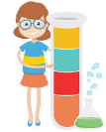

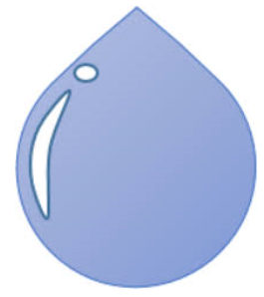
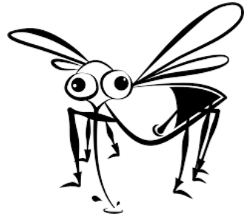

More Disease
Less Disease
Less Water Used
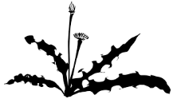
More Water Used

What is conventional farming? ____________________________________________________________________________________________________________________________________________________

Compare and contrast hydroponics and conventional farming in three sentences or more. _____________________________________________________________________________________________________________________________________________________________________________________________________________________________________________________________________________________________________________________________________________________________________________________________________________________________________________________________________________________________________________________________________________________________________________________________________________________________________________________________________________________________________________________
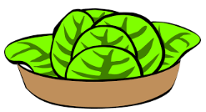
Describe why hydroponics can be such a powerful resource for food production.
________________________________________________________________________________________________________________________________________________________________________________________________________________________________________________________________________________________________________________________________________________________________________________________________________________________________________________________________________________________________________________________________________________________________________________________________

Appendix 6: Climb out of the Box … or Is It In?
Aligned to the following standards:
CS.02; CS.04; FFA.PL-A; FFA.PL-F; FFA.PG-J; AG2; AGC10.04; CCSS.RI.9-10.4; CCSS.SL.9-10.2; MP2; MP5; MP6; CRP.02; CRP.04; CRP.05; CRP.06; CRP.07; CRP.08

Directions:
Read the article “Out-of-the-Box Agriculture” in the Winter 2018 issue of FFA New Horizons. Once finished, complete the following activities.

Bryan High School took advantage of the materials and resources they had to create and develop a hydroponic system that works for them. Utilizing the website https://www.greenandvibrant.com/hydroponic-gardening, design a hydroponic system that would work at your school.

- Type of system: ___________________________________________________________________
  - Why?

- Where will this system be housed at your school? ________________________________________

- Growing media selected: ___________________________________________________________
  - Why?

- pH needed: _____________________

- Grow light selected: ______________________________________________________________
  - Why?

- Select two types of plants to produce: (1) ____________________ and (2) ______________________
  - Why did you select these plants?

- Draw your finished hydroponic system. Include colors and labels.
Appendix 7: Putting Our Knowledge to Work
Aligned to the following standards:
CS.02; CS.04; FFA.PL-A; FFA.PL-F; FFA.PG-J; AG2; AGC10.04; CCSS.RI.9-10.4; CCSS.SL.9-10.2; MP2; MP5; MP6; CRP.02; CRP.04; CRP.05; CRP.06; CRP.07; CRP.08

Directions:
Create your own hydroponic system in a two-liter bottle by following these instructions. You will use the table below to keep track of your plant’s growth.

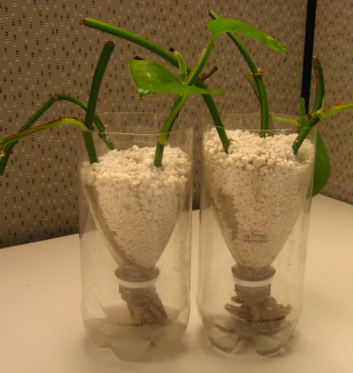
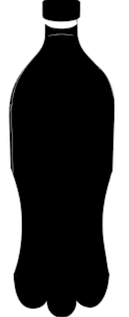
Materials Needed:
- Clean 2-liter bottle
- Growing medium (Ex: perlite)
- Wicking material (felt or cotton material)
- Drill with bit
- Box cutter
- Duct tape
- Seeds (lettuce and herbs do well)
- Aluminum foil
- Warm, sunny environment

Directions:
- Clean your bottle and remove label.
- Drill a hole in the center of the cap.
- Cut the plastic bottle at the “shoulder.”
- Thread your wick through the cap so that it can reach into the top
as well as reach the nutrient solution.
- Mix your nutrient solution, and place it in the bottom of the bottle.
- Flip the top portion of the bottle over and set it in the bottom portion with
the cap inside the lower part (see picture above, next to the materials).
- Add two pieces of duct tape to hold the top and outer wall together if
the plastic is flimsy. You do not want the top to fall into the water below!
- Place growing medium in the top half of the bottle, making sure the
wick is stretched throughout,
- Plant your selected plants in the growing media,
- Wrap aluminum foil around the bottle.
**Original concept adapted from Bottle Biology.

Date | Plant Height | Additional Notes:
What conclusions can you draw about hydroponics after completing this activity? ____________________________________________________________________________________________________________________________________________________________________________________________________________________________________________________________________________________________________________________________________________________________________________________________

KEY — Appendix 5: I Can Grow Food Without Soil?
Aligned to the following standards:
CS.02; CS.04; FFA.PL-A; FFA.PL-F; FFA.PG-J; AG2; AGC10.04; CCSS.RI.9-10.4; CCSS.SL.9-10.2; MP2; MP5; MP6; CRP.02; CRP.04; CRP.05; CRP.06; CRP.07; CRP.08

Created: Winter 2018 by the National FFA Organization
Directions:
Watch the video “Hydroponics—A Short Introduction” and complete the following activities. The video is available at https://youtu.be/Y7cGd0JHrs4.
HYDROPONICS
Ponos
Hydro
The process of growing plants with a medium other than soil.
Water

Work

(Draw a picture)
What do plants rely on instead of soil?
(Hint: It is found in the water.)
What are the benefits of replacing soil? Circle all that apply.

Nutrient Solution

More Disease
Less Disease
Less Water Used
More Water Used

What is conventional farming? Considered to be “traditional” farming that utilizes pesticides, GMOs, etc.

Compare and contrast hydroponics and conventional farming in three sentences or more. _____________________________________________________________________________________________________________________________________________________________________________________________________________________________________________________________________________________________________________________________________________________________________________________________________________________________________________________________________________________________________________________________________________________________________________________________________________________________________________________________________________________________________________________
Describe why hydroponics can be such a powerful resource for food production.
Hydroponics can be utilized in places where conventional/traditional farming cannot take place. Additionally, less pests and weeds are found, and less water is utilized in this type of plant production.

