Aligned to the following standards: FFA. PL-A; FFA.PL-F; FFA.PG-I; FFA.CS-M; FFA.CS-P;CCSS.ELA.W.9-10.2; CCSS.ELA.W.0-10.4; CCSS.ELA.SL.9-10.6; CCSS.ELA.L.9-10.6; CRP.02; CRP.04; CRP.08.
Appendix 5: Advocating for Agriculture
Part 1
Directions:
Read the article “Advocating for Agriculture” in the spring/summer 2025 issue of FFA New Horizons and answer the questions below.

- In the space below, draw the type of ranch that Raylynn Kubik grew up on.

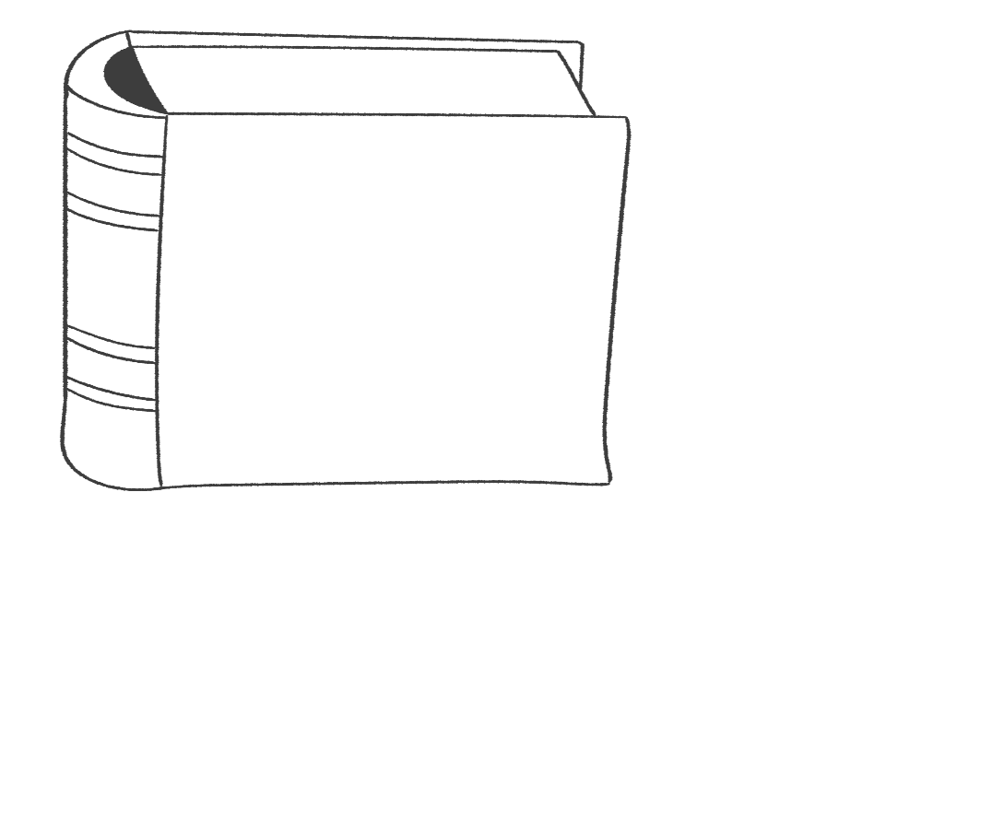
- 3.
During Read Across America Week in March of 2024, how many classrooms did Kubik read to?

What is the main goal of “The Little Sprout”?

- What is one issue that Kubik addresses through her advocacy work in agriculture?

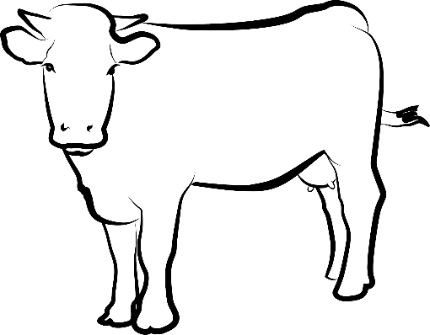

- What surprising fact about Oklahoma does Kubik enjoy sharing with others?

- List two things that the agriculture industry is currently doing to help our nation.

- How does Kubik encourage others to advocate for agriculture within their communities?

- Why do you think advocacy is important? If there were no one advocating for different causes or topics, what do you think would happen?

Part 2
Directions:
Agricultural literacy is important because it helps people understand the value of agriculture and how it impacts their lives, the environment and the economy. For this activity, you are going to create a lesson plan for an elementary class that will help guide you in creating a student activity in Part 3. Additional resources and topic ideas are linked at the bottom of the table.

Lesson Title/ Topic: |  |  | Grade: 1-5 | Date:
Subject:

Central Focus | - What is the central focus for the material covered in this lesson?
State Content Standards | Each state's Department of Education (DOE) website typically provides resources related to the educational standards in place for each grade level and subject area.  Example: AFNR CS.02. Evaluate the nature and scope of the Agriculture, Food & Natural Resources Career Cluster and the role of agriculture, food and natural resources (AFNR) in society and the economy.
Learning Objectives | After completing these activities students will be able to …  - Example: Identify how agriculture impacts their daily lives.
Assessment: Describe how you will assess students’ knowledge.
Type of Assessment  (informal or formal)  Description of the Assessment | Informal assessments (classroom observations, exit slips, quick quizzes, questioning during instruction, etc.) | Formal assessments (tests, exams, etc.)
Instructional Strategies and Learning Tasks: Describe specifically what you and the students will be doing.
How are you going to start your lesson to get students excited about the topic?
Explain how you will introduce and develop students’ understanding of the lesson objectives.

What are three to five vocabulary words students need to understand?

How will you teach these?

Describe how you will adapt the lesson to meet the needs of students with different learning styles and abilities.

Describe how you will assess if students are learning objectives throughout your instruction.

Closure: Explain how you will you end the lesson. Include what assessments or activities (exit tickets) will be used as the lesson ends.
Materials: List the materials, resources, equipment and technology needed for this lesson. Detail what is used by the teacher and what students will use. | Teacher Materials:  Student Materials:
Resources: Include a list of reference websites or additional sources used in this lesson.
Space for Planning: Use this space to brainstorm for your student activity in Part 3. Use the questions below to guide your planning.

What questions will you ask?

What hands-on activity will you create?

What visuals will you use?

Are they working in small groups or individually?

Resources to Help With Lesson Planning: | iCEV, What Is a Lesson Plan, and How Do You Make One? https://www.icevonline.com/blog/what-is-a-lesson-plan  Mrs. Folkenberg edTPA Lesson Plan Example, https://mrsfolkenberg.weebly.com/uploads/2/5/6/0/25609637/learning_segment_.pdf  Stanford University | TeachingWriting — Planning Class Activities, https://teachingwriting.stanford.edu/teaching/planning-class-activities  University of Michigan, Sample Lesson Plan, https://crlt.umich.edu/sites/default/files/instructor_resources/sample_lesson_plans.pdf  University of Michiagn, Stiliana Milkova Center for Research on Learning and Teaching, https://crlt.umich.edu/gsis/p2_5  Yale University, Center for Teaching and Learning | Examples of Active Learning Activities, https://poorvucenter.yale.edu/sites/default/files/basic-page-supplementary-materials-files/section_activities_1.pdf.
Topic Ideas: | Where food comes from, parts of a plant, what plants need to grow, careers in agriculture, pollinators, farm animals, etc.

Part 3
Directions:
After completing your lesson plan in Part 2, use the space below to craft your student worksheet. Please include any additional materials used in your lesson, including presentation materials, visuals and assessments. As a reminder, think about what questions you will ask, what hands-on activity you will create and what visuals you will use, and determine if students are working in small groups or individually.

After completing your lesson planning, please answer the questions below.
- What role does teaching have in advocacy?
- What challenges do you think exist in educating people about agriculture today?
- What was your biggest challenge in executing your lesson?

Aligned to the following standards: FFA. PL-A; FFA.PL-F; FFA.PG-I; FFA.CS-M; FFA.CS-P;CCSS.ELA.W.9-10.2; CCSS.ELA.W.0-10.4; CCSS.ELA.SL.9-10.6; CCSS.ELA.L.9-10.6; CRP.02; CRP.04; CRP.08.
KEY: Appendix 5: Advocating for Agriculture
Part 1
Directions:
Read the article “Advocating for Agriculture” in the spring/summer 2025 issue of FFA New Horizons and answer the questions below.

- In the space below, draw the type of ranch that Raylynn Kubik grew up on.

Cow-calf ranch

- 3.
What is the main goal of “The Little Sprout”?

Agricultural education and literacy
During Read Across America Week in March of 2024, how many classrooms did Kubik read to?

12

- What is one issue that Kubik addresses through her advocacy work in agriculture?
Sharing where food comes from

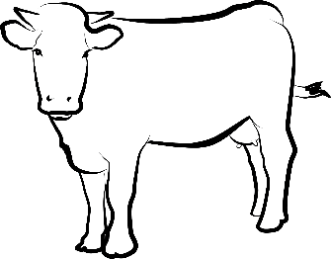

- What surprising fact about Oklahoma does Kubik enjoy sharing with others?
Oklahoma is one of seven states that is home to more cattle than people.

- List two things that the agriculture industry is currently doing to help our nation.
  - Feeding
  - Clothing

- How does Kubik encourage others to advocate for agriculture within their communities?
Research your community’s strengths in agriculture and share these with everyone you meet.

- Why do you think advocacy is important? If there were no one advocating for different causes or topics, what do you think would happen?
Answers will vary.

Part 2
Directions:
Agricultural literacy is important because it helps people understand the value of agriculture and how it impacts their lives, the environment and the economy. For this activity, you are going to create a lesson plan for an elementary class that will help guide you in creating a student activity in Part 3. Additional resources and topic ideas are linked at the bottom of the table.

Lesson Title/ Topic: Answers will vary. |  |  | Grade: 1-5 | Date: Answers will vary.
Subject: Answers will vary.

Central Focus | - What is the central focus for the material covered in this lesson?  Answers will vary.
State Content Standards | Each state's Department of Education (DOE) website typically provides resources related to the educational standards in place for each grade level and subject area.  Example: AFNR CS.02. Evaluate the nature and scope of the Agriculture, Food & Natural Resources Career Cluster and the role of agriculture, food and natural resources (AFNR) in society and the economy.  Answers will vary.
Learning Objectives | After completing these activities, students will be able to …  - Example: Identify how agriculture impacts their daily lives.  - Answers will vary.  - Answers will vary.
Assessment: Describe how you will assess students' knowledge.
Type of Assessment  (informal or formal)  Description of the Assessment | Informal assessments (classroom observations, exit slips, quick quizzes, questioning during instruction, etc.)  Answers will vary. | Formal assessments (tests, exams, etc.)  Answers will vary.
Instructional Strategies and Learning Tasks: Describe specifically what you and the students will be doing.
How are you going to start your lesson to get students excited about the topic? | Answers will vary.
Explain how you will introduce and develop students’ understanding of the lesson objectives. | Answers will vary.
What are three to five vocabulary words students need to understand?  How will you teach these? | Answers will vary.
Describe how you will adapt the lesson to meet the needs of students with different learning styles and abilities. | Answers will vary.
Describe how you will assess if students are learning objectives throughout your instruction. | Answers will vary.
Closure: Explain how you will you end the lesson. Include what assessments or activities (exit tickets) will be used as the lesson ends. | Answers will vary.
Materials: List the materials, resources, equipment and technology needed for this lesson. Detail what is used by the teacher and what students will use. | Teacher Materials:  Student Materials:  Answers will vary.
Resources: Include a list of reference websites or additional sources used in this lesson. | Answers will vary.
Space for Planning: Use this space to brainstorm for your student activity in Part 3. Use the questions below to guide your planning.  What questions will you ask?  What hands-on activity will you create?  What visuals will you use?  Are they working in small groups or individually? | Answers will vary.
Resources to Help With Lesson Planning: | iCEV, What Is a Lesson Plan, and How Do You Make One? https://www.icevonline.com/blog/what-is-a-lesson-plan  Mrs. Folkenberg edTPA Lesson Plan Example, https://mrsfolkenberg.weebly.com/uploads/2/5/6/0/25609637/learning_segment_.pdf  Stanford University | TeachingWriting — Planning Class Activities, https://teachingwriting.stanford.edu/teaching/planning-class-activities  University of Michigan, Sample Lesson Plan, https://crlt.umich.edu/sites/default/files/instructor_resources/sample_lesson_plans.pdf  University of Michigan, Stiliana Milkova Center for Research on Learning and Teaching, https://crlt.umich.edu/gsis/p2_5  Yale University, Center for Teaching and Learning | Examples of Active Learning Activities, https://poorvucenter.yale.edu/sites/default/files/basic-page-supplementary-materials-files/section_activities_1.pdf
Topic Ideas: | Where food comes from, parts of a plant, what plants need to grow, careers in agriculture, pollinators, farm animals, etc.

Part 3
Directions:
After completing your lesson plan in Part 2, use the space below to craft your student worksheet. Please include any additional materials used in your lesson, including presentation materials, visuals and assessments. As a reminder, think about what questions you will ask, what hands-on activity you will create and what visuals you will use, and determine if students are working in small groups or individually.

Answers will vary.

After completing your lesson planning, please answer the questions below.
- What role does teaching have in advocacy? Answers will vary.
- What challenges do you think exist in educating people about agriculture today? Answers will vary.
- What was your biggest challenge in executing your lesson? Answers will vary.

Rubric
Lesson Plan
Criteria | Points Available | Points Received | Comments
Lesson Title/Topic | 1
Grade | 1
Date | 1
Central Focus | 2
State Standards | 4
Learning Objectives | 4
Assessment (Informal/Formal) | 2
Instructional Strategies | 8
Closure | 1
Materials | 1
Total (25)

student Activity Sheet |  |  |  | Comments
Criteria | Below Average  (0–1 points) | Average  (2–3 points) | Above Average  (4–5 points)
Knowledge | Worksheet shows little to no understanding of the topic. | Worksheet shows some understanding of the topic. | Worksheet shows excellent understanding of the topic.
Quality | Worksheet is very low quality with little evidence of effort. | Worksheet shows some effort and is mostly neat. | Worksheet shows excellent effort and is of high quality.
Creativity | Worksheet has little to no creative elements. | Worksheet has some creative elements. | Worksheet is very creative.
Grammar | Difficult to understand due to grammatical errors | Generally clear writing with few grammatical errors | Well written with proper grammar
Instructions | Student did not follow instructions for the task. | Student followed some of the instructions. | Student followed all instructions for the task.
Total (25)
Grand Total: _____/50

