Appendix 5: An Equine Education
Aligned to the following standards:
CS.05; AG5; FFA.PL-A; FFA.PL-C; FFA.PL-E; FFA.PL-F; FFA.CS-M; FFA.CS-N; CCSS.SL.9-10.2; CCSS.WHST.9.10.4; MP5; MP6

Created: Spring 2021 by the National FFA Organization
Part 1
Directions:
Begin reading the article “An Equine Education” in the spring 2021 issue of FFA New Horizons and complete the following activities.
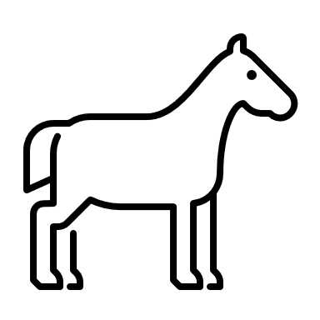
At what age did Erick begin going to the horse stables with his dad?

- 5
- 8
- 11
- 14
What tasks did Erick help his dad perform?

- Riding and loping
- Walking
- Bathing
- Trimming hooves
What career does Erik now want to pursue due to his experiences?

- Veterinary technician
- Veterinarian
- Veterinary assistant
- Zoologist
Equine = ______________________________
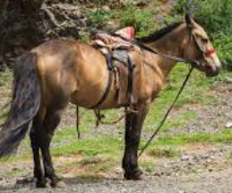
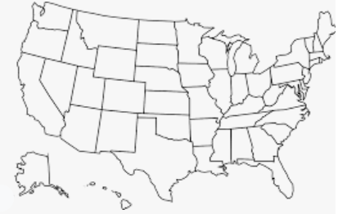

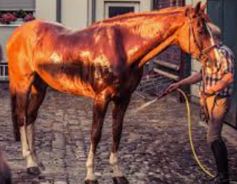
Identify three different supervised agricultural experiences (SAEs) that a student could have within the equine industry. If you need help, use the SAE for All website, https://saeforall.org/.

1.

2.

3.
According to the article, what does the industry struggle to find?

- People that can ride horses
- Skilled workers
- Equine dentists
- Veterinarians
Place a on the “horse capital” of the world.
Describe the economic impact of the horse industry. Check out the American Horse Council.

Think about the state you live in. What is the impact of the horse industry on your state?
Part 2
Directions:
Careers in the equine industry are very diverse. Today, we will look at just three of the opportunities that exist within the industry. Read each career description below and then research the following: education needed, skills required and day-to-day activities of the career.
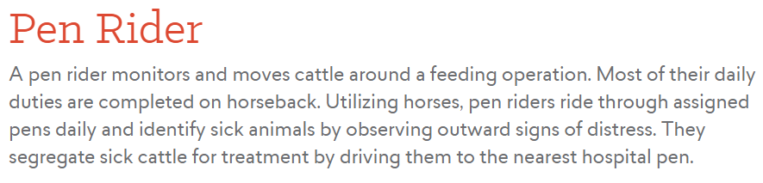
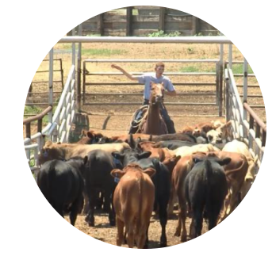
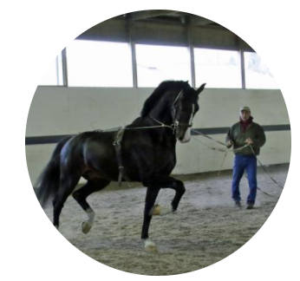
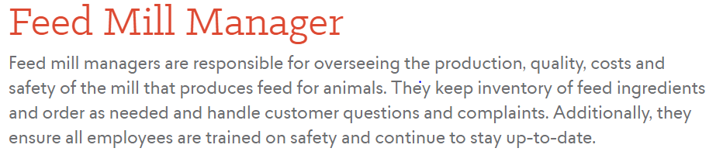
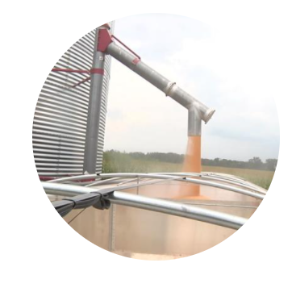

- What education is needed? ________________________

- Identify three skills you would need to be successful in this career.

- What are the day-to-day activities you would do in this career?

In one sentence, how would you describe the equine industry to a friend?
How does the equine industry impact you?
Identify two things that you find most interesting about the equine industry.

1.

2.
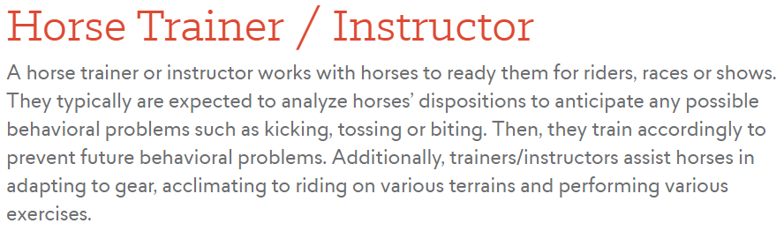
- What education is needed? ________________________
- Identify three skills you would need to be successful in this career.

- What are the day-to-day activities you would do in this career?

- What education is needed? ________________________

- Identify three skills you would need to be successful in this career.

- What are the day-to-day activities you would do in this career?
KEY — Appendix 5: An Equine Education
Aligned to the following standards:
CS.05; AG5; FFA.PL-A; FFA.PL-C; FFA.PL-E; FFA.PL-F; FFA.CS-M; FFA.CS-N; CCSS.SL.9-10.2; CCSS.WHST.9.10.4; MP5; MP6

Created: Spring 2021 by the National FFA Organization
Part 1
Directions:
Begin reading the article “An Equine Education” in the spring 2021 issue of FFA New Horizons and complete the following activities.
At what age did Erick begin going to the horse stables with his dad?

- 5
- 8
- 11
- 14
What tasks did Erick help his dad perform?

- Riding and loping
- Walking
- Bathing
- Trimming hooves
What career does Erik now want to pursue due to his experiences?

- Veterinary technician
- Veterinarian
- Veterinary assistant
- Zoologist
Equine = Horse
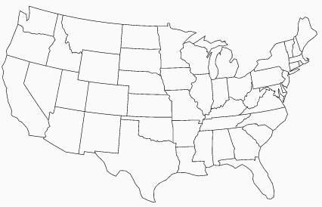
Identify three different supervised agricultural experiences (SAEs) that a student could have within the equine industry. If you need help, use the SAE for All website, https://saeforall.org/. Answers will vary.

1.

2.

3.
According to the article, what does the industry struggle to find?

- People that can ride horses
- Skilled workers
- Equine dentists
- Veterinarians
Describe the economic impact of the horse industry. Check out the American Horse Council.

- There are about 7.2 million horses in the U.S.
- Recreation has the largest number of horses associated.
- Texas is No. 1 in estimated number of horses.
- California is No. 2 in estimated number of horses.

Think about the state that you live in. What is the impact of the horse industry on your state? Answers will vary.
Place a on the “horse capital” of the world.
Part 2
Directions:
Careers in the equine industry are very diverse. Today, we will look at just three of the opportunities that exist within the industry. Read each career description below and then research the following: education needed, skills required and day-to-day activities of the career.
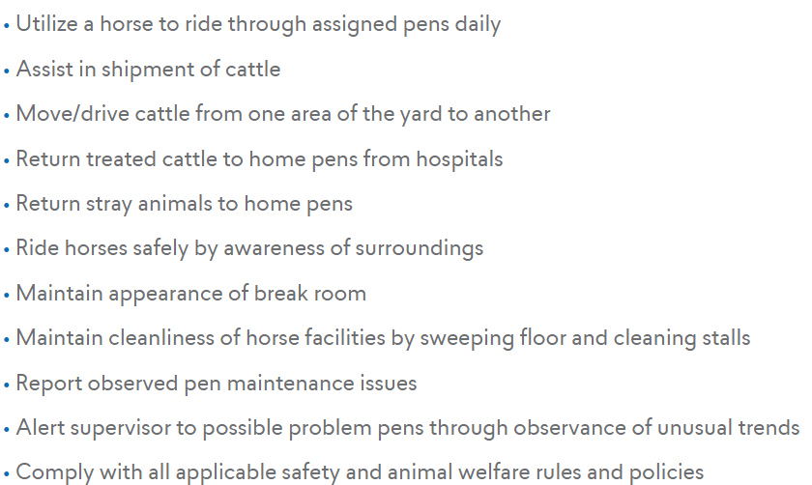
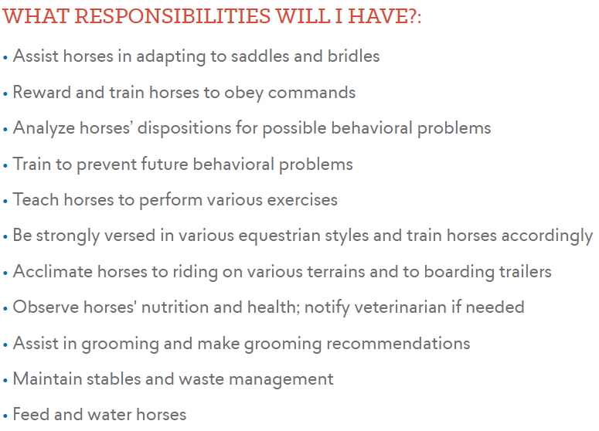
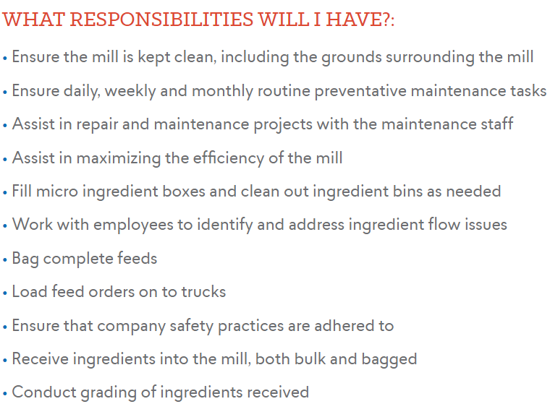
- What education is needed? Associate degree and certifications
- Identify three skills you would need to be successful in this career. Answers will vary.

- What education is needed? Bachelor’s in feed grain science

- Identify three skills you would need to be successful in this career. Answers will vary.

- What education is needed? High school diploma and experience.
- Identify three skills you would need to be successful in this career. Answers will vary.

In one sentence, how would you describe the equine industry to a friend? Answers will vary.
How does the equine industry impact you? Answers will vary.
Identify two things that you find most interesting about the equine industry. Answers will vary.

1.

2.

