Appendix 5: Ag 101
Aligned to the following standards:
FFA.PL-C.; FFA.PL-D.; FFA.PL-F.; FFA.PG-J.; FFA.CS-M.; FFA.CS-N.; FFA.CS-O.; CCSS.RI.9-10.4;
CCSS.W.9-10.2; CCSS.W.9-10.4; CCSS.SL.9-10.4; CRP.04; CRP.06, MP1, MP2, MP6

Created: Spring 2019 by the National FFA Organization

Directions:
Read the article “Ag 101 — 9 Moneymaking Ways to Diversify” in the Spring 2019 issue of FFA New Horizons. Complete the activities below.

Part 1
Divide into groups. In your group, brainstorm a product or business concept that can be used in your school and/or community that will help solve a problem or need. The product/business concept must connect to agriculture.
Career Focus Areas:
Agribusiness Systems, Animal Systems, Biotechnology Systems, Environmental Service Systems, Food Products and Processing Systems, Natural Resources Systems, Plant Systems, Power Structural and Technical Systems & Agricultural Educaiton
Choose a career focus area for your product/business. Choose from these options:



What is the use of the product or purpose of the business?
What are your ideas for the product or business that would fit in your chosen career pathway?
How will this product or business benefit your school and/or community?

Aligned to the following standards:
FFA.PL-C.; FFA.PL-D.; FFA.PL-F.; FFA.PG-J.; FFA.CS-M.; FFA.CS-N.; FFA.CS-O.; CCSS.RI.9-10.4;
CCSS.W.9-10.2; CCSS.W.9-10.4; CCSS.SL.9-10.4; CRP.04; CRP.06, MP1, MP2, MP6


Part 2
Complete a business proposal by answering the questions below (taken from a portion of the agricultural marketing plan career development event). Reference the rubric to guide you through the process.

1. Create a mission statement for your business/product. (Visit this website to see examples of mission statements for various non-profit organizations: https://topnonprofits.com/mission-vision-statements/)

2. Who is the target market/audience?

3. Create goals for this product/business concept. Reference this website, https://www.smartsheet.com/blog/essential-guide-writing-smart-goals, for examples.


Short-term Goals (Must have at least 2): Long-term Goals (Must have at least 2):

Aligned to the following standards:
FFA.PL-C.; FFA.PL-D.; FFA.PL-F.; FFA.PG-J.; FFA.CS-M.; FFA.CS-N.; FFA.CS-O.; CCSS.RI.9-10.4;
CCSS.W.9-10.2; CCSS.W.9-10.4; CCSS.SL.9-10.4; CRP.04; CRP.06, MP1, MP2, MP6

List the components of the product/business and the cost for EACH.

Product/Business Component | Price per unit | Total
 | Total:

4.Total Price of product/business concept:
$

5. Location: Where do you plan to sell this product/business concept?



Why did you choose this location to sell your product?

6. Promotion: Use the space below to create a promotional material of your choice (social media plan, brochure, flyer, etc.) to promote your product. (Include name of product, picture, price, etc.)

Aligned to the following standards:
FFA.PL-C.; FFA.PL-D.; FFA.PL-F.; FFA.PG-J.; FFA.CS-M.; FFA.CS-N.; FFA.CS-O.; CCSS.RI.9-10.4;
CCSS.W.9-10.2; CCSS.W.9-10.4; CCSS.SL.9-10.4; CRP.04; CRP.06, MP1, MP2, MP6

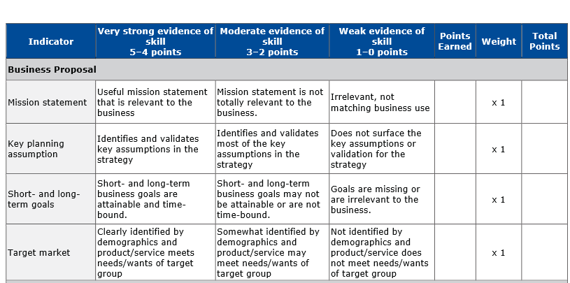
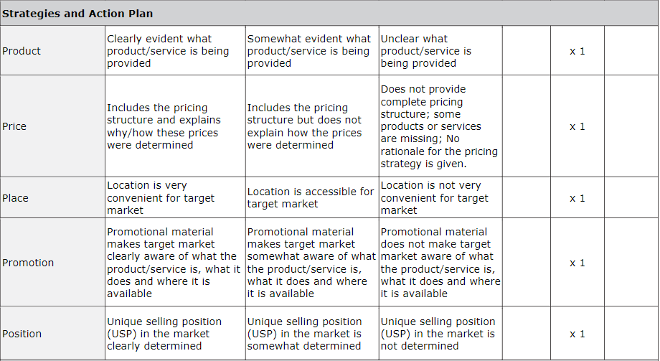
(The above rubric is taken from the National FFA Marketing Plan Career Development Event 2017–2021 Handbook. Access the handbook directly by visiting FFA.box.com/s/ihquogqlau5nesazrffzmmz4hz2nqmtk.)

