Appendix 5: Convincing Cotton Cynics
Aligned to the following standards:
FFA. PL-A;FFA.PL-C.; FFA.PL-D.;FFA.PL-E; FFA.PG-J.;FFA.CS-M.; FFA.CS-N.; FFA.CS-O; CCSS.RI.9-10.2;CCSS.RI.9-10.4; CCSS.W.9-10.2; CCSS.W.9-10.4; CCSS.ELA.WHST.9.10.4;CCSS.SL.9-10.4;CCSS.ELA.W.9-10.4 CRP.02; CRP.04
Created: Summer 2019 by the National FFA Organization
Directions:
Part 1
Read “Convincing Cotton Cynics” in the Summer 2019 issue of FFA New Horizons. Answer the questions below.

1. Circle the items made with cotton and cotton by-products.
2. How many acres of cotton did Garrett start with?
3. How many acres does Garrett currently have?
4. What happened to his first crop?
6. What has Garrett learned from producing cotton?
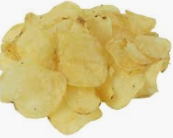
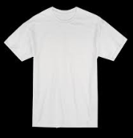

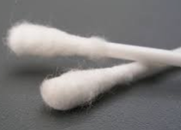

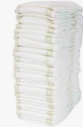




1. Look around your classroom. Identify 5 items produced from cotton.

5. “Growing cotton not only has been a ____________ ________________ _______________ (_____) project for me, but also has been a way for me to ____________ an ______________after it’s been ____________ and ______________.

7. How does cotton production affect your daily life?
Part 2
Aligned to the following standards:
FFA. PL-A;FFA.PL-C.; FFA.PL-D.;FFA.PL-E; FFA.PG-J.;FFA.CS-M.; FFA.CS-N.; FFA.CS-O; CCSS.RI.9-10.2;CCSS.RI.9-10.4; CCSS.W.9-10.2; CCSS.W.9-10.4; CCSS.ELA.WHST.9.10.4;CCSS.SL.9-10.4;CCSS.ELA.W.9-10.4 CRP.02; CRP.04
directions:
Reference this website, https://kids.kiddle.co/Cotton, to answer the questions below.

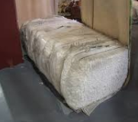
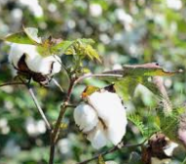

Aligned to the following standards:
FFA. PL-A;FFA.PL-C.; FFA.PL-D.;FFA.PL-E; FFA.PG-J.;FFA.CS-M.; FFA.CS-N.; FFA.CS-O.; CCSS.RI.9-10.2;CCSS.RI.9-10.4;
CCSS.W.9-10.2; CCSS.W.9-10.4; CCSS.ELA.WHST.9.10.4;CCSS.SL.9-10.4;CCSS.ELA.W.9-10.4 CRP.02; CRP.04

1. Describe the machines used to harvest cotton.
3. Describe the strength of cotton fibers.
2. What is the process after cotton is harvested?
4. What happens to the cottonseed after it is removed?

Aligned to the following standards:
FFA. PL-A;FFA.PL-C.; FFA.PL-D.;FFA.PL-E; FFA.PG-J.;FFA.CS-M.; FFA.CS-N.; FFA.CS-O.; CCSS.RI.9-10.2;CCSS.RI.9-10.4;
CCSS.W.9-10.2; CCSS.W.9-10.4; CCSS.ELA.WHST.9.10.4; CCSS.SL.9-10.4; CCSS.ELA.W.9-10.4 CRP.02; CRP.04

To further learn about cotton production, watch The Story of Cotton and answer the questions below. The video URL is https://www.youtube.com/watch?v=AAUQNMldp_Y. While watching the video, focus on the steps from planting to the finished product, flower of the cotton plant and how farmers know when it is time to harvest. If YouTube is blocked, read this article (or one similar), “Cotton is a Miracle of Nature,” to answer the questions. The URL for the article is http://www.nccotton.org/wp-content/uploads/2012/05/cottonmiraclewebformat.pdf.
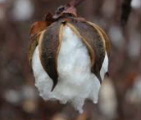
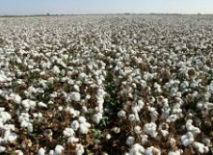
What are 10 cool facts you learned about cotton production while watching the video? List the facts below.
How does a farmer know when it is time for harvest?

Using the facts you listed, write a 2- to 3-sentence summary of the video.

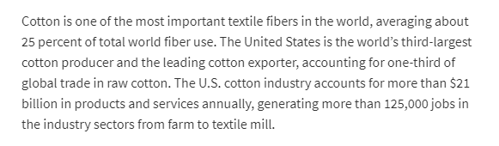
(https://www.ers.usda.gov/topics/crops/cotton-wool/)
Read the passage to the left. How does cotton contribute to the economy?

Aligned to the following standards:
FFA. PL-A;FFA.PL-C.; FFA.PL-D.;FFA.PL-E; FFA.PG-J.;FFA.CS-M.; FFA.CS-N.; FFA.CS-O; CCSS.RI.9-10.2;CCSS.RI.9-10.4; CCSS.W.9-10.2; CCSS.W.9-10.4; CCSS.ELA.WHST.9.10.4;CCSS.SL.9-10.4;CCSS.ELA.W.9-10.4 CRP.02; CRP.04

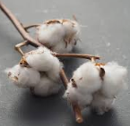

In the labeled areas below, draw a cotton plant and cotton boll and describe each.

Cotton Boll:

Cotton Plant:

Part 3
Aligned to the following standards:
FFA. PL-A;FFA.PL-C.; FFA.PL-D.;FFA.PL-E; FFA.PG-J.;FFA.CS-M.; FFA.CS-N.; FFA.CS-O; CCSS.RI.9-10.2;CCSS.RI.9-10.4; CCSS.W.9-10.2; CCSS.W.9-10.4; CCSS.ELA.WHST.9.10.4;CCSS.SL.9-10.4;CCSS.ELA.W.9-10.4 CRP.02; CRP.04
Directions
Utilize this website, https://www.cotton.org/pubs/cottoncounts/story/where.cfm, to answer the questions below.
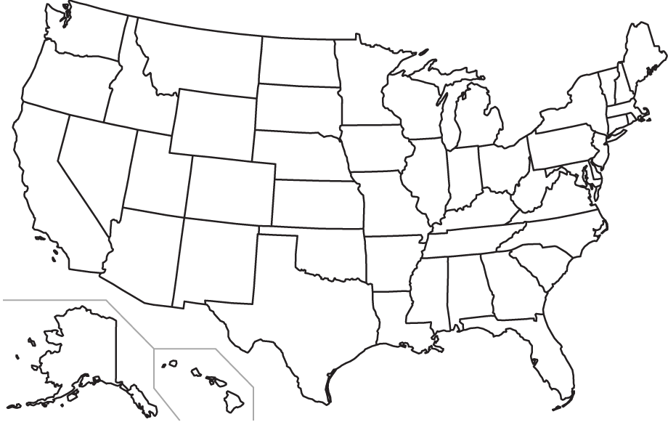
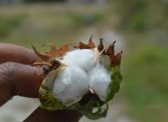
1. What climate can cotton grow in?
2. Why can cotton not be grown in certain climates?
3. What is the average yield for cotton?
What does yield mean?
4. What countries grow most of the world’s cotton?
Color the states/region where cotton is produced in the United States.

Aligned to the following standards:
FFA. PL-A;FFA.PL-C.; FFA.PL-D.;FFA.PL-E; FFA.PG-J.;FFA.CS-M.; FFA.CS-N.; FFA.CS-O; CCSS.RI.9-10.2;CCSS.RI.9-10.4; CCSS.W.9-10.2; CCSS.W.9-10.4; CCSS.ELA.WHST.9.10.4;CCSS.SL.9-10.4;CCSS.ELA.W.9-10.4 CRP.02; CRP.04
KEY — Appendix 5: Convincing Cotton Cynics
Created: Winter 2018 by the National FFA Organization

Directions:
Read “Convincing Cotton Cynics” in the Summer 2019 issue of FFA New Horizons. Answer the questions below.

1. Circle the items made with cotton and cotton by-products.
2. How many acres of cotton did Garrett start with?
Garrett started with 5 acres of cotton on his family’s farm.
3. How many acres does Garrett currently have?
Since he started, his production has grown to 130 acres.
4. What happened to his first crop?
It was hard to find cotton seed to plant, and he ended up using seed from a discarded bag in a local warehouse. His first crop was ruined in a flood.
6. What has Garrett learned from producing cotton?
Producing cotton has taught Garrett that taking chances can really pay off, especially if it is something you have a passion for.
5. “Growing cotton not only has been a supervised agriculture experience (SAE) project for me, but also has been a way for me to generate an income after it’s been ginned and graded.

1. Look around your classroom. Identify 5 items produced from cotton.
Answers will vary.

7. How does cotton production affect your daily life?
Answers will vary.
Part 2
Aligned to the following standards:
FFA. PL-A;FFA.PL-C.; FFA.PL-D.;FFA.PL-E; FFA.PG-J.;FFA.CS-M.; FFA.CS-N.; FFA.CS-O; CCSS.RI.9-10.2;CCSS.RI.9-10.4; CCSS.W.9-10.2; CCSS.W.9-10.4; CCSS.ELA.WHST.9.10.4;CCSS.SL.9-10.4;CCSS.ELA.W.9-10.4 CRP.02; CRP.04
directions:
Reference this website, https://kids.kiddle.co/Cotton, to answer the questions below.

1. Describe the machines used to harvest cotton.
Cotton picker – removes the cotton from the boll without damaging the cotton plant.

Cotton stripper – strips entire boll off the plant.
3. Describe the strength of cotton fibers.
A single fiber is not terribly strong. However, when multiple curling fibers are straightened and twisted together, they form a strong, smooth thread that can be knitted, woven or dyed.
2. What is the process after it is harvested?

Cotton must be combed to remove the seeds. This was labor intensive until the invention of the cotton gin. The cotton gin quickly separates the seeds from fiber and combs them for spinning.
4. What happens to the cottonseed after it is removed?
The cottonseed that remains after the cotton is ginned is used to produce cottonseed oil, and after refining, it can be consumed by humans. The cottonseed meal that is left is usually fed to livestock.

To further learn about cotton production, watch The Story of Cotton and answer the questions below. The video URL is https://www.youtube.com/watch?v=AAUQNMldp_Y. While watching the video, focus on the steps from planting to the finished product, flower of the cotton plant and how farmers know when it is time to harvest. If YouTube is blocked, read this article (or one similar), “Cotton is a Miracle of Nature,” to answer the questions. The URL for the article is http://www.nccotton.org/wp-content/uploads/2012/05/cottonmiraclewebformat.pdf.
Aligned to the following standards:
FFA. PL-A;FFA.PL-C.; FFA.PL-D.;FFA.PL-E; FFA.PG-J.;FFA.CS-M.; FFA.CS-N.; FFA.CS-O.; CCSS.RI.9-10.2;CCSS.RI.9-10.4;
CCSS.W.9-10.2; CCSS.W.9-10.4; CCSS.ELA.WHST.9.10.4; CCSS.SL.9-10.4; CCSS.ELA.W.9-10.4 CRP.02; CRP.04

What are 10 cool facts you learned about cotton production while watching the video? List the facts below.
Answers will vary.
How does a farmer know when it is time for harvest?
When the plant leaves are dried and a sea of white surrounds the farmer. (~3:39 mark)
Using the facts you listed, write a 2- to 3-sentence summary of the video.
Answers will vary.

(https://www.ers.usda.gov/topics/crops/cotton-wool/)
Read the passage to the left. How does cotton contribute to the economy?
The U.S. is the world’s third-largest cotton producer and leading cotton exporter. The U.S. cotton industry accounts for more than $21 billion in products and services annually. This generates more than 125,000 jobs in the industry.

Aligned to the following standards:
FFA. PL-A;FFA.PL-C.; FFA.PL-D.;FFA.PL-E; FFA.PG-J.;FFA.CS-M.; FFA.CS-N.; FFA.CS-O; CCSS.RI.9-10.2;CCSS.RI.9-10.4; CCSS.W.9-10.2; CCSS.W.9-10.4; CCSS.ELA.WHST.9.10.4;CCSS.SL.9-10.4;CCSS.ELA.W.9-10.4 CRP.02; CRP.04

In the labeled areas below, draw a cotton plant and cotton boll and describe each.

Cotton Plant:
This website provides an extensive description of the parts of the cotton plant.
https://www.cottonacres.com/cotton-plant/

Cotton Boll:
This website provides an extensive description of a cotton boll. (6th paragraph)
http://www.cottonsjourney.com/storyofcotton/page3.asp

Part 3
Aligned to the following standards:
FFA. PL-A;FFA.PL-C.; FFA.PL-D.;FFA.PL-E; FFA.PG-J.;FFA.CS-M.; FFA.CS-N.; FFA.CS-O; CCSS.RI.9-10.2;CCSS.RI.9-10.4; CCSS.W.9-10.2; CCSS.W.9-10.4; CCSS.ELA.WHST.9.10.4;CCSS.SL.9-10.4;CCSS.ELA.W.9-10.4 CRP.02; CRP.04
Directions
Utilize this website, https://www.cotton.org/pubs/cottoncounts/story/where.cfm, to answer the questions below.

1. What climate can cotton grow in?
Cotton grows in warm climates.
2. Why can cotton not be grown in certain climates?
Because the climate is not warm enough.
3. What is the average yield for cotton?
1 1/3 bales per acres and about 1,078 pounds of seed.
What does yield mean?
To produce or provide
4. What countries grow most of the world’s cotton?
U.S., Uzbekistan, the People’s Republic of China and India.
Color the states/region where cotton is produced in the United States.
Alabama, Arizona, Arkansas, California, Georgia, Louisiana, Mississippi, Missouri, New Mexico, North Carolina, Oklahoma, South Carolina, Tennessee, Texas, Florida, Kansas, Virginia

