Aligned to the following standards: CS.01; CS.06; FFA.PL-A; FFA.PG-J; FFA.PG-K; FFA.CS-M; FFA.CS-N; FFA.CS-P; CCSS.ELA.RI.9-10.1; CCSS.ELA.RI.9-10.4; CCSS.ELA.W.9-10.1; CCSS.ELA.SL.9-10.1; CCSS.ELA.SL.9-10.4; CCSS.ELA.L.9-10.6; CRP.02; CRP.04; CRP.07; CRP.08
Appendix 6: A Sweet Opportunity
Part 1
Directions: Read the article “A Sweet Opportunity” in the fall/winter 2025 issue of FFA New Horizons and answer the questions below.

Quick Facts About Milton Hershey School (MHS) | 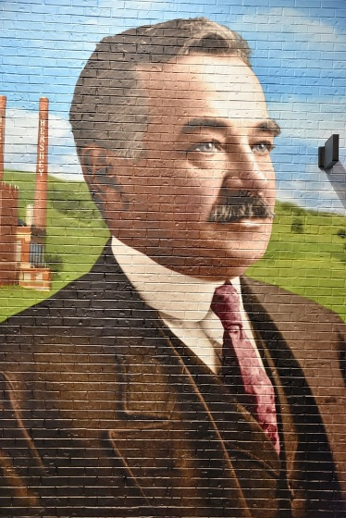
Who founded the school?
When was the school founded?
Where is the school located?
Why was the school created?

- List the four one-of-a-kind centers that are included in the Agricultural and Environmental Education program at MHS.

- List the extracurricular activities that are offered for pre-K through 12th-grade students at MHS. Then circle your top two favorites that interest you.

- Describe the growth in the MHS AEE program and why they believe the growth has happened.

- What are two things that stand out about the experience Kalena Williams-Ross had as a student at MHS?

- What are two things that stand out about the experience Logan Keister had as a student at MHS?

- How does the residential and community setting on the MHS campus support student success?

- Share one way that MHS benefits its surrounding community.

- Why do you think hands-on learning is emphasized at MHS?

- How do you think Milton Hershey’s legacy connects agriculture and education?

- What could other schools learn from MHS about integrating agriculture?

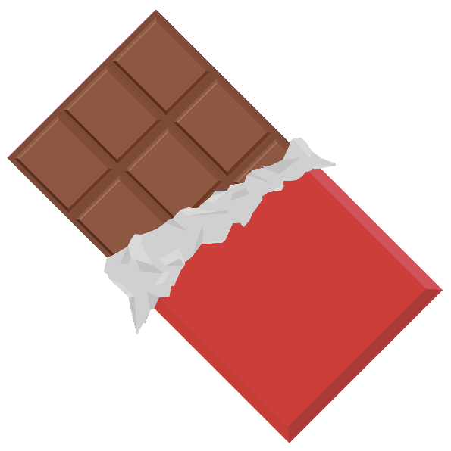

Part 2
Directions: Explore the process of making chocolate and the different ingredients needed for the three main types of chocolate: dark, milk and white. You will be assigned two sections from the chart below to answer. Then you will connect with other students who complete the other sections to learn from them and complete the chart.

Use this website to complete your sections below: https://www.lakechamplainchocolates.com/making-chocolate/

Cacao Cultivation  Draw a picture to match this step, and answer the questions on the right. | - Where does chocolate begin?  - What weather conditions are needed for a cacao  tree?  - What part of the fruits is cacao?  - Explain the difference between “cacao” and “cocoa.”
- What color are ripe cacao pods?  - How often are cacao pods harvested?  - How big are the seeds?  - What is the pulp of the pod called, and how was it used 3,000 years ago? | Harvesting  Draw a picture to match this step, and answer the questions on the left.
Fermentation  Draw a picture to match this step, and answer the questions on the right. | - What is left on the beans to help develop flavor?  - What color do the beans turn once exposed to light?  - What are the two methods of fermentation called?  - Describe what happens in both methods of fermentation:
- Explain how fermented beans are dried.  - What happens to the beans once they are dried?  - What does “direct trade” mean? | Drying and Shipping  Draw a picture to match this step, and answer the questions on the left.
Preparing Cocoa Mass  Draw a picture to match this step, and answer the questions on the right. | - Fill in the blanks of the steps that happen once beans are received by the processor.  - Beans may be ________________________ with other origins and estates.  - Beans are ________________________.  - Then they are __________________________ at low temperatures to develop _______________________.  - _______________ are separated from the _________ by a process called _____________________________.  - Nibs are finely ground into cocoa _____________ (a.k.a. cocoa liquor), which is solid at room temperature.  - Placed under extremely high pressure, this paste yields two products: _____________________________ ________________ and ____________________________ _________________________.
- What are the first steps to making chocolate?  - List the ingredients used in dark chocolate.  - What is added to the list above to create milk chocolate?  - List the ingredients used in white chocolate. | Producing Chocolate  Draw a picture to match this step, and answer the questions on the left.
Conching  Draw a picture to match this step, and answer the questions on the right. | - Explain what “conching” is.  - What is a “conche”?  - Why is this step important in the process?  - What two ingredients can be added in this step for required fluidity?
- What are “pistoles”?  - What is “tempering”?  - What happens to the cocoa butter during the tempering process? | Tempering and Moulding  Draw a picture to match this step, and answer the questions on the left.
Never-Ending Creativity
Draw a picture of your favorite way to eat chocolate.

- How does the chocolate-making process (from fermentation to tempering) demonstrate key principles of food science, such as chemical changes, preservation and quality control?

- Although cocoa is not typically grown in the U.S., what agriculture and food industry sectors in the U.S. could play a role in chocolate production?

Part 3
Directions: You will be completing a sensory evaluation on the three main types of chocolate: dark, milk and white. As you taste each chocolate, complete the sensory evaluation chart. Then, complete the questions that follow. You will discuss your answers with a partner.

Step 1: Taste one sample at a time.
Step 2: Use your senses — sight, smell, touch and taste — to evaluate and rate each attribute.
Step 3: Record observations in each column of the chart. Write short descriptions such as “smooth, glossy finish” or “creamy, vanilla aroma.”
Step 4: Repeat the process for each type of chocolate, using water to cleanse your palate between samples, if able.

Tips:
- Be descriptive: Use adjectives that describe sensory experience.
- Stay neutral: Taste with an open mind — even if it’s a type you don’t normally like.
- Use all senses: Look at the chocolate, smell it, feel the texture in your mouth, notice the flavor.

Dark Chocolate
Appearance (color, sheen, smoothness, etc.) | Aroma (strength, scent notes, etc.) | Texture (snap, melt, smoothness, etc.) | Taste (sweet, bitter, rich, etc.) | Aftertaste (lingering flavors, pleasant?) | Overall Rating  (1-5 stars)

Milk Chocolate
Appearance (color, sheen, smoothness, etc.) | Aroma (strength, scent notes, etc.) | Texture (snap, melt, smoothness, etc.) | Taste (sweet, bitter, rich, etc.) | Aftertaste (lingering flavors, pleasant?) | Overall Rating  (1-5 stars)

White Chocolate
Appearance (color, sheen, smoothness, etc.) | Aroma (strength, scent notes, etc.) | Texture (snap, melt, smoothness, etc.) | Taste (sweet, bitter, rich, etc.) | Aftertaste (lingering flavors, pleasant?) | Overall Rating  (1-5 stars)

- Which type of chocolate did you rate the highest and why?

- Were there any surprises in your evaluation compared to what you were expecting before the tasting?

- How do you think the ingredients influenced the taste and texture of each chocolate?

- If you were developing your own chocolate product to sell, which type of chocolate would you use and why?

- How could sensory evaluation be important in a career related to agriculture? Food science?
Aligned to the following standards: CS.01; CS.06; FFA.PL-A; FFA.PG-J; FFA.PG-K; FFA.CS-M; FFA.CS-N; FFA.CS-P; CCSS.ELA.RI.9-10.1; CCSS.ELA.RI.9-10.4; CCSS.ELA.W.9-10.1; CCSS.ELA.SL.9-10.1; CCSS.ELA.SL.9-10.4; CCSS.ELA.L.9-10.6; CRP.02; CRP.04; CRP.07; CRP.08

KEY: Appendix 6: A Sweet Opportunity
Part 1
Directions: Read the article “A Sweet Opportunity” in the fall/winter 2025 issue of FFA New Horizons and answer the questions below.

Quick Facts About Milton Hershey School (MHS)
Who founded the school? Milton S. Hershey and his wife, Catherine
When was the school founded? 1909
Where is the school located? Hershey, Pa.
Why was the school created?
The school was created to provide a tuition-free, private education for students from low-income families, providing a rigorous academic environment that includes education in agriculture and vocational disciplines to “transform lives.”

- List the four one-of-a-kind centers that are included in the Agricultural and Environmental Education program at MHS.

  - Environmental Center

  - Animal Center

  - Horticultural Center

  - Ice Cream Center

- List the extracurricular activities that are offered for pre-K through 12th-grade students at MHS. Then circle your top two favorites that interest you.

  - Horsemanship

  - Soap-making clubs

  - Growing succulents

  - Making ice cream

  - Internships and student work opportunities

  - FFA

- Describe the growth in the MHS AEE program and why they believe the growth has happened.
There were two students in the Agricultural and Environmental Education program when it started twenty years ago, and now there are 42 students. They believe the integration of the CASE curriculum has added rigor and relevance, which has built interest in the program.

- What are two things that stand out about the experience Kalena Williams-Ross had as a student at MHS?

  - Answers will vary.

- What are two things that stand out about the experience Logan Keister had as a student at MHS?

  - Answers will vary.

- How does the residential and community setting on the MHS campus support student success?
The students share housing, which allows them to share experiences. If they are wary about the AEE program, they can ask people who have already been involved, and it helps them feel less alone. The residential setting creates connectedness among students of all ages and creates a family dynamic.

- Share one way that MHS benefits its surrounding community.
MHS hosts plant sales, petting zoos and open house events, and the students sell produce grown on the farm in the MHS Project Market. They also have an ice cream shop that is open to the community.

- Why do you think hands-on learning is emphasized at MHS?
Answers will vary.

- How do you think Milton Hershey’s legacy connects agriculture and education?
Answers will vary.

- What could other schools learn from MHS about integrating agriculture?
Answers will vary.

Part 2
Directions: Explore the process of making chocolate and the different ingredients needed for the three main types of chocolate: dark, milk and white. You will be assigned two sections from the chart below to answer. Then, you will connect with other students who complete the other sections to learn from them and complete the chart.

Use this website to complete your sections below: https://www.lakechamplainchocolates.com/making-chocolate/

Cacao Cultivation  Draw a picture to match this step, and answer the questions on the right. | - Where does chocolate begin?  Chocolate begins on a cacao tree, which grows within 20 degrees N and S of the Equator.  - What weather conditions are needed for a cacao  tree?  A mix of hot temperatures, rain and shade  - What part of the fruits is cacao?  The seeds  - Explain the difference between “cacao” and “cocoa.”  The tree, pod and bean/seed are typically referred to as “cacao” while the word “cocoa” is reserved for the bean after it has been fermented, dried and roasted.
- What color are ripe cacao pods?  Vibrant yellow/orange color  - How often are cacao pods harvested?  Twice per year  - How big are the seeds?  The size of an olive  - What is the pulp of the pod called, and how was it used 3,000 years ago?  The pulp is called baba, and it was used to make fermented cacao wine. | Harvesting  Draw a picture to match this step, and answer the questions on the left.
Fermentation  Draw a picture to match this step, and answer the questions on the right. | - What is left on the beans to help develop flavor?  Baba is left on the beans.  - What color do the beans turn once exposed to light?  They turn a purplish color.  - What are the two methods of fermentation called?  Heap method and cascading boxes  - Describe what happens in both methods of fermentation.  Beans are covered with banana leaves.
- Explain how fermented beans are dried.  They are placed either on wooden boards or bamboo mats for anywhere from 7 to 14 days under the hot sun and are continually raked and turned over for consistent drying.  - What happens to the beans once they are dried?  The beans are graded, packed into sacks, bundled and checked for quality. Then they are shipped and traded on the international market.  - What does “direct trade” mean?  This means the beans are exported directly to the chocolate maker, which is considered “bean-to-bar chocolate.” | Drying and Shipping  Draw a picture to match this step, and answer the questions on the left.
Preparing Cocoa Mass  Draw a picture to match this step, and answer the questions on the right. | - Fill in the blank of the steps that happen once beans are received by the processor.  - Beans may be blended with other origins and estates.  - Beans are cleaned.  - Then they are roasted at low temperatures to develop flavor.  - Shells are separated from the nibs by a process called winnowing.  - Nibs are finely ground into cocoa mass (a.k.a. cocoa liquor), which is solid at room temperature.  - Placed under extremely high pressure, this paste yields two products: cocoa powder and cocoa butter.
- What are the first steps to making chocolate?  The first steps are to mix, grind and knead the various raw ingredients into a paste.  - List the ingredients used in dark chocolate.  - Cocoa mass  - Cocoa butter  - Sugar  - What is added to the list above to create milk chocolate?  Milk powder  - List the ingredients used in white chocolate.  - Cocoa butter  - Sugar  - Milk | Producing Chocolate  Draw a picture to match this step, and answer the questions on the left.
Conching  Draw a picture to match this step, and answer the questions on the right. | - Explain what “conching” is.  Conching is a careful process of rolling, kneading, heating and aeration.  - What is a “conche”?  A conche is a large agitator that stirs and smooths the mixture under heat.  - Why is this step important in the process?  This step helps produce consistent, pure and delicious gourmet chocolate, and the final aroma and flavor are defined.  - What two ingredients can be added in this step for required fluidity?  Soy lecithin and cocoa butter may be added for required fluidity.
- What are “pistoles”?  Pistoles are the blocks or drops that chocolate is put into for delivery to the chocolatier.  - What is “tempering”?  This is when chocolate is slowly brought to a certain temperature.  - What happens to the cocoa butter during the tempering process?  The cocoa butter reaches its most stable form, which gives it the “snap,” shiny surface and smoothness. | Tempering and Moulding  Draw a picture to match this step, and answer the questions on the left.
Never-Ending Creativity
Draw a picture of your favorite way to eat chocolate.

- How does the chocolate-making process (from fermentation to tempering) demonstrate key principles of food science, such as chemical changes, preservation and quality control?
Answers will vary.

- Although cocoa is not typically grown in the U.S., what agriculture and food industry sectors in the U.S. could play a role in chocolate production?
Answers will vary.

Part 3
Directions: You will be completing a sensory evaluation on the three main types of chocolate: dark, milk and white. As you taste each chocolate, complete the sensory evaluation chart. Then, complete the questions that follow. You will discuss your answers with a partner.

Step 1: Taste one sample at a time.
Step 2: Use your senses — sight, smell, touch and taste — to evaluate and rate each attribute.
Step 3: Record observations in each column of the chart. Write short descriptions such as “smooth, glossy finish” or “creamy, vanilla aroma.”
Step 4: Repeat the process for each type of chocolate, using water to cleanse your palate between samples, if able.

Tips:
- Be descriptive: Use adjectives that describe sensory experience.
- Stay neutral: Taste with an open mind — even if it’s a type you don’t normally like.
- Use all senses: Look at the chocolate, smell it, feel the texture in your mouth, notice the flavor.

Dark Chocolate
Appearance (color, sheen, smoothness, etc.) | Aroma (strength, scent notes, etc.) | Texture (snap, melt, smoothness, etc.) | Taste (sweet, bitter, rich, etc.) | Aftertaste (lingering flavors, pleasant?) | Overall Rating  (1-5 stars)
All answers will vary.

Milk Chocolate
Appearance (color, sheen, smoothness, etc.) | Aroma (strength, scent notes, etc.) | Texture (snap, melt, smoothness, etc.) | Taste (sweet, bitter, rich, etc.) | Aftertaste (lingering flavors, pleasant?) | Overall Rating  (1-5 stars)
All answers will vary.

White Chocolate
Appearance (color, sheen, smoothness, etc.) | Aroma (strength, scent notes, etc.) | Texture (snap, melt, smoothness, etc.) | Taste (sweet, bitter, rich, etc.) | Aftertaste (lingering flavors, pleasant?) | Overall Rating  (1-5 stars)
All answers will vary.

- Which type of chocolate did you rate the highest and why?
Answers will vary.

- Were there any surprises in your evaluation compared to what you were expecting before the tasting?
Answers will vary.

- How do you think the ingredients influenced the taste and texture of each chocolate?
Answers will vary.

- If you were developing your own chocolate product to sell, which type of chocolate would you use and why?
Answers will vary.

- How could sensory evaluation be important in a career related to agriculture? Food science?
Answers will vary.

