Aligned to the following standards:
FFA.PL-A, FFA.PL-E, FFA.PL-F, FFA.PG-G, FFA.PG-I; FFA.PG-J, FFA.CS-M, FFA.CS-N, CCSS.RI.9-10.2, CCSS.RI.9-10.4, CCSS.WHST.9.10.4, CCSS.W.9-10.2, CCSS.ELA.W.9-10.4, CCSS.SL.9-10.2, AG2; AG3, CRP.02, CRP.03, CRP.04, CRP.07, CRP.08

Appendix 6: Curiosity Amid Chemotherapy
Directions:
Read the article “Curiosity Amid Chemotherapy” in the fall 2021 issue of FFA New Horizons and answer the following questions.
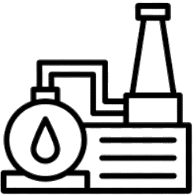


Part 1
- Draw the state where Austin Hooten is from.
- What is the port that is used to deliver his chemotherapy medications made of?

3. Learning what the port was made of inspired him to do what in FFA?
6. What FFA office does Austin hold?
5. Austin used the research from

his ____________ ____________

project for his _______________

_________________ experience and

as the basis for exploring

____________________ agriculture.
7. Where did he receive a grant
from?
8. What did he use the grant for?
9. What proficiency area did he compete in on the national level?
10. Where does he plan to attend college?

What does he plan to major in?
11. Overall, how did this experience have an impact on him?

4. What awards did he win?

Directions:
Learn about where our natural gas comes from and about the industry. Utilize these websites to answer the questions below: https://www.eia.gov/energyexplained/natural-gas/where-our-natural-gas-comes-from.php and https://www.eia.gov/energyexplained/natural-gas/. Additionally, you’ll answer questions to learn where our oil comes from. Utilize this site to answer the questions: https://www.eia.gov/energyexplained/oil-and-petroleum-products/where-our-oil-comes-from.php.
Part 2
What is natural gas?
How did natural gas form?

= _______
= _______
= _______
= _______
= _______
In the blank space below, draw each of the top five natural gas–producing states and write its share of total U.S. natural gas production in 2019 in the box.


2. What does “crude” mean?
- What country is one of the largest crude oil producers?

How long has that country held that position?

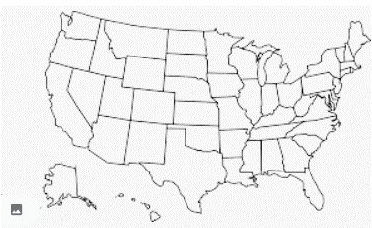
4. List the top five crude oil–producing states and their percentage shares in the space below:
Color in on the U.S. map the top five crude oil–producing states.
3. How many U.S. states produce crude oil?

5. Color in the top five crude oil–producing countries.
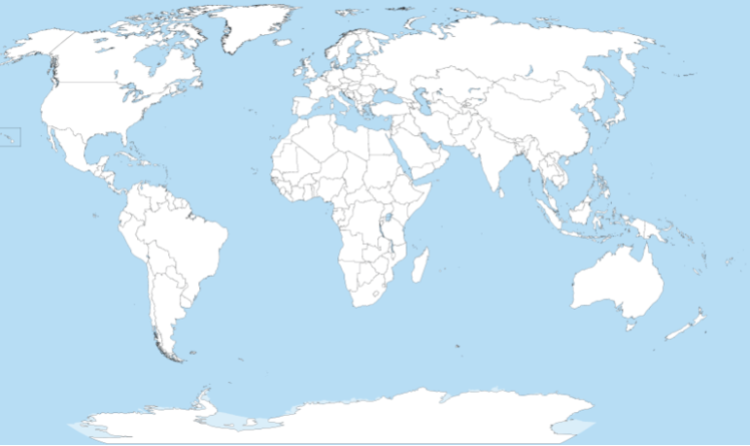

6. Conduct research to determine one similarity and one difference between the top crude oil-producing states and the top crude oil-producing countries.

Directions:
Answer the questions below and complete the activities to learn how plastics are made. Utilize these websites to answer the questions below: https://plastics.americanchemistry.com/How-Plastics-Are-Made/ and https://homeguides.sfgate.com/renewable-plastics-79403.html.

Part 3

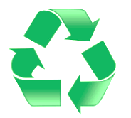

- What does the term “plastics” include?

2. What is another name for plastics?
3. What is another term for renewable plastics?
4. What are renewable plastics made from?
5. List seven uses of renewable plastic.
6. Identify at least one renewable plastic in your life (at home, school, etc.).

Directions:
Let’s make soy plastic. Utilize this website, https://agclassroom.org/matrix/lesson/740/, to aid in the activity below. *Note: This activity is from National Agriculture in the Classroom. Have students make soy plastic (Activity 2 in the lesson).

Part 4

Step 2: Follow these steps:
- Part 1:
- Place 1 tablespoon of cornstarch into the plastic bag. (Figure 1)
- Add 2 drops of soybean oil. (Figure 2)
- Add 1 tablespoon of water. (Figure 3)
- Close the bag and knead it with your fingers, mixing the contents. (Figure 4)
- Add 2 drops of food coloring. (Figure 5)
- Seal the bag and mix remaining contents.
- Open the bag slightly so it can vent.
- Weigh the contents of the bag on a kitchen scale. (Figure 6)
- Part 2:
- Heat the bag in the microwave for 20 to 25 seconds. (Figure 7)
- Remove the bag from the microwave and let the plastic cool. Caution: The bag and contents will be hot!
- Weigh the contents of the bag again. (Figure 8) Compare the weight measurements from before and after microwaving.

Step 1: Collect the items needed for this activity:

- Measuring spoon
- 1 tablespoon cornstarch
- 2 drops (about 1/8 teaspoon) of soybean oil
- 1 tablespoon water
- 2 drops food coloring
- Resealable sandwich-sized bag
- Microwave
- Kitchen scale

Answer the following questions as you are completing the activity (Part 1):

- How many grams does your bag of contents weigh before microwaving?

- Describe the mixture in your plastic bag.

- How does it feel when you squish the bag?

- Is your mixture a solid or a liquid?

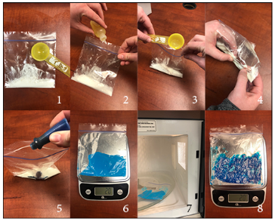

Answer the following questions as you are completing the activity (Part 2):
5. What does your new substance look like?

6. How many grams does your bioplastic weigh? Is it the same weight as before? Why or why not?

8. What products can be made with bioplastic?

Aligned to the following standards:
FFA.PL-A, FFA.PL-E, FFA.PL-F, FFA.PG-G, FFA.PG-I; FFA.PG-J, FFA.CS-M, FFA.CS-N, CCSS.RI.9-10.2, CCSS.RI.9-10.4, CCSS.WHST.9.10.4, CCSS.W.9-10.2, CCSS.W.9-10.4, CCSS.SL.9-10.2, AG2; AG3, CRP.02, CRP.03, CRP.04, CRP.07, CRP.08

KEY: Appendix 6: Curiosity Amid Chemotherapy
Directions:
Read the article “Curiosity Amid Chemotherapy” in the fall 2021 issue of FFA New Horizons and answer the following questions.

Part 1

- Draw the state where Austin Hooten is from.
Oklahoma
- What is the port that is used to deliver his chemotherapy medications made of?
Plastic and rubber, both oil and gas by-products
3. Learning what the port was made of inspired him to do what in FFA?
To do an agriscience fair project
4. What awards did he win?
He won several awards, including a first-place win in the power, structural and technical systems category at the Oklahoma FFA Agriscience Fair and first place at the National FFA Convention & Expo.
6. What FFA office does Austin hold?
President
5. Austin used the research from

his Agriscience Fair

project for his supervised

agricultural experience and

as the basis for exploring

precision agriculture.
7. Where did he receive a grant?
Stillwater Public Education Foundation and the Oklahoma FFA Foundation
8. What did he use the grant for?
He acquired a “farm bot,” a hydroponics cart and an aquaponics system.
9. What proficiency area did he compete in on the national level?
Agriscience Research – Integrated Systems.
10. Where does he plan to attend college?
Oklahoma State University

What does he plan to major in?
Animal science and agribusiness
11. Overall, how did this experience have an impact on him?
The experience helped him heal just as much as chemotherapy and surgery because it helped boost his morale and spirit. It taught him to live life to the fullest and never take an opportunity for granted.

Directions:
Learn about where our natural gas comes from and about the industry. Utilize these websites to answer the questions below: https://www.eia.gov/energyexplained/natural-gas/where-our-natural-gas-comes-from.php and https://www.eia.gov/energyexplained/natural-gas/. Additionally, you’ll answer questions to learn where our oil comes from. Utilize this site to answer the questions: https://www.eia.gov/energyexplained/oil-and-petroleum-products/where-our-oil-comes-from.php.
How did natural gas form?
Millions to hundreds of millions of years ago and over long periods of time, the remains of plants and animals (such as diatoms) built up in thick layers on the earth’s surface and ocean floors, sometimes mixed with sand, silt and calcium carbonate. Over time, the layers were buried under sand, silt and rock. Pressure and heat changed some of the carbon and hydrogen-rich material into coal, some into oil and some into natural gas.

Part 2
What is natural gas?
Natural gas is a fossil energy source that formed deep beneath the earth’s surface. Natural gas contains many different compounds. The largest component of natural gas is methane, a compound with one carbon atom and four hydrogen atoms.

= 7.7%
= 8.5%
= 9.3%
1. In the blank space below, draw each of the top five natural gas-producing states and write in its share of total U.S. natural gas production in 2019 in the box.

Texas

Pennsylvania

Louisiana

Oklahoma

Ohio
= 20.0 %
= 23.9%

- What country is one of the largest crude oil producers? United States

How long has that country held that position?
Became the top oil producer in 2018 and maintained position in 2019 and 2020.

2. What does “crude” mean?
Unrefined petroleum
3. How many U.S. states produce crude oil?
32

Color in on the map the top five crude oil–producing states.
4. List the top five crude oil–producing states and their percentage shares in the space below:
Texas – 43%
North Dakota – 10.4%
New Mexico – 9.2%
Oklahoma – 4.1%
Colorado – 4.0%
5. Color in the top five crude oil–producing countries.

6. Conduct research to determine one similarity and one difference between the top oil-producing states and the top oil-producing countries.
Answers will vary.

Directions:
Answer the questions below and complete the activities to learn how plastics are made. Utilize these websites to answer the questions below: https://plastics.americanchemistry.com/How-Plastics-Are-Made/ and https://homeguides.sfgate.com/renewable-plastics-79403.html.

Part 3
- What does the term “plastics” include?
The term plastics includes materials composed of various elements such as carbon, hydrogen, oxygen, nitrogen, chlorine and sulfur. Plastics typically have molecular weight, meaning each molecule can have thousands of atoms bound together.
2. What is another name for plastics?
Polymers
3. What is another term for renewable plastics? Bioplastics
4. What are renewable plastics made from?
Renewable plastics are made from plant sources rather than petroleum products.
5. List seven uses of renewable plastic:
Wood fiber–based plastics are used for hard plastics that need to have visual appeal such as toothbrush handles. Corn-based plastics are found in food containers and disposable flatware. Other bioplastics are used in products such as plastic furniture, shoes, electronics, toys and office supplies.
6. Identify at least one renewable plastic in your life (at home, school, etc.).
Answers will vary.

