Aligned to the following standards: AG2; AG5; FFA.PL-A; FFA.PL-C; FFA.PL-D; FFA.PL-E; FFA.PL-F; FFA.PG-I; FFA.CS-N; FFA.CS-O; FFA.CS-P; CS.02; AG2; CCSS.ELA.RI.9-10.2; CCSS.ELA.RI.9-10.4; CCSS.W.9-10.4; CCSS.ELA.W.9-10.8; CCSS.SL.9-10.2; CCSS.SL.9-10.4; CRP.02; CRP.04; CRP.07; CRP.08
Appendix 6: 70 Years of FFA Stories
Part 1
Directions:
Read the article “70 Years of FFA Stories” in the fall 2022 issue of FFA New Horizons. Complete the following activities to learn more.
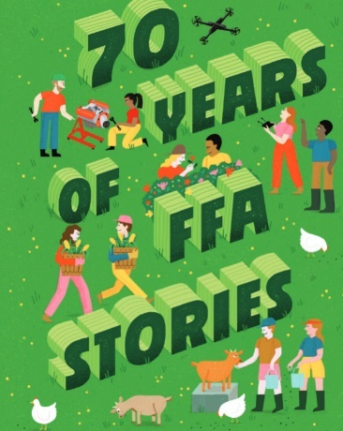
1. What was the title of the first agricultural magazine? ______________________________________
1a. When was the magazine published?
- 1811
- 1810
- 1825
- 1928
2. It was a publication by _____________ for _______________ and about _______________.
3. Fast-forward more than ________________ years, and the ___________________
Future __________________, a publication for FFA members about FFA _________________ hits
members’ mailboxes.
4. While browsing the National FFA Organization archives, you might run across the National FFA Board minutes from
October 7, ___________. The very last line on the very last page reads, “It was moved by ______________ ________________
King that the Board of Trustees and _____________ Council advise the _____________ at the convention that we are
working on a _____________ magazine and have requested that it be published at the earliest possible __________________.
5. What has happened since that motion was passed?

6. In what decade did the name of the magazine change to FFA New Horizons?
- 1970s
- 1980s
- 1990s
- 2000s
7. Identify a quote from the article that stands out to you and explain why.

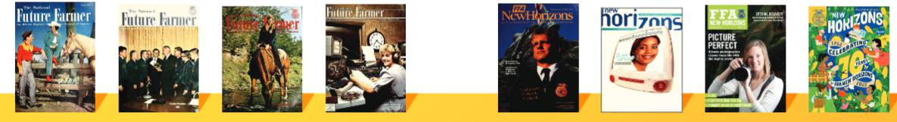
Part 2
Directions:
Utilize the magazine-cover template, on the next page, to design and create your very own FFA New Horizons magazine cover to represent and summarize your FFA and agricultural class experience. If you want to design your cover digitally, you can use the PosterMyWall website. After you’re done, display your cover around the classroom and complete a gallery walk to look at other covers. Pick out two to three covers that stood out to you and be prepared to discuss why.
Items to include in your design:
- Picture
- Three or four story titles (like in the example covers below)
- Your design should be colorful. Be creative!
Examples of past covers:
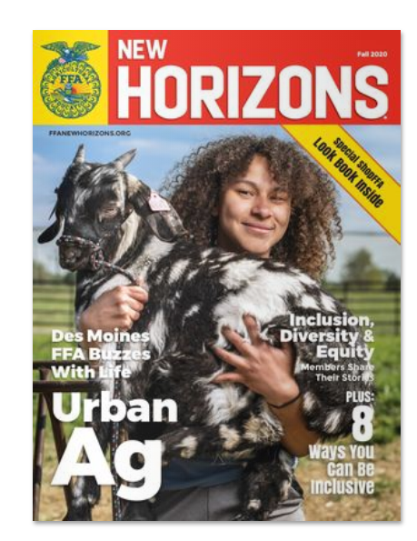
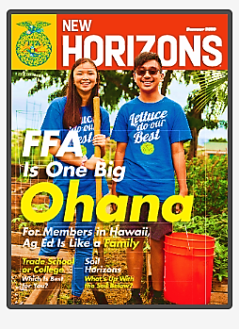
After you design your cover, answer these questions to reflect.
How does your experience in FFA and/or agricultural class(es) influence some of your future behaviors and decisions?
Explain why you chose the stories and images you did.
Looking back at your completed magazine cover, which activity that you experienced was the most enjoyable and why?

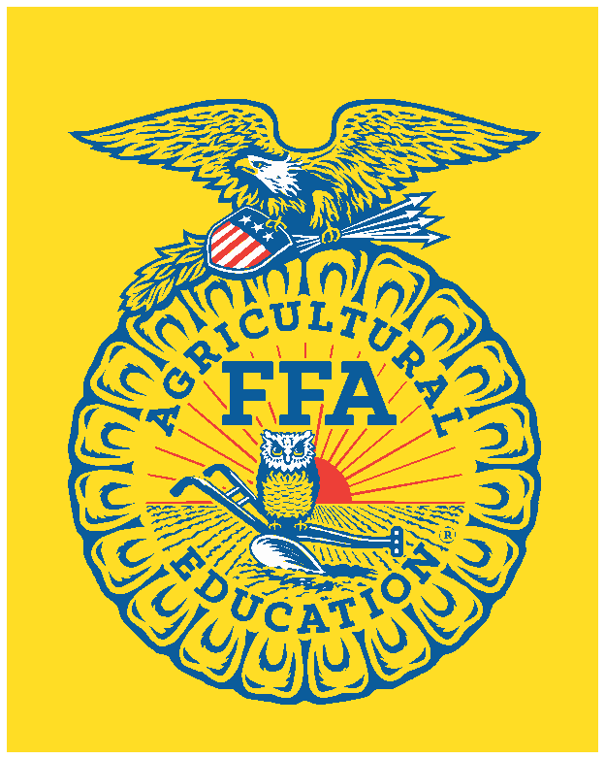


F

FFANEWHORIZONS.ORG Fall 2022

KEY: Appendix 6: 70 Years of FFA Stories
Aligned to the following standards: AG2; AG5; FFA.PL-A; FFA.PL-C; FFA.PL-D; FFA.PL-E; FFA.PL-F; FFA.PG-I; FFA.CS-N; FFA.CS-O; FFA.CS-P; CS.02; AG2; CCSS.ELA.RI.9-10.2; CCSS.ELA.RI.9-10.4; CCSS.W.9-10.4; CCSS.ELA.W.9-10.8; CCSS.SL.9-10.2; CCSS.SL.9-10.4; CRP.02; CRP.04; CRP.07; CRP.08
Part 1
Directions:
Read the article “70 Years of FFA Stories” in the fall 2022 issue of FFA New Horizons. Complete the following activities to learn more.
1. What was the title of the first agricultural magazine? The Agricultural Museum
1a. When was the magazine published?
- 1811
- 1810
- 1825
- 1928
2. It was a publication by farmers for farmers and about farming.
3. Fast-forward more than 100 years, and the National Future Farmer, a publication for FFA members about FFA activities hits members’ mailboxes.

4. While browsing the National FFA Organization archives, you might run across the National FFA board minutes from October 7, 1950. The very last line on the very last page reads, “It was moved by Vice President King that the Board of Trustees and Advisory Council advise the delegates at the convention that we are working on a national magazine and have requested that it be published at the earliest possible date.

5. What has happened since that motion was passed? Since the motion was made more than 70 years ago, millions of copies of national FFA magazines have been circulated to FFA members across the country.

6. In what decade did the name of the magazine change to FFA New Horizons?
- 1970s
- 1980s
- 1990s
- 2000s

7. Identify a quote from the article that stands out to you and explain why. Answers will vary.

Part 2
Directions:
Utilize the magazine-cover template, on the next page, to design and create your very own FFA New Horizons magazine cover to represent and summarize your FFA and agricultural class experience. If you want to design your cover digitally, you can use the PosterMyWall website. After you’re done, display your cover around the classroom and complete a gallery walk to look at other covers. Pick out two to three covers that stood out to you and be prepared to discuss why. Answers will vary.
Items to include in your design:
- Picture
- Three or four story titles (like in the example covers below)
- Your design should be colorful. Be creative!
Examples of past covers:
After you design your cover, answer these questions to reflect.
How does your experience in FFA and/or agricultural class(es) influence some of your future behaviors and decisions?
Explain why you chose the stories and images you did.
Looking back at your completed magazine cover, which activity that you experienced was the most enjoyable and why?

F

FFANEWHORIZONS.ORG Fall 2022
Answers will vary.

