Aligned to the following standards: FFA. PL-A; FFA.PL-F; FFA.PG-I; FFA.CS-M; FFA.CS-P; CCSS.ELA.RI.9-10.2; CCSS.ELA.RI.9-10.3; CCSS.ELA.RI.9-10.7; CCSS.ELA.SL.9-10.2; CCSS.ELA.SL.9-10.5; CCSS.ELA.L.9-10.6; CRP.02; CRP.04; CRP.08.
Appendix 6: FFA Moment: 1935 and 1965
Part 1
Directions:
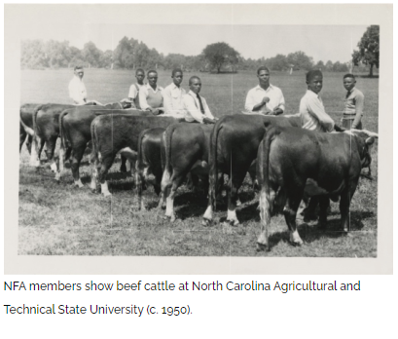
Read the article “FFA Moment: 1935 and 1965” in the Spring/Summer 2025 issue of FFA New Horizons and answer the questions below.

- Where was the New Farmers of America (NFA) founded?

- Who was elected as the first national NFA president?

- Who was the organization shaped and influenced by?

- How many chapters and members did the NFA grow to before coming under the authority of the U.S. Department of Education in 1941?

- What significant legislative act was signed into law by President Lyndon B. Johnson?

- What year did the NFA merge with the Future Farmers of America (now known as the National FFA Organization)?

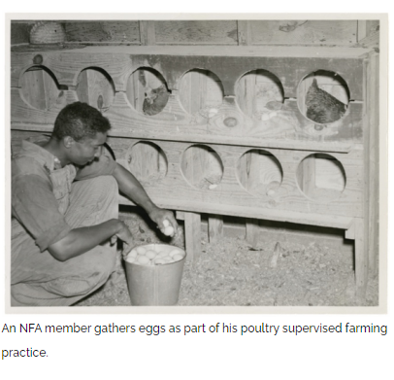

- How are scholars and students contributing to the preservation of the historical significance of the NFA today?

Part 2
Directions:
To learn more about NFA and the lasting implications of its merger with FFA, use this link https://www.ffa.org/the-feed/recapturing-a-lost-culture/ to answer the questions below.
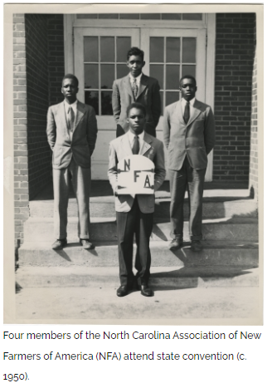
- After reading the section “Understand the History,” write a five-sentence summary of what you learned.

- Create a timeline, with at least four dates from the section “Understand the Journey.” Explain the significance of each date you selected.

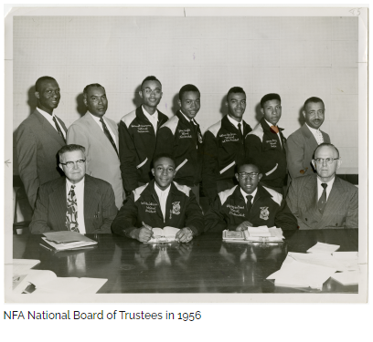

- Share three losses the NFA experienced with desegregation and the NFA/FFA merger.

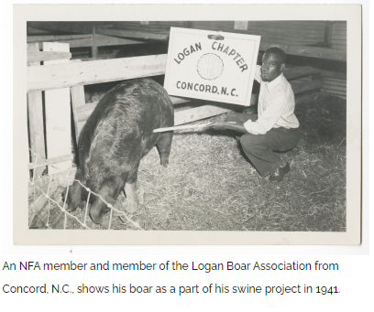
- How can you take action and preserve NFA culture?

- Why is preserving the history of the NFA important?

- What are two things you learned about the NFA?

Part 3
Directions:
It’s your turn to research and commit to preserving the history of NFA by recognizing its historical significance. Use the following link to access a full collection of digitized archives created by students and faculty at North Carolina Agricultural and Technical State University: https://digital.library.ncat.edu/nfa/. You will create a historical book around the prompts below using the link provided. You can find the answers by exploring the documents, photos and records in the archives. To create your book, you will need printer paper, folded in half and stapled at the edge. On the last page of your book, please answer the two questions listed at the bottom of the page.
Find a document that references the year the NFA was founded.

What year was it established, and where was the first meeting held?
Find a photo in the archives that stands out to you.

Describe the photo and its historical significance.

Locate a document or photo that displays the NFA emblem.

How does the emblem reflect the values and mission of the organization?
Find a document highlighting a major event in NFA history.

Summarize the event in two or three sentences.
Identify a specific chapter or school featured in the archives.

Share one interesting fact or accomplishment about this chapter.
Find a document or article referencing the merger of the NFA and FFA.

What year did the merger happen, and why was it significant?
Find a document highlighting a major event in NFA history.

Summarize the event in two or three sentences.
Identify at least one key leader in the NFA mentioned in the archives.

What role did they serve, and what is their legacy?

Find a letter that was exchanged between two people.

Share the contents of the letter and its historical significance.

- What did you learn about the history of the NFA and its significance within agricultural education?

- What steps can your chapter take to ensure you are preserving the history of your chapter?

Aligned to the following standards: FFA. PL-A; FFA.PL-F; FFA.PG-I; FFA.CS-M; FFA.CS-P; CCSS.ELA.RI.9-10.2; CCSS.ELA.RI.9-10.3; CCSS.ELA.RI.9-10.7; CCSS.ELA.SL.9-10.2; CCSS.ELA.SL.9-10.5; CCSS.ELA.L.9-10.6; CRP.02; CRP.04; CRP.08.

KEY: Appendix 6: FFA Moment: 1935 and 1965
Part 1
Directions:
Read the article “FFA Moment: 1935 and 1965” in the spring/summer 2025 issue of FFA New Horizons and answer the questions below.

- Where was the New Farmers of America (NFA) founded?
Tuskegee Institute in Alabama

- Who was elected as the first national NFA president?
David Simmons

- Who was the organization shaped and influenced by?
Booker T. Washington

- How many chapters and members did the NFA grow to before coming under the authority of the U.S. Department of Education in 1941?
The NFA grew to 1,004 chapters in 12 states with more than 50,000 members.

- What significant legislative act was signed into law by President Lyndon B. Johnson?
The Civil Rights Act of 1964

- What year did the NFA merge with the Future Farmers of America (now known as the National FFA Organization)?
1965

- How are scholars and students contributing to the preservation of the historical significance of the NFA today?
By creating digital archives

Part 2
Directions:
To learn more about NFA and the lasting implications of its merger with FFA, use this link https://www.ffa.org/the-feed/recapturing-a-lost-culture/ to answer the questions below.
- After reading the section “Understand the History,” write a five-sentence summary of what you learned.
Answers will vary.

- Create a timeline, with at least four dates from the section “Understand the Journey.” Explain the significance of each date you selected.

Answers will vary. Dates include 1927, 1935, 1941 and 1954.

- Share three losses the NFA experienced with desegregation and the NFA/FFA merger.

  - Answers will vary.
  - Answers will vary.
  - Answers will vary.

- How can you take action and preserve the NFA culture?
Answers will vary.

- Why is preserving the history of the NFA important?
Answers will vary.

- What are two things you learned about the NFA?
Answers will vary.

Part 3
Directions:
It’s your turn to research and commit to preserving the history of NFA by recognizing its historical significance. Use the following link to access a full collection of digitized archives created by students and faculty at North Carolina Agricultural and Technical State University: https://digital.library.ncat.edu/nfa/. You will create a historical book around the prompts below using the link provided. You can find the answers by exploring the documents, photos and records in the archives. To create your book, you will need printer paper, folded in half and stapled at the edge. On the last page of your book, please answer the two questions listed at the bottom of the page.
Find a document that references the year the NFA was founded.
Answers will vary.

What year was it established, and where was the first meeting held?
1935. Tuskegee Institute in Tuskegee, Alabama
Find a photo in the archives that stands out to you.
Answers will vary.

Describe the photo and its historical significance.
Answers will vary.

Locate a document or photo that displays the NFA emblem.
Answers will vary.

How does the emblem reflect the values and mission of the organization?
Answers will vary.

Find a document highlighting a major event in NFA history.
Answers will vary.

Summarize the event in two or three sentences.
Answers will vary.

Identify a specific chapter or school featured in the archives.
Answers will vary.

Share one interesting fact or accomplishment about this chapter.
Answers will vary.

Find a document or article referencing the merger of the NFA and FFA.
Answers will vary.

What year did the merger happen, and why was it significant?
1965. Answers will vary.

Find a document highlighting a major event in NFA history.
Answers will vary.

Summarize the event in two or three sentences.
Answers will vary.

Identify at least one key leader in the NFA mentioned in the archives.
Answers will vary.

What role did they serve, and what is their legacy?
Answers will vary.

Find a letter that was exchanged between two people.
Answers will vary.

Share the contents of the letter and its historical significance.
Answers will vary.

- What did you learn about the history of the NFA and its significance within agricultural education?
Answers will vary.

- What steps can your chapter take to ensure you are preserving the history of your chapter?
Answers will vary.

