Aligned to the following standards: FFA.PL-A; FFA.PL-B; FFA.PL-C; FFA.PL-D; CCSS.ELA.RI.9-10.1; CCSS.ELA.W.9-10.3; CCSS.ELZ.W.9-10.8; CRP.04; CRP.05; CRP.06; CRP.08
Appendix 6: More Than a Jacket
Part 1
Directions:
Read the article “More Than a Jacket” in the fall/winter 2024 issue of FFA New Horizons and answer the questions below.

- Explain in your own words why Grace felt a sense of pride when she zipped up her FFA jacket for the first time.

- In the first jacket, write down how many Greenwood FFA freshmen received a jacket in 2023. In the second jacket, write down how many freshman FFA members across the whole state received a jacket in 2023.



- Which organization in Pennsylvania began the First-Year Member Jacket Campaign?

- Fill in the blanks.

In the first year, they gave out ______ jackets.
Now, they give out an average of _______ jackets.

- Explain how the Greenwood FFA Chapter initiated their own fundraising efforts.

- Based on what you’ve read, list two benefits of the First-Year Member Jacket Campaign in Pennsylvania.

- Do you feel a program like this would be beneficial in your state? Explain why.

Part 2
Directions:
Visit the Give the Gift of Blue website from National FFA: FFA.org/giveblue/. Watch the three videos and answer the questions below for each video.

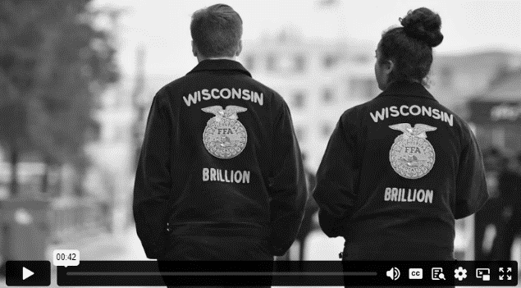
Video 2
Video 1
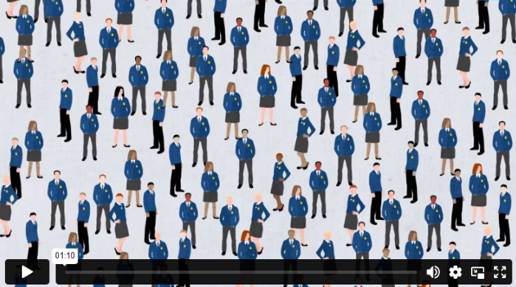
Video 3
1. In FFA, a corduroy jacket is an article of _______________, ______________ and _____________ for millions of FFA members past and present.
2. The FFA jacket remind us __________________
______________________________________________
______________________________________________.

3. What does the Gift of Blue program do?
1. As a member of FFA, you are the most important part of an organization that creates ____________________, ____________________, _______________________, _____________________ and _____________________.
2. How many hours of community service do FFA members give across the country?

3. What unites us all, generation to generation?

4. How many FFA members have a blue jacket?
1. What year did the National FFA Foundation award the 10,000th FFA jacket through Give the Gift of Blue?

2. Only _____ out of ______ FFA members have a jacket with their name stitched on the front.
3. How does a personalized FFA jacket impact the members?
Part 3
Directions:
You and your FFA chapter have been asked to plan a “First-Year Member Jacket Campaign” for your state. Answer the prompts below.

- Fill in the five FFA jackets with five different requirements for students to receive an FFA jacket.

- Create two Instagram posts to advertise your “First-Year Member Jacket Campaign” for your state.


- List three partners or supporters who could help provide financial support for this project.

- Why do you think this project would benefit members in your state?

- Do you think FFA members would apply? Why or why not?

Aligned to the following standards: FFA.PL-A; FFA.PL-B; FFA.PL-C; FFA.PL-D; CCSS.ELA.RI.9-10.1; CCSS.ELA.W.9-10.3; CCSS.ELZ.W.9-10.8; CRP.04; CRP.05; CRP.06; CRP.08
KEY: Appendix 6: More Than a Jacket
Part 1
Directions:
Read the article “More Than a Jacket” in the fall/winter 2024 issue of FFA New Horizons and answer the questions below.

- Explain in your own words why Grace felt a sense of pride when she zipped up her FFA jacket for the first time.

Answers will vary.

- In the first jacket, write down how many Greenwood FFA freshmen received a jacket in 2023. In the second jacket, write down how many freshman FFA members across the whole state received a jacket in 2023.

970
24

- Which organization in Pennsylvania began the First-Year Member Jacket Campaign?
Pennsylvania FFA Alumni and Supporters

- Fill in the blanks.

In the first year, they gave out 75 jackets.
Now, they give out an average of 400 jackets.

- Explain how the Greenwood FFA Chapter initiated their own fundraising efforts.

They encouraged freshman members to write letters to community members and business owners, inviting them to sponsor jackets.

- Based on what you’ve read, list two benefits of the First-Year Member Jacket Campaign in Pennsylvania.

  - Answers will vary.

  - Answers will vary.

- Do you feel a program like this would be beneficial in your state? Explain why.

Answers will vary.

Part 2
Directions:
Visit the Give the Gift of Blue website from National FFA: FFA.org/giveblue/ Watch the three videos and answers the questions below for each video.
Video 2
Video 1
Video 3
1. In FFA, a corduroy jacket is an article of faith, honor and pride for millions of FFA members past and present.
2. The FFA jacket remind us that we are part of something bigger than ourselves.

3. What does the Gift of Blue program do?
Helps provide an FFA jacket to those who may not be able to afford their own
1. As a member of FFA, you are the most important part of an organization that creates citizens, volunteers, patriots, leaders and scholars.
2. How many hours of community service do FFA members give across the country?
200,000 hours
3. What unites us all, generation to generation?
The FFA jacket unites us all.
4. How many FFA members have a blue jacket?
Only 50% of our members
1. What year did the National FFA Foundation award the 10,000th FFA jacket through Give the Gift of Blue?
2020
2. Only 4 out of 10 FFA members have a jacket with their name stitched on the front.
3. How does a personalized FFA jacket impact the members?
An FFA jacket helps students feel they belong and are seen and that they matter.
Part 3
Directions:
You and your FFA chapter have been asked to plan a “First-Year Member Jacket Campaign” for your state. Answer the prompts below.

- Fill in the five FFA jackets with five different requirements for students to receive an FFA jacket.
Answers will vary.
Answers will vary.

Answers will vary.

Answers will vary.

Answers will vary.

- Create two Instagram posts to advertise your “First-Year Member Jacket Campaign” for your state.

- List three partners or supporters who could help provide financial support for this project.
- Answers will vary.

- Answers will vary.

- Answers will vary.

- Why do you think this project would benefit members in your state?

Answers will vary.

- Do you think FFA members would apply? Why or why not?

Answers will vary.

