Appendix 6: Water Quality
Aligned to the following standards:
FFA.PL-C.; FFA.PL-D.; FFA.PL-F.; FFA.PG-J.; FFA.CS-M.; FFA.CS-N.; FFA.CS-O.; CS.01.; CS.04.;CCSS.RI.9-10.4;
CCSS.W.9-10.2; CCSS.W.9-10.4; CCSS.SL.9-10.4; CRP.04; CRP.06

Created: Spring 2019 by the National FFA Organization

Directions:
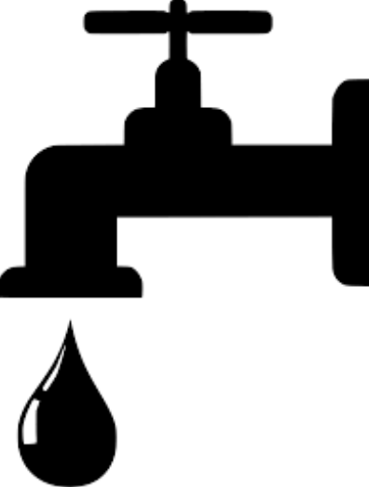
Read the article “Water Quality” in the Spring 2019 issue of FFA New Horizons. Answer the questions below and reference the map on page 2. The map is divided into the four regions of the National FFA Organization.
How would you explain water rights to a non-agriculturist?

Part 1

1. What is the definition of water rights?

2. Pick a state in your region (reference the map below).
Research the water rights for that state. Identify and
describe/explain 3 facts about the water rights (list them below in the water droplets).
(Some websites to help start your research:
http://soilandwater.ohiodnr.gov/portals/soilwater/pdf/stream/stfs02.pdf
https://www.waterboards.ca.gov/waterrights/board_info/faqs.html, https://www.waterrights.utah.gov/, https://www.oregon.gov/OWRD/WRDPublications1/aquabook.pdf)

Which state did you choose? Write it here and circle it on the map: ______________________

Fact 3 (Reference the site you use.)

Fact 1 (Reference the site you use.)
Fact 2 (Reference the site you use.)

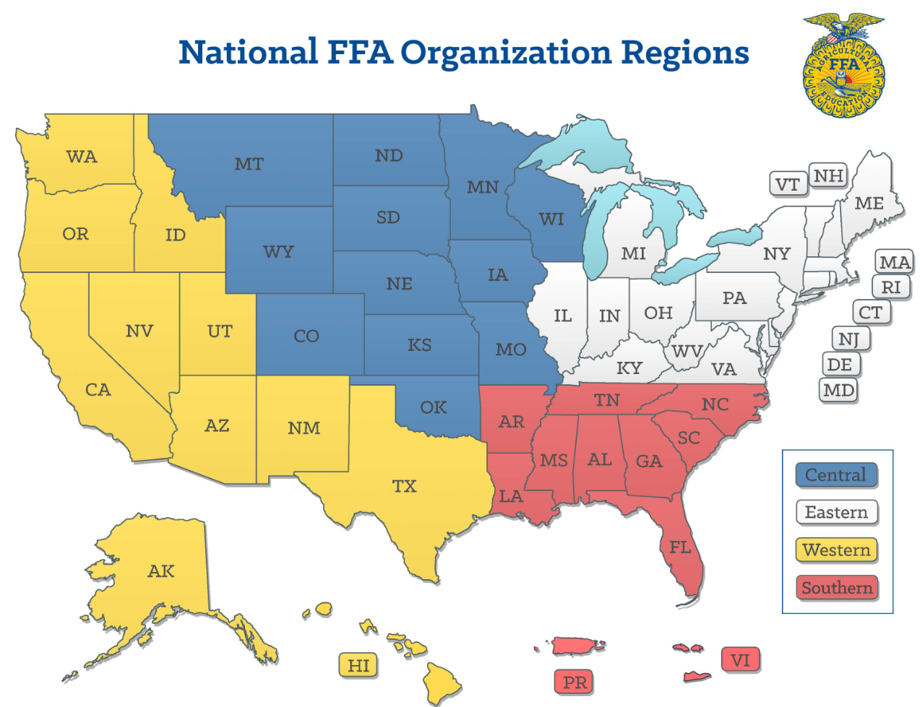

Aligned to the following standards:
FFA.PL-C.; FFA.PL-D.; FFA.PL-F.; FFA.PG-J.; FFA.CS-M.; FFA.CS-N.; FFA.CS-O.; CS.01.; CS.04.;CCSS.RI.9-10.4;
CCSS.W.9-10.2; CCSS.W.9-10.4; CCSS.SL.9-10.4; CRP.04; CRP.06

Part 2

Select a different state in another region. Research the water rights for that state.

1. What state did you choose? Write it here and circle it on the map: ________________
What region is the state in? ________________

2. Research the water rights for that state. Identify and
describe/explain 3 facts about the water rights (list them below in the water droplets).
(Some websites to help start your research:
http://soilandwater.ohiodnr.gov/portals/soilwater/pdf/stream/stfs02.pdf
https://www.waterboards.ca.gov/waterrights/board_info/faqs.html, https://www.waterrights.utah.gov/, https://www.oregon.gov/OWRD/WRDPublications1/aquabook.pdf)
Fact 3 (Reference the site you use.)

Fact 1 (Reference the site you use.)

Fact 2 (Reference the site you use.)

Aligned to the following standards:
FFA.PL-C.; FFA.PL-D.; FFA.PL-F.; FFA.PG-J.; FFA.CS-M.; FFA.CS-N.; FFA.CS-O.; CS.01.; CS.04.;CCSS.RI.9-10.4;
CCSS.W.9-10.2; CCSS.W.9-10.4; CCSS.SL.9-10.4; CRP.04; CRP.06

Part 3
1. Describe how water rights affect agriculture. Provide three examples from the resources you reviewed.

How would you explain water rights to an elementary-age student?


KEY — Appendix 6: Water Quality
Aligned to the following standards:
FFA.PL-C.; FFA.PL-D.; FFA.PL-F.; FFA.PG-J.; FFA.CS-M.; FFA.CS-N.; FFA.CS-O.; CS.01.; CS.04.;CCSS.RI.9-10.4;
CCSS.W.9-10.2; CCSS.W.9-10.4; CCSS.SL.9-10.4; CRP.04; CRP.06

How would you explain water rights to a non-agriculturist?

Created: Spring 2019 by the National FFA Organization

Directions:
Read the article “Water Quality” in the Spring 2019 issue of FFA New Horizons. Answer the questions below and reference the map on page 2. The map is divided into the four regions of the National FFA Organization.

Part 1

1. What is the definition of water rights?
According to Merriam-Webster.com, water rights is a right to the use of water (as for irrigation).

2. Pick a state in your region (reference the map below).
Research the water rights for that state. Identify and
describe/explain 3 facts about the water rights (list them below in the water droplets).
(Some websites to help start your research:
http://soilandwater.ohiodnr.gov/portals/soilwater/pdf/stream/stfs02.pdf
https://www.waterboards.ca.gov/waterrights/board_info/faqs.html, https://www.waterrights.utah.gov/, https://www.oregon.gov/OWRD/WRDPublications1/aquabook.pdf)

Which state did you choose? Write it here and circle it on the map: Ohio
Fact 1 (Reference the site you use.)

Example: According to this document (http://soilandwater.ohiodnr.gov/portals/soilwater/pdf/stream/stfs02.pdf), Ohio’s Constitution does not address the question of who owns Ohio’s streams. The answer must be derived from the common law.
Fact 2 (Reference the site you use.)

Fact 3 (Reference the site you use.)

Part 2

Select a different state in another region. Research the water rights for that state.
Aligned to the following standards:
FFA.PL-C.; FFA.PL-D.; FFA.PL-F.; FFA.PG-J.; FFA.CS-M.; FFA.CS-N.; FFA.CS-O.; CS.01.; CS.04.;CCSS.RI.9-10.4;
CCSS.W.9-10.2; CCSS.W.9-10.4; CCSS.SL.9-10.4; CRP.04; CRP.06

1. What state did you choose? Write it here and circle it on the map: Oregon
What region is the state in? Western

2. Research the water rights for that state. Identify and
describe/explain 3 facts about the water rights (list them below in the water droplets).
(Some websites to help start your research:
http://soilandwater.ohiodnr.gov/portals/soilwater/pdf/stream/stfs02.pdf
https://www.waterboards.ca.gov/waterrights/board_info/faqs.html, https://www.waterrights.utah.gov/, https://www.oregon.gov/OWRD/WRDPublications1/aquabook.pdf)

Fact 1 (Reference the site you use.)

Example: Oregon’s water laws are based on the doctrine of prior appropriation. This means the first person to obtain a water right on a stream is the last to be shut off in times of low streamflows.
https://www.oregon.gov/OWRD/WRDPublications1/aquabook.pdf
Fact 3 (Reference the site you use.)

Fact 2 (Reference the site you use.)

