Aligned to the following standards: CS.05; AG5; AGC09.02; CRP.02, CRP.07; CRP.08; CRP.10; CRP.11; FFA.PL-A; FFA.PL-C; FFA.PL-E; FFA.PG-I; FFA.CS-N; FFA.CS-P; CCSS.RI.9-10.1; CCSS.W.9-10.2; CCSS.W.9-10.7; CCSS.W.9-10.9
Appendix 6: Hands-On Education
Part 1
Directions:
Read the article “Hands-On Education” in the spring/summer 2024 issue of FFA New Horizons and answer the questions below.

- In the space below, draw a timeline to show the history of Bristol Aggies. On the timeline, tell what happened in each of the following years: 1912, 1936, 1960, 2024.

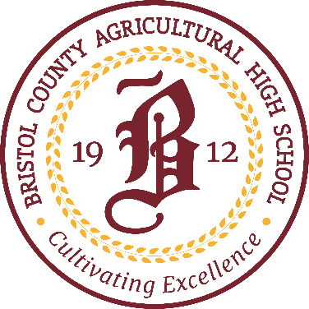
- Why do you think the Massachusetts Legislature started Bristol Aggie?

- Why do you think the school only accepted boys in the beginning?

- How many acres is the Bristol Aggie campus?

- List the seven majors that Bristol Aggie offers:

- Describe a typical school day at Bristol Aggie:

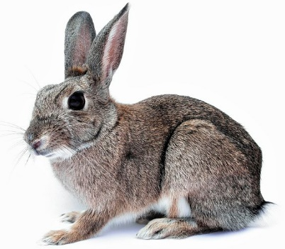
Julianna’s Story

- Circle the animals that Julianna oversees the care of:

Horse Rabbit Pig Bird Mice Snake Rat Guinea Pig

- Which concentration in the animal science department is Julianna part of?

- Although Julianna works mostly with small animals, describe one way she also works with large animals on campus.

- Julianna is interested in a career at the intersection of animal science, microbiology and human medicine. Describe her career goals.

- What is Julianna’s upcoming research project focused on?

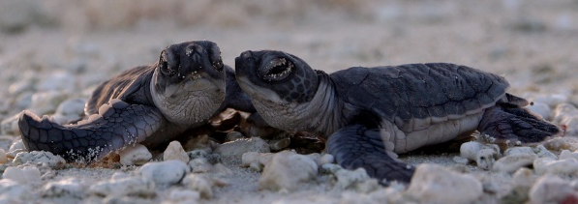
Brian’s Story

- What did Brian see at the Bristol Aggie Fall Show that encouraged him to apply to Bristol Aggie?

- What is Brian’s job at Bristol Aggie as a senior NRM major?

- What happens in the endangered turtle hatching project at Bristol Aggie?

- Name two partners that help Bristol Aggie with this project.

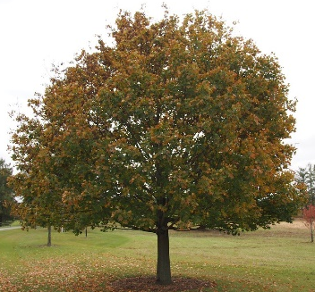

Brody’s Story

- What is Brody’s major at Bristol Aggie?

- What is Brody learning in this major?

- To practice pruning, planting and removing trees from campus, what tools and equipment do Bristol Aggie students use?

- Why did Brody choose his major?

- What are two things Brody says are beneficial at Bristol Aggie?

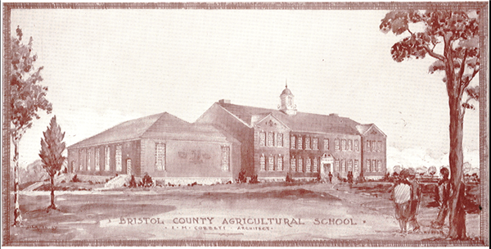

Part 2
Directions:
Use the appropriate links below to complete career profiles about three agricultural careers that related to the three Bristol Aggie students in the article.

- Explore the research and development manager career information found at AgExplorer.FFA.org/career/research-and-development-manager/.
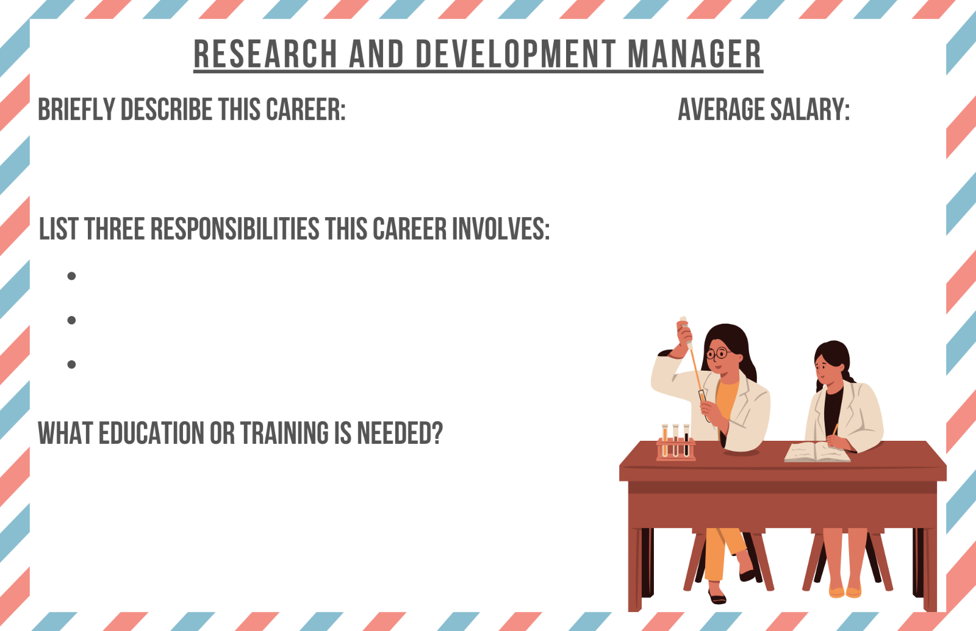

Would this career be a good match for Julianna from the article? Why or why not?

- Explore the wildlife biologist career information found at AgExplorer.FFA.org/career/wildlife-biologist/.

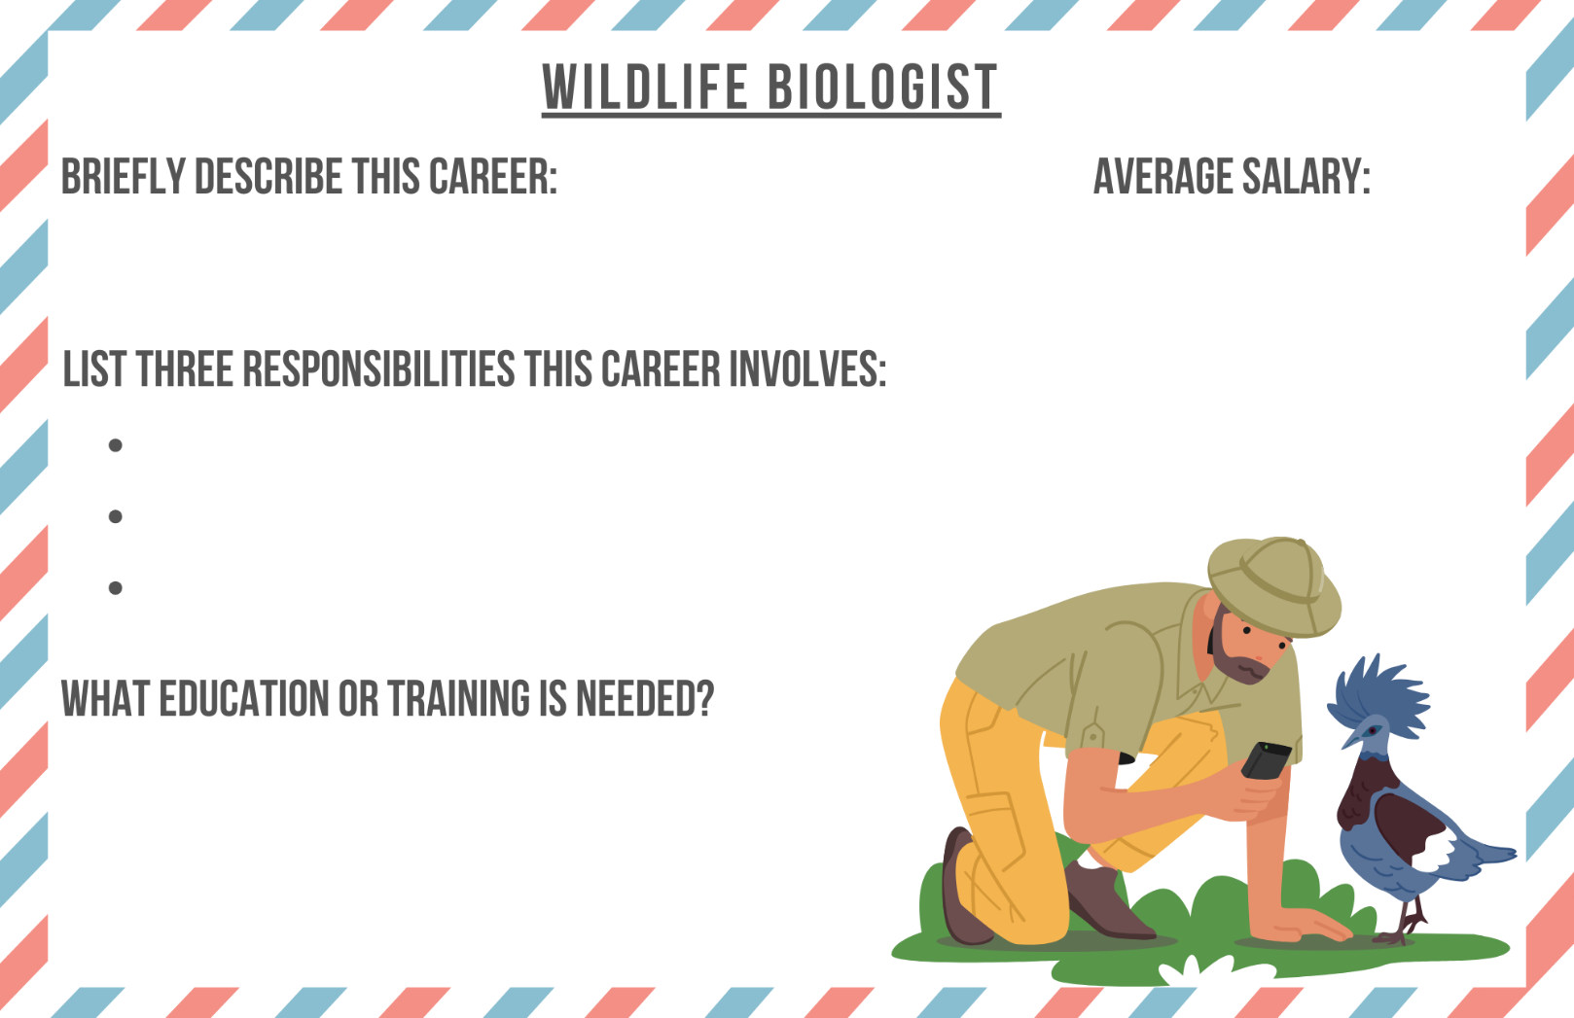

Would this career be a good match for Brian from the article? Why or why not?

- Explore the arborist career information found at AgExplorer.FFA.org/career/arborist/.

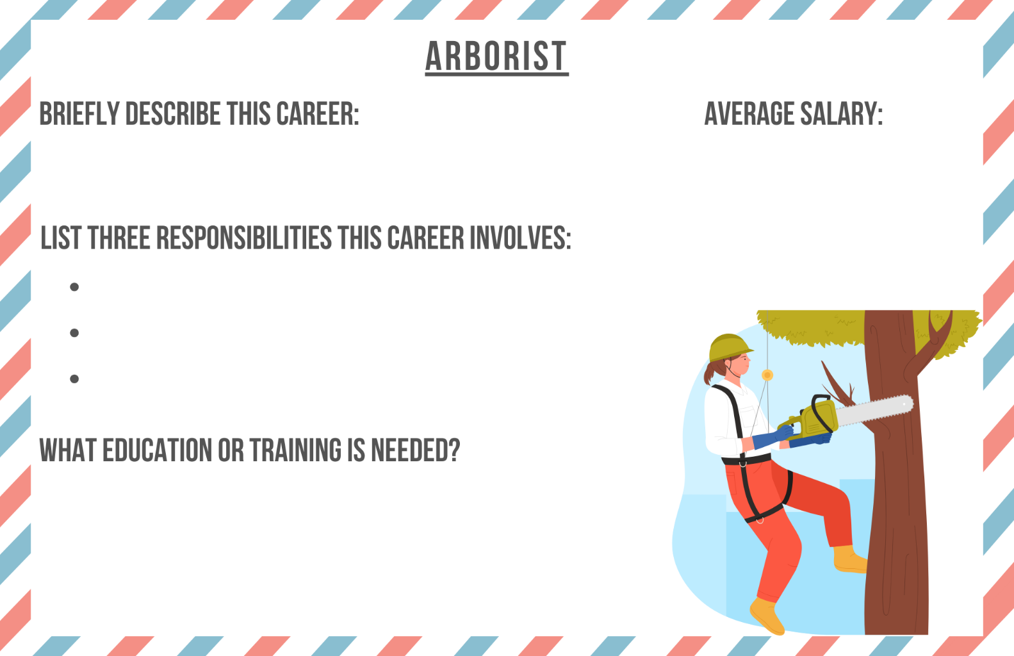

Would this career be a good match for Brody from the article? Why or why not?

KEY: Appendix 6: Hands-On Education
Aligned to the following standards: CS.05; AG5; AGC09.02; CRP.02, CRP.07; CRP.08; CRP.10; CRP.11; FFA.PL-A; FFA.PL-C; FFA.PL-E; FFA.PG-I; FFA.CS-N; FFA.CS-P; CCSS.RI.9-10.1; CCSS.W.9-10.2; CCSS.W.9-10.7; CCSS.W.9-10.9
Part 1
Directions:
Read the article “Hands-On Education” in the spring/summer 2024 issue of FFA New Horizons and answer the questions below.

- In the space below, draw a timeline to show the history of Bristol Aggies. On the timeline, tell what happened in each of the following years: 1912, 1936, 1960, 2024.

Answers will vary, but should include the following:
- 1912: Bristol Aggie started, created for boys only, taught them how to be farmers
- 1936: First female student, Elizabeth Bowen
- 1960s: Girls allowed to attend
- 2024: Over 220 acres at the school and seven agricultural majors, has students from 16 different towns and four cities in Bristol County

- Why do you think the Massachusetts Legislature started Bristol Aggie?

Answers will vary, but should include that the school helps teach students how to become better farmers.

- Why do you think the school only accepted boys in the beginning?
Answers will vary.

- How many acres is the Bristol Aggie campus?

Over 220 acres

- List the seven majors that Bristol Aggie offers:
- Agricultural mechanics
- Animal science
- Arboriculture
- Floriculture
- Landscape design and contracting
- Natural resource management
- Environmental engineering

- Describe a typical school day at Bristol Aggie:

Half the day is spent studying academics and the other half is focused on vocational training, in and outside of the classroom.

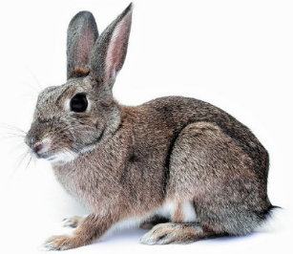
Julianna’s Story
- Circle the animals that Julianna oversees the care of:

Horse Rabbit Pig Bird Mice Snake Rat Guinea Pig

- Which concentration in the animal science department is Julianna part of?

The veterinary science and laboratory animal technology concentration

- Although Julianna works mostly with small animals, describe one way she also works with large animals on campus.

She occasionally works in the school’s new robotic dairy barn, helps with the horses, pigs and cattle, and helps dehorn and vaccinate dairy calves

- Julianna is interested in a career at the intersection of animal science, microbiology and human medicine. Describe her career goals:

She wants to pursue a doctorate in virology or immunology, then work for a research company where she can observe the effects of drugs or other human-health treatments on different pathogens in research animals.

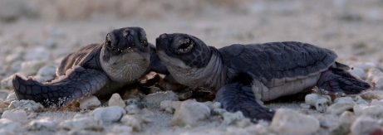
- What is Julianna’s upcoming research project focused on?

She will observe the effects of different disinfectants on microbial growth.

Brian’s Story
- What did Brian see at the Bristol Aggie Fall Show that encouraged him to apply to Bristol Aggie?

He visited the Natural Resource Management Museum and saw taxidermy, snake and reptile exhibits and arachnids.

- What is Brian’s job at Bristol Aggie as a senior NRM major?

He is teaching juniors how to run turtle tanks at the museum.

- What happens in the endangered turtle hatching project at Bristol Aggie?

The eggs will hatch at school, and students will care for them over the winter, then they release the turtles into their natural habitat in the spring with hopes of boosting populations.

- Name two partners that help Bristol Aggie with this project.

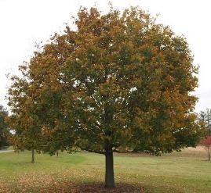
Wildlife biologists at the University of Georgia, the state and federal departments of wildlife and fisheries and a private company called Oxbow Associates

Brody’s Story
- What is Brody’s major at Bristol Aggie?

Arboriculture

- What is Brody learning in this major?

He is learning how to diagnose diseases and other issues in trees and how to make them more aesthetically pleasing.

- To practice pruning, planting and removing trees from campus, what tools and equipment do Bristol Aggie students use?

They use chainsaws and bucket trucks as well as other tools/equipment that professionals use.

- Why did Brody choose his major?

Brody really likes hands-on work and working outdoors.

- What are two things Brody says are beneficial at Bristol Aggie?

The hands-on education and the community

Part 2
Directions:
Use the appropriate links below to complete career profiles about three agricultural careers that related to the three Bristol Aggie students in the article.

- Explore the research and development manager career information found at AgExplorer.FFA.org/career/research-and-development-manager/.
Answers will vary from the list on the website.
$149,000
A master’s or doctorate degree in the field in which you are applying your knowledge – agriculture, food science, chemistry, biology, agronomy
They research activities and develop new agricultural products and processes for companies. This can include in-depth research.

Would this career be a good match for Julianna from the article? Why or why not?

Answers will vary.

- Explore the wildlife biologist career information found at AgExplorer.FFA.org/career/wildlife-biologist/.
They study and oversee the protection and management of an assigned population of one or several species of animals or plants.
Answers will vary from the list on the website.
$58,000
A bachelor’s or master’s degree in wildlife biology, biology, ecology, environmental science, natural resources, wildlife management, wildlife sciences or a related area

Would this career be a good match for Brian from the article? Why or why not?

Answers will vary.

- Explore the arborist career information found at AgExplorer.FFA.org/career/arborist/.

They plant, grow, maintain and remove trees.
Answers will vary from the list on the website.
$54,000
A bachelor’s degree in arboriculture, landscape architecture, urban forestry, environmental conservation, plant science, horticulture, biology or a related field

Would this career be a good match for Brody from the article? Why or why not?

Answers will vary.

