Appendix 6: Talking Points: Food Waste
Created: Summer 2019 by the National FFA Organization

Directions:
Read “Talking Points: Food Waste” in the Summer 2019 issue of FFA New Horizons. Answer the questions below.

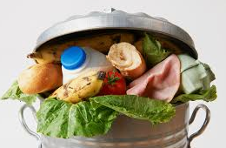
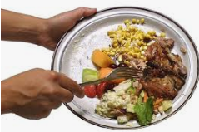

1. How much does the average American family throw away?
2. How much does this cost a family annually?
3. Between 125 and 260 billion pounds of food are left _________ in the ________ every year — ____ billion of that is due to _____________ waste.
4. What is the No. 1 contributor to landfills? _______________________________________
This takes up ________ percent of all landfill content each year.
5. Food waste is hard to break down. Because of this, it is responsible for at least ________ percent of all U.S. greenhouse gas emissions.

A. 5
B. 5.2
C. 2.8
D. 2.6
6. The land used to grow uneaten food makes up about _________ to ________ percent of total U.S. cropland (more than the entire state of ___________________ __________________).
7. What are farmers doing to help the food waste issue?

Aligned to the following standards:
FFA.PL-A.; FFA.PL-C.; FFA.PL-D.; FFA.PL-E.;FFA.PG-J.; FFA.CS-M.; FFA.CS-N.; FFA.CS-O; CCSS.ELA.RI.9.10.2; CCSS.RI.9-10.4; CCSS.W.9-10.2; CCSS.W.9-10.4; CCSS.SL.9-10.4; CRP.02; CRP.04; CCSS.ELA.WHST.9.10.4; AFNR Career Cluster, Statement 3; MP2; MP6
Aligned to the following standards:
FFA.PL-C.; FFA.PL-D.; FFA.PL-F.; FFA.PG-J.; FFA.CS-M.; FFA.CS-N.; FFA.CS-O.; CCSS.RI.9-10.4;
CCSS.W.9-10.2; CCSS.W.9-10.4; CCSS.SL.9-10.4; CRP.04; CRP.06

Part 2
Aligned to the following standards:
FFA.PL-A.; FFA.PL-C.; FFA.PL-D.; FFA.PL-E.;FFA.PG-J.; FFA.CS-M.; FFA.CS-N.; FFA.CS-O; CCSS.ELA.RI.9.10.2; CCSS.RI.9-10.4; CCSS.W.9-10.2; CCSS.W.9-10.4; CCSS.SL.9-10.4; CRP.02; CRP.04; CCSS.ELA.WHST.9.10.4; AFNR Career Cluster, Statement 3; MP2; MP6

Directions:
Answer the questions below based on your own food waste and what you see in your school cafeteria and at home.

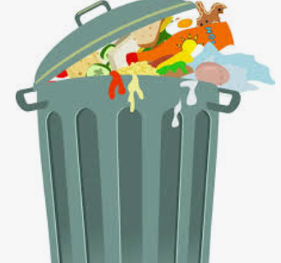

Record the food items you see in the trash at your house:

In the space below, list the food items you throw away over the course of one day. List each item and the quantity. Example: one apple
Write a paragraph describing what food items you see in the trash after lunch at school:

How do you feel after seeing all of the food waste in the trash cans?

Part 3
Aligned to the following standards:
FFA.PL-A.; FFA.PL-C.; FFA.PL-D.; FFA.PL-E.;FFA.PG-J.; FFA.CS-M.; FFA.CS-N.; FFA.CS-O; CCSS.ELA.RI.9.10.2; CCSS.RI.9-10.4; CCSS.W.9-10.2; CCSS.W.9-10.4; CCSS.SL.9-10.4; CRP.02; CRP.04; CCSS.ELA.WHST.9.10.4; AFNR Career Cluster, Statement 3; MP2; MP6
directions
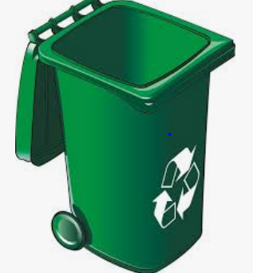
Answer the questions below. Utilize this website, https://www.epa.gov/recycle/reducing-wasted-food-home, to help answer some of the questions.
How often will they be collected?
1. What can you do to reduce your own food waste? What steps can you take?
Does your school have a recycling program?
Who collects the recycling?
YES
NO
When is it collected?
Develop a plan to start a recycling program by answer the following questions.

How will the recyclables be collected?
When will the recyclables be collected?
Who will collect the recyclables?
Where will the recyclables be taken?

KEY — Appendix 6: Talking Points: Food Waste
Aligned to the following standards:
FFA.PL-A.; FFA.PL-C.; FFA.PL-D.; FFA.PL-E.;FFA.PG-J.; FFA.CS-M.; FFA.CS-N.; FFA.CS-O; CCSS.ELA.RI.9.10.2; CCSS.RI.9-10.4; CCSS.W.9-10.2; CCSS.W.9-10.4; CCSS.SL.9-10.4; CRP.02; CRP.04; CCSS.ELA.WHST.9.10.4; AFNR Career Cluster, Statement 3; MP2; MP6
Created: Summer 2019 by the National FFA Organization

Part 1
Directions:
Read “Talking Points: Food Waste” in the Summer 2019 issue of FFA New Horizons. Answer the questions below.

1. How much does the average American family throw away?
25 percent of the food and beverages it purchases
2. How much does this cost the family annually?
This costs the family around $1,600 annually.
3. Between 125 and 260 billion pounds of food are left uneaten in the ___U.S._____ every year — ___76_ billion of that is due to _household_ waste.
4. What is the No. 1 contributor to landfills?
Food waste

This takes up 21 percent of all landfill content each year.
5. Food waste is hard to break down. Because of this, it is responsible for at least ________ percent of all U.S. greenhouse gas emissions.

A. 5
B. 5.2
C. 2.8
D. 2.6
6. The land used to grow uneaten food makes up about 18 to 28 percent of total U.S. cropland (more than the entire state of New Mexico).
7. What are farmers doing to help the food waste issue?
Farmers have cut back on food waste by using unsold produce as feed or compost. Others have donated unused food.

