Aligned to the following standards: AG2; AG5; CS.02 CS.05; FFA.PL-A; FFA.PL-C; FFA.PL-D; FFA.PL-E; FFA.PL-F; FFA.PG-G.; FFA.PG-I; FFA.CS-M; FFA.CS-N; FFA.CS-O; FFA.CS-P; CCSS.ELA.RI.9-10.2; CCSS.ELA.RI.9-10.4; CCSS.W.9-10.2; CCSS.W.9-10.4; CCSS.ELA.W.9-10.8; CCSS.SL.9-10.2; CCSS.SL.9-10.4; CRP.02; CRP.04; CRP.08; CRP.09
Appendix 7: From CDE to a Successful Business
Part 1
Directions:
Read the article “From CDE to a Successful Business” in the spring 2023 issue of FFA New Horizons and answer the questions below.

1. Who is this article about? ________________________

2. In the box to the right, draw the state where this person was an FFA member.

3. What state does Banner currently live in? _____________

4. The name of the company he started is:

5. What is the purpose of the company?

6. He got the idea for one of his company’s products more than _______ years ago when he was an FFA member.

- 15

- 10

- 20

- 5

7. Describe the idea, referenced in Question 6, that he had for one of his company’s products.

8. What did he do after he graduated from high school?

9. What did Banner major in during college?

____________________________ and __________________________

10. What two products did he create, and what is the purpose of those products?
Product and Purpose:
Product and Purpose:

11. Explain how he manages his business, and explain how he credits his SAE:


12. What is his advice for developing successful new products?

13. After reading this article and answering the questions, how can you apply what you learned to your current SAE or to starting an SAE?

Part 2
Directions:
Todd Banner used scientific methods to help create and develop products for his business. Using the agriscience research information page (following this page), complete the following activities to learn about agriscience research.

- Animal Systems

- Environmental Service/Natural Resources
Systems

- Food Products and Processing Systems

- Plant Systems

- Power, Structural and Technical Systems

- Social Science
Draw a line to match the agriscience research category with the correct project opportunity. Hint: There could be more than one match for each category.
Consumer confidence and understanding of food labels

Compare plant growth of hydroponics and conventional methods

Effect of agricultural chemicals on water quality

Research new disease-control mechanisms

Control of molds on bakery products

Create minimum energy use structures

Comparison of profitability of various agricultural/natural resources practices

Effects of lunar climate and soil conditions on plant growth

Resistance of organic fruits to common diseases

Effects of growth hormone on meat/milk production

Compare water movement through different soil types

Compare properties of various alternative insulation products
Icons can be a great way for people to gain familiarity with something. Create an icon for each of the agriscience research categories. The icon should be strong enough that someone who is unfamiliar with the categories could gain a basic understanding by seeing the icon you create.

Animal Systems
Environmental Service/Natural Resources Systems
Food Products and Processing Systems
Plant Systems
Power, Structural and Technical Systems
Social Science
Why is agricultural research important?
Which research category interests you the most?

Agriscience Research
Agriscience research gives students the opportunity to gain real-world, hands-on experiences in agricultural enterprises. Students use scientific principles and emerging technologies to solve complex problems related to agriculture, food and natural resources. Agriscience research can be completed by students of any age.



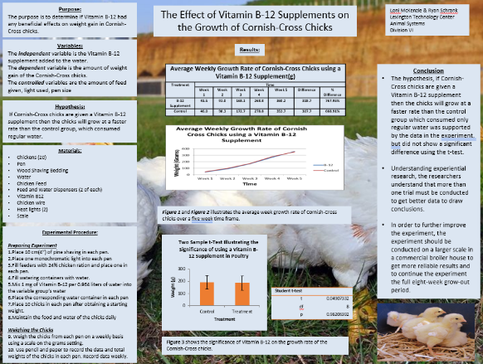
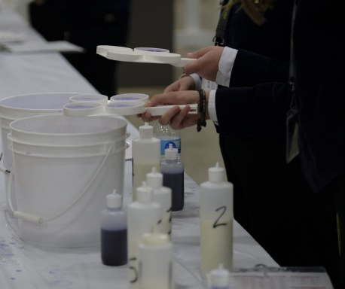
Skills

- Collaboration
- Communication
- Presentation
- Record keeping
- Research
- Scientific reasoning
- Writing
Category Options

- Animal Systems
  - The study of animal systems, including life processes, health, nutrition, genetics, management and processing, through the study of small animals, aquaculture, livestock, dairy, horses and/or poultry
- Environmental Service/Natural Resources Systems
  - Environmental Service: The study of systems, instruments of technology used to monitor and minimize the impact of human activity on environmental systems
  - Natural Resources: The study of the management, protection, enhancement and improvement of soil, water, wildlife, forests and air as natural resources
- Food Products and Processing Systems
  - The study of product development, quality assurance, food safety, production, regulation and compliance and food service within the food service industry
- Plant Systems
  - The study of plant life cycles, classifications, functions, structures, reproduction, media and nutrients, as well as growth and cultural practices, through the study of crops, turf grass, trees and shrubs and/or ornamental plants
- Power, Structural and Technical Systems
  - The study of agricultural equipment, power systems, alternative fuel sources and precision technology, as well as woodworking, metalworking, welding and project planning for agricultural structures
- Social Science
  - The study of agricultural areas including agricultural education, agribusiness, agricultural communication, agricultural leadership and sales in agriculture, food and natural resources
Agriscience Research
Students can work alone or with a partner based on age:

- 1 – Individual member in grades 7 and 8
- 2 – Team of two members in grades 7 and 8
- 3 – Individual member in grades 9 and 10
- 4 – Team of two members in grades 9 and 10
- 5 – Individual member in grades 11 and 12
- 6 – Team of two members in grades 11 and 12

Parts of your project:

- Written report
- Research notebook
- Research poster
- Research presentation
Want to be recognized for your research?

National finalists are selected in each category and division to compete at the National FFA Agriscience Fair.

Award winners will be announced on stage during the National FFA Convention & Expo.

Directions:
For agriscience research to be worthwhile, it is important to carefully plan to ensure an effective study. Follow the outline below to begin planning an agriscience research project of your own!




Step 1: Circle the agriscience research category you would like to research.
- Animal Systems

- Environmental Service/Natural Resources Systems

- Food Products and Processing Systems

- Plant Systems

- Power, Structural and Technical Systems

- Social Science
Step 2: What is your research question? What question will you try to answer?
Step 3: What are three resources that you could use to help you gain some knowledge on your topic? Ex. United States Department of Agriculture, Purdue University, etc.

- _______________________________________

- _______________________________________

- _______________________________________

Step 4: Brainstorm a list of materials you may need to complete your research. Ex. feed, soil, etc.

Why did you select this topic? What about it interests you?

How could this research help with a current problem in the agriculture industry?

What skills could you gain from completing an agriscience research project?

KEY: Appendix 7: From CDE to a Successful Business
Aligned to the following standards: AG2; AG5; CS.02 CS.05; FFA.PL-A; FFA.PL-C; FFA.PL-D; FFA.PL-E; FFA.PL-F; FFA.PG-G.; FFA.PG-I; FFA.CS-M; FFA.CS-N; FFA.CS-O; FFA.CS-P; CCSS.ELA.RI.9-10.2; CCSS.ELA.RI.9-10.4; CCSS.W.9-10.2; CCSS.W.9-10.4; CCSS.ELA.W.9-10.8; CCSS.SL.9-10.2; CCSS.SL.9-10.4; CRP.02; CRP.04; CRP.08; CRP.09
Part 1
Directions:
Read the article “From CDE to a Successful Business” in the winter 2023 issue of FFA New Horizons and answer the questions below.


1. Who is this article about? Todd Banner

2. In the box to the right, draw the state where this person was an FFA member.

3. What state does Banner currently live in? Iowa

4. The name of the company he started is:
Swamp Fox Innovations LLC

5. What is the purpose of the company?
A technology company that provides solutions to everyday challenges in the equine, livestock and recreational industries

6. He got the idea for one of his company’s products more than _______ years ago when he was an FFA member.

- 15

- 10

- 20

- 5

7. Describe the idea, referenced in Question 6, that he had for one of his company’s products.

8. What did he do after he graduated from high school?
He grew up on a cattle farm and showed animals at county and state fairs. He noticed problems with animals
drinking water. The animals weren’t drinking enough water at shows, and some were not drinking at all. He
thought the problem could be the chlorine in municipal water. Along with his agricultural sales career
development event team, he created the concept of a product that could be added to water to remove chlorine
so animals would drink more.

He got his Ph.D. in chemistry and worked for Cargill as a scientist for two decades before starting his business.

9. What did Banner major in during college?

Agriculture and Biochemistry

10. What two products did he create, and what is the purpose of those products?
Product and Purpose:
Advanced Arena® Dust Control Fluid: It reduces dust in indoor riding arenas.
Product and Purpose:
Show Fresh H20®: It instantly neutralizes the chlorine and odor in municipal water.

11. Explain how he manages his business, and explain how he credits his SAE.
He manages the business like his old SAE projects-he keeps track of expenses and sales, create awareness for the product and teach people how to use it. He was always quiet and introverted and FFA helped him gain self-confidence. His SAE projects helped him learn how to run a small business.
12. What is his advice for developing successful new products?
The key is to find unmet needs in the marketplace. Be aware of problems that exist.
13. After reading this article and answering the questions, how can you apply what you learned to your current SAE or to starting an SAE?
Answers will vary.

Part 2
Directions:
Todd Banner used scientific methods to help create and develop products for his business. Using the agriscience research information page (following this page), complete the following activities to learn about agriscience research.

- Animal Systems

- Environmental Service/Natural Resources
Systems

- Food Products and Processing Systems

- Plant Systems

- Power, Structural and Technical Systems

- Social Science

Draw a line to match the agriscience research category with the correct project opportunity. Hint: There could be more than one match for each category.
Consumer confidence and understanding of food labels

Compare plant growth of hydroponics and conventional methods

Effect of agricultural chemicals on water quality

Research new disease-control mechanisms

Control of molds on bakery products

Create minimum energy use structures

Comparison of profitability of various agricultural/natural resources practices

Effects of lunar climate and soil conditions on plant growth

Resistance of organic fruits to common diseases

Effects of growth hormone on meat/milk production

Compare water movement through different soil types

Compare properties of various alternative insulation products
Which research category interests you the most?
Answers will vary.
Why is agricultural research important?
Agricultural research is important for finding solutions to problems that exist in the industry.
Icons can be a great way for people to gain familiarity with something. Create an icon for each of the agriscience research categories. The icon should be strong enough that someone who is unfamiliar with the categories could gain a basic understanding by seeing the icon you create. Answers will vary.
Animal Systems
Environmental Service/Natural Resources Systems
Food Products and Processing Systems
Plant Systems
Power, Structural and Technical Systems
Social Science
If you love this type of work, check out the National FFA Agriscience Fair!

