Honor the Heritage
Aligned to the following standards:
AG2: AG5; FFA.PL-A; FFA.PL-C; FFA.PL_E; FFA.PL-F; FFA.PG-I; FFA.CS-N; FFA.CS-P; CS.02; CS.05; CCSS.RI.9-10.2; CCSS.RI.9-10.3; CCSS.W.9-10.4; CCSS.L.9-10.6; CRP.04; CRP.05; CRP.06
Part 1
Directions:
Read the article “Honor the Heritage” in the fall 2021 issue of FFA New Horizons and complete the following activities.
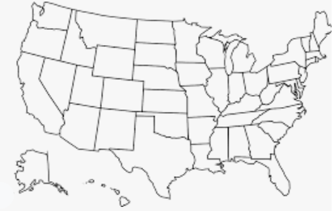
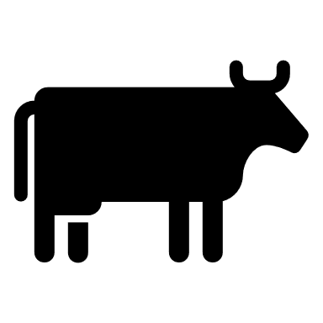
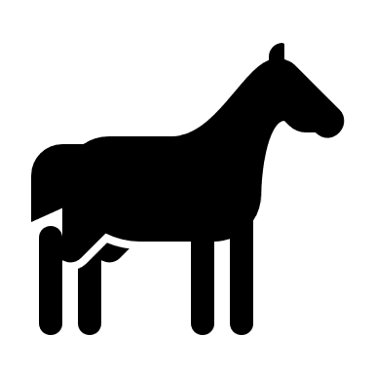
Place a on the two states the Duck Valley Indian Reservation spans.
Identify four skills Cummins has gained from his cattle operation.
1.
2.
3.
4.
What does Cummins enjoy about having his own herd?
What are three tasks Cummins completed in his SAE for his cattle operation?
1.
2.
3.
4.
What craft did Cummins learn from his dad?

___________________________
How many head of cattle does Cummins now manage?
- 10
- 20
- 30
- 40
- 50
What percentage of the Duck Valley FFA Chapter population is native?
- 25%
- 50%
- 75%
- 100%
What are two physical characteristics of this breed of cattle? Tip: Use this resource to help you: http://afs.okstate.edu/breeds/cattle/.
1.
2.
What breed of cattle does Cummins raise?
- Angus
- Hereford
- Simmental
- Holstein

Part 2
Directions:
Leather is a by-product of the meat-animal industry. Complete the following activities to gain a better understanding of the production process that goes into producing leather.
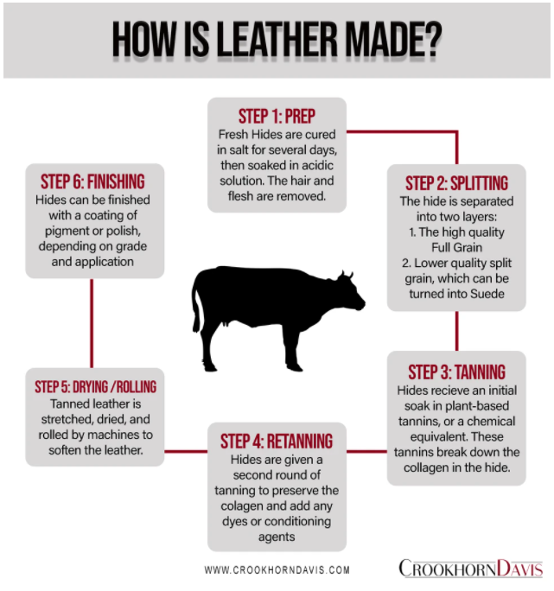
Why do you think leather is such a common product in our homes/lives?
Step 4:
Step 5:
Step 6:
Step 3:
Step 2:
Step 1:
Using this resource, https://www.trafalgarstore.com/blogs/news/how-is-leather-made-1, and the chart below, answer the following questions about each step:
- Why is this step performed?
- What would happen if this step was skipped?
Think about the things in your house. Identify
five items that are made of leather.
1.
2.
3.
4.
5.

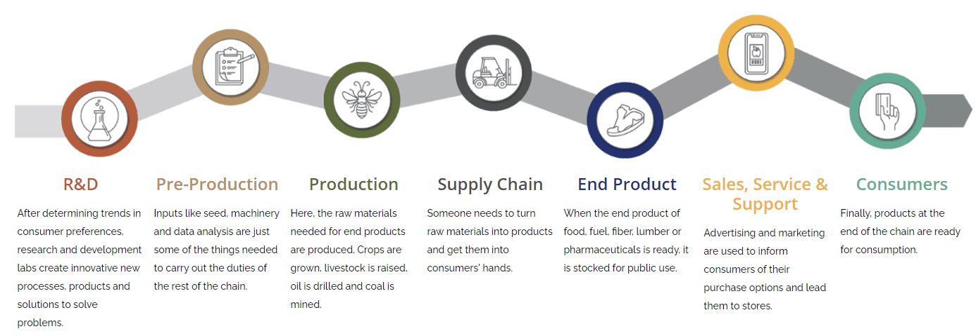
Directions:
Using the Agriculture, Food and Natural Resources (AFNR) Value Chain (shown below), identify where the following processes in leather making would occur along the AFNR Value Chain by drawing arrows to the different steps.

- Hide salting and curing
- Hair and flesh removed
- Initial hide soak
- Consumer purchases the leather product/good
- Hide finished with coating

- Stretching and drying
- Second round of tanning
- Hide made into leather goods
- Leather product/good marketed to the consumer
- Hide separated
- Leather stocked in stores for sale
Directions:
Use this resource, https://www.trafalgarstore.com/blogs/news/how-is-leather-made-1, to answer the following questions. Use the underlined letters to unscramble the hidden word.

- The hides are packed in salt to prevent ____________l_______g.
- Liming helps to break down the stiffened ___________a________.
- ____________i_____ is the final step to turn the hide into a useable leather product.
- One form of tanning is ____________________e tanning, which is the oldest form of tanning.
- Today, many leather products are tanned by using C_______________u______.
- This process of tanning is faster: ______r_________u________.
- Lastly, leather may receive a coating of ___________________t to mask any imperfections.

_______ _______ _______ _______ _______ _______ _______ _______ _______ _______ _______

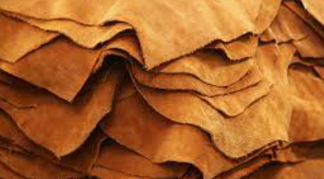
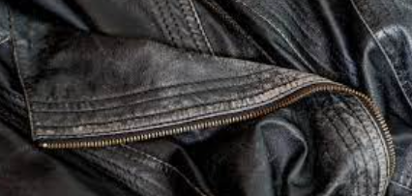
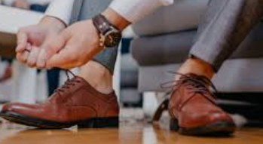
In two to three sentences, describe the leather production process and its impact on the economy and our day-to-day lives.
What role does leather production have in the agriculture industry? What would happen if we did not produce leather?
Using AgExplorer.FFA.org, identify three careers that exist in leather production and the tasks performed within those careers.

- __________________________:

- __________________________:

- __________________________:
What personality traits do you think you should have if you want to work in the leather production industry? Identify a minimum of three.

1.

2.

3.
How does the leather industry impact you every day?
What would life be like without leather?
KEY: Honor the Heritage
Aligned to the following standards:
AG2: AG5; FFA.PL-A; FFA.PL-C; FFA.PL_E; FFA.PL-F; FFA.PG-I; FFA.CS-N; FFA.CS-P; CS.02; CS.05; CCSS.RI.9-10.2; CCSS.RI.9-10.3; CCSS.W.9-10.4; CCSS.L.9-10.6; CRP.04; CRP.05; CRP.06
Part 1
Directions:
Read the article “Honor the Heritage” in the fall 2021 issue of FFA New Horizons and complete the following activities.
Place a on the two states the Duck Valley Indian Reservation spans.
Identify four skills Cummins has gained from his cattle operation. Answers will vary.
1.
2.
3.
4.
What are three tasks Cummins completed in his SAE for his cattle operation? Record weights, record of color, feed ratios, medicine doses given, costs
1.
2.
3.
4.
What breed of cattle does Cummins raise?
- Angus
- Hereford
- Simmental
- Holstein
What does Cummins enjoy about having his own herd? The opportunity to build a bigger and better business.
What craft did Cummins learn from his dad?

Leatherworking
How many head of cattle does Cummins now manage?
- 10
- 20
- 30
- 40
- 50
What percentage of the Duck Valley FFA Chapter population is native?
- 25%
- 50%
- 75%
- 100%
What are two physical characteristics of this breed of cattle? Tip: Use this resource to help you: http://afs.okstate.edu/breeds/cattle/. Answers will vary.
1.
2.

Part 2
Directions:
Leather is a by-product of the meat-animal industry. Complete the following activities to gain a better understanding of the production process that goes into producing leather.
Why do you think leather is such a common product in our homes/lives?
Answers will vary.
Step 4: Further prepares the leather for the final product. The leather would not be as smooth and flexible without this step.
Step 5: Soft leather is expected by consumers.
Step 6: This allows imperfections to be masked to ensure durability.
Step 3: Tanning allows for the leather to be more flexible and to resist rotting when wet.
Step 2: This step allows for multiple different products to be produced. We would not have as much product from one hide.
Step 1: Prevents molding/decay. If this step was skipped, we would have hides that would decay/rot before they could be turned into a final leather product.
Using this resource, https://www.trafalgarstore.com/blogs/news/how-is-leather-made-1, and the chart below, answer the following questions about each step:
- Why is this step performed?
- What would happen if this step was skipped?
Think about the things in your house. Identify
five items that are made of leather.
1. Answers will vary.
2.
3.
4.
5.

Directions:
Using the Agriculture, Food and Natural Resources (AFNR) Value Chain (shown below), identify where the following processes in leather making would occur along the AFNR Value Chain by drawing arrows to the different steps.

- Hide salting and curing Supply chain
- Hair and flesh removed Supply Chain
- Initial hide soak Supply Chain
- Consumer purchases the leather product/good Consumers
- Hide finished with coating Supply Chain

- Stretching and drying Supply Chain
- Second round of tanning Supply Chain
- Hide made into leather goods Supply Chain
- Leather product/good marketed to the consumer Sales, Service and Support
- Hide separated Supply Chain
- Leather stocked in stores for sale End Product
Directions:
Use this resource, https://www.trafalgarstore.com/blogs/news/how-is-leather-made-1, to answer the following questions. Use the underlined letters to unscramble the hidden word.

- The hides are packed in salt to prevent spoiling.
- Liming helps to break down the stiffened colagen.
- Tanning is the final step to turn the hide into a useable leather product.
- One form of tanning is vegetable tanning which is the oldest form of tanning.
- Today, many leather products are tanned by using chromium.
- This process of tanning is faster: chromium.
- Lastly, leather may receive a coating of pigment to mask any imperfections.

AGRICULTURE

In two to three sentences, describe the leather production process and its impact on the economy and our day-to-day lives.
Answers will vary.
What role does leather production have in the agriculture industry? What would happen if we did not produce leather? Answers will vary. Example answer: Leather sales are a large part of the economy, adding money to the buying and selling of goods. If we did not have leather, we would not have many of the products we have come to accept, and there would potentially be a large amount of waste from the livestock industry after animal processing.
Using AgExplorer.FFA.org, identify three careers that exist in leather production and the tasks performed within those careers. Answers will vary.

- __________________________:

- __________________________:

- __________________________:
What personality traits do you think you should have if you want to work in the leather production industry? Identify a minimum of three.
Answers will vary.

1.

2.

3.
How does the leather industry impact you every day?
Answers will vary.
What would life be like without leather?
Without leather we would not have a lot of the items we have come to expect in our everyday lives. Examples: leather seats in our cars, leather wallets/purses, etc. Also, with leather being a by-product of the livestock industry, we are ensuring we are using all parts of the animal.

