Appendix 8: Rise of the Robots
Aligned to the following standards:
CS.01; CS.02; FFA.PL-A; FFA.PL-C; FFA.PL-F; FFA.PG-I; FFA.PG-J; FFA.CS-N; AG1; AG2; AGC10.03; AGC10.04; CCSS.SL.9-10.2; CCSS.SL.9-10.4; CCSS.WHST.9.10.1; CCSS.WHST.9.10.4; CCSS.MP3; CRP.02; CRP.04; CRP.05; CRP.06; CRP 07; CRP.08

Created: Winter 2018 by the National FFA Organization
Directions:
There have been many changes in technology throughout history. Watch the following two cartoon video clips from The Flintstones and The Jetsons, and identify five technology differences.
Identify five technology differences between the two videos.

- __________________________________________________________________________________________________
- __________________________________________________________________________________________________
- __________________________________________________________________________________________________
- __________________________________________________________________________________________________
- __________________________________________________________________________________________________
The Flintstones Clip: https://youtu.be/uq7noaMwLfg . The Jetsons Clip: https://youtu.be/0JQbeCAlF6s.

Which video are we more like today?

______________________________________
Watch the video available here: https://www.youtube.com/watch?v=4qrlFse5I1U. Why might the use of technology such as robots be controversial in the agriculture industry?

How do you think technology will change over the next 50 years?



Directions:
Aligned to the following standards:
CS.01; CS.02; FFA.PL-A; FFA.PL-C; FFA.PL-F; FFA.PG-I; FFA.PG-J; FFA.CS-N; AG1; AG2; AGC10.03; AGC10.04; CCSS.SL.9-10.2; CCSS.SL.9-10.4; CCSS.WHST.9.10.1; CCSS.WHST.9.10.4; CCSS.MP3; CRP.02; CRP.04; CRP.05; CRP.06; CRP 07; CRP.08

Currently, the way robots are used in agriculture is a “hot-button” topic. In FFA, the agricultural issues forum leadership development event gives students the opportunity to show both sides of an issue through research and presentations. Below, answer the questions about how robots are being used in agriculture. Use the empty space to record your notes.

- Why is this issue important now?
- What is the nature of the issue?
- Who is involved in the issue?
- How can the issue be defined?
- What is the historical background of the issue?
- What caused the issue?
- What are the risks?
- What are the benefits?





Directions:
Aligned to the following standards:
CS.01; CS.02; FFA.PL-A; FFA.PL-C; FFA.PL-F; FFA.PG-I; FFA.PG-J; FFA.CS-N; AG1; AG2; AGC10.03; AGC10.04; CCSS.SL.9-10.2; CCSS.SL.9-10.4; CCSS.WHST.9.10.1; CCSS.WHST.9.10.4; CCSS.MP3; CRP.02; CRP.04; CRP.05; CRP.06; CRP 07; CRP.08

Watch the video “How to Make a Paper Slideshow,” available at https://youtu.be/E5RXynA_D3I. Create a paper slideshow video that details the agricultural issue of robotics in agriculture. Videos should last a minimum of 60 to 90 seconds. If you do not have access to technology to film this, then complete the paper portion only. Use the questions from above and information from the article to help you develop your paper slideshow. Use the template below to plan your paper slideshow. You can have as many or as few paper slides as you like as long as all questions from above are covered and you meet the requirements outlined on the attached rubric. (Illustrations go in the boxes and your narration on the lines.)

Robotics in Agriculture
Slide One:
Narration:

__________________________________________

__________________________________________

__________________________________________

__________________________________________

__________________________________________

Slide Two:

Narration: Narration:

__________________________________________

__________________________________________

__________________________________________

__________________________________________

__________________________________________

Slide Three:
Narration:

__________________________________________

__________________________________________

__________________________________________

__________________________________________

__________________________________________

Slide Four:
Narration:

__________________________________________

__________________________________________

__________________________________________

__________________________________________

__________________________________________

Narration:
Slide Five:

__________________________________________

__________________________________________

__________________________________________

__________________________________________

__________________________________________

Narration:
Slide Six:

__________________________________________

__________________________________________

__________________________________________

__________________________________________

__________________________________________

Slide Seven:
Narration:

__________________________________________

__________________________________________

__________________________________________

__________________________________________

__________________________________________

Narration:
Slide Eight:

__________________________________________

__________________________________________

__________________________________________

__________________________________________

__________________________________________

Paper Slideshow Video Rubric
Aligned to the following standards:
CS.01; CS.02; FFA.PL-A; FFA.PL-C; FFA.PL-F; FFA.PG-I; FFA.PG-J; FFA.CS-N; AG1; AG2; AGC10.03; AGC10.04; CCSS.SL.9-10.2; CCSS.SL.9-10.4; CCSS.WHST.9.10.1; CCSS.WHST.9.10.4; CCSS.MP3; CRP.02; CRP.04; CRP.05; CRP.06; CRP 07; CRP.08

Area | 4 Points | 3 Points | 2 Points | 1 Point
Content | All content is accurate. There are no factual errors. | Most of the content is accurate, but there is one piece of information that seems inaccurate. | The content is generally accurate, but one piece of information is clearly inaccurate. | Content is confusing or contains more than one factual error.
Clarity and Neatness | The paper slideshow is easy to read, and all elements are clearly written, labeled and drawn. Creativity was used. | The paper slideshow is easy to read, and most elements are clearly written, labeled and drawn. Some creativity was used. | The paper slideshow is hard to read with rough drawings, labels and color. Little creativity was used. | The paper slideshow is hard to read, and one cannot tell what goes where or what the illustrations represent. No creativity was used.
Narration and Preparedness | The paper slideshow is clearly rehearsed and narrated with no mistakes.  Student spoke slowly and clear. | One mistake is heard in the paper slideshow video. | Two mistakes are heard in the paper slideshow video. | Three or more mistakes are heard in the paper slideshow video.  Student spoke very fast and was unclear.
Time | Student met or exceeded the 60- to 90-second timeframe. |  |  | Student was under the allotted time frame.
 |  |  |  | Total: _______

Comments:

___________________________________________________________________________________________________

___________________________________________________________________________________________________

___________________________________________________________________________________________________

___________________________________________________________________________________________________

KEY — Appendix 8: Rise of the Robots
Aligned to the following standards:
CS.01; CS.02; FFA.PL-A; FFA.PL-C; FFA.PL-F; FFA.PG-I; FFA.PG-J; FFA.CS-N; AG1; AG2; AGC10.03; AGC10.04; CCSS.SL.9-10.2; CCSS.SL.9-10.4; CCSS.WHST.9.10.1; CCSS.WHST.9.10.4; CCSS.MP3; CRP.02; CRP.04; CRP.05; CRP.06; CRP 07; CRP.08

Created: Winter 2018 by the National FFA Organization
Directions:
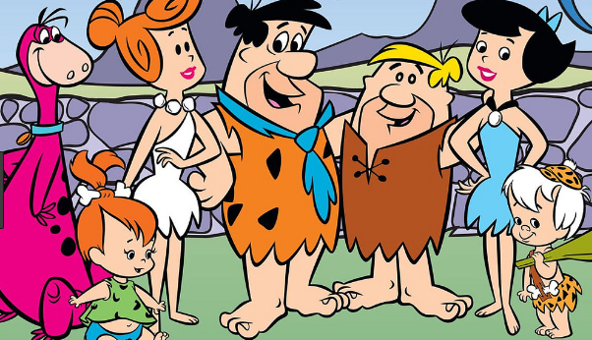
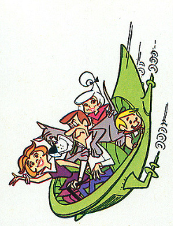
There have been many changes in technology throughout history. Watch the following two cartoon video clips from The Flintstones and The Jetsons, and identify five technology differences.
Identify five technology differences between the two videos.

- __________Answers will vary._________________________ _________________________________________________
- __________________________________________________________________________________________________
- __________________________________________________________________________________________________
- __________________________________________________________________________________________________
- __________________________________________________________________________________________________
The Flintstones Clip: https://youtu.be/uq7noaMwLfg . The Jetsons Clip: https://youtu.be/0JQbeCAlF6s.

Which video are we more like today?

______________________________________
Watch the video available here: https://www.youtube.com/watch?v=4qrlFse5I1U. Why might the use of technology such as robots be controversial in the agriculture industry?
Answers will vary.

How do you think technology will change over the next 50 years? Answers will vary.

