Appendix 8: Vocabulary Activity
Aligned to the following standards:
FFA.PL-A; FFA.PL-E; FFA.PL-F; FFA.PG-I; FFA.PG-J; FFA.CS-M; FFA.CS-N; FFA.CS-O; CCSS.ELA.WHST.9.10.4; CCSS.ELA.RI.9-10.2, CCSS.ELA.RI.9-10.4; CCSS.ELA.W.9-10.2; CCSS.SL.9-10.4; CCSS.ELA.SL.9-10.4; CRP.02; CRP.04
directions:
Use the vocabulary words listed below to complete the activity.
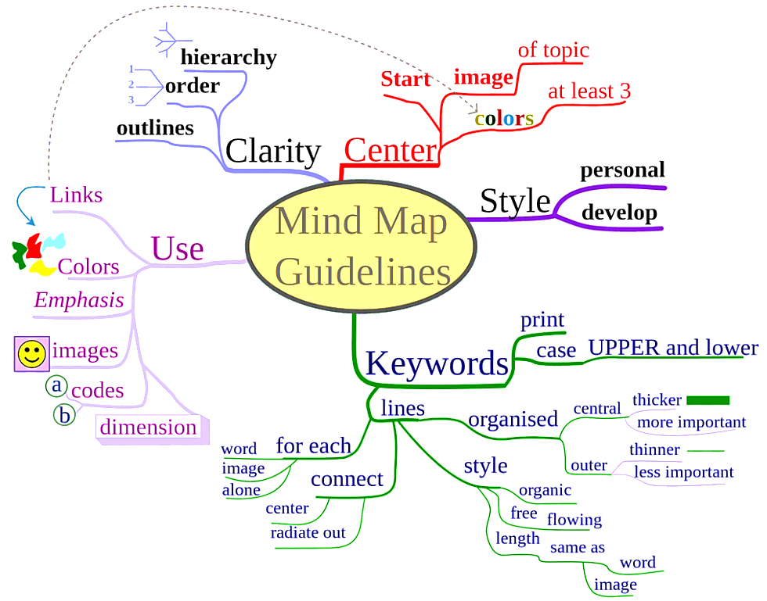
Activity reference: https://www.readingandwritinghaven.com/5-brain-based-vocabulary-activities-for-the-secondary-classroom/

Step 1: From the list, circle four words that you want to learn more about.

Step 2: From your circled words, create a mind map for each word. See example of a mind map to the right. It is an example of a mind map and includes guidelines on how to create one. Use the space on the next page to create your mind maps.

Entrepreneur
Inventor
Overachieve
Perspective
Agritourism
Attraction
Undertaking
Biodiversity
Colony
Nectar
Pollinator
Pollen
Sustainability
Agricultural advocate
Agricultural literacy

Census
Communication
Sustainability
Pollinator
Conservationists
Initiative
Habitat
Stewardship
Innovators
Geneticists
Bonobos
Cognitive
Wind turbine
Symposiums
Tilapia

Hydroponics
Enrichment
Bulrush reeds
Erosion
Marsh
Perennial
Wetland
Ecosystem
Bayou

Vocabulary words:

Mind Map 1

Mind Map 2

Mind Map 3

Mind Map 4

