Appendix 2: National Hispanic Heritage Month
Aligned to the following standards:
FFA.PL-A; FFA.PL-C; FFA.PL-E; FFA.PG-J; FFA.CS-N; CCSS.ELA.RI.9-10.2; CCSS.ELA.WHST.9-10.4; MP5; MP6; CRP.02; CRP.04
Created: Fall 2019 by the National FFA Organization
Part 1
Directions:
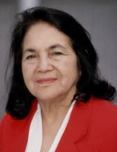
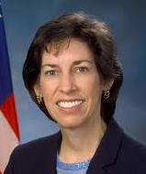
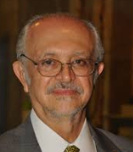
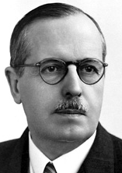
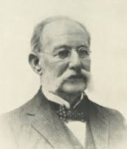
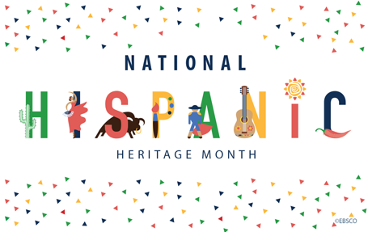
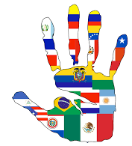
Read the “Here’s to Our Latino Members” article in the Fall 2019 issue of FFA New Horizons and complete the following activities. Using the internet, research famous Latinos in history to unscramble each name. Then cut out and glue the picture and name to a blank piece of paper. Next, identify the historical date range and accomplishment of each individual and glue them next to the picture. There will be one historical date range and one accomplishment for each picture.
LLENE OOHCA
___ ___ ___ ___ ___

___ ___ ___ ___ ___ ___
OMRIA AOILNM
___ ___ ___ ___ ___

___ ___ ___ ___ ___ ___
DONARRBE SSYAOHU
___ ___ ___ ___ ___ ___ ___ ___

___ ___ ___ ___ ___ ___ ___
SCLROA YLINFA
___ ___ ___ ___ ___ ___

___ ___ ___ ___ ___ ___
SLORDEO THAURE
___ ___ ___ ___ ___ ___ ___

___ ___ ___ ___ ___ ___
Why is it important to gain an understanding about other cultures and heritages?
What percent of FFA membership is Hispanic?

___________________________
What is the date range for National Hispanic Heritage Month?

___________________________

Accomplishment

Studied the pituitary gland and blood sugar, which led to better understanding and management for diabetes

First Latino to travel to space
Studies informational processing

First scientist to begin making the connection between mosquitos and yellow fever

Labor activist who helped to create the United Farm Workers of America

Studied and brought attention to chlorofluorocarbons (CFCs) and the damage they can cause to the environment and ozone
Aligned to the following standards:
FFA.PL-A; FFA.PL-E; FFA.CS-N; FFA.PG-J; FFA.PL-C; CCSS.ELA.RI.9-10.2; CCSS.ELA.WHST.9-10.4; MP5; MP6; CRP.02; CRP.04

Dates in History

1833–1915

1887–1971

1930–present

1943–present

1958–present



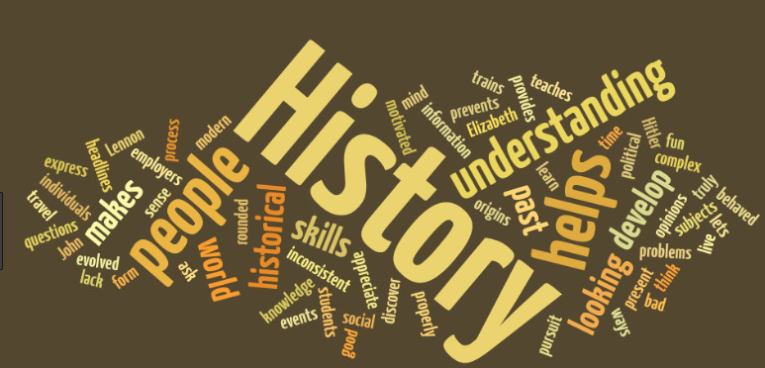

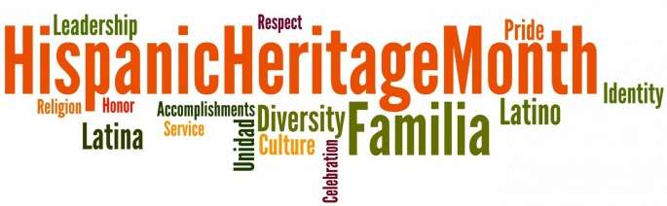

Part 2
Directions:
Select a country that has Hispanic roots and Spanish as the official language (Ex. Spain, Argentina, etc.) that does not share a border with the United States. Complete the following.

- Select a country: _______________________________________

- Draw and color the flag of the country you selected.

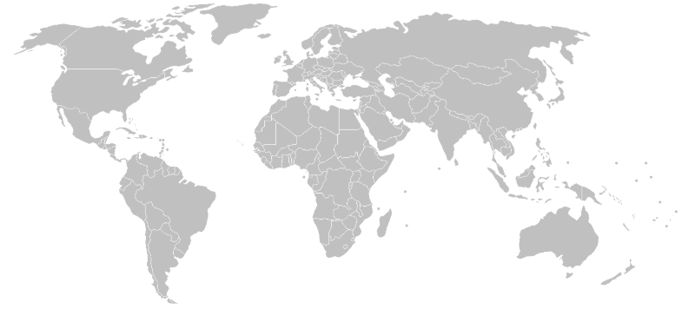
- Locate and label the country and capital on the map.
- What is the top export for the country? _________________________________________

- What is the top agricultural commodity? ________________________________________

- What type of government structure do they have? (Ex. monarchy) _____________________________________

- In three to five sentences, describe why a person would want to visit this country.

KEY — Appendix 2: National Hispanic Heritage Month
Aligned to the following standards:
FFA.PL-A; FFA.PL-E; FFA.CS-N; FFA.PG-J; FFA.PL-C; CCSS.ELA.RI.9-10.2; CCSS.ELA.WHST.9-10.4; MP5; MP6; CRP.02; CRP.04
Created: Fall 2019 by the National FFA Organization
Directions:
Read the “Here’s to Our Latino Members” article in the Fall 2019 issue of FFA New Horizons and complete the following activities. Using the internet, research famous Latinos in history to unscramble each name. Then cut out and glue the picture and name to a blank piece of paper. Next, identify the historical date range and accomplishment of each individual and glue them next to the picture. There will be one historical date range and one accomplishment for each picture.
What is the date range for National Hispanic Heritage Month?

Sept. 15 to Oct. 15, 2019
What percent of FFA membership is Hispanic?

15.45%

LLENE OOHCA
Ellen Ochoa
(1958–present) First Hispanic to travel to space; studies informational processing
OMRIA AOILNM
Mario Molina
(1943–present) Studied and brought attention to chlorofluorocarbons (CFCs) and the damage they can cause to the environment and ozone
DONARRBE SSYAOHU
Bernardo Houssay
(1887–1971) Studied the pituitary gland and blood sugar, which led to better understanding and management for diabetes
SCLROA YLINFA
Carlos Finlay
(1833–1915) First scientist to begin making the connection between mosquitos and yellow fever
SLORDEO THAURE
Delores Huerta
(1930–present) Labor activist who helped to create the United Farm Workers of America
Why is it important to gain an understanding about other cultures and heritages?
Answers will vary.

