From Dreaming to Primetime
Created: 12/2021 by the National FFA Organization
Description of Lesson: In this retiring address, 2020-21 National FFA Southern Region Vice President Artha Jonassaint discusses how dreams are the beginning of extraordinary actions.
Student Learning Objectives:
After completing these activities, students will …
- Identify the steps to being extraordinary.
- Create a mural to depict a personal dream, how to show love and a plan of how to take action.

Suggested Grade Level:
Grades 9 and 10 (This lesson is written so instructors can scale up or down based on class needs.)

Suggested Time: 45 minutes (*Time requirements may vary based upon student understanding and class schedule.)
Resources/References:
- Video: “Artha Jonassaint Retiring Address,” https://vimeo.com/640503378

Related Resources:
- Retiring Addresses and Keynotes, FFA.org/ffa-video-center/convention-keynotes-and-retiring-addresses/

Equipment and Supplies Needed:
- A copy of the “From Dreaming to Primetime” worksheet for each student
- Internet access to play the video in real time or embed it in a PowerPoint ahead of time

Vocabulary:
- Dream
- Extraordinary
- Primetime

Cross-Curricular Connections:
English/Language Arts
Develop and describe a mural.

Virtual Instruction Ideas:
Have students download and watch the video on a device of their choice and complete the worksheet.

Student Activity Sheets:
Direct access to student activity sheets without lesson plan or answer key for easy upload to a learning management system or printing for classwork.

https://ffa.box.com/s/toijfdy4fxglk0t9yythfr54jawjc914 (Word)
https://ffa.box.com/s/oeqdvgqtd85ywbovqxqjhvwrc6sw0bbl (Non-Designed)
https://ffa.box.com/s/z255ozd5catus8xie4c6v89i5e262oo9 (PDF)
https://docs.google.com/document/d/18ZCVPMq4a8VYMD6HI0dta5jPJvTOscMk92b-zi5-BrA/copy (Google)

These Activities are Aligned to the Following Standards:
FFA Precept
- FFA.PL-A.Action: Assume responsibility and take the necessary steps to achieve the desired results, no matter what the goal or task at hand.
- FFA.PL-C.Vision: Visualize the future and how to get there.
- FFA.PL-E.Awareness: Understand personal vision, mission and goals.
- FFA.PG-J.Mental Growth: Embrace cognitive and intellectual development relative to reasoning, thinking and coping.
- FFA.CS-N.Decision Making: Analyze a situation and execute an appropriate course of action.
Common Core – Writing
- CCSS.ELA-Literacy.W.9-10.4: Produce clear and coherent writing in which the development, organization, and style are appropriate to task, purpose, and audience.
AFNR Career Ready Practices
- CRP.02: Apply appropriate academic and technical skills. Career-ready individuals readily access and use the knowledge and skills acquired through experience and education to be more productive.
- CRP.04: Communicate clearly, effectively, and with reason. Career-ready individuals communicate thoughts, ideas and action plans with clarity, whether using written, verbal and/or visual methods.
- CRP.06: Demonstrate creativity and innovation. Career-ready individuals regularly think of ideas that solve problems in new and different ways, and they contribute those ideas in a useful and productive manner to improve their organization.
- CRP.08: Utilize critical thinking to make sense of problems and persevere in solving them. Career-ready individuals readily recognize problems in the workplace, understand the nature of the problem, and devise effective plans to solve the problem.
Partnership for 21st Century Skills
- Critical Thinking and Problem Solving
- Flexibility and Adaptability
- Initiative and Self-Direction
- Leadership and Responsibility
Lesson Plan:
- Bell Ringer: Describe a dream that you have had this month. What do you think it means?

- Introduction: We spend roughly one-third of our lives sleeping, and the best part is dreaming. The other two-thirds of our lives are left for being extraordinary. Today, we are going to watch a retiring address from the 94th National FFA Convention & Expo. This retiring address was given by 2020-21 National FFA Southern Region Vice President Artha Jonassaint. In her speech, she discusses how dreams are merely the beginning to extraordinary actions.

Before watching the video, look over the questions on the “From Dreaming to Primetime” worksheet, and be ready to listen for the answers as you view the video.

- Activity: Each student needs a copy of the worksheet “From Dreaming to Primetime.”
  - Part 1: Have students complete the activities while watching the retiring address of 2020-21 National FFA Southern Region Vice President Artha Jonassaint. The video is available at https://vimeo.com/640503378.
  - Part 2: Murals are fabulous works of art that convey meaning and/or stories. Using the space provided, have students create a mural to depict their dream, how they will show love and the action they will take related to their dream and showing love. Note: This can be something for the future or something that they are currently working on. Students should be sure to include lots of color and pictures to accurately represent their thoughts.

- Follow-up: Have students hang up their murals in the classroom.

- Exit Ticket: How would you describe what you learned from this retiring address to a classmate?

From Dreaming to Primetime
Aligned to the following standards:
FFA.PL-A; FFA.PL-C; FFA.PL-E; FFA.PG-J; FFA.CS-N; CCSS.ELA.W.9-10.4; CRP.02; CRP.04; CRP.06; CRP.08
Part 1
Directions:





Complete the following activities while watching the retiring address of 2020-21 National FFA Southern Region Vice President Artha Jonassaint. The video is available at https://vimeo.com/640503378.
According to Artha, two-thirds of our lives are spent being

E___________________y.
According to Artha, how much of our lives are spent sleeping?

_____________________
Dreaming gives us something to

_______________ for.
What are the steps to an extraordinary life?

- D________________________
- L________________________
- D_________ m____________ = d_________________ + l__________
  - What are three things Artha says this equation means?
    - Use your v________________________________.
    - Do _____________________________________________________________________________________.
    - Invite ____________________________________.
Consider what Artha says about this word. What does it mean to you?
What will you dream about?

How will you show love to others?

What are you going to do with the answers to the first two questions?
Part 2
Directions:
Murals are fabulous works of art that convey meaning and/or stories. Using the space below, create a mural to depict your dream, how you will show love and the action you will take related to your dream and showing love. Note: This can be something for the future or something that you are currently working on. Be sure to include lots of color and pictures to accurately represent your thoughts.
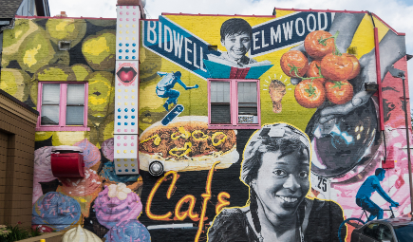
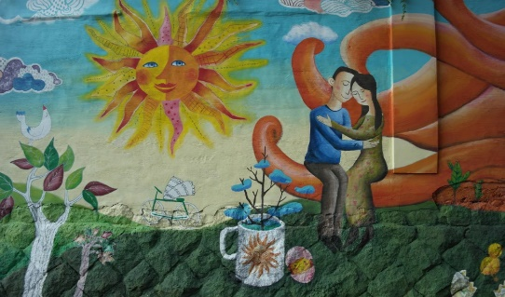
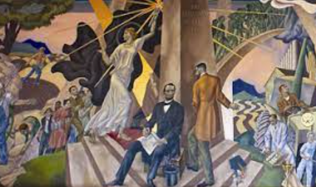

Write a brief description of your mural. Be sure to discuss how the dream, showing love and the action are represented.
KEY: From Dreaming to Primetime
Part 1
Directions:
Complete the following activities while watching the retiring address of 2020-21 National FFA Southern Region Vice President Artha Jonassaint. The video is available at https://vimeo.com/640503378.
According to Artha, two-thirds of our lives are spent being

Extraordinary.
According to Artha, how much of our lives are spent sleeping?

1/3
Dreaming gives us something to

work for.
What are the steps to an extraordinary life?

- Dreaming
- Love
- Doing more = dreaming + love
  - What are three things Artha says this equation means?
    - Use your voice.
    - Do what is right, not popular.
    - Invite people.
Consider what Artha says about this word. What does it mean to you? Answers will vary.
What will you dream about? Answers will vary.

How will you show love to others? Answers will vary.

What are you going to do with the answers to the first two questions? Answers will vary.

Part 2
Directions:
Murals are fabulous works of art that convey meaning and/or stories. Using the space below, create a mural to depict your dream, how you will show love and the action you will take related to your dream and showing love. Note: This can be something for the future or something that you are currently working on. Be sure to include lots of color and pictures to accurately represent your thoughts. Answers will vary.
Write a brief description of your mural. Be sure to discuss how the dream, showing love and the action are represented.
Answers will vary.
Answers will vary.

