From Dreaming to Primetime
Aligned to the following standards:
FFA.PL-A; FFA.PL-C; FFA.PL-E; FFA.PG-J; FFA.CS-N; CCSS.ELA.W.9-10.4; CRP.02; CRP.04; CRP.06; CRP.08
Part 1
Directions:





Complete the following activities while watching the retiring address of 2020-21 National FFA Southern Region Vice President Artha Jonassaint. The video is available at https://vimeo.com/640503378.
According to Artha, two-thirds of our lives are spent being

E___________________y.
According to Artha, how much of our lives are spent sleeping?

_____________________
Dreaming gives us something to

_______________ for.
What are the steps to an extraordinary life?

- D________________________
- L________________________
- D_________ m____________ = d_________________ + l__________
  - What are three things Artha says this equation means?
    - Use your v________________________________.
    - Do _____________________________________________________________________________________.
    - Invite ____________________________________.
Consider what Artha says about this word. What does it mean to you?
What will you dream about?

How will you show love to others?

What are you going to do with the answers to the first two questions?
Part 2
Directions:
Murals are fabulous works of art that convey meaning and/or stories. Using the space below, create a mural to depict your dream, how you will show love and the action you will take related to your dream and showing love. Note: This can be something for the future or something that you are currently working on. Be sure to include lots of color and pictures to accurately represent your thoughts.
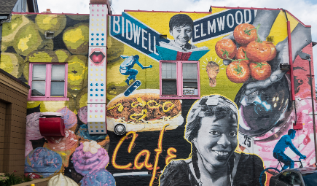
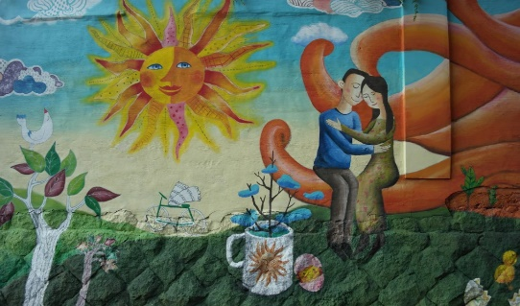
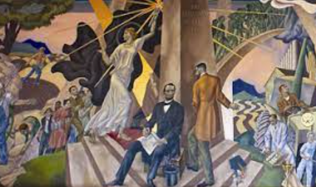

Write a brief description of your mural. Be sure to discuss how the dream, showing love and the action are represented.

