Organic Oat Hay
Aligned to the following standards:
PS.03; FFA.PL-A; FFA.PL-C; FFA.PL-E; FFA.PL-F; FFA.PG-I; FFA.CS-M; CCSS.SL.9-10.1; CCSS.SL.9-10.2; CRP.04; CRP.10

Directions:
Answer the questions below as you watch the video “Bailey Morrell – SAE – Organic Oat Hay.” The video URL is https://vimeo.com/279517525.

What motivated Bailey to start this SAE project?
What is Bailey’s SAE project?

Bailey’s beginning steps:

1.

2.

3.

4.

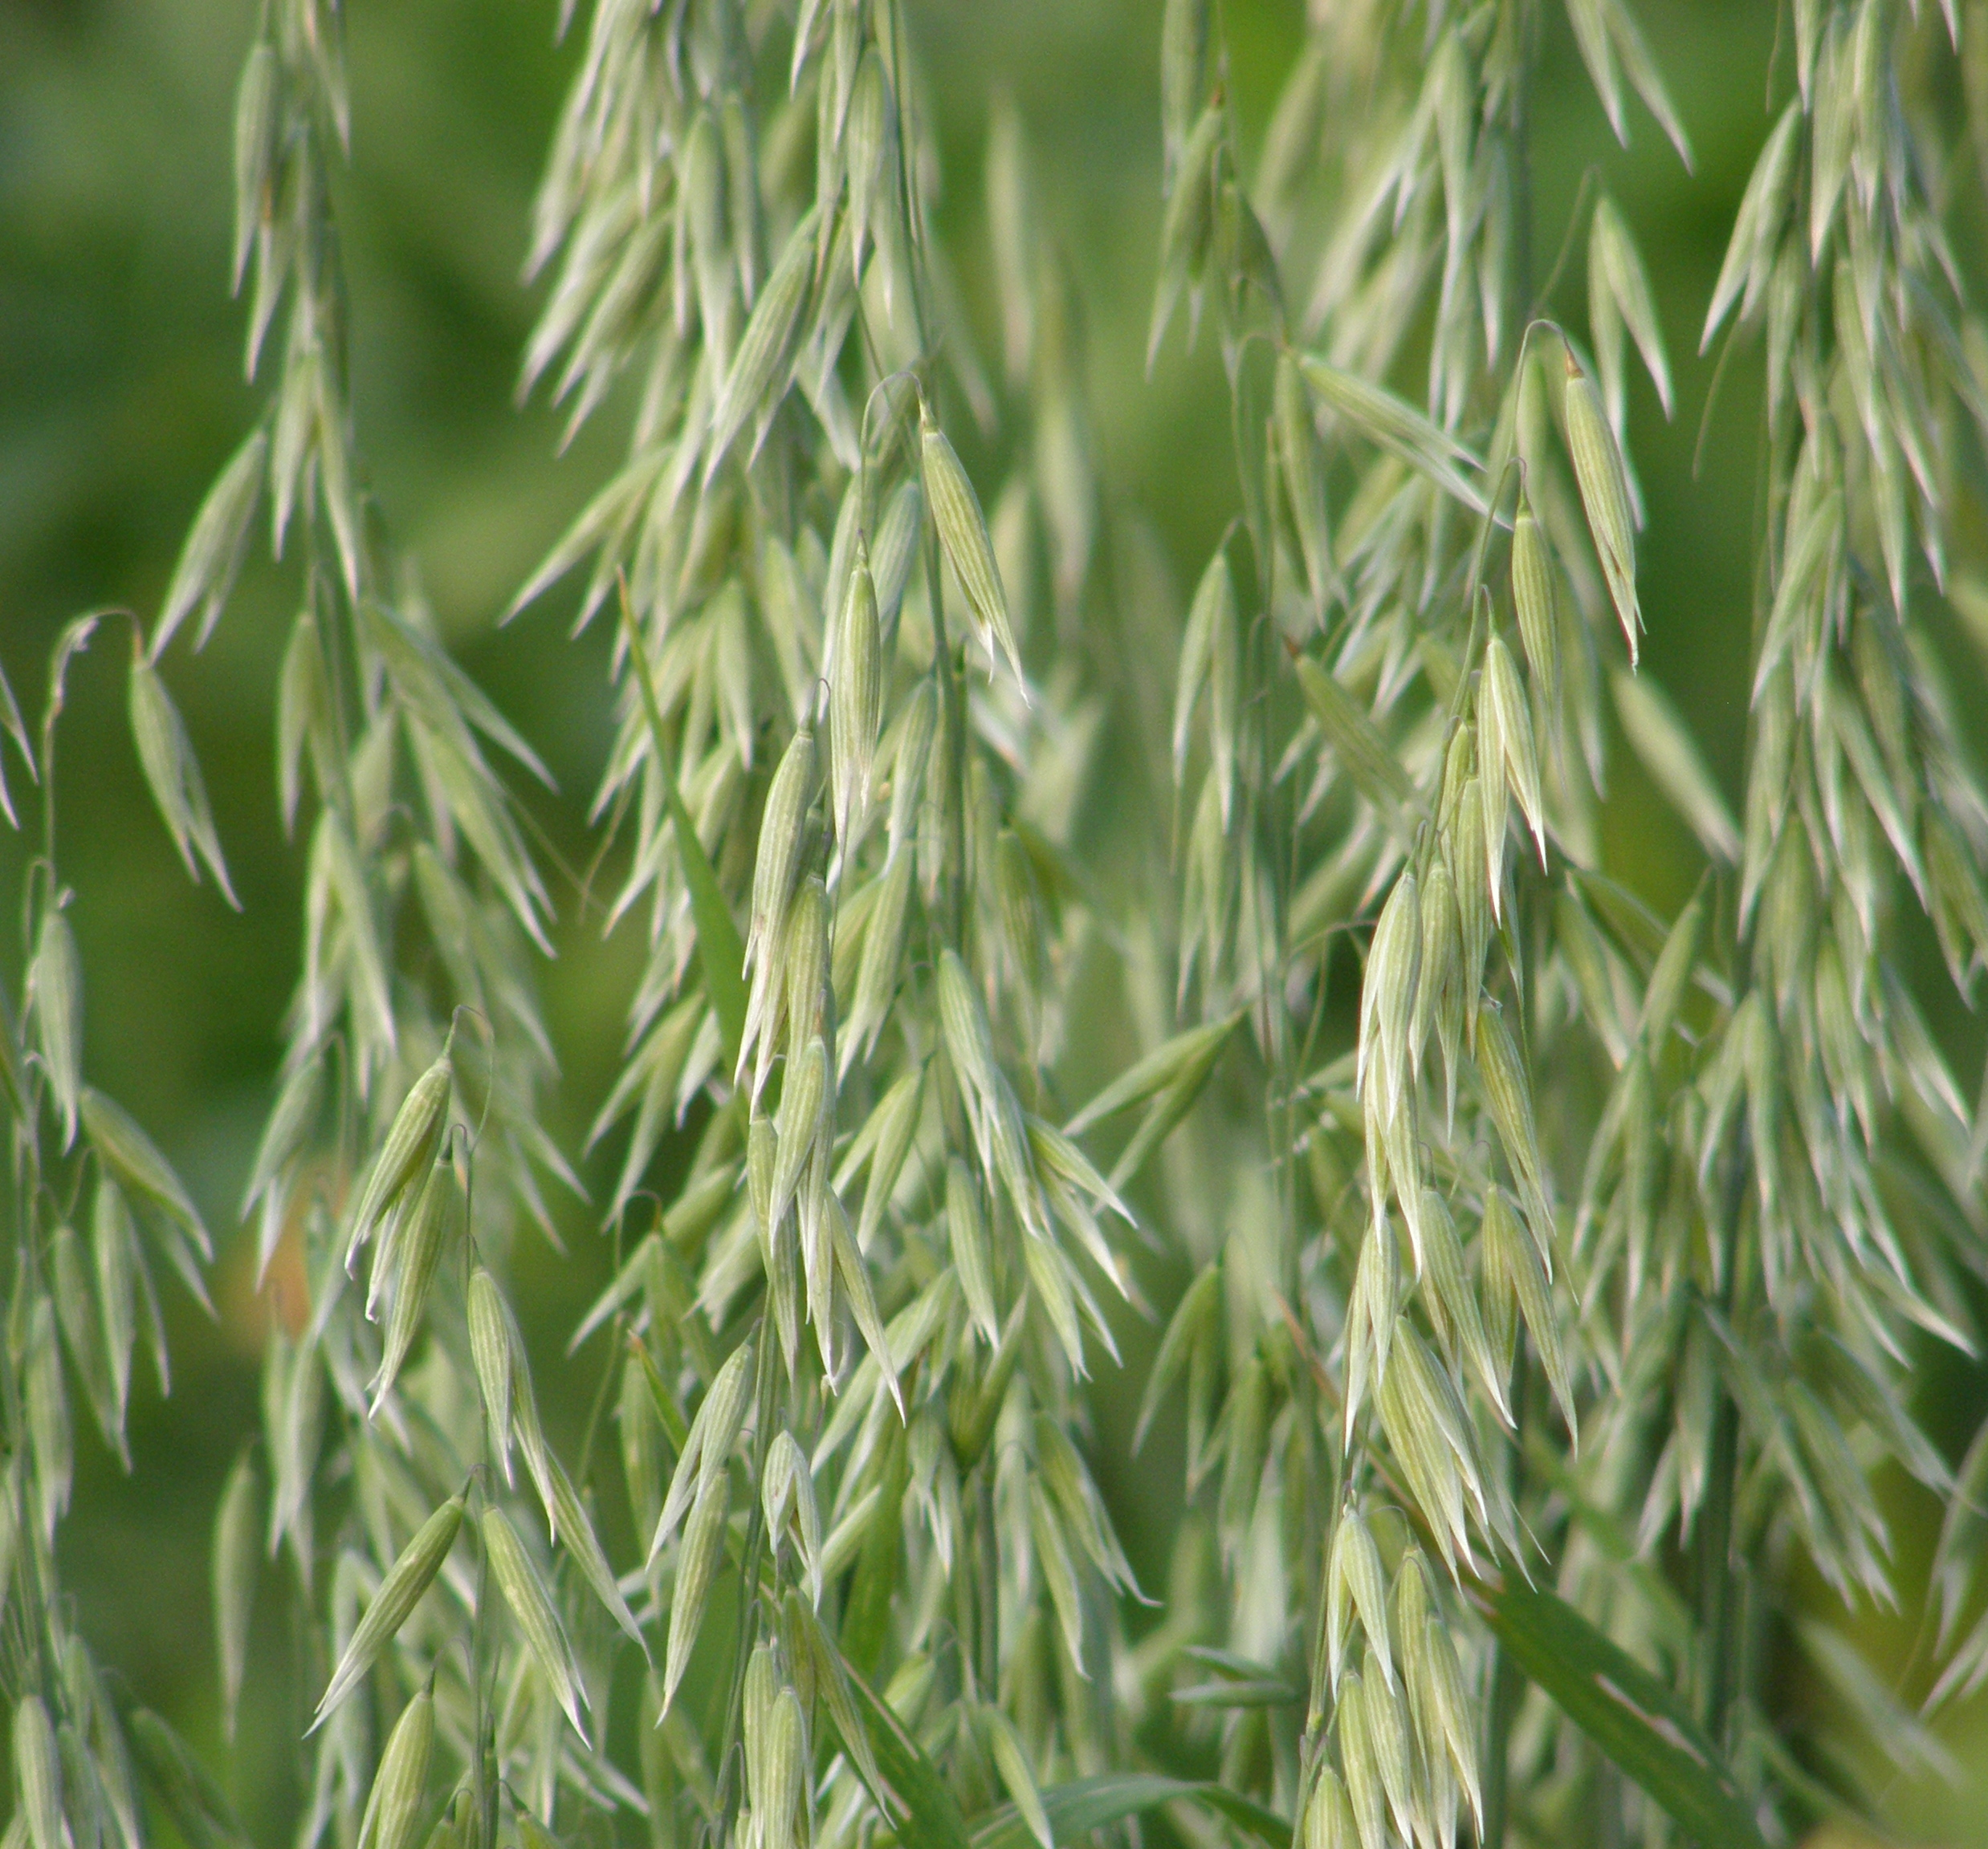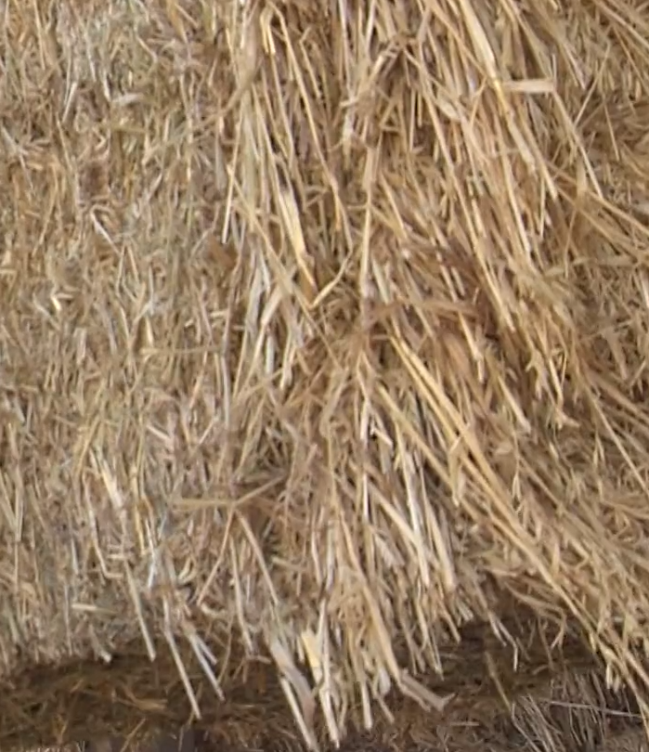

Bailey mentions “Dry Land Farming” in the video. What does this mean?
Bailey’s biggest challenge:
How has Bailey overcome this challenge?

Becoming Certified Organic
Aligned to the following standards:
PS.03; FFA.PL-A; FFA.PL-C; FFA.PL-E; FFA.PL-F; FFA.PG-I; FFA.CS-M; CCSS.SL.9-10.1; CCSS.SL.9-10.2; CRP.04; CRP.10

Directions:
Utilize the USDA Agricultural Marketing Service website to research the steps to becoming certified organic (https://www.ams.usda.gov/services/organic-certification/becoming-certified).
Bailey mentions in the video that the ground she leases was in the conservation resource program. What does that mean?

What are the steps to becoming “Certified Organic?”








What is the cost of organic certification?
What is the transition period for land?

What does having the USDA Seal mean?

Based on the criteria for becoming organic, if you were a farmer, would you choose to become organically certified? Why or why not?

Organic vs. Conventional
Aligned to the following standards:
PS.03; FFA.PL-A; FFA.PL-C; FFA.PL-E; FFA.PL-F; FFA.PG-I; FFA.CS-M; CCSS.SL.9-10.1; CCSS.SL.9-10.2; CRP.04; CRP.10

Directions:
Utilize your prior knowledge and/or internet research to compare and contrast organic and conventional production practices.
Organic
Conventional
How are they the same?
How are they different?

Why is it important to have both in the agriculture industry?

