Certified Organic
Created: 02/2019 by the National FFA Organization

SAE Video Summary: Bailey walks us through how she developed her supervised agricultural experience (SAE) program by producing organic oat hay. She discusses the steps she took to become a certified organic producer and the challenges she has faced with her SAE.
Student Learning Objectives:
After completing these activities, students will …
- Describe the challenges and steps in an SAE program.
- Identify and describe the steps to become certified organic by the USDA.
- Compare and contrast organic and conventional production methods.

Time Required: 45 minutes
Resources:
- Video: “Bailey Morrell – SAE – Organic Oat Hay,” https://vimeo.com/279517525
- Website: USDA Agricultural Marketing Service, https://www.ams.usda.gov/services/organic-certification/becoming-certified
- PDF: “National FFA Agricultural Issues Forum LDE Handbook,” https://FFA.box.com/s/6wxoo00dedbdfgd9qd82sd8l7f9h0ygc

Equipment and Supplies Needed:
- A copy of the “Organic Oat Hay” worksheet for each student
- A copy of the “Becoming Certified Organic” worksheet for each student
- A copy of the “Organic vs. Conventional” worksheet for each student
- Internet access to play the video in real time or embed it in a PowerPoint ahead of time
- Internet access for students

This quick lesson plan would work well as Part Of:
- An SAE lesson/unit.
- A plant science lesson.
- An agricultural issues lesson.

Student Activity Sheets:
Direct access to student activity sheets without lesson plan or answer key for easy upload to learning management systems or printing for classwork.
https://ffa.box.com/s/r28af9z986psotqlev27puuoh5wpsihe (Word)
https://ffa.box.com/s/awqbowc3j1ceaygtlokrlu7nwqxf7lvy (PDF)
These activities are aligned to the following standards:
AFNR Performance Element
- PS.03. Propagate, culture and harvest plants and plant products based on current industry standards.
FFA Precept
- FFA.PL-A.Action: Assume responsibility and take the necessary steps to achieve the desired results, no matter what the goal or task at hand.
- FFA.PL-C.Vision: Visualize the future and how to get there.
- FFA.PL-E.Awareness: Understand personal vision, mission and goals.
- FFA.PL-F.Continuous Improvement: Accept responsibility for learning and personal growth.
- FFA.PG-I.Professional Growth: Assume responsibility for attaining and improving upon the skills needed for career success.
- FFA.CS-M.Communication: Effectively interact with others in personal and professional settings.
Common Core – Speaking and Listening
- CCSS.ELA-Literacy.SL.9-10.1 Initiate and participate effectively in a range of collaborative discussions (one-on-one, in groups, and teacher-led) with diverse partners on grades 9-10 topics, texts, and issues, building on others' ideas and expressing their own clearly and persuasively.
- CCSS.ELA-Literacy.SL.9-10.2 Integrate multiple sources of information presented in diverse media or formats (e.g., visually, quantitatively, orally) evaluating the credibility and accuracy of each source.

AFNR Career Ready Practices
- CRP.04. Communicate clearly, effectively, and with reason. Career-ready individuals communicate thoughts, ideas and action plans with clarity, whether using written, verbal and/or visual methods.
- CRP.10. Plan education and career path aligned to personal goals. Career-ready individuals take personal ownership of their own educational and career goals, and they regularly act on a plan to attain these goals.
Partnership for 21st Century Skills
- Communication
- Initiative and Self-Direction
- Leadership and Responsibility

Lesson Plan:
- Bell Ringer: Organic is a huge buzz word in today’s society. What does organic mean?

- Introduction: Having a supervised agricultural experience (SAE) program is an integral part of agricultural education. Today, we are going to watch a short video about one students’ organic oat hay production SAE. After the video, we will discover more about organic and conventional agriculture practices.

- Activity:
  - Each student needs a copy of the worksheet “Organic Oat Hay.” Have students watch the video “Bailey Morrell – SAE – Organic Oat Hay” (https://vimeo.com/279517525) and answer the accompanying questions.

  - Each student needs a copy of the worksheet “Becoming Certified Organic.” Students will utilize the USDA Agricultural Marketing Service website to research what it means to be certified organic and the steps to become certified. The website URL is https://www.ams.usda.gov/services/organic-certification/becoming-certified.

  - Each student needs a copy of the worksheet “Organic vs. Conventional.” Students will utilize their prior knowledge and/or internet research to identify the similarities and differences between organic and conventional agricultural production methods.

- Follow Up: Upon completion of the activity, have students participate in mini-debates. Split the class into groups of three. One student will take the side of organic practices, one will take conventional practices and the third will be the judge. The judge will create a list of questions the debaters will use as their outline. At the end of the debate, the judge decides the winner. You can have groups conduct the debate in front of the entire class or in their groups.

- Leveling Up: To take this lesson one step further, have students utilize the “National FFA Agricultural Issues Forum LDE Handbook,” available at https://FFA.box.com/s/6wxoo00dedbdfgd9qd82sd8l7f9h0ygc to create a ten minute skit debating the issue of organic vs. conventional.

- Exit Ticket: What are the steps to becoming certified organic? What does having the UDSA Organic Seal mean?

Organic Oat Hay
Aligned to the following standards:
PS.03; FFA.PL-A; FFA.PL-C; FFA.PL-E; FFA.PL-F; FFA.PG-I; FFA.CS-M; CCSS.SL.9-10.1; CCSS.SL.9-10.2; CRP.04; CRP.10

Directions:
Answer the questions below as you watch the video “Bailey Morrell – SAE – Organic Oat Hay.” The video URL is https://vimeo.com/279517525.

What motivated Bailey to start this SAE project?
What is Bailey’s SAE project?

Bailey’s beginning steps:

1.

2.

3.

4.

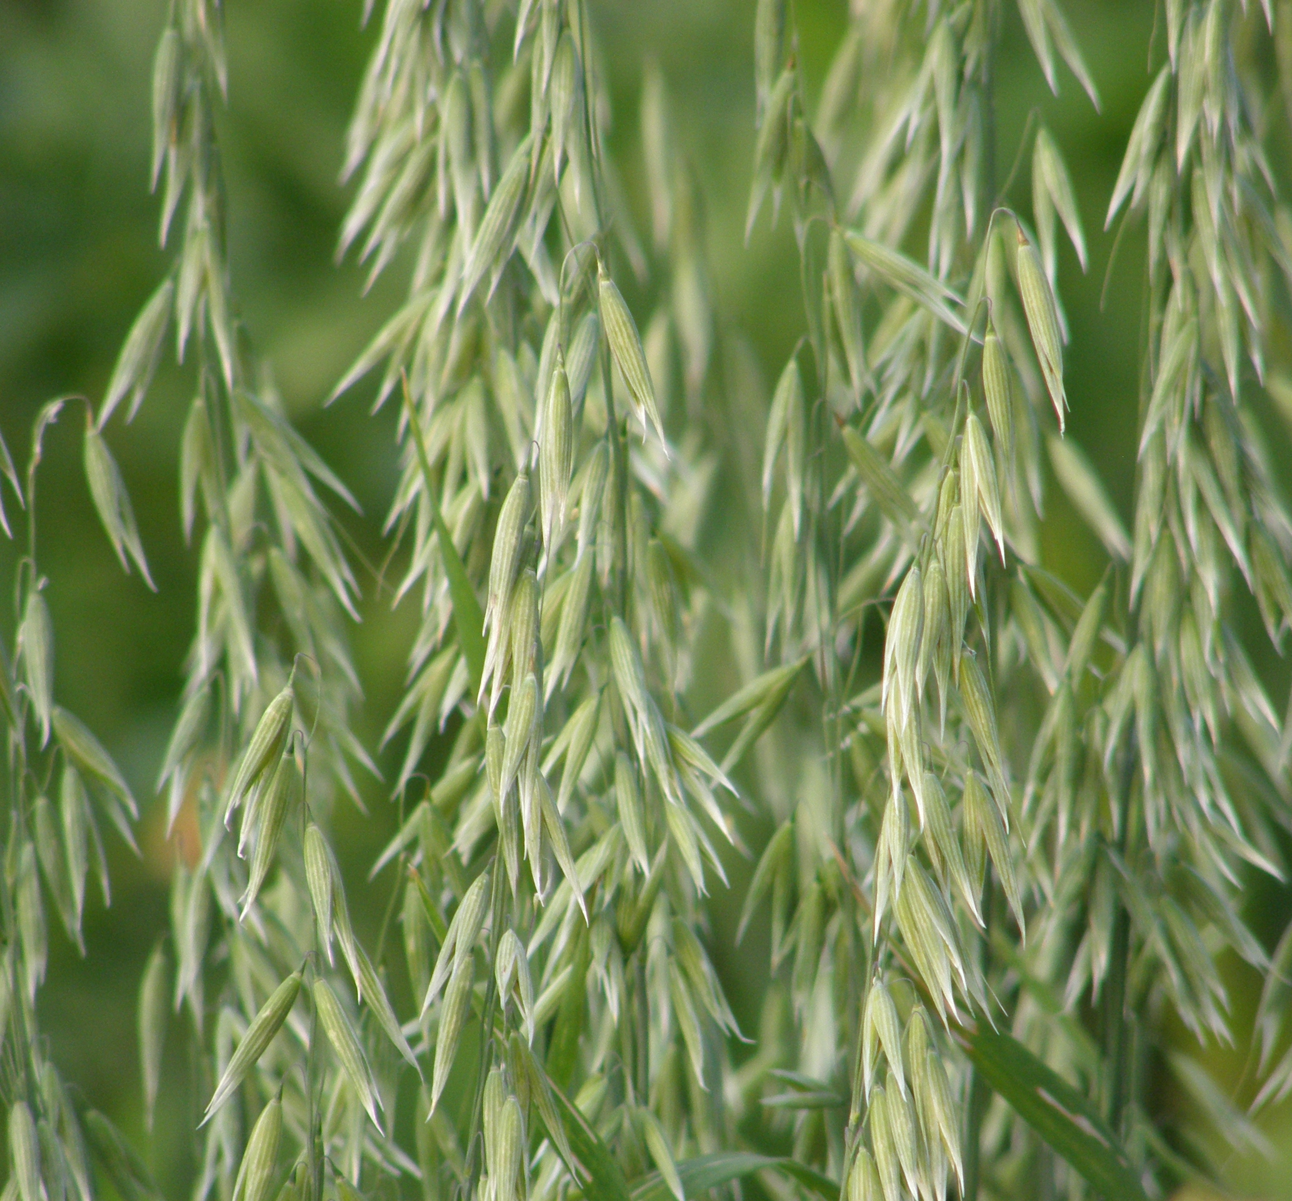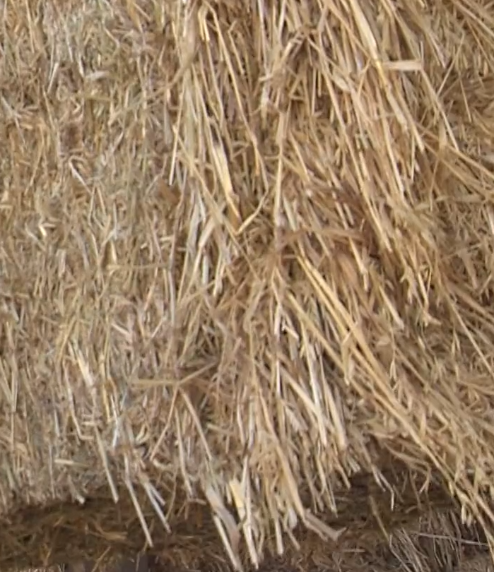

Bailey mentions “Dry Land Farming” in the video. What does this mean?
Bailey’s biggest challenge:
How has Bailey overcome this challenge?

Becoming Certified Organic
Aligned to the following standards:
PS.03; FFA.PL-A; FFA.PL-C; FFA.PL-E; FFA.PL-F; FFA.PG-I; FFA.CS-M; CCSS.SL.9-10.1; CCSS.SL.9-10.2; CRP.04; CRP.10

Directions:
Utilize the USDA Agricultural Marketing Service website to research the steps to becoming certified organic (https://www.ams.usda.gov/services/organic-certification/becoming-certified).
Bailey mentions in the video that the ground she leases was in the conservation resource program. What does that mean?

What are the steps to becoming “Certified Organic?”








What is the cost of organic certification?
What is the transition period for land?

What does having the USDA Seal mean?

Based on the criteria for becoming organic, if you were a farmer, would you choose to become organically certified? Why or why not?

Organic vs. Conventional
Aligned to the following standards:
PS.03; FFA.PL-A; FFA.PL-C; FFA.PL-E; FFA.PL-F; FFA.PG-I; FFA.CS-M; CCSS.SL.9-10.1; CCSS.SL.9-10.2; CRP.04; CRP.10

Directions:
Utilize your prior knowledge and/or internet research to compare and contrast organic and conventional production practices.
Organic
Conventional
How are they the same?
How are they different?

Why is it important to have both in the agriculture industry?

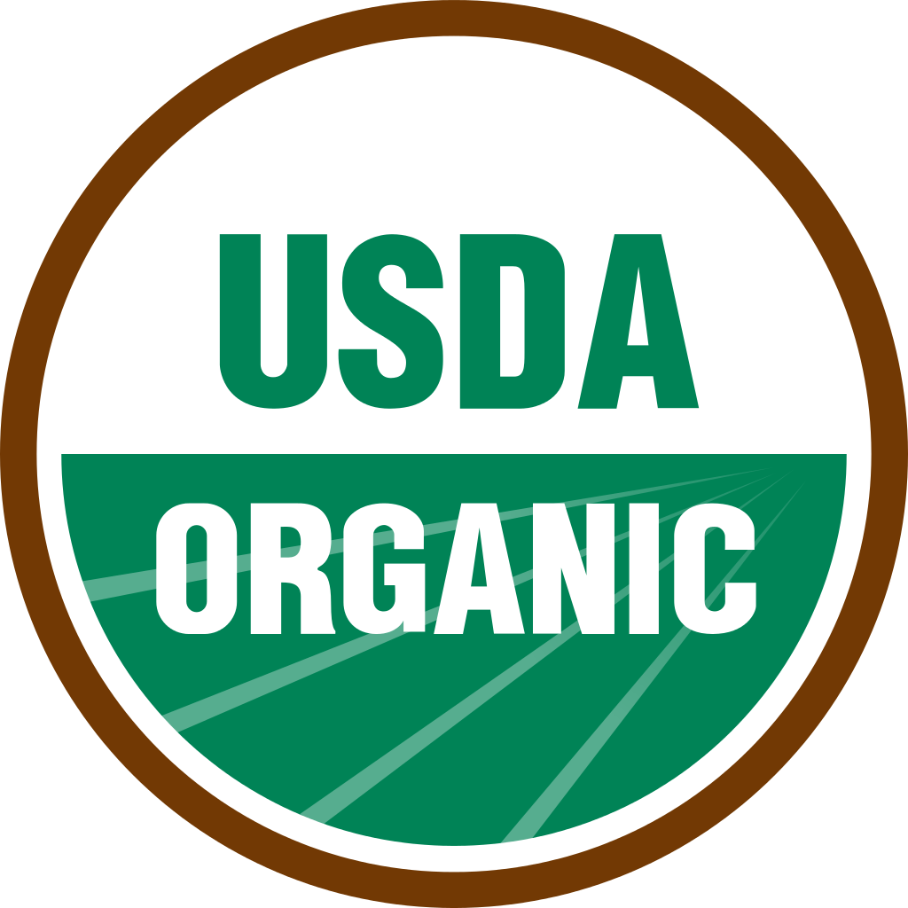

KEY: Organic Oat Hay
Aligned to the following standards:
PS.03; FFA.PL-A; FFA.PL-C; FFA.PL-E; FFA.PL-F; FFA.PG-I; FFA.CS-M; CCSS.SL.9-10.1; CCSS.SL.9-10.2; CRP.04; CRP.10

Directions:
Answer the questions below as you watch the video “Bailey Morrell – SAE – Organic Oat Hay.” The video URL is https://vimeo.com/279517525.

What motivated Bailey to start this SAE project?

She wanted to learn about the plant science side of agriculture. She grew up on a cattle ranch and wanted to diversify.
What is Bailey’s SAE project?

She produces 74.5 acres of certified organic oat hay.

Bailey’s beginning steps:

1. Working with her county department of agriculture

2.Becoming a certified organic producer

3.Having organic inspectors come out to the farm each year to test her product

4.Becoming a reputable organic producer in the area

Bailey mentions “Dry Land Farming” in the video. What does this mean?

Her farm is not connected to any irrigation or water source.
Bailey’s biggest challenge:

Lack of water
How has Bailey overcome this challenge?

Supplementing the soil in other ways

KEY: Becoming Certified Organic
Aligned to the following standards:
PS.03; FFA.PL-A; FFA.PL-C; FFA.PL-E; FFA.PL-F; FFA.PG-I; FFA.CS-M; CCSS.SL.9-10.1; CCSS.SL.9-10.2; CRP.04; CRP.10

Directions:
Utilize the USDA Agricultural Marketing Service website to research the steps to becoming certified organic (https://www.ams.usda.gov/services/organic-certification/becoming-certified).
Bailey mentions in the video that the ground she leases was in the conservation resource program. What does that mean?

What are the steps to becoming “Certified Organic?”
The certifying agent reviews the application to verify that practices comply with USDA organic regulations.

The farm or business adopts organic practices, selects a USDA-accredited certifying agent, and submits an application and fees to the certifying agent.

An inspector conducts an on-site inspection of the applicant’s operation.

The certifying agent issues organic certificate.

The certifying agent reviews the application and the inspector’s report to determine if the applicant complies with the USDA organic regulations.

What is the cost of organic certification?

Actual certification costs or fees vary widely depending on the certifying agent and the size, type and complexity of your operation. Certification costs may range from a few hundred to several thousand dollars. Before you apply, ask your certifier for a fee structure and billing cycle. Typically, there is an application fee, annual renewal fee, assessment on annual production or sales and inspection fees.
What is the transition period for land?
Any land used to produce raw organic commodities must not have had prohibited substances applied to it for the past three years. Until the full 36-month transition period is met, you may not:
-Sell, label or represent the product as “organic.”
-Use the USDA organic or certifying agent’s seal.

What does having the USDA Seal mean?

You have met all the requirements from the USDA and your product is certified organic.

Based on the criteria for becoming organic, if you were a farmer, would you choose to become organically certified? Why or why not?

Answer will vary.

KEY: Organic vs. Conventional
Aligned to the following standards:
PS.03; FFA.PL-A; FFA.PL-C; FFA.PL-E; FFA.PL-F; FFA.PG-I; FFA.CS-M; CCSS.SL.9-10.1; CCSS.SL.9-10.2; CRP.04; CRP.10

Directions:
Utilize your prior knowledge and/or internet research to compare and contrast organic and conventional production practices.
Organic
Conventional
How are they the same?
How are they different?
Use pesticides
Use of GMOs

No use of pesticides
Higher prices
Meet the demand of health groups
Production of food

Why is it important to have both in the agriculture industry?

They are needed to meet the need of feeding the growing population and various groups of individuals.

