Be Curious: Opportunities for Collaboration
Created: 07/2015 by the National FFA Organization

Student Learning Objectives
After completing these activities students will…
- Define some polar issues that exist in agriculture.
- Define collaboration as used in issue resolution and discussion.
- Identify agriculture issues that are important in their lives.

Time Required: 15 minutes
Resources: FFA.org
Equipment and Supplies Needed:
- A copy of the “Be Curious” worksheet for each student.
- Internet access to play the video in real time or embed it in a PowerPoint ahead of time.

This quick lesson plan would work well as:
- A Start-the-Day or opening for any agriculture course.
- Reflection or brainstorm activity before or after a guest presenter.

These activities are aligned to the following standards:

FFA Precept
- CS-M. Communication: Effectively interact with others in personal and professional settings.
AFNR Performance Element
- CS.01. Analyze how issues, trends, technologies and public policies impact systems in the Agriculture, Food & Natural Resources Career Cluster.
NASDCTEc
- AGC02.01 Use oral and written communication skills in creating, expressing and interpreting information and ideas including technical terminology to communicate technical information within AFNR.
AFNR Career Ready Practices
- CRP.04. Communicate clearly, effectively, and with reason. Career-ready individuals communicate thoughts, ideas and action plans with clarity, whether using written, verbal and/or visual methods.
Common Core- Speaking and Listening
- CCSS.ELA-LITERACY.SL.9-10.1 Initiate and participate effectively in a range of collaborative discussions (one-on-one, in groups, and teacher-led) with diverse partners on grades 9-10 topics, texts, and issues, building on others' ideas and expressing their own clearly and persuasively.
Common Core-Language
- CCSS.ELA-LITERACY.L.9-10.6 Acquire and use accurately general academic and domain-specific words and phrases, sufficient for reading, writing, speaking, and listening at the college and career readiness level; demonstrate independence in gathering vocabulary knowledge when considering a word or phrase important to comprehension or expression.
Common Core-Writing
- CCSS.ELA-LITERACY.W.9-10.2 Write informative/explanatory texts to examine and convey complex ideas, concepts, and information clearly and accurately through the effective selection, organization, and analysis of content.
Common Core- Math
- MP3: Construct viable arguments and critique the reasoning of others.
Partnership for 21st Century Skills
- Collaboration
- Communication
- Global Awareness
- Social and Cross-Cultural Skills
- Work Creatively with Others

Lesson Plan:
Introduction: Give an explanation of agriculture issues that may be polar in nature. Describe how collaboration, science, and respect for the perspective of others is important to addressing these issues.
Activity: Each student needs a copy of the handout “Be Curious”
  - Show the video Feed Your Curiosity About Food. The direct url is https://www.youtube.com/watch?app=desktop&v=M9KtG91FdBE
  - Students should have time to think about the topic of the video and complete the “Be Curious” worksheet.

Follow-up: Have students share their thoughts on the video. Use the worksheet questions a primer for discussion.

Be Curious
Directions:
Watch the video https://www.youtube.com/watch?app=desktop&v=M9KtG91FdBE.
From the Video 

What are the three examples of polar arguments in agriculture mentioned in the video?

1.  VS. | 2.  VS. | 3.  VS.

How can we work with others to address these issues?

Critical Thinking 
What other groups could agriculture professionals call upon to help solve agricultural problems?

What are other challenging issues within agriculture?

Reflection 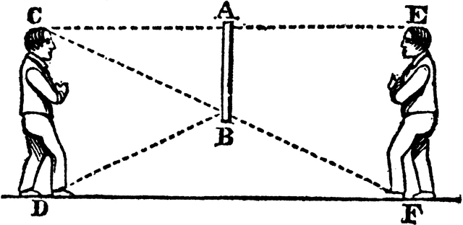

What are some issues in agriculture that you are curious about?

Aligned to the following standards:
FFA.CS-M; CCSS.L.9-10.6; CS.01; AGC02.01; CRP.04; CCSS.W.9-10.2

