At the Docks
Aligned to the following standards:
ABS.04; PL-A.; PL-C.; PG-J.; CS-M.; CS-N.; AG-BIZ4; AGPG01.01; CCSS.W.9-10.2; CCSS.L.9-10.6; CCSS.RST.9-10.4; CCSS.WHST.9-10.2; CRP.02; CRP.04; CRP.05; CRP.06; CRP.07; CRP.08
Directions:
Answer the questions below as you watch the video “Marina SAE | Ben Walker,” available at https://vimeo.com/377156789.

Describe the facilities at the marina where Ben works.

What are his daily tasks?


What records do they keep at the marina and when is that information collected?


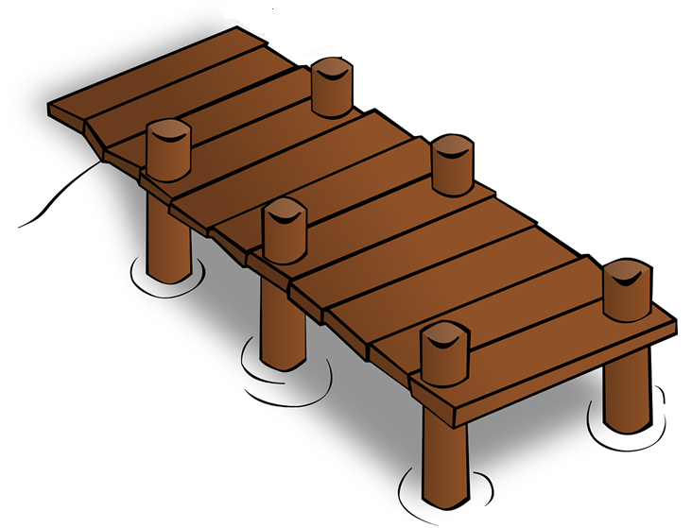
What has Ben learned the most through his SAE?

How has this SAE impacted his future?

Outdoor Recreation
Aligned to the following standards:
ABS.04; PL-A.; PL-C.; PG-J.; CS-M.; CS-N.; AG-BIZ4; AGPG01.01; CCSS.W.9-10.2; CCSS.L.9-10.6; CCSS.RST.9-10.4; CCSS.WHST.9-10.2; CRP.02; CRP.04; CRP.05; CRP.06; CRP.07; CRP.08
Directions:
If Ben Walker applied for an FFA proficiency award, his SAE would fall under the category of outdoor recreation. This is an area of agriculture that often gets overlooked. Complete the following activities to explore the concept of outdoor recreation and agriculture.

The National FFA Outdoor Recreation Proficiency Award description:

The member owns the enterprise or works for a business that develops or provides outdoor recreational activities for public or family use as experiential or income-producing enterprises. These enterprises could include agro-tourism, vacation cabins and cottages, camping and/or picnic areas, recreational fishing and/or hunting areas, winter sports, shooting preserves, guide services, riding stables, trail rides (ATV, horseback, etc.), vacation farms and guest ranches, natural scenic or historic areas, and running petting zoos and rodeo events where the member does not own or manage animals.

- Read the outdoor recreation description above. Were you surprised that any of these activities are potential supervised agricultural experiences (SAEs)? If you were surprised, why? If you were not surprised, what originally made you aware of opportunities available in outdoor recreation?

- Do you know of any similar enterprises in your own area? If yes, describe them. If not, do you think this is a missed opportunity in your area? Why or why not?


- Use the diagram below to brainstorm outdoor recreation businesses you could start in your area (or in the area you wish to live in one day). Even if being involved in this type of business is of no interest to you, brainstorm what could appeal to people who do enjoy those types of activities. Your goal is to come up with ideas for a successful outdoor recreation business; even if you don’t want to do it, you might meet someone who would love to take your idea and make it reality!

- Choose two of the ideas you came up with in Question 3 and fill in the table below for each of those ideas.

Business Idea | Business Description | Potential Customers  (consider people who live locally and those who might travel for the experience) | Resources Needed to Get the Business Started | Roadblocks to Starting This Business | Potential Ways to Overcome Roadblocks

- Sometimes looking at the roadblocks for an idea can be discouraging. Let’s motivate ourselves by designing a logo for our potential outdoor recreation business! Choose one of the ideas from Question 4, and create a business name and logo that clearly indicates what your business is. It should be something that would catch a potential customer’s eye. Be sure to refer to the “Logo Design Rubric” for additional details.

Not sure what a logo should look like? Check out this suggested resource:

- “The Four Most Important Features of a Professional Logo Design,” https://www.freelogoservices.com/blog/2017/10/03/the-4-most-important-features-of-a-professional-logo-design/#:~:text=An%20effective%20logo%20should%20have,and%20a%20relevant%20color%20choice.

Logo Design Rubric
 | 25–19 Points | 18–12 Points | 11–6 Points | 5–0 Points
Attractiveness | The overall appearance of the logo is pleasing. Titles, text, colors and graphics are exemplary. The logo is attractive and stimulates the viewers interest. | Overall graphic balance and organization of the logo is acceptable. There is an appropriate balance of easy to read titles, text, colors and graphics. The logo is attractive but promotes limited viewer interest. | Colors, backgrounds and/or text are not used effectively, but are readable. Icons and other graphical elements don’t seem to serve any useful purpose other than for decoration. The logo is unattractive or distracting. | The colors or background are too busy, which makes the text hard to read. There are few icons or graphical elements. The project is unattractive.
Layout/Design | There is unity and consistency among text and graphic elements. Text and graphic elements are arranged to create an organized white space. | There is adequate unity but some inconsistency among text and graphic elements. Text and graphic elements are arranged but lack appropriate white space, appearing cluttered. | Project has text and graphics; however, they lack or have too much white space. There is little unity and consistency among the text and graphic elements. | Project lacks text or graphics with no organized white space. There is no unity or consistency among text and graphic elements.
Detail and Difficulty | Student is very attentive to detail, and level of difficulty is high. | Student is attentive to detail, and level of difficulty is medium. | Some detail is shown. Level of difficulty is medium. | Very little detail is shown, and level of difficulty is low.
Content and Originality | The design is unique and original. The student can recognize a logo and the elements that make up a logo. | Design is original but similar in one way to another logo. Student can recognize a logo and the elements that make up a logo. | The design is similar in several ways to another logo. Student appears to have recognized a logo and some of the elements that make up a logo. | The logo looks like it has been copied from someone or somewhere else. Student can describe something about a logo but cannot be sure of what a logo is.

Modified from “Personal Logo Rubric” created by I Teach You Stuff.com and available at http://www.iteachyoustuff.com/plogo.html.

