The Gap
Created: 11/2018 by the National FFA Organization

Student Learning Objectives:
After completing these activities, students will …
- Recognize gaps that exist in the community.
- Plan how to address gaps that exist in the community.

Time Required: 45 minutes
Resources:
- FFA.org
- Access to the video “2017-18 National FFA President Breanna Holbert’s Retiring Address,” https://vimeo.com/297512630
Equipment and Supplies Needed:
- A copy of the “The Gap” worksheet for each student
- A copy of the “Addressing the Gap in Our Own Lives” worksheet for each student
- Internet access to play the video in real time or embed it in a PowerPoint ahead of time

This quick lesson plan would work well as:
- A personal growth activity.
- An inclusivity activity.
- An activity for self-reflection.

Student Activity Sheets:
Direct access to student activity sheets without lesson plan or answer key for easy upload to learning management systems or printing for classwork.
https://ffa.box.com/s/obwlbsfl2eofsc5q1ia7g7c3rtjizzwi (Word)
https://ffa.box.com/s/lwojgau9smuvvgzax7m7o0ubavybjlji (Non-Designed)
https://ffa.box.com/s/ysdbioyjjz5k1lfqq0kw7kj8p39zyns3 (PDF)

These activities are aligned to the following standards:
FFA Precept
- FFA.PL-A.Action: Assume responsibility and take the necessary steps to achieve the desired results, no matter what the goal or task at hand.
- FFA.PL-C.Vision: Visualize the future and how to get there.
- FFA.PL-E.Awareness: Understand personal vision, mission and goals.
- FFA.PG-J.Mental Growth: Embrace cognitive and intellectual development relative to reasoning, thinking and coping.
- FFA.CS-M.Communication: Effectively interact with others in personal and professional settings.
- FFA.CS-N.Decision Making: Analyze a situation and execute an appropriate course of action.
Common Core–Speaking and Listening
- CCSS.ELA-Literacy.SL.9-10.1: Initiate and participate effectively in a range of collaborative discussions (one-on-one, in groups, and teacher-led) with diverse partners on grades 9-10 topics, texts, and issues, building on others' ideas and expressing their own clearly and persuasively.
Common Core–Literacy in Science & Technical Subjects: Writing
- CCSS.ELA-Literacy.WHST.9.10.4: Produce clear and coherent writing in which the development, organization, and style are appropriate to task, purpose, and audience.
Common Core–Math Practices
- CCSS.MP1: Make sense of problems and persevere in solving them.
- CCSS.MP3: Construct viable arguments and critique the reasoning of others.
- CCSS.MP5: Use appropriate tools strategically.
- CCSS.MP6: Attend to precision.
AFNR Career Ready Practices
- CRP.02: Apply appropriate academic and technical skills. Career-ready individuals readily access and use the knowledge and skills acquired through experience and education to be more productive.
- CRP.04: Communicate clearly, effectively, and with reason. Career-ready individuals communicate thoughts, ideas and action plans with clarity, whether using written, verbal and/or visual methods.
- CRP.06: Demonstrate creativity and innovation. Career-ready individuals regularly think of ideas that solve problems in new and different ways, and they contribute those ideas in a useful and productive manner to improve their organization.
- CRP.08: Utilize critical thinking to make sense of problems and persevere in solving them. Career-ready individuals readily recognize problems in the workplace, understand the nature of the problem, and devise effective plans to solve the problem.
Partnership for 21st Century Skills
- Communication
- Critical Thinking and Problem Solving
- Flexibility and Adaptability
- Initiative and Self-direction
- Leadership and Responsibility

Lesson Plan:
- Bell Ringer: Distribute the worksheet “The Gap.” Have students look at the two pictures and answer the questions outlined between the pictures.

- Activity 1: Today, we are going to watch a retiring address from the 91st National FFA Convention and Expo. This retiring address was given by 2017-18 National FFA President Breanna Holbert. In her speech, she shares how we should recognize and embrace the gaps in our lives.

Before watching the video, look over the questions on the “The Gap” worksheet, and be ready to listen for the answers as you view the video.

Show the video “2017–18 National FFA President Breanna Holbert’s Retiring Address.” The direct URL is https://vimeo.com/297512630.

After the video is over, discuss as a class the main concepts (Ex. we create distance between ourselves and others based on the quick opinions we make) that Breanna shared and how students can apply them to their own lives.

- Activity 2: Students will complete the “Addressing the Gaps in our Own Lives” activity individually and then share based on personal discretion.

- Follow-up: Identify the gaps in your school and create a plan on how you can actively work to embrace and love the gaps that exist. Optional guiding questions:
  - What are the gaps that exist in your school?
  - What could you do to address those gaps?

- Leveling Up: Develop an activity or set of activities that can help bring everybody together. Potential ideas could include community activities, a dinner, a community service project, a trivia night, etc.

- Exit Ticket: Have students answer the following question on a piece of paper: How can you know the gap, embrace the gap and love the gaps in your own life?

The Gap
Aligned to the following standards:
FFA.PL-A; FFA.PL-C; FFA.PL-E; FFA.PG-J; FFA.CS-M; FFA.CS-N; CCSS.ELA.SL.9-10.1; CCSS.ELA.WHST.9.10.4; MP1; MP3; MP5; MP6; CRP.02; CRP.04; CRP.06; CRP.08
Directions:
Bell Ringer: Answer the questions in the box between the images.

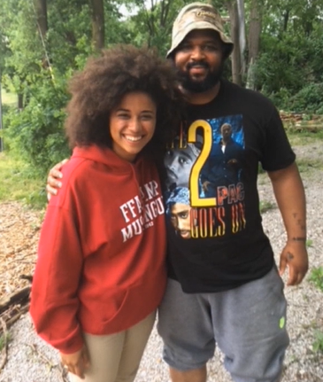
What are three differences between these two pictures?

- ___________________________
- ___________________________
- ___________________________
What do you think is the occupation of each individual pictured?

Directions:
Answer the questions below based on the video “2017–18 National FFA President Breanna Holbert’s Retiring Address,” available at https://vimeo.com/297512630.

Identify 3 ways in which you have created a gap in your life.
- ____________________________________________________________________________________________________________________________________
- ____________________________________________________________________________________________________________________________________
- ____________________________________________________________________________________________________________________________________

“I think Tim said it best. I don’t like knowing that I have to walk around, up and over, down this way, back that way, towards this road to avoid someone that didn’t and doesn’t have the same opportunity as me. There is a gap in our society that needs to be filled.” —Breanna Holbert, 2017-18 National FFA President

What is the meaning and purpose of the above quote from Breanna’s speech?

Aligned to the following standards:
FFA.PL-A; FFA.PL-C; FFA.PL-E; FFA.PG-J; FFA.CS-M; FFA.CS-N; CCSS.ELA.SL.9-10.1; CCSS.ELA.WHST.9.10.4; MP1; MP3; MP5; MP6; CRP.02; CRP.04; CRP.06; CRP.08
Know the Gap

What does Breanna mean by “know the gap”?

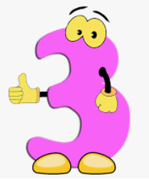
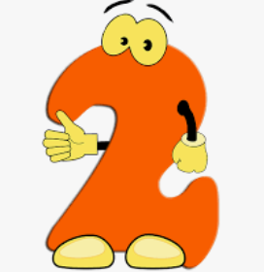
Addressing the Gaps in Our Own Life
Take Note!

Look around and think about your class. What do you know? What are the gaps?
Love the Gap

What does Breanna mean by “love the gap”?
Embrace the Gap

What does Breanna mean by “embrace the gap”?
Aligned to the following standards:
FFA.PL-A; FFA.PL-C; FFA.PL-E; FFA.PG-J; FFA.CS-M; FFA.CS-N; CCSS.ELA.SL.9-10.1; CCSS.ELA.WHST.9.10.4; MP1; MP3; MP5; MP6; CRP.02; CRP.04; CRP.06; CRP.08
Directions:

Think about the gaps you have already identified in your life and select one. How can you work to bridge that gap?
Gap identified:

____________________________________________

Plan:

Directions:
With a minimum of 10 kind words, thoughts and actions, construct a bridge over the river to eliminate “the gap” in your life and community.
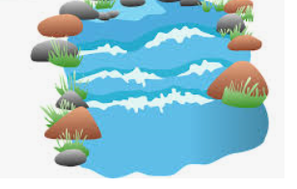
KEY — The Gap
Aligned to the following standards:
FFA.PL-A; FFA.PL-C; FFA.PL-E; FFA.PG-J; FFA.CS-M; FFA.CS-N; CCSS.ELA.SL.9-10.1; CCSS.ELA.WHST.9.10.4; MP1; MP3; MP5; MP6; CRP.02; CRP.04; CRP.06; CRP.08
Directions:
Bell Ringer: Answer the questions in the box between the images.
What are three differences between these two pictures?

- ___________________________
- ___________________________
- ___________________________
What do you think is the occupation of each individual pictured?

Answers will vary.

Directions:
Answer the questions below based on the video “2017–18 National FFA President Breanna Holbert’s Retiring Address,” available at https://vimeo.com/297512630.
Identify 3 ways in which you have created a gap in your life. Answers will vary.
- ____________________________________________________________________________________________________________________________________
- ____________________________________________________________________________________________________________________________________
- ____________________________________________________________________________________________________________________________________

“I think Tim said it best. I don’t like knowing that I have to walk around up and over, own this way, back this way, towards this road to avoid someone that didn’t and doesn’t have the same opportunity as me. There is a gap in our society that needs to be filled.” —Breanna Holbert, 2017-18 National FFA President

What is the meaning and purpose of the above quote from Breanna’s speech? The opinions we form in the moment can create a distance between people and cause undue judgement. This distance in society needs to be filled.

Aligned to the following standards:
FFA.PL-A; FFA.PL-C; FFA.PL-E; FFA.PG-J; FFA.CS-M; FFA.CS-N; CCSS.ELA.SL.9-10.1; CCSS.ELA.WHST.9.10.4; MP1; MP3; MP5; MP6; CRP.02; CRP.04; CRP.06; CRP.08
Know the Gap

What does Breanna mean by “know the gap”? We need to know what makes us different.
Take Note!

Look around and think about your class. What do you know? What are the gaps? Answers will vary.
Love the Gap

What does Breanna mean by “love the gap”? We need to acknowledge our differences.
Embrace the Gap

What does Breanna mean by “embrace the gap”? Embrace the differences so we can build each
other up.

