The Gap
Aligned to the following standards:
FFA.PL-A; FFA.PL-C; FFA.PL-E; FFA.PG-J; FFA.CS-M; FFA.CS-N; CCSS.ELA.SL.9-10.1; CCSS.ELA.WHST.9.10.4; MP1; MP3; MP5; MP6; CRP.02; CRP.04; CRP.06; CRP.08
Directions:
Bell Ringer: Answer the questions in the box between the images.
- What are three differences between these two pictures?

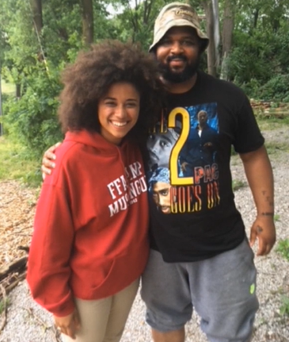
- ___________________________
- ___________________________
- ___________________________
What do you think is the occupation
of each individual pictured?

Directions:
Answer the questions below based on the video “2017–18 National FFA President Breanna Holbert’s Retiring Address,” available at https://vimeo.com/297512630.

- Identify 3 ways in which you have created a gap in your life.
- __________________________________________________________________________________________________________________________________________________________________________________
- __________________________________________________________________________________________________________________________________________________________________________________
- __________________________________________________________________________________________________________________________________________________________________________________

- “I think Tim said it best. I don’t like knowing that I have to walk around, up and over, down this way, back that way, towards this road to avoid someone that didn’t and doesn’t have the same opportunity as me. There is a gap in our society that needs to be filled.” —Breanna Holbert, 2017-18 National FFA President

What is the meaning and purpose of the above quote from Breanna’s speech?

- Know the Gap: What does Breanna mean by “know the gap”?

- Embrace the Gap: What does Breanna mean by “embrace the gap”?

- Take Note!: Look around and think about your class. What do you know? What are the gaps?

- Love the Gap: What does Breanna mean by “love the gap”?

Addressing the Gaps in Our Own Life
Aligned to the following standards:
FFA.PL-A; FFA.PL-C; FFA.PL-E; FFA.PG-J; FFA.CS-M; FFA.CS-N; CCSS.ELA.SL.9-10.1; CCSS.ELA.WHST.9.10.4; MP1; MP3; MP5; MP6; CRP.02; CRP.04; CRP.06; CRP.08
Directions:
Think about the gaps you have already identified in your life and select one. How can you work to bridge that gap?

- Gap identified: ____________________________________________

- Plan:

Directions:
With a minimum of 10 kind words, thoughts and actions, construct a bridge over the river to eliminate “the gap” in your life and community.
