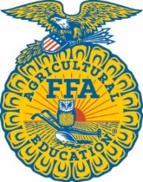

Horse Evaluation Career Development Event
Created: Sep-21

Breed and tack identification Exam

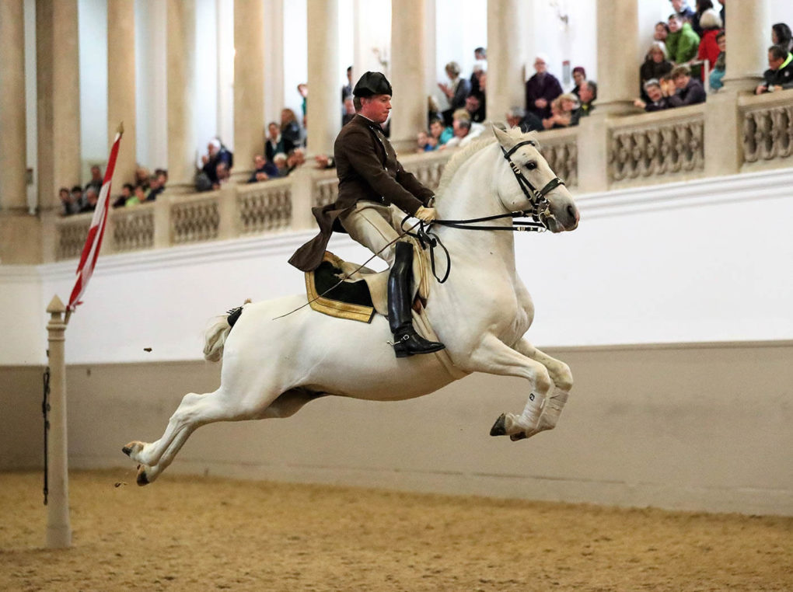
1.

A. Lipizzan B. Hanoverian
C. Hackney D. Friesian
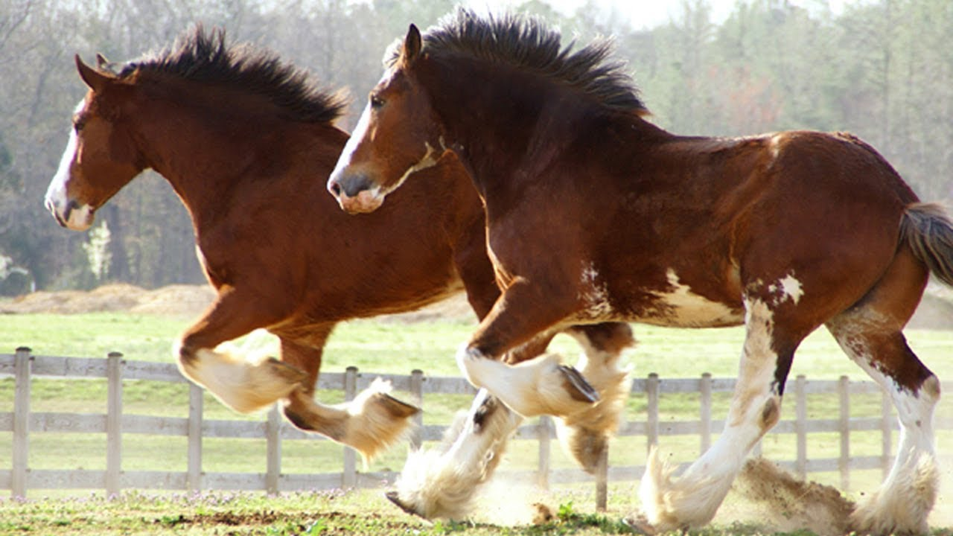
2.

A. Lipizzan B. Paint
C. Clydesdale D. Friesian
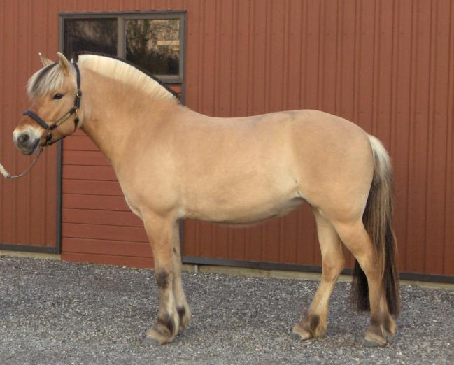
3.

A. Haflinger B. Norwegian Fjord
C. Arabian D. Shetland Pony
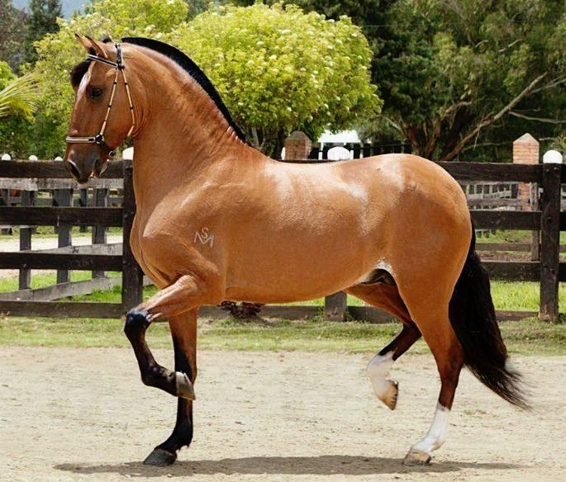
4.

A. Morgan B. Quarter Horse
C. Paso Fino D. Tennessee Walking Horse
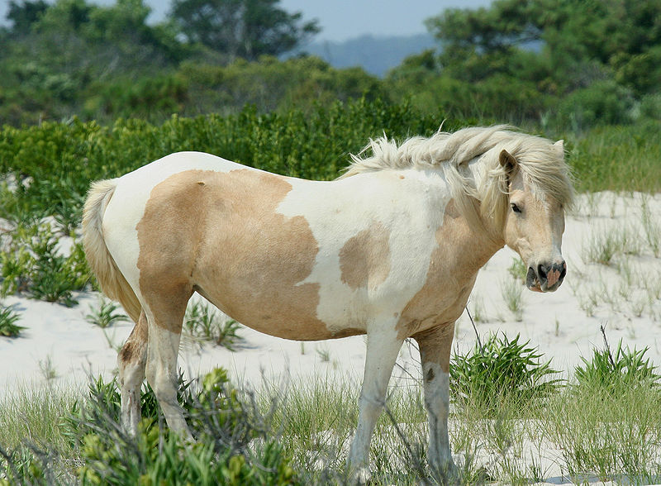
5.

A. Morgan B. Haflinger
C. Suffolk D. Chincoteague Pony
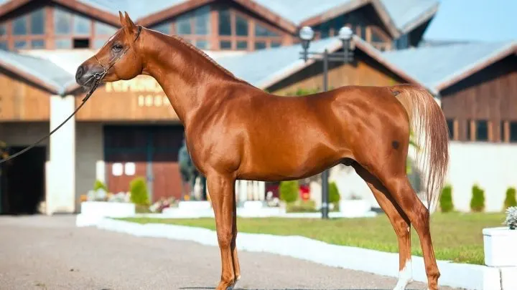
6.

A. Oldenburg B. Haflinger
C. Suffolk D. Arabian
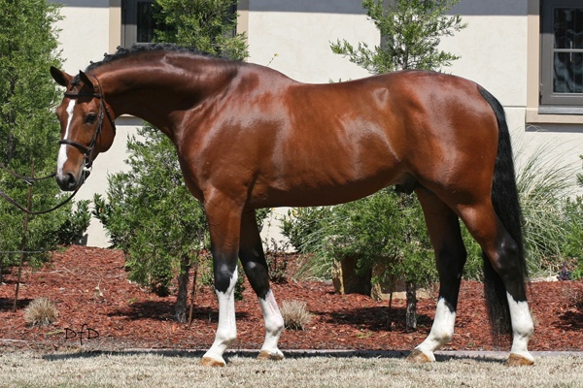
7.

A. Tennessee Walking Horse B. Hanoverian
C. Suffolk D. Quarter Horse
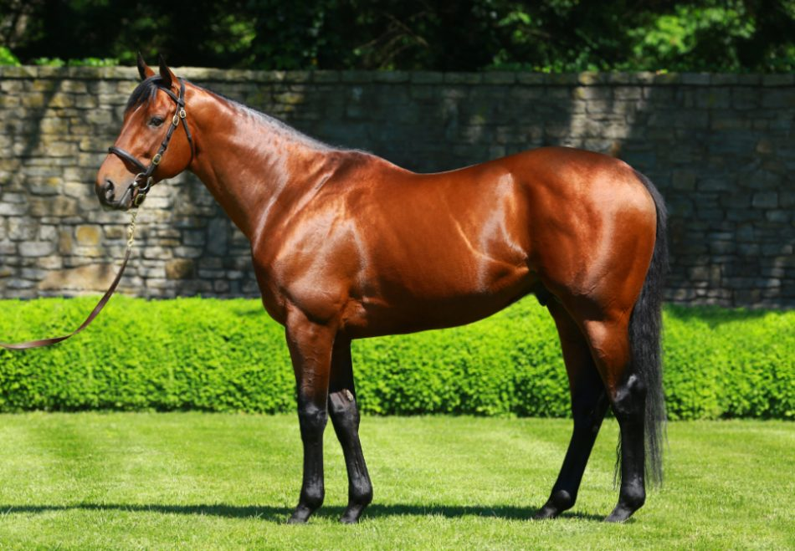
8.

A. Clydesdale B. Morgan
C. Thoroughbred D. Arabian
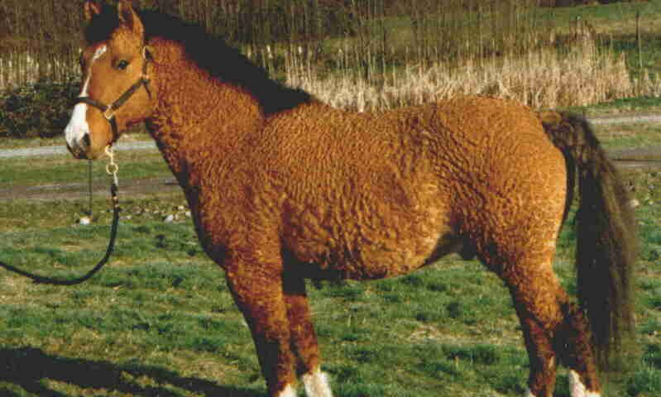
9.

A. Haflinger B. Bashkir Curly
C. Thoroughbred D. Arabian
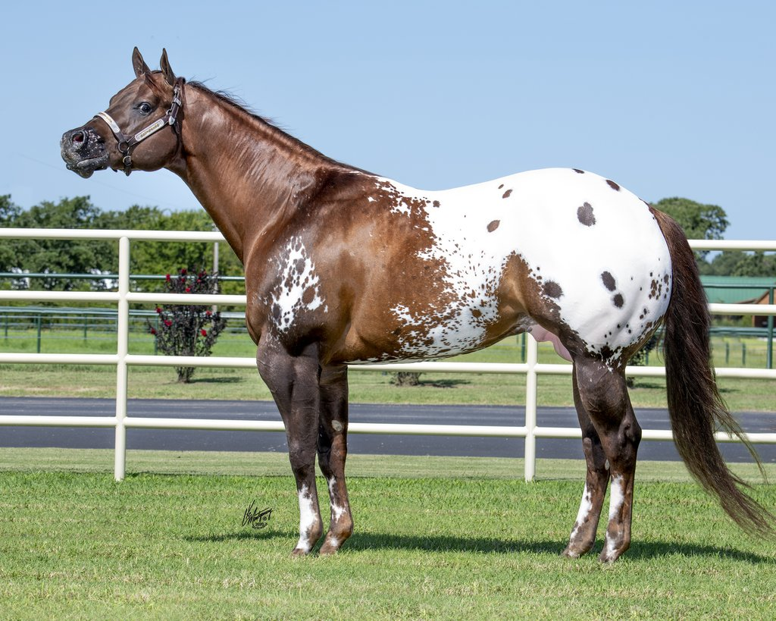
10.

A. Paint B. Appaloosa
C. Quarter Horse D. Hanoverian
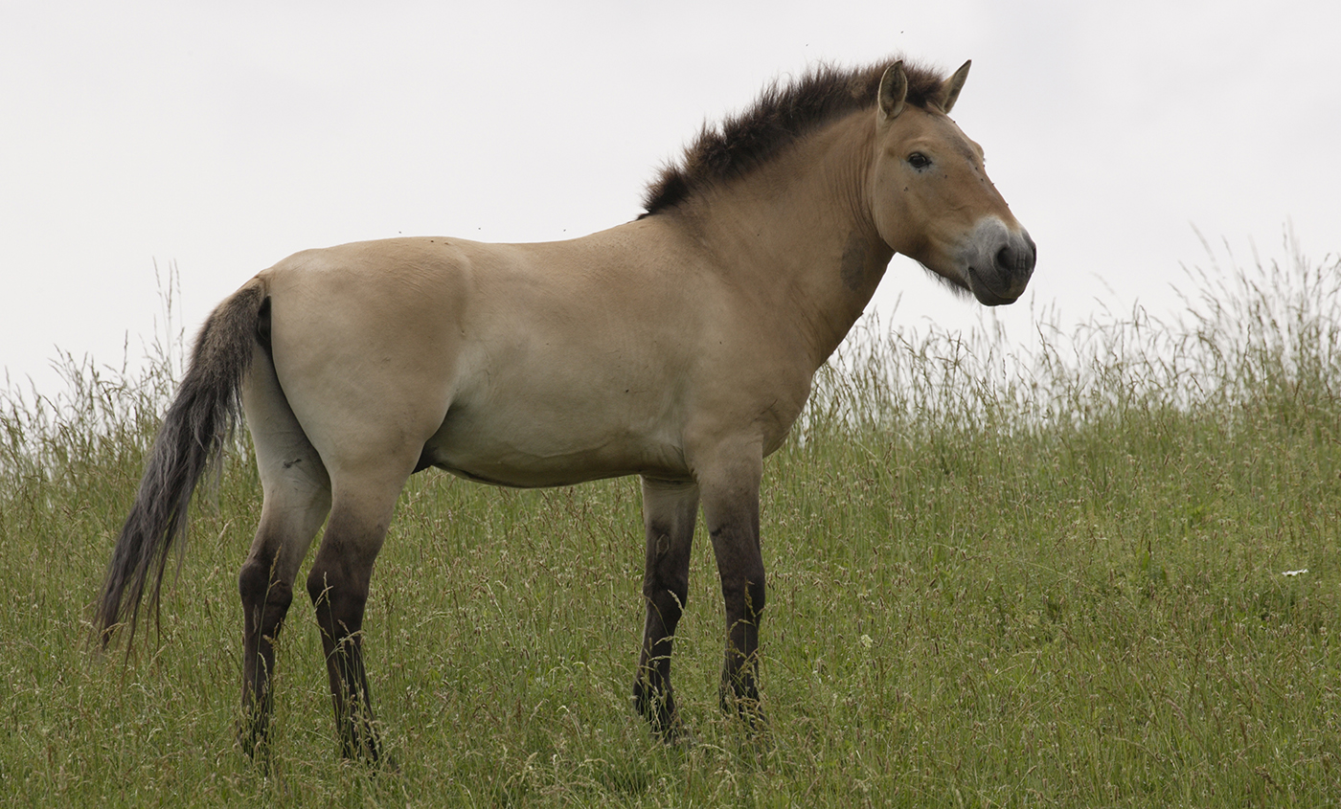
11.

A. Przewalski B. Clydesdale
C. Bashkir Curly D. Haflinger
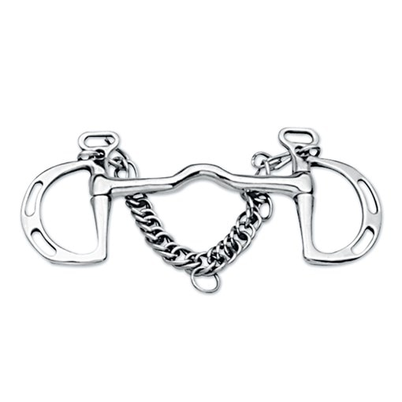
12.

What type of bit is this?
A. D Ring Snaffle B. Gag Bit
C. Curb Bit D. Kimberwick Bit
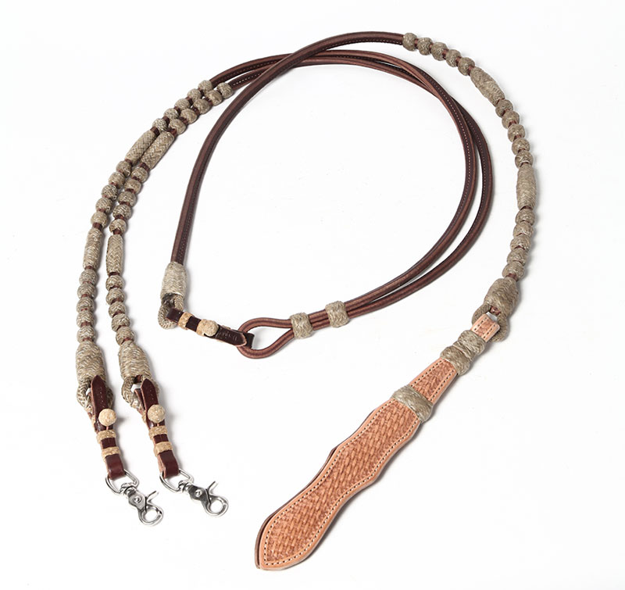
13.

What type of rein is this?
A. Split Reins B. Draw Reins
C. Romal Reins D. Mecate Reins
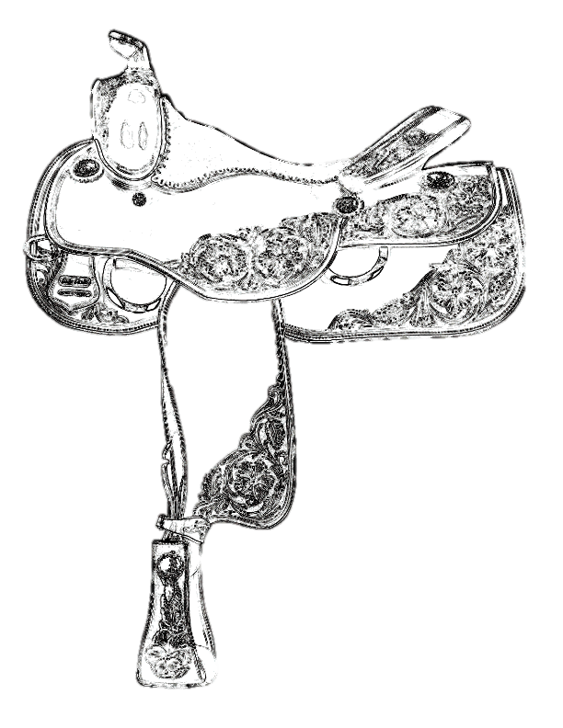
14.

Identify the piece of the saddle that is indicated with the arrow.
A. Skirt B. Cantle
C. Stirrup D. Fender
15.

Identify the piece of the saddle is indicated with the arrow.
A. Fender B. Skirt
C. Cantle D. Stirrup
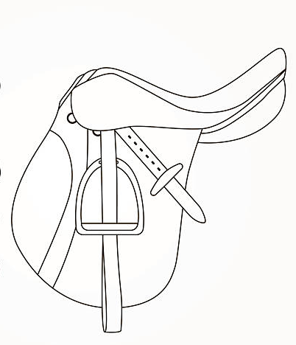
16.

Identify the piece of the saddle indicated with the arrow.
A. Seat B. Pommel
C. Knee Roll D. Cantle
17.

Identify the piece of the saddle indicated with the arrow.
A. Pommel B. Cantle
C. Seat D. Knee Roll
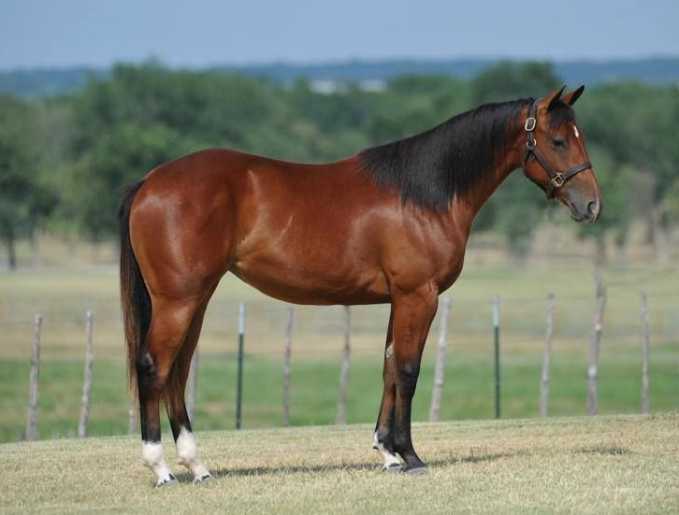
18.

What is the coat color pattern seen here?
A. Bay B. Sorrel
C. Brown D. Black
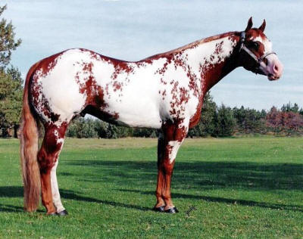
19.

What is the coat color pattern seen here?
A. Bay Tobiano B. Bay Overo
C. Sorrel Tobiano D. Sorrel Overo
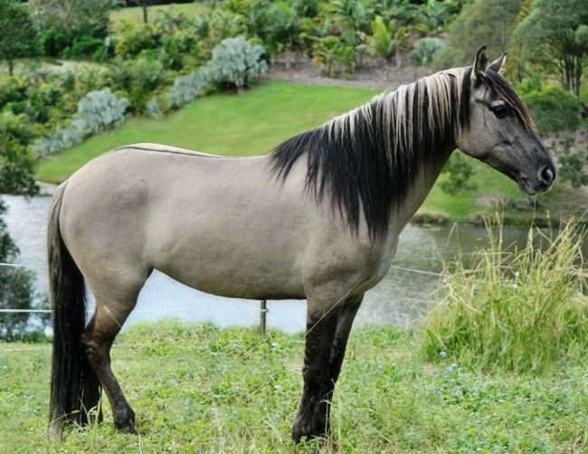
20.

What is the coat color seen here?
A. Grey B. Buckskin
C. Grulla D. Dun
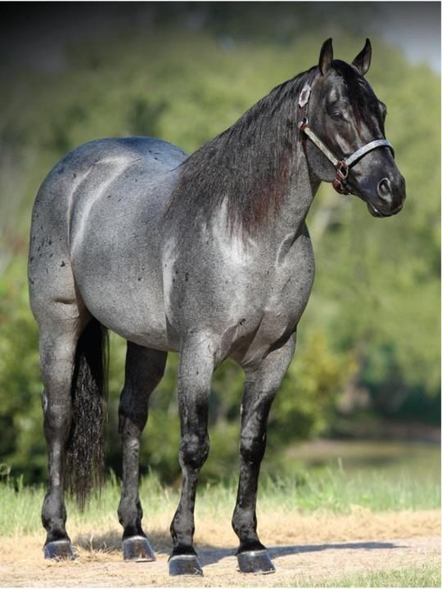
21.

What is the coat color seen here?
A. Bay Roan B. Blue Roan
C. Black D. Dun
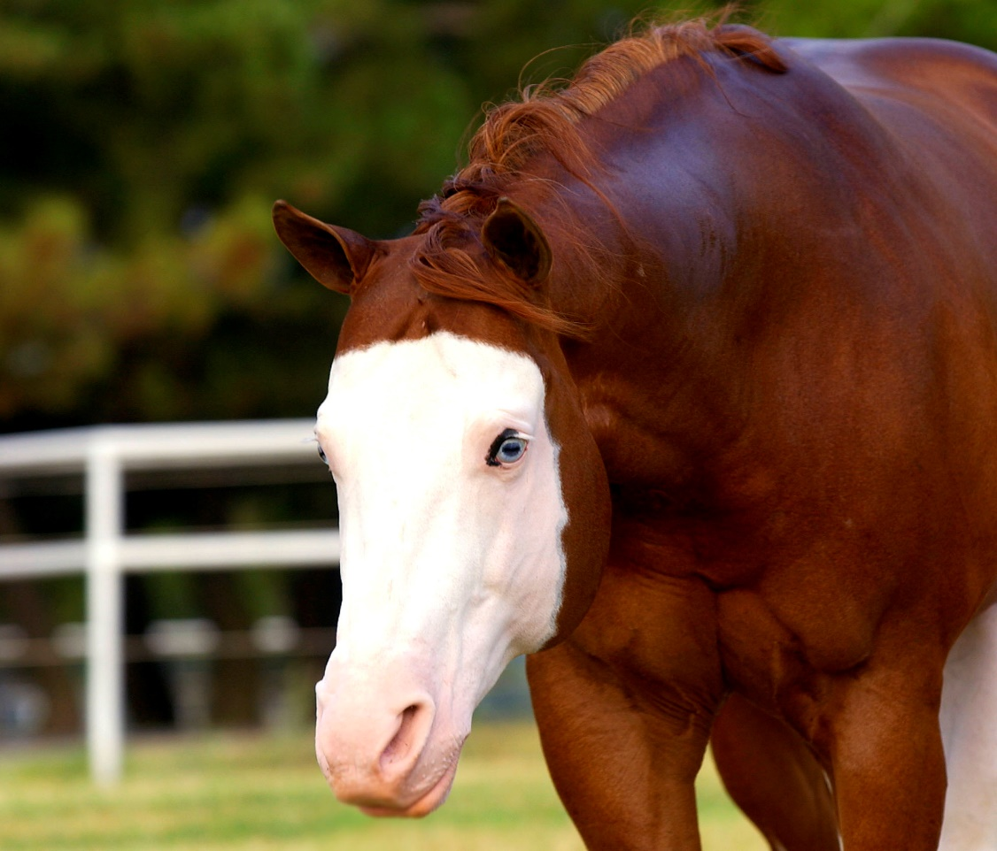
22.

What is the face marking seen here?
A. Blaze B. Star and Strip
C. Bald Face D. Strip
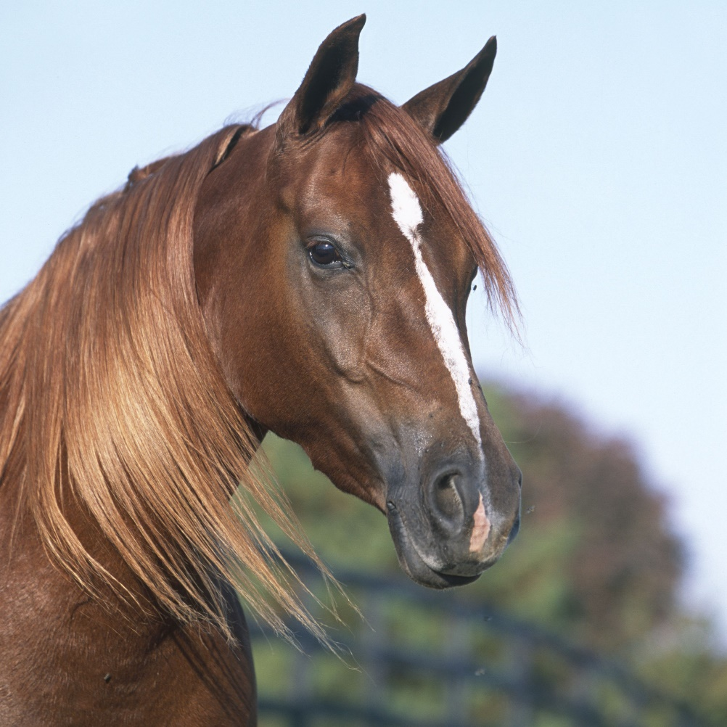
23.

What is the face marking seen here?
A. Blaze B. Star and Strip
C. Snip D. Star, Strip, and Snip
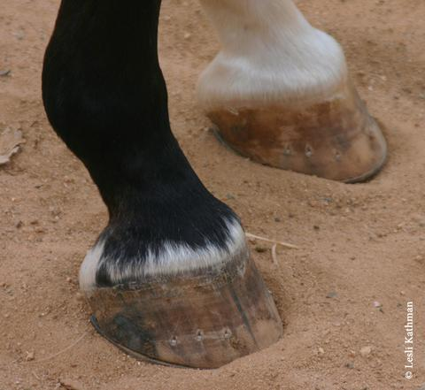
24.

What is the leg marking seen here?
A. Coronet B. Pastern
C. Half Pastern D. Sock

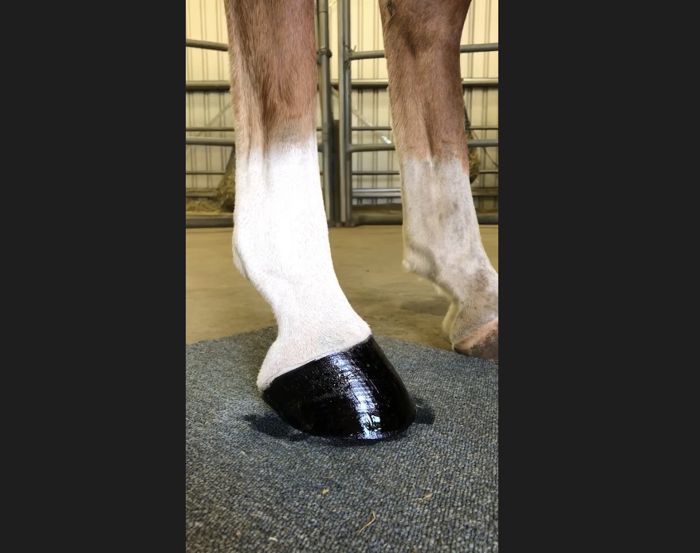
25.

What is the leg marking seen here?
A. Coronet B. Pastern
C. Half Pastern D. Sock

