Tillamook FFA
Tillamook, Oregon
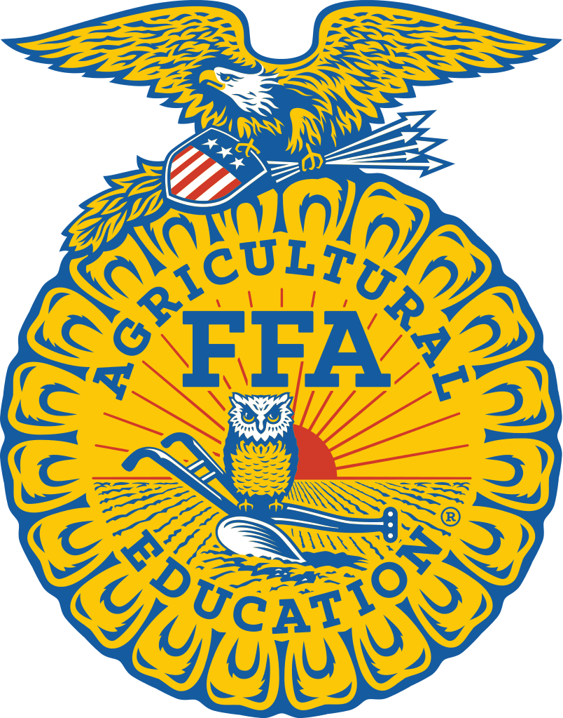

Chapter Officer Handbook
2020-21

Dear Chapter FFA Officer Candidate,

Becoming a Chapter FFA Officer is a challenging process, yet a very rewarding opportunity. Through this chapter officer candidate process, you will grow as a person and advance in leadership development and career preparation. Congratulations on deciding to run for office!
Although Chapter FFA Office takes a great deal of hard work and dedication, officers will gain experiences and contacts that will last a lifetime. The skills gained will help prepare them for future careers, opportunities in college, and leadership roles in other organizations. Chapter officers serve the Tillamook FFA members. They make a positive difference in the lives of many people.
This handbook is to help you prepare your candidacy for Chapter FFA Office. In it, you will find everything you need to get you on your way. Please thoroughly review all the enclosed information as you prepare for the chapter officer selection process.
Remember this handbook is only the beginning! As a candidate, you will need to study FFA information, practice interviewing and presenting yourself in front of people. It will take your personal commitment and dedication to truly prepare for this process. You know yourself best! You know what areas you need to work on. We wish you the very best.
If you have any further questions, regarding the responsibilities of Chapter FFA Officers, or the Selection Process, please contact your advisor.
Congratulations on taking the next step in developing yourself as a leader! Good luck!

Mr. and Mrs. Bush
Tillamook FFA Advisors

Overview
Organization
The Tillamook FFA Officers are overseen by the FFA Advisor, who also serves as the agricultural teacher, with the support of the school administration.
Qualifications
To participate in the Tillamook FFA Chapter Officer program, officer candidates must meet all of the eligibility requirements:
- Have and maintain a 2.0 GPA or higher.
- Have and maintain a clean discipline and attendance record.
- Attend the summer Chapter Officer Retreat – date to be determined.
- Have a signed, completed application on file with the chapter advisors, including the Officer Contract.
- Have a signed, completed chapter Code of Ethics on file with the chapter advisors.
- Be a member of the local FFA chapter for the current school year.
- Review the Chapter Officer Handbook.
- Go through the chapter selection process.
- Be enrolled in an Agricultural Education class for the upcoming school year.

Discipline
All Chapter FFA Officers will be placed on behavior contracts for any of the offenses listed below. The Chapter Officer is allowed two chances to improve their behavior, with the third offense resulting in removal from the team.
Offenses:
- Not abiding by the FFA Code of Ethics.
- Unexcused absences to meetings and events – anything but an illness or family emergency.

Offenses resulting in immediate removal from Chapter Officer Team:
- Use and/or possession of alcohol or drugs.
- Use and/or possession of tobacco.
- Stealing or possession of stolen goods.
- Use and/or possession of weapons.
- Defiance of school faculty and/or staff.
- Two grading periods below a 2.0 GPA.
- Fighting.
The parent and/or officer have the right to request a hearing regarding this action. The hearing will be held as soon as possible with a panel consisting of an administrator, advisors, officer’s counselor, and one other teacher. The officer and parent will be given the opportunity to present reasons for this action to be voided. The decision of the hearing panel will be final.

Chapter Officers and Responsibilities
There will be a minimum of six chapter officers for the school and the possibility of others, as decided upon by the nominating committee. Election results for the Tillamook FFA Chapter Officer team will be announced on the designated day following the completion of all candidate events.

President:
- Run meetings using indicated format
- Create PowerPoints for meetings
- Create Banquet scripts
- Run/lead Ag in the Classroom
- Check in to support and help the rest of the officers
Vice President:
- Program of Activities
- Oversee all committees
- Act as co-chair
- National Chapter application
Secretary:
- Take minutes at executive meetings
- Run check in/attendance
- Write thank you letters
- Create invitations
- Create programs (for Banquet and PMD)
Treasurer:
- Track receipts
- Develop budget – by November 1
- Complete treasurer book
- Collect monthly financial reports
Reporter:
- Create newsletters
- Handle news releases
- Take photos
- Handle school announcement updates
Sentinel:
- Ensure that room is set up
- Buy door prizes
- Check on facility requests (Banquet/PMD)
- Co-run activity points spreadsheet for meetings
Advisor (not elected)
- Supervise chapter activities year-round.
- Inform prospective students and parents about the FFA.
- Instruct students in leadership and personal development.
- Encourage involvement of all chapter members in activities.

Other Elected Offices (if desired by the nominating committee)
Historian:
- Scrapbook - technology
- Take photos
- Create slideshows for Banquet
- Runs activities spreadsheet for meetings
- Support website with photos

Election Schedule & Process
Tillamook FFA Chapter Officer Elections
Application: Due Friday, April 3, 2020 by 4:00 PM
Applications will be Ranked President----Historian
- Quality of your application is important!
- Your application will be ranked, so highlight active involvement, leadership experience & community service.
- Make it clear about why you want to be a Tillamook FFA Officer.

Interview: 4:00 PM ~ Wednesday, April 8, 20208

Speech: 6:30 PM FFA Meeting ~ Wednesday, April 8, 20208
Speeches are not Ranked or Scored
- Be prepared to deliver a speech during the chapter meeting.
- No longer than 2 minutes!
- Can use props…..Make them fun, but they must have a leadership point.

Elections: All Day, Thursday, April 9, 2020
Each vote for an Office Counts toward the Candidates Total
- Voting Pamphlet & Ballots will be handed out to all FFA members.
- At this meeting, the candidate with the highest points earned through the whole process will get their choice of officer position. The second high score then will select and so forth.

Application Rank & Slate Scoring Process: | Election Scoring Process:
President – 80pts | Depending on the amount of people running for Chapter Office, the amount of votes allowed per person voting will increase or decrease to reflect the total number of people running.
Vice President – 70pts
Secretary – 60pts
Treasurer – 50pts | The amount of votes allowed per person will be 40% of the total running candidates up to a max of 7 votes, and down to a minimum of 3. If there is an uneven number of candidates, it will be rounded down to the nearest whole number. For example out of 11 candidates there will not be 5 votes, there will be 4.
Reporter – 40pts
Sentinel – 30pts
Historian – 20pts

FFA Point System
To encourage participation throughout one's high school career, for every officially sanctioned FFA event or activity one attends will count for one point. Activities will be verified via a third party, with the following guidelines: FFA activities will count for 1 point if the activity is an officially sanctioned FFA event (i.e. CDE, fundraiser, community service event, community information event). Practices DO NOT count.

For example: 2017 District Ag sales 1pt, 2018 Pumpkin Patch 1pt, 2018 National Convention 1pt, 2019 Creed Speaking 1pt.

Chapter Officer Application ~ Tillamook FFA
Applicant’s Name: _____________________________________ Degree Held: __________________
Address: ______________________________ City: _____________ State: ____ Zip: ________
Phone #: ____________________________________________ Grade: ________ Age: ______
GENERAL QUESTIONS
- Agriculture classes planned for the coming year: __________________________________

- List the offices you want to be considered for, if you are elected, in order of preference.
(Offices available are listed in the Chapter Officer Handbook.)

A. ___________________ B. ___________________ C. ___________________

- Current GPA: _____________________________ Guidance Counselor Initials: _________
EXPERIENCE QUESTIONS
- List all FFA leadership roles you have experienced. (Officer, committees, etc.)

- List all FFA activities/CDE’s you have participated in (excluding any practices). Please list the activity and what you did at that activity. Example: October FFA Meeting – attended, or Pumpkin patch – group leader.

- List any FFA awards or honors you have received.

- List involvement in school/community activities outside the FFA.

- Describe your experiences speaking in front of large groups of students/people?

LEADERSHIP THOUGHT QUESTIONS
- Briefly state the qualities you possess that qualify you for a chapter office.

2. If you were elected to a chapter office, what would be your main goal for the chapter?

- Select one of your personal qualities and explain how it will be of value to the chapter officer team.

- What other commitments do you have in the year that would compete for your time?

- What do you believe are the most important responsibilities of a chapter officer?

- List at least three ideas for new chapter activities for the upcoming year.

CANDIDATE’S AGREEMENT
I understand I am responsible for my duties as a chapter officer and will uphold them to the best of my ability. I have read and understand the information presented in the Tillamook FFA Chapter Officer Handbook. I have completed the officer application honestly and accurately to the best of my ability, completed the Officer’s Contract and Code of Contact. Upon my election, I understand I am required to be at all officer team meetings, on time, or will fall subject to the consequences associated with absence and tardiness. I am aware that repeated absences from required functions will result in my being dismissed from the officer team early. My presence at the officer retreat is mandatory!

Applicant Signature: _______________________________________ Date: ____________

PARENT/GUARDIAN AGREEMENT
I ____________________________, hereby approve of my son/daughter, ___________________, running/becoming a Tillamook FFA Chapter Officer for the 2020-2021 school year. I realize that s(he) is responsible for their officer duties and will uphold them to the best of their ability. I have read and understand the information presented in the Tillamook FFA Chapter Officer Handbook. I further understand my child is required to be at all officer team meetings, on time, or will fall subject to the consequences associated with absence and tardiness. I am aware that repeated absences (no more than three) from required functions will result in my student’s early dismissal from the officer team. His/Her presence at the officer retreat is mandatory!

Parent/Guardian Signature: _________________________________ Date: ____________

Officer Code of Conduct
It is a both a privilege and responsibility to be elected an officer of the Tillamook FFA Chapter. The following guidelines are written to help you approach the year with a clear understanding of what is expected.
All Officers Are Expected to:
- Observe both the FFA Code of Ethics, as printed in the Official FFA Manual and the Tillamook High School Student Handbook.
- Attend the Chapter Officer Retreat.
- Strictly forego any use of alcohol, tobacco, drugs and profanity, on school property or at FFA events.
- Maintain a professional relationship at all times with other officers, teacher and administrators.
- Maintain high academic achievement by carrying a minimum 2.0 GPA at all times.
- Follow instructions given by the FFA advisors and other high school faculty.
- Be willing to make the Tillamook FFA chapter your first priority for the coming year.
- Be punctual and prepared for all assignments and activities.
- Avoid places and/or activities that, in any way, raise questions as to your moral character.
- Accept suggestions, feedback, and criticism in a mature way.
- Follow accepted standards of behavior and etiquette in public places.
- Observe all of the above guidelines in all areas of life for the coming year. You represent this chapter 24 hours a day, 365 days a year.
- Complete all assigned officer tasks by appropriate deadlines and make every effort to assist the other members of the team with their assignments.

Furthermore, it is Recommended that All Officers:
- Refrain from speaking negatively about anyone.
- Refrain from reckless operation of motor vehicles, including speeding.
- Plan ahead to be in attendance at all chapter activities. Notify the advisors as soon as possible if you will not be able to attend.
- Keep your advisors informed of any problems you encounter or mistakes you make.
- Become knowledgeable about agriculture, agribusiness, agricultural education and the FFA.
- Attempt, through preparation and practice, to develop yourself into an effective public speaker.
- Be prompt and consistent in completing all assignments.
- Periodically evaluate your personality and attitudes, making every effort to improve yourself.
- Maintain and protect your health.
- Treat ALL FFA members equally, not favoring one over another.
- Behave in a manner that conveys and commands respect.
- Maintain dignity while being personable, concerned and interested in the people around you.
- Serve as a member of the team, always maintaining a cooperative attitude.

In the event an officer has a problem following these guidelines:
- The advisors shall meet with the officer in question privately and discuss the situation.
- If the officer continues to display problems meeting the requirements of this agreement, a written notice will be sent to the officer, the officer’s parents, and the high school administration. At that time, a meeting will be held between the advisors, officer and parents to resolve the situation.
- If problems continue, a meeting, including an administrator, will be arranged to discuss dismissal, or the officer’s resignation.

In the event an officer no longer wishes to serve as an officer:
- The officer shall submit an official letter of resignation stating their reason for vacating their duties to the advisors or Chapter President.
- The advisors shall meet with the officer in question privately and discuss their intent and the situation.
- The officer team will be presented with the request for resignation and will decide as a team how to divide the remaining responsibilities from the vacated position.
- If the officer in question wishes to be reinstated to their office, they shall submit a letter of intent to the Chapter President and the officer team will have full power to accept or deny reinstatement in a private meeting with the advisors.

Discipline Guidelines
All Chapter FFA Officers will be placed on behavior contracts for any of the offenses listed below. The Chapter Officer is allowed two chances to improve their behavior, with the third offense resulting in removal from the team.
The parent and/or officer have the right to request a hearing regarding this action. The hearing will be held as soon as possible with a panel consisting of an administrator, advisors, officer’s counselor, and one other teacher. The officer and parent will be given the opportunity to present reasons for this action to be voided. The decision of the hearing panel will be final.

Candidate and Parent/Guardian Agreement
I have read, studied, and understand the above points. As an elected officer of the Tillamook FFA, I will carry out my responsibilities in accordance with these statements and understand that I can be suspended or removed from office if I do not satisfactorily follow these established standards.

___________________________________ ___________________________________
Candidate Signature Date Parent/Guardian Signature Date

Tentative Schedule of Events
The following dates are Mandatory for Officers. Please remember this is a TENTATIVE schedule. Officers will be expected to attend officer meetings which will be scheduled by the team once a month.

April 9, 2020 FFA Meeting – Officer Speeches – Ag Classroom – 7:00 PM
May 9, 2020 Chapter Banquet – THS Cafeteria
Summer 2020 Officer Planning Retreat – TBA
September 2020 Freshmen Club Table
October 2020 Leadership Camp – Rituals Contest
November 2020 Annual Alumni Dinner
February 2021 National FFA Week
May 2021 Annual Chapter Banquet
**Scheduled Officer Meetings**

